**MY452 – Applied Regression Analysis:**

**Lectures & Seminars**

**Lecture: Week 1 – About the course & recap on inferential statistics.**

**MY452 looks like:**

* Review of simple linear regression (W2)
* Multiple linear regression (W2-4)
* Binary Logistic regression (W5, W7)
* Multinomial logistic regression (W8)
* Ordinal logistic regression (W9)
* Count regression (W10)
* Overview of advanced topics (W11)

**It assumes:**

* Descriptive statistics
* Populations and samples
* Chi-sq for independence in contingency tables
* T-tests for comparison of means
* Simple and multiple linear regression
* How do we use regression models to make social scientific arguments?
* To apply regression methodologies to answer your research questions.
* To understand what kinds of questions can, and cannot, be answered using regression analysis.
* To think critically about the assumptions, implications and limitations of evidence produced by regression analysis.
* To make more rigorous, accurate and persuasive arguments using quant evidence.

**Teaching**

* 2 hour lecture
  + Cover course content
* 1 hour seminar (computer class)
  + Practice course content

**Assessment**

* Formative assessment
  + Weekly exercises to be done before class
  + Moodle quiz to consolidate
* Summative assessment
  + Exam in Summer term (100% of final mark)

**Support**

* Quizzes
* Exercises
* Office hours
* Bespoke office hours for R (Vikas Chandra)
* Moodle forum
* Collaboration

**A rough outline of the research process**

* ***Design:*** determining what kind of data will answer the question
* ***Collection:*** finding/measuring/recording relevant data
* ***Analysis*:** learning what the data reveals about the answer to the question
* ***Reporting*:** reporting the findings in words, tables and graphs.
  + This course is primarily about Analysis & Reporting

**Quantitative analysis is the the process of translation from substantive concepts to numerical measures which we *analyse* using quantitative methods and translate back to conceptual arguments via *reporting.***

**Knowledge is largely about expressing relations, patterns, categories, distinctions in the world around us.**

Everyday language:

* Great for comms
* Indispensable for conveying the complexity and meaning of social phenomena
* Poor for analysing and summarizing large quantities of structured information.

Numbers:

* Mediocre for comms
* Fantastic for describing structure in the world

**Regression Models**

* Relate the values of a response variable (“dependent variable”) to the values of explanatory variables (“independent variables”).
* One way of summarizing relationships between quantitative measurs/variables.
  + Describe how a response variable varies across a population.
  + Predict a response variable *given* values of explanatory variables.
* Regression models are
  + Most widely applied is SS research
  + The starting point for many other models.
* They can be misused to try to make claims that the underlying data do not support
  + We will discuss common issues.

**Basic logic of linear regression model**

* The mean of “expected value” (E[Y]) of the response variable (Y) is assumed to be a linear combination of explanatory variables and unknown parameters (regression coefficients & error (epsilon))
* E[Y] = alpha + B1X1 + B2X2 + … + BkXk
* Two key assumptions
  + It makes sense to model the mean of Y.
  + It makes sense to treat the relationship between E[Y] and each X variable as linear and additive.
  + These assumptions are not always met!

**Types of regression covered in this course:**

* Interval Scale
  + Continuous or discrete, positive or negative, where differences (intervals) have the same meaning anywhere on the scale.
    - E.g. age, P/L
* Ratio scale
  + Continuous variable, strictly positive, where ratios have the same meaning anywhere on the scale.
    - E.g. GDP
* Nominal scale
  + Categorical variable with no relative information in categories.
    - E.g. a choice between political parties.
* Ordinal scale
  + Categorical variable where it’s possible to rank categories
    - E.g. ‘strongly agree, agree, neither disagree or agree, disagree, strongly disagree.’
* Count scale
  + Discrete non-negative integers
    - E.g. number of students on different courses at LSE.
* **All can have multiple explanatory variables of varying types.**

**Structure of the generalized linear model (GLM)**

* Model some characteristic f() of a distribution of the response variable using a linear combination of the explanatory variables and unknown parameters (regression coefficient)
* F(Response variable) = alpha + B1X1 + B2X2 + … + BkXk
* If I get rid of the expectation symbol and replace it with f() (some function). I can model some function of my response variable as a linear additive combination of terms and regression functions.
* Course basically walks you through different ways we can define f() so tht we can explore different response variables.
* So, in case of Binary Logistic model, we’re not looking at mean, we’re looking at Log(odds ratio).
* If we crack the GLM, we’re a pro.

**For each model, we will discuss:**

* Specification of different types of explanatory variables
* Interpretation of the regression coefficients
* Statistical inference for the coefficients
* Model selection and diagnostics
* Interpretation and presentation of results
* Some identical, some similar, some not.

**“The Lady Tasting Tea” (Fisher, 1935)**

* Claimed to be able to distinguish whether the milk or the tea had been poured into the cup first.
* Colleagues thought this was a dubious claim.
* 8 cups, 4 of each type, were brewed in random order
  + She identified all 8 cups.
  + What’s the chance that this was by chance?
* How much evidence is this for Dr. Bristol’s claim? (P-value)
  + How many different ways are there to pick 4 cups out of 8?
  + 70 ways of choosing, of which 1 was realised
* What is the relevant null hypothesis for evaluating Dr. Bristol’s claim?
  + Assume that she’s a liar and cannot tell the different between the methods of preparing the tea.
    - This is the null hypothesis.
  + To perform a *test* of the *null hypothesis*, we ask:
    - IF the null hypothesis is true, what is the probability that we would observe what we observed?
  + In the example of the lady tasting tea:
    - If Dr. Bristol was really only guessing, what is the probability that she would have correctly identified all four cups of tea made according to one of the methods on the first try? 1/70, 0.014, this is a p-value.
* All the hypothesis testing we will do will be based on this logic.

Research question: What is the effect of a job training program on wages?

* Data: Job Training Partnership Act experiment
  + “A large federal program that provided subsidized training to disadvantages American workers in 1980s”
    - Treatment: offer of training
      * 60% acceptance rate
      * 2% non-compliance in control group
      * We are going to ignore these details for now.
    - Outcome: earnings over 30 months.
* Graphical representation didn’t answer the question. We need statistical tools to make sense of this.
* We can fix the scale & overlay the histograms via a density graph.
* Comparison of Means via control vs. treatment, gives us Y-bar (mean). Standard deviation also present.
  + Calculate difference of sample means
  + Individuals assigned to the treatment group earned 1160 more, on average, than those assigned to the control group, in the 30 months after the experiment.
* We **usually** want to make inferences about a broader population, based on sample information.
  + Such generalizations are possible when the samples are probability samples from the populations.
  + Sometimes the data we observe are a sample from an actual population.
    - E.g., the subjects of the JTPA were drawn from the broader population of Americans who had interacted with the unemployment insurance systems in the US.
  + Sometimes the data we observe are a sample from a conceptual population
    - E.g., the 8 cups of tea tasted by Dr. Bristol is a sample of the conceptual population of cups of tea prepared in the prescribed ways.
  + The focus of interest is some population *parameter* e.g., the difference:
    - Delta (triangle) = mean of group 2 – mean of group 1.
    - Of the means of a variable Y in two populations
  + Possible questions:
    1. What is our best guess of the value of the parameter? (Point estimate)
    2. Is it plausible that the parameter has a particular value? E.g., delta = 0 (hypothesis testing)
    3. What values of the parameter are plausible? (Interval estimate)
* Here, a point estimate of Delta is Y-bar-2 – Y-bar-1. Delta-hat (estimate of delta) = Y-2-hat – Y-1-hat However, this is not enough:
  + Delta-hat is not equal to delta in the population: there is **sampling error.**
  + If we ran the same experiment again, in the same way, on a new sample of 11204 Americans in the 1980s, we would not get the same difference between the means.
  + Want to quantify the likely extent of the sampling error. I.e., the uncertainty in the point estimate.
    - This is done by using the sampling distribution of Delta-hat.
* The ***sampling distribution*** of a point estimate (Delta-hat) is the distribution of its values in infinitely many (hypothetical) samples from the population.
  + The general idea is:
    - The sampling distribution gives an idea of how much values of the estimate may vary from sample to sample.
    - This gives an idea of the uncertainty in the point estimate obtained from the one sample we actually collected.
* We need to make a set of assumptions about the population distributions of the variables of interest.
  + In the two-sample case, a simple model is:
    - The mean of variable Y is mu-1 in population1 and mu-2 in population 2.
    - Y has a normal distribution in both populations, and the same variable (sd^2)
    - Observations of Y within and between samples from the 2 populations are statistically independent.
  + Under this model, the sample distribution of Delta-hat = Y-2-hat - Y-1-hat is:
    - A normal distribution, with
    - Mean (Delta) (i.e. Delta-hat is an unbiased estimate of Delta)
    - Standard deviation =
      * Standard Error (Delta-hat) = variance*sqrt(1/n1+ 1/n2)
      * This is known as the standard error of delta-hat.
    - The standard error is inversely proportional to sqrt(n)
      * i.e. larger samples give us more precise estimates.
    - These results do not *only* apply when the population distributions are normal.
      * The sampling distribution of delta-hat has the same approximate form for *any* population distribution of Y.
      * So long as the sample sizes n1 and n2 are not too small.

**Hypothesis/Significance Tests**

* Tool for examining the plausibility of a claim (hypothesis) that one or more population parameters have specific values.
* Main elements:
  + Hypotheses
  + Test statistic
  + Sampling distribution of the test statistic
  + P-value
  + Conclusion
* Using our JTPA example
  + Hypothesis
    - The null hypothesis is that there is no group difference of means.
    - Hypothesis is that those in treatment group have a higher mean over 30 months of earnings than those in control group.
  + We observe delta-hat, the sample difference between the groups
    - We now want to know where this lies in the sampling distribution under the null hypothesis.
    - How weird (or outlying) is our actual estimate?
  + We use one- or two-sided test statistic (based on hypothesis).
    - In this case, we use a two-sided (can argue case for a one) to quantify chance of *any* impact the JTPA training scheme has.
    - We characterize the location of delta-hat across sampling distribution with this test statistic.
    - We can calculate the probability (area under curve) of observing the value that we did observe, or a more extreme one, given the assumptions of the null hypothesis.
    - This is the p-value.
    - The two-sample t-test statistic for the null hypothesis is used to calculate the p-value.
      * Large (pos or neg) values of t indicate evidence against the null hypothesis.
      * In the JTPA example, t=3.45
* The t-statistic is just the parameter estimate divided by the standard error.
  + - * Only the sampling distribution under the null hypothesis is needed for the test.
      * Here, if the model assumptions of normal population distributions with equal variances holds,
        + The sampling distribution of t under null hypothesis (H-0) of no difference is a t-distribution with n1 + n2 – 2 degrees of freedom.
        + When df is lower, there’s a lower peak and wider tail.
        + When df = infinity, its basically a normal distribution with a higher density peak in the center.
    - Even when the population distributions are not normal, the sampling distribution of t is approx. standard normal when the sample sizes n1 and n2 is large enough.
* The hypothesis/significance test (p-value) provides a measure of plausibility of a null hypothesis about the population, considering the evidence from the observed sample.
* A small p-value is evidence against the null hypothesis.
* Select a significance level, if it’s less than that then **then null hypothesis is rejected.**
* 0.05 significance level is convenient as we can use approx. 1.96 standard deviations. This is conventional and arbitrary.
* Hypothesis test is binary – we reject the null hypothesis or we fail to do so.

**Confidence intervals**

* What if we want to say something about what the true value of the parameter is, rather than is not?
  + We can invert the hypothesis test to generate an inerval of plausible parameter values.
  + A confidence interval is the range of null hypotheses that cannot be ruled out by the sample at a given alpha.
  + This gives us a measure of the study’s precision
  + In repeated sampling, 1 – alpha of confidence intervals will cover the true value of the parameter.
  + 95% of intervals I draw will contain the true parameter value. This is a claim about the sampling rather than the interval.
* **Calculation: Parameter estimate + qnorm(0.025)*standard error.**
* IF Confidence interval DOES NOT contain 0, then we can reject null hypothesis. This is how confidence intervals and p-values are connected.
* How to interpret a 95% confidence interval?
  + “In the long run, about 95% of intervals generated would contain the parameter.”
  + “The claim that the parameter lies between […] has 0.95 probability of being true.”
  + “We can say with 95% confidence that the interval […] contains the parameter.”
  + THIS IS NOT THE SAME AS:
    - * There is a 95% chance that the parameter value is in the confidence interval. DO NOT WRITE THIS ON EXAM
      * The CI either contains the parameter or it does not.

**Readings: Week 1 – Review of inferential statistics**

**One versus two sided tests**

The null hypothesis is tested against an alternative hypothesis, here either the two-sided hypothesis

Alternative Hypothesis (H_a) : ∆ ̸= 0

or one of the one-sided hypotheses

H_a : ∆ < 0 or

H_a : ∆ > 0.

Sample evidence which is consistent with the alternative hypothesis will be regarded as evidence against the null hypothesis. This means that for the two-sided alternative, evidence that ∆ differs from zero, whether in the negative or positive direction, will be evidence against H0.

For the one-sided alternatives, on the other hand, only one side of zero matters. If H_a is, for example, only evidence of a negative mean difference (i.e., of µ1 < µ2) will ever be regarded as evidence against the null hypothesis.

For the models discussed on this course, two-sided alternative hypotheses are in practice used much more commonly than one-sided ones, so we will also concentrate on them throughout the course. If required, modifications for the one-sided case (which are needed only in calculating the P-value of the test) are easily done as explained below. A decision to consider a one-sided alternative hypothesis should usually be based on subject-matter arguments which suggested that only deviations from H_0 (null hypothesis) in one direction are important and/or interesting.

When a statistic is used as an estimate of some population quantity, its standard error is best thought of as a measure of the precision of the estimate. An estimate with a low standard error, i.e., one whose values would be expected to vary little from sample to sample, is said to be more precise than an estimate with a higher standard error.

where we have introduced the notation ˆse, which will also be used later for other estimated standard errors. An important feature of the standard error is that it is a decreasing function of the sample sizes n1 and n2. In other words, the standard error is, other things being equal, going to be smaller when the estimate ∆ is calculated from large samples than when it is calculated from small samples. ˆ This is a general result which holds for virtually all statistical analyses.

**Confidence Intervals & Significance tests**

The second general observation concerns the relationship between confidence intervals and significance tests. Suppose we use the test statistic for the null hypothesis ∆ = 0 against a two-sided alternative hypothesis ∆ ̸= 0, and the confidence interval for ∆, both under the same model assumptions, using the same estimates ∆ˆ and ˆse(∆), same sampling distributions and matching significance and confidence levels ˆ (e.g. 5% significance level for the test and 95% (= 100% − 5%) confidence level for the interval). The following correspondences then hold in general:

• If the null hypothesis H0 : ∆ = 0 is not rejected by the test, the confidence interval for ∆ = 0 contains 0, and vice versa. For instance, this is the case in for the average interview lengths, where P = 0.28 and the 95% confidence interval (−1.49; 5.17) does contain ∆ = 0.

• If the null hypothesis H0 : ∆ = 0 is rejected by the test, the confidence interval for ∆ = 0 does not contain 0, and vice versa. For instance, this is the case for the average weekly working hours, where P = 0.003 and the 95% confidence interval (0.54; 2.68) does not contain ∆ = 0.

**Lecture: Week 2 – Linear Model with Multiple Explanatory Variables and onwards…**

**RQ: Did poorer countries catch up to rich countries economically or did they fall further behind?**

Most countries better off in 2010 than 1970, but likely growing at different rates.

Assume epsilon (errors) are statistically independent of one another.

Alpha (intercept) term represents extreme case (all features = 0). However, if above 0 then could be interpreted as the presence of growth due to being higher than the 1-1-infinity line.

Using fitted (predicted) values for Y given the values of X:

* Set Xj to specific values and use coefficients to thus calculate Y.

Residual Standard Deviation (sigma-hat)

* Sigma standard deviation goes down as more explanatory variables
  + Amount of unexplained variance declines as we account for more variance with.
  + How to interpret? 95% of cases fall within qnorm(0.025)*standard_deviation.
* Sums of Squares is the total sample variation in Y.
* (n-1)*sample variance^2
* Total Sum of Squares = Sum of Squares of Model (difference between predicted and our mean Y-bar, squared) + Sum of Squares error (difference between observed outcome Yi and predicted outcome Yi-hat, squared).
* R^2, or coefficient of determination is the part of the total variation “explained by the model” and the coefficient of determination. If R^2 = 0.8, then we explain 80% of model and residual s.d. drops from a model with a lower R^2. R^2 rises as residual s.d. falls.

The theory guides the variable choice AND model selection.

**Readings: Week 2 – Simple & Multiple Linear Regression**

**Chapter 3: Review of simple linear regression models**

This spirit of modelling is best summarized by the well-known statement by the statistician George Box: All models are wrong, but some are useful.

All models are wrong because the world, especially the social world, is an exceedingly complex place, full of local detail. As social scientists we do not want to reproduce that local detail in our models. What we are trying to do is capture the essentials and leave out the inessentials. A model that was one hundred percent correct would be of no value because it would be as complex as reality itself and if we could understand reality in all its complexity, we would have no need for models!

These specifications define the simple linear regression model:

• **Simple** because it has only one explanatory variable, as opposed to multiple linear regression models which will have more than one.

• **Linear** because is a linear function of the parameters α and β. The specification (3.3) is also linear in the explanatory variable X, meaning that it defines a linear (straight-line) relationship between X and µ. Later, however, we will encounter more flexible linear models which do not need to be linear in the explanatory variables. This subtlety will be discussed in Section 4.6.3.

• **Regression**: these days, a “regression model” typically refers to any statistical model which describes how response variables depend on explanatory variables. The original reasons for the use of the word in this context are somewhat accidental and of no relevance here.

• **Model**, because this is a statistical model in the sense discussed above.

**Interpretation of the model parameters**

The simple linear regression model has three parameters, α, β and σ^2 . The first two of these appear in the model for the conditional mean µ = α + βX of Y given X in the population (dropping the subscript i for now for notational simplicity). The parameters α and β in this formula are known as regression coefficients. They are interpreted as follows:

• **α** is the expected value of Y when X is equal to 0. It is known as the intercept or constant term of the model. Because 0 is typically not a specifically interesting value of X, α is usually not interpreted in any detail.

• **β** is the change in the expected value of Y when X increases by 1 unit.

The parameter β is known as the **slope** term or the **coefficient of X**. It is typically the only parameter of substantive interest in the model, because it describes the association between X and Y, in the above terms of expected changes in Y corresponding to changes in X.

The third parameter of the simple regression model is σ^2. This is the variance of the conditional distribution of Y given X. It is also known as the conditional variance of Y, the error variance or the residual variance. Similarly, its square root σ is known as the conditional, error or residual standard deviation; it is in fact more convenient to consider σ rather than σ^2, because σ is on the same scale as the measurements of Y.

If we were to (hypothetically) collect a large number of observations, all with this same value of X, the distribution of Y for them would describe the conditional distribution of Y given that value of X.

In this coursepack, estimates of the regression coefficients α and β will be denoted by ˆα and βˆ (“alpha-hat” and “beta-hat”) respectively (other notations are also often used, e.g. a and b). Once they are available, we can also calculate fitted values Yˆ = ˆα + βXˆ for Y given any value of X. Fitted values Yˆ i = ˆα+βXˆ i can be calculated at the values Xi of the explanatory variable X for each unit i in the observed sample. These can then be compared to the corresponding values Yi the response variable had. Their differences Yi − Yˆ i are known as the (sample) residuals.

The point further to the left is the one for Mali, which has School enrolment Xi = 43.0 and IMR Yi = 14.1. Using the estimated coefficients ˆα = 19.736 and βˆ = −0.179 (obtained as explained below), the fitted value for Mali is Yˆ i = 19.736 − 0.179 × 43.0 = 12.0. Their difference is the residual Yi − Yˆ i = 14.1 − 12.0 = 2.1. Because the observed value is here larger than the fitted value, the residual is positive, and the observed value is above the fitted line. The second point shown in Figure 3.6 corresponds to the observation for Ghana, for which Xi = 58.0, Yi = 5.7, and the fitted value is Yˆ i = 19.736 − 0.179 × 58.0 = 9.4. The residual is then Yi − Yˆ i = 5.7 − 9.4 = −3.7, which is negative as the observed value is here smaller than the fitted value.

**How to select the best regression line**

It remains to define a method for calculating specific values for the parameter estimates αˆ and βˆ. In doing so, we are faced with the task of identifying a regression line which provides the best fit to the observed points in a scatterplot like Figure 3.3. Each possible choice of ˆα and βˆ corresponds to a different regression line, and some choices are clearly better than others. To make such considerations explicit, the residuals can be used as a criterion of model fit. The aim will then be to make their total magnitude as small as possible, so that the fitted line is as close as possible to the observed points Yi in some overall sense. (Sum of squares of errors, or residual sum of squares, SSE, RSS).

**Sums of Squares and R^2**

A number of useful concepts and results in linear regression models involve sample statistics known as sums of squares.

SSM is the part of the total variation T SS “explained” by the fitted regression model, and SSE is the part left “unexplained” by the model. In this language, (3.13) can be stated as:

Total variation of Y = Variation explained by regression + Unexplained variation

TSS = SSM + SSE

The most common summary of these sums of squares is the coefficient of determination, more commonly known as R2 (“R-squared”). It is a measure of association very often used to describe the results of linear regression models.

This is the proportion of the total variation of Y in the sample explained by the fitted regression model. Its smallest possible value is 0, which is obtained when βˆ = 0, so that X and Y are completely unassociated, X provides no help for predicting Y , and thus SSE = T SS. The largest possible value of R2 is 1, obtained when ˆσ = 0, so that the observed Y can be predicted perfectly from the corresponding X and thus SSE = 0. More generally, R2 is somewhere between 0 and 1, with large values indicating strong linear association between X and Y . For our model for IMR given School enrolment, the coefficient of determination is R2 = 0.567.

Because the sums of squares TSS and SSE can be thought of as measures of errors in predicting the sample values of Yi , the difference TSS − SSE shows the reduction in the level of prediction errors when we allow the predicted values Yˆi to depend on the values Xi of the explanatory variable for each unit, compared to using the overall sample mean Y¯ as the prediction for every unit. R2 then expresses this reduction as a proportion of TSS.

In our example R2 = 0.567, so using each country’s level of School enrolment to predict its IMR reduces the prediction errors by 56.7% compared to the situation where the predicted IMR is the overall sample mean (here 4.34) for every country. Another conventional way of describing this R2 result is to say that the variation in rates of School enrolment explains 56.7% of the observed variation in Infant mortality rates.

R2 is also related to the correlation coefficient, a simple measure of linear association between two interval-level variables. In simple linear regression, R2 is the square of the correlation r between Xi and Yi. Furthermore, the square root of R2 is the correlation between Yi and the fitted values Yˆi. This quantity, known as the multiple correlation coefficient and typically denoted R, is always between 0 and 1. It is equal to the correlation r between Xi and Yi when r is positive, and the absolute value (removing the − sign) of r when r is negative.

**Chapter 4 – Multiple Linear Regression Models**

Multiple linear regression modelling is the most widely used of all techniques of statistical modelling. It is employed in situations where the response variable Y is a continuous, interval-level variable, and the explanatory variables can be of any type.

The requirement of a “continuous, interval-level” response variable is in fact often interpreted in a fairly relaxed manner. First, linear models are sometimes fitted for responses which are undeniably discrete, in particular counts of some events; situations in which it is or is not sensible to do this will be discussed further in Section 4.7. Second, the models are frequently used for response variables whose measurement level might strictly speaking be better regarded as ordinal rather than interval. A very common instance of this in the social sciences is modelling of scales for attitudes, opinions, beliefs and other such characteristics, obtained by aggregating responses to a set of survey questions on the same topic. Such scales are arguably measured only at an ordinal level, yet they are routinely modelled using linear regression. This is partly a practical matter, as regression models designed specifically for ordinal-level responses are impracticable when the variable has many possible value. It can thus be more broadly stated that linear regression models may be considered for modelling a response variable which has a reasonably large number of distinct observed values, and whose measurement level is clearly at least ordinal. This clearly contrasts them with categorical responses with a small number of possible values.

The lower part of Figure 4.1 introduces a third variable, a control variable denoted by Z (in practice there will usually be several such variables). For sensible interpretation, a potential control variable should usually be logically prior to Y, and prior to or on an equal footing with X. In other words, it should not be explanatory for Y but a response to X (a so-called intervening variable) and it should not be a response to Y. The arrows from Z to X and Y in Figure 4.1 indicate possible associations between Z and the other two variables. The dashed arrow between X and Y denotes the effect of X on Y, controlling for Z, also known as the partial effect. This may well be different from the bivariate effect of X on Y denoted in the upper part of the figure, because of the associations Z may have with X and Y. An association like this, controlling for relevant control variables, is in most contexts regarded as the more fundamental association between X and Y, and will be reported instead of the bivariate association.

What, then, does it mean to **“control for”** variables in the analysis of associations? Informally, this involves “**holding constant**” the values of control variable(s) Z while examining the association between X and Y. Multiple regression modelling provides a general way of implementing

Recall that statistical control essentially means holding the control variable constant when assessing the association between X and Y. Here we can do this literally by considering the regression lines for Y given X separately for each subset of observations with the same value of Z (there are 3 discrete values). There are three such lines, one for each value of Z; these are shown as solid lines in the plots.

In plot (c), the slope of the bivariate regression line (the dashed line) is again around 0.8. Here, however, the third variable Z is associated with both X and Y , so the association will be different when we control for Z. The regression lines at all levels of Z are in fact parallel to the horizontal axis, i.e. each has a zero slope. There is thus no association between X and Y at any level of Z. Controlling for Z has here completely explained away the original bivariate association, which is revealed to have been a spurious correlation, entirely due to the fact that both X and Y were associated with the third variable Z.

Plot (d) shows a less dramatic case than plot (c), but still one where controlling for Z changes the conclusions about the association between X and Y . Here that association is not eliminated, but it does become weaker when controlling for Z.

SAT scores, public school expenditure & % of students who take SAT case: The solid lines are not parallel. In other words, the strength of the association between X and Y is different at different levels of the control variable Z. This is an example of a statistical interaction, a subtle but important concept to which we will return in Section 4.6.22 . • Two of the solid lines slope upwards. In other words, these partial associations between spending and SAT performance are positive, the opposite of the negative bivariate association. This reversal is known as Simpson’s paradox. It is a consequence of a particular pattern of positive and negative correlations between the control variable and the other two variables.

Still other patterns of effects of statistical control are possible, especially in more complex situations with many control variables. In such cases we would not in practice investigate all the effects graphically as above. Instead, we would simply implement the control by using multiple regression models and see what happens. The general idea is always the same: when controlling for a variable change some of the estimated associations, it does so because of correlations between the control variables on the one hand, and the other explanatory variables and the response variable on the other. As noted above, the one situation where controlling for further explanatory variables will not change the conclusions about the association between X and Y is when the control variables are not correlated with X or Y or both. Unfortunately, however, this will not usually be the case when we just measure the values of the variables of interest for the units in our data (e.g. respondents in a survey) but have no way of influencing those values: the associations between variables are then whatever they are in the population. Such research designs are known as **observational studies. Same as my study.**

A crucially different research design is possible if the values of X are in the control of the researchers. The best thing to do is then to assign them to the participants at random. If we do this, we have a randomized experiment. The profound difference between a randomized experiment and an observational study is that the random allocation of the values of X to the units of study makes X uncorrelated (on average) with all possible confounding variables Z, known and unknown. In other words, randomization removes the arrow from any Z to X.

Definition of the model

The data considered here consist of n sets of observations (Yi , X1i , X2i , . . . , Xki), one for each unit i = 1, . . . , n, where Y is a response variable and X1, X2, . . . , Xk are k different explanatory variables. The multiple linear regression model for such data is an obvious generalisation of the simple linear model defined in Section 3.4.1, extended to include several explanatory variables. The model assumptions are as follows:

1. Observations Yi are statistically independent of each other.
2. Observations Yi are a random sample from a population where Yi has a normal distribution with mean µi and variance σ^2.

• Note that the variance σ^2 is assumed to be the same for all units i, i.e. it is assumed that it does not depend on Xi. This is known as the assumption of homoscedasticity.

• The assumption that the population distribution is normal, although typically included, is not strictly speaking necessary for some purposes.

1. The mean µi of Yi for each unit i depends on the value of the explanatory variables X1i , X2i , . . . , Xki through the linear function. The only difference to the simple linear model is thus that the mean µi now depends on several explanatory variables, each contributing to the linear function with its own regression coefficient.
2. Residuals have following components:

• All ϵi are statistically independent of each other.

• The mean (expected value) of ϵi is 0 for all i, not depending on X1i , X2i , . . . , Xki. This is often written concisely as E(ϵi) = 0, where E denotes the expected value.

• The variance of ϵi is σ 2 for all i, not depending on X1i , X2i , . . . , Xki; in shorter notation, this is written as var(ϵi) = σ 2 .

• All ϵi are normally distributed. Again, this assumption is conventionally included although not absolutely essential.

The constant term (intercept) α is interpreted as the expected value of Y when all of the explanatory variables have the value 0.

The regression coefficient βj of any explanatory variable Xj in a multiple linear regression model shows the change in expected value of the response variable Y when Xj is increased by one unit (from any value), while holding all other explanatory variables constant (at any values).

The association between Y and Xj described in this way by the coefficient βj is known as a partial association between Xj and Y, controlling for the other explanatory variables in the model.

In the example output in Figure 4.5 we have three explanatory variables for GHI, age X1, education X2 and income X3, for which the estimated coefficients are βˆ 1 = −0.128, βˆ 2 = 0.990 and βˆ 3 = 0.275. These are interpreted as follows:

• Holding levels of education and family income constant, increasing age by one year decreases expected GHI by 0.128 points.

• Holding levels of age and family income constant, increasing education by one year of school completed increases expected GHI by 0.990 points.

• Holding levels of age and education constant, increasing family income by 1000 dollars increases expected GHI by 0.275 points.

Statistical control is implemented with the help of a multiple regression model, and interpreted in terms of the regression coefficients in the way stated above. When discussing the coefficients, we will thus often talk of “controlling for” other variables instead of “holding constant” their values. This interpretation of the coefficients is obtained by “increasing by one unit” and “holding constant” values of explanatory variables by mathematical manipulations alone. It is thus true within the model even when the values of the explanatory variables are not and cannot actually be controlled and set at different values by the researcher. This, however, also implies that this appealing interpretation is a mathematical construction which does not automatically correspond to reality.

The estimated regression coefficients are again obtained with the method of least squares, by finding the values for ˆα, βˆ 1, βˆ 2, . . . , βˆ k which make the error sum of squares:

SSE = X(Yi − Yˆ i)^2

as small as possible. These estimates are known as the least squares (or Ordinary least squares, or OLS) estimates of the parameters. Finding them is both mathematically and intuitively the same exercise as least squares estimation for a simple linear model. The only difference is that we are now operating in more dimensions, trying to find the best-fitting hyperplane through a high-dimensional cloud of points rather than the best-fitting straight line through a two-dimensional scatterplot.

Besides being intuitively easy to explain and understand, least squares estimates of the regression coefficients also have several attractive theoretical properties. First, the OLS estimate βˆ j of any coefficient βj is unbiased, meaning that the mean of its sampling distribution is equal to βj (in short, E(βˆ j ) = βj ). In other words, the estimates are, on average, estimating the correct parameters, and have no systematic bias.

Second, among all the unbiased estimates of βj which are linear functions of the observations Y1, . . . , Yn, the OLS estimate has the smallest standard error, for which it is known as the Best Linear Unbiased Estimate or BLUE (the fact that βˆ j is a linear function of the observations is neither obvious nor particularly important here, but it is). This means that for any given set of data, the least squares method gives estimates which are more precise than any other estimates, and thus make the most efficient use of the available data. The BLUE property holds even without the assumption of normality for the error terms ϵi of the model (c.f. Section 4.3.2). If this is assumed, the condition on linearity in BLUE can be removed.

The OLS estimates are then also Maximum likelihood estimates of the coefficients, which implies that they possess further useful properties. The upshot of these results (which you do not need to know to use the models) is that least squares is the standard method of estimation for linear models, and other kinds of estimates are very rarely considered.

**Fitted Values**

The most effective way to describe and illustrate the implications of a fitted regression model is typically to do so in two complementary ways. One of these is the interpretation of the regression coefficients. The second is the presentation of a selection of fitted values for the response variable Y , calculated from the estimated model. Such fitted (or predicted) values are also the key output of the model when it is used mainly to predict future values of Y at some values of the Xs. Calculation of fitted values, and interpretation of the model in general, should be limited to the range of values of the explanatory variables about which the data provide information, and extrapolation beyond this should be avoided.

R^2 shows proportion of total variation of Y in the sample explained by the fitted regression model. An alternative expression for this is that R2 is the proportional reduction in prediction errors when we use fitted values from the model to predict the observed values Yi , compared to ignoring the explanatory variables and using the overall mean Y¯ as the predicted value for every observation. The square root of R2 is the multiple correlation coefficient R, which is the correlation between Yi and the fitted values Yˆ i. Unlike for a simple linear model, R does not now correspond to the correlation between Yi and any individual explanatory variable. The possible values of both R2 and R range from 0 (none of explanatory variables are associated with Y, so the model is of no help in predicting Y) to 1 (values of Y can be predicted perfectly using the explanatory variables). In our example, R2 = 0.061 and R = 0.247. Thus 6.1% of the observed variation in the values of General Health Index is explained by variation in the respondents’ age, education and family income.

R2 is a useful statistic with a convenient interpretation. However, its importance should not be exaggerated. R2 is rarely the only or the most important part of the model results. This may be the case if the regression model is fitted solely for the purpose of predicting future observations of the response variable. More often, however, we are at least or more interested in examining the nature and strength of the associations between the response and explanatory variables, in which case the regression coefficients are the main parameters of interest. This point is worth emphasising because in our experience many users of linear regression models tend to place far too much importance on R2 , often hoping to treat it as the ultimate measure of the goodness of the model.

• Which values of R2 are large or small or “good” is not a statistical question but a substantive one, to which the answer depends on the nature of the variables under consideration. For example, most associations between variables in the social sciences involve much unexplained variation, so their R2 values tend to be smaller than for quantities in, say, physics.

• In any case, achieving large R2 is usually not the ultimate criterion for selecting a model, and a model can be very useful without having a large R2 . The R2 statistic reflects the magnitude of the variation around the fitted regression line, corresponding to the residual standard deviation ˆσ. Because this is an accepted part of the model, R2 is not a measure of how well the model fits: we can have a model which is essentially true (in that the Xs are linearly associated with Y) but has large residual standard error and thus small R2 .

The “Adjusted R2.” - This is most relevant in situations where the main purpose of the model is prediction of future observations of Y. The population value of the R2 statistic is then a key criterion of model selection. R2 adj is a better estimate of it than standard R2. Unlike R2, R2 adj does not always increase when new explanatory variables are added to the model. As a sample statistic, R2 adj does not have the same interpretation as the proportion of variation of Y explained as standard R2.

The “standardized regression coefficient” describes the expected change in Y in units of its sample standard error sy, when Xj is increased by one of its standard errors sxj , holding other explanatory variables constant. Such a quantity may be used for two largely related purposes. The first is rescaling, which here reexpresses the model results as the effect of Xj on Y when both are measured in standard deviation units. The second purpose of standardisation is to facilitate direct comparisons between the effects of different explanatory variables. This ultimately refers to the question of their relative importance, i.e. “which of the explanatory variables in the model is the most important?”

Issues with standardised regression coefficient for variable importance - Despite their appealing title, however, standardized coefficients do not really provide a simple and widely accepted tool for judging relative importance. First, the standardisation with respect to Y is unnnecessary for comparison purposes, because Y is the same for all of the explanatory variables6 . This suggests that we might consider semi standardised coefficients sxjβˆ j , which indicate the estimated effect on the expected Y (in its natural units) of a one standard deviation increase in Xj . This, however, still leaves the question of whether a standard deviation is really the increase which is most meaningfully comparable as being of “similar magnitude” across variables, or whether some other increments might be considered instead. For example, the difference between the largest and smallest values of each variable might be another such reference increment. Using this (e.g. 46 years for age) to multiply the coefficients in our example gives new “standardised” coefficients of −5.9, 24.8 and 8.9 for age, education and income respectively. A more fundamental problem with assessment of relative importance using any version of the parameter estimates is that it often involves conceptually troublesome comparisons of variables of very different natures and practical implications. For instance, suppose that we have fitted a model for the General Health Index of a person, given the amount of physical exercise the person takes (which can be changed by him/herself), investment in preventive healthcare in the area where the person lives (which can be changed, but with more effort and not by the individual) and the person’s age (which cannot be manipulated at all). The values of the unstandardized or standardized coefficients of these explanatory variables can certainly be compared, but it is not clear what statements about the relative sizes of the effects of “increasing” them would really mean. All of this makes the question of relative importance of explanatory variables, while understandably one of great interest in many cases, also one of the hardest questions in modelling, and one without a purely statistical solution.

Inference for Regression Coefficients - Virtually all interesting questions about the population values of the parameters of a multiple linear model concern the regression coefficients β1, . . ., βk rather than α or σ. This is because the coefficients are the parameters corresponding to (partial) associations between the explanatory variables and the response.

Significance testing of individual regression coefficients in a multiple linear model differs from that for the simple model in interpretation but not in execution. The null hypothesis considered here is

H0 : βj = 0, other regression coefficients are unrestricted

against the two-sided alternative hypothesis

Ha : βj ̸= 0, other regression coefficients are unrestricted.

These are subtly but crucially different from the hypotheses in the case of a simple linear model. Here the statement about “unrestricted” other parameters implies that neither hypothesis makes any claims about the values of other coefficients than βj , and these are allowed to have any values. The null hypothesis is a claim about the association between Xj and Y when the other explanatory variables are already included in the model. This can be stated as:

H0 : There is no partial association between Xj and Y, controlling for the other explanatory variables.

It is important to note two things about the results of such tests for multiple regression models. First, the t-statistic formula implies that if the null hypothesis is not rejected, Xj is not associated with Y , if the other explanatory variables are already included in the model. We would typically react to this by removing Xj from the model altogether, while keeping the other variables in it. . Second, the k tests and P-values in the output actually refer to k different hypotheses of the form (4.12), one for each explanatory variable. This raises the question of what to do if, say, tests for two variables have large P-values, suggesting that either of them could be removed from the model. The appropriate reaction is to remove one of the variables (perhaps the one with the larger P-value) rather than both at once, and then see whether the other still remains nonsignificant. This is part of the general area of model selection.

As the last observation on this example, consider model (6) which includes education, income and experience, but not age. The coefficient of experience is now significant at the 5% significance level (with P = 0.045), so experience does appear to have an effect on GHI, controlling for income and experience. What is happening here is that experience is picking up some of the effect of the missing age variable, with which it is (for obvious logical reasons) quite strongly correlated (with correlation 0.618). It is only when age itself is included in the model (giving us model 5) that this effect is attributed back to age, and experience is left nonsignificant. Results of the tests for a sequence of models thus depend on the order in which explanatory variables are added to or removed from the models. Similar behaviour was observed for model sums of squares and R2.

Table 4.3 shows 95% confidence intervals for the coefficients in that model (where df = n − 4 = 1695 and t (1695) 0.025 = 1.96). For example, we are 95% confident that the population effect of a one-year increase in level of education is an expected increase of between 0.709 and 1.272 GHI points, controlling for age and income.

**F-tests of several coefficients**

The test statistic for the null hypothesis (4.15) is the general F test statistic. Large values of F indicate that H0 should be rejected as F is correlated with how much R^2 rises as a new explanatory variable is added.

A large P-value would indicate that none of the explanatory variables had an effect on the response, in which case there is little point in proceeding with the model. In practice, however, this is not often the case, as it is more common that we have enough understanding of the variables to select for consideration at least some which are associated with the response. Thus it is more common to obtain a very small P-value for the overall F-test, indicating that at least one of the explanatory variables is significant. The test is then of little further use, because it gives us no information on which of the explanatory variables should be retained.

Finally, note that the quantities in the F-test statistic (4.16) should be based on the restricted and full models fitted to the same set of observations, i.e. n should be the same for both.

**Week 3 – Readings**

Dummy variables for logit categories.

The standard t-test of an individual coefficient is thus a test of the hypothesis of no difference between a particular category and the reference category. In cases where a variable has more than two categories, this is not the same as the hypothesis that the variable has no effect at all on the response. Such a claim corresponds to the hypothesis that the coefficients of the dummies for all of the categories are zero. This can be tested using the F-test.

Suppose we have a linear model with two explanatory variables X1 and X2, and the mean model µ = α + β1X1 + β2X2. Here the coefficient β2 of X2 describes the effect of X2 on Y, controlling for X1. Importantly, this effect is the same irrespective of the value at which we fix X1 while considering the partial effect of X2.

The situation changes if we create a new variable X3 which is the product of X1 and X2, i.e. X3 = X1X2, and add this to the model. The expression for µ is now:

µ = α + β1X1 + β2X2 + β3(X1X2) = α + β1X1 + (β2 + β3X1)X2.

The last expression shows that the coefficient of X2 in (4.18) is now β2 + β3X1, which depends also on X1. In other words, the partial effect of X2 on Y depends on the value at which X1 is controlled. In this case there is said to be a (two-way) statistical interaction between X1 and X2. In general, such an interaction is defined as follows:

* **There is an interaction between two explanatory variables in a regression model if the magnitude of the partial effect of one of them on the response variable depends on the value at which the other explanatory variable is fixed.**

The definition is symmetric in the two variables. For example, we could rearrange (4.18) as µ = α + β2X2 + (β1 + β3X2)X1. This emphasises how the coefficient of X1 depends on X2 rather than vice versa, but the model is unchanged. In practice the roles of the two variables are discussed in whichever order is more natural for interpretation.

An interaction is included in a model by using the product of the two variables as an additional explanatory variable. A model which includes such an interaction term — e.g. β3(X1X2) above — should also always include the corresponding terms involving the two variables alone, e.g. β1X1 and β2X2 above; these terms are known as the **main effects** of X1 and X2. A model which satisfies this condition is known as a **hierarchical model**.

**Nonlinear functions of explanatory variable**

When a model includes a quadratic of effect of a variable X, the coefficients of X and X2 cannot be interpreted in the usual simple way for coefficients in linear models. The reason is that it is not possible to change one of X and X2 without changing the other. Thus, βX no longer corresponds to the increase in the expected value of Y when we increase X by one, holding other variables constant because when we change X, we are also changing X2 . Of course this is the whole point of including the X2 term: a nonlinear model is one where increasing X by one unit does not correspond to the same increase in the expected value of Y regardless of the value of X.

The second nonlinear transformation discussed here is the logarithm of an explanatory variable X, here denoted log(X).10 Unlike X2 and other powers of X, this is included in the model instead of, rather than in addition to, X. The model is thus of the form:

µ = α + β log(X).

which may again include other explanatory variables as well. The reason for considering log(X) is typically less to improve the fit of the model (although this may also happen) than to obtain a convenient interpretation. The estimated coefficient of log(X) can be interpreted in terms of effects on expected value of Y of proportional (rather than additive) changes in X itself. For example, suppose that X increases by 10%. Because log(1.1 × X) = log(X) + log(1.1) = log(X) + 0.095, this proportional increase corresponds to an additive increase of about 0.095 in log(X) in model (4.20). Applying the usual interpretation of the coefficients of linear models, this means that 0.095β for model (4.20) is the expected change in Y when X increases by 10% (controlling for other explanatory variables, if included). Similarly (because log(2.72) = 1.0), β itself indicates the expected change corresponding to multiplying X by 2.72, i.e. a 172%-increase in X.

we first need to discuss a common problem with models which include log-transformations of any variables. This is that the logarithm cannot be calculated when the value of a variable is 0 (or negative). One relatively common ad-hoc solution is then to add a small constant to every observation of the variable before taking the logarithm (or sometimes just to every observation which is 0). Here we have done this, by defining the log-income variable as the log of the recorded family income plus 1; in effect, we pretend that everyone’s family income was $1000 higher than it actually was. We note, however, that this is in general a rather unsatisfactory solution, with a degree of arbitrariness and various conceptual problems, so it cannot be recommended as a general strategy. A different, also imperfect remedy to the same problem is to exclude observations with values of 0.

How should you choose whether to use log(X), or include X2 , or X3 , etc? There are a few ways to make this decision. First, you should think about whether a log transformation makes sense in the particular case you are considering. Would it make sense for a multiplicative change in X to correspond to an additive change in Y ? This might make sense for an X variable like income and a Y variable like life expectancy. Having a higher income might be associated with longer life expectancy, but we would expect the effects to be diminishing as income increases. Thus, it might make sense to assume that the difference between the life expectancy of someone with an income of £10000 and someone with an income of £20000 would be the same as the difference between £20000 and £40000, rather than assuming a linear relationship.

While log transformations of explanatory variables often can be justified in terms of the application, as above, quadratic, cubic, and higher polynomial transformations seldom reflect any substantive theory about the relationship between an explanatory variable and the outcome. They are useful when one is really not sure of the relationship between X and Y , and one wants to allow for the possibility that the relationship is not linear. The cost is that the coefficients are not directly interpretable in most cases, so one typically must plot fitted values to make sense of the estimates.

**Ordinal-level explanatory variables**

Ordinal explanatory variables are in practice either demoted or promoted, i.e. treated as if their measurement level was actually nominal or interval. The nominal approach involves simply defining dummy variables for the categories. Doing this is always appropriate, but it has the disadvantage that it ignores the ordering of the categories and requires many parameters (one for each of the dummy variables).

The second way to treat an ordinal explanatory variable is to assign values (scores) to its categories and to include these scores as if they were values of an interval-level variable. This has the advantage that the effect of the variable is then described by a single parameter, but the disadvantage that doing so might not actually be appropriate. The numerical values of the scores must be in the correct order, but otherwise they are arbitrary. The scores do not even have to have equal intervals: something like 1, 5, 7, 15 would not necessarily be any less valid than, say, 1, 2, 3, 4. Normally, however, such exotics would be used only if there was a substantive reason to do so. The most important example of this is when an ordinal variable represents grouped values of a continuous variable. Suppose, for example, that age is recorded only in four groups, 20–30, 31–50, 51–70, and over 70. It is then common practice to use midpoints of the intervals as scores for the categories, e.g. here 25, 40, 60 and, say, 80.

We can actually make a formal decision between the two models, by calculating the Ftest statistic (4.16) between them. This is possible because the model with an ordinal explanatory variable included as category scores is nested in the model where it is included as dummy variables, in a way which makes the test appropriate (the null hypothesis is then a generalisation of 4.15). The degrees of freedom for this test are K − 2 and n − (k + 1), where K is the number categories of the ordinal variable, and k the number of all the explanatory variables (including the dummies) in the model where it is treated as nominal.

**Week 3: Lecture – Categorical Explanatory Variables**

Expected value for control group = alpha (intercept)

Expected value for treatment group = alpha + beta*x

Can also use binary groups such as:

* Treatment/Control
* Male/Female
* Dead/Alive
* UK/non-UK

We have to start thinking about partial associations, interactions, etc.

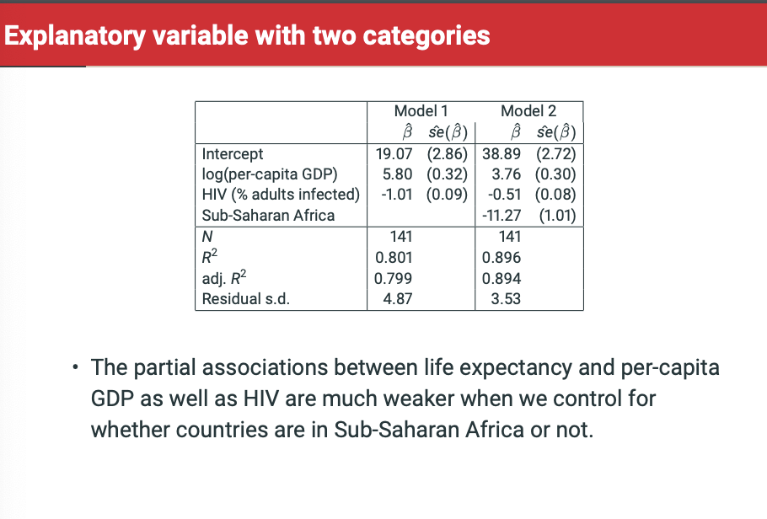

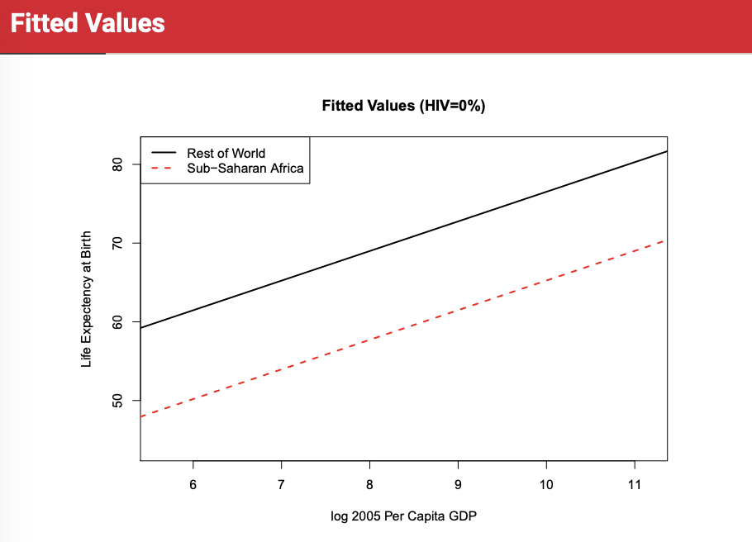



**Include dummy for all but 1 category in each variable. The category that we exclude, that is without a dummy, is the reference (baseline) category.**

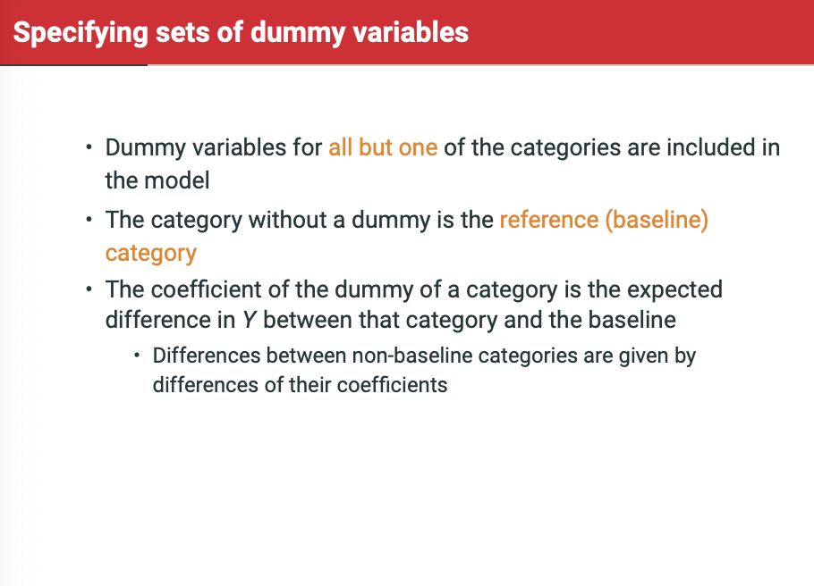

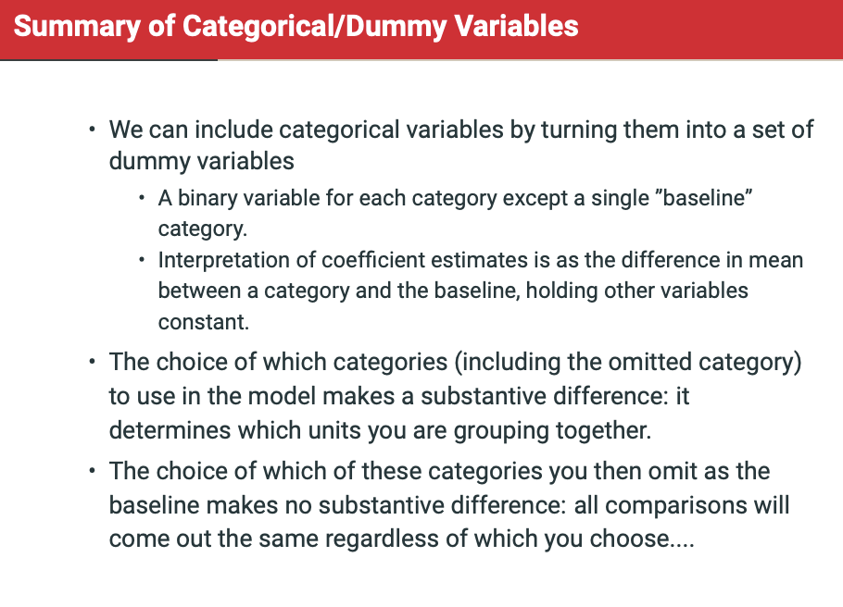

**Did including regional indicators change parameters for GDP & HIV %? Point estimate only changes if explanatory variables are associated with each other. So, if they change as variables are added then they’re correlated.**

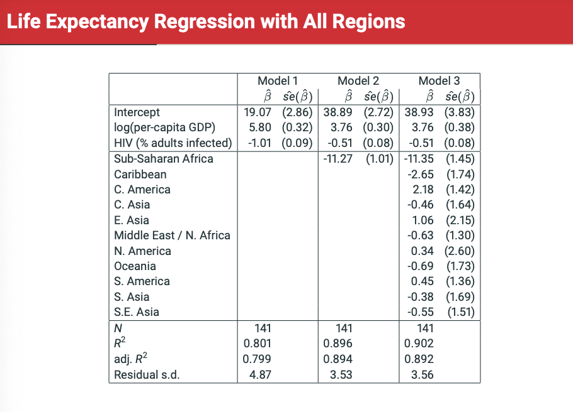

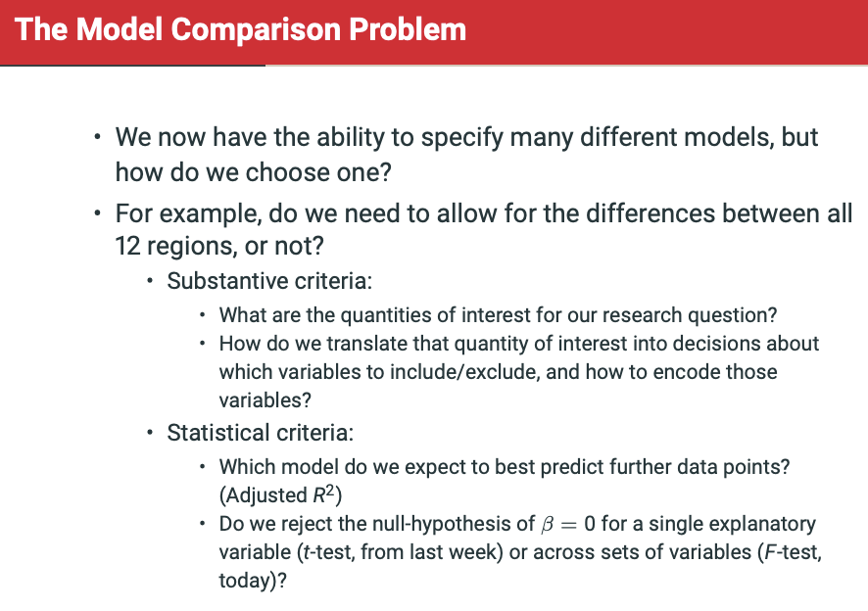

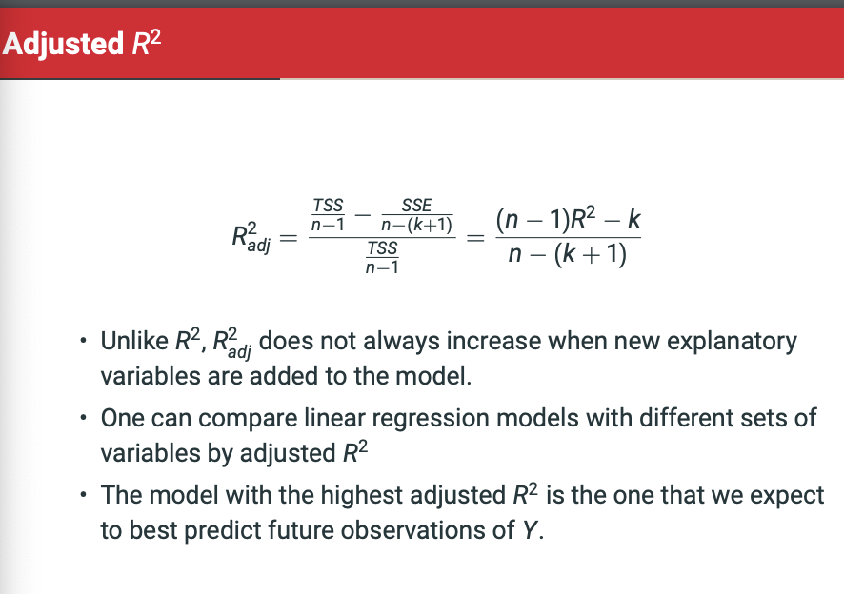

**The F-test.**

To test whether a set of coefficient estimates for a set of explanatory variables are all zero, e need a different test: the F test.

Test multiple-coefficient hypotheses of the form coefficients ALL = 0 against the alternative that at least one doesn’t equal 0. Alternative model is original model + additional explanatory variables. For example: Testing the hypothesis that the coefficients of all the region dummies except Sub-Saharan Africa are 0. Here, the alternative is the original + region dummies.

F is change in Rsquared from original to alternative model, divided by change in degrees of freedom (as we change number of coefficients), all divided by denominator. So F test is test of difference in predictiveness of model, rather than any specific coefficients is statistically significant.

We have a corresponding F distribution. F-value is converted to p-values by any statistical software in same way we’d go from t-statistic to p-value.

**BRING IN EQUATIONS AND BRING IN TO EXAM.**

* If M0 has only one fewer coefficient than Ma the F-test is identical to the t-test for that coefficient. S**o F-statistic is EQUAL TO THE T-STATISTIC SQUARED.**
* If M0 has no explanatory variables at all, we get the null hypothesis that none of the explanatory varialbes are associated with the response. The model has k0 = 0 R-squared-0 = and SSE-0 = TSS. This is often provided by default in computer output, but failing to reject null is rare unless there are few observations or explanatory variables are little more than random noise.
* F test most useful for examining groups of variables that have logical relationship to one another.

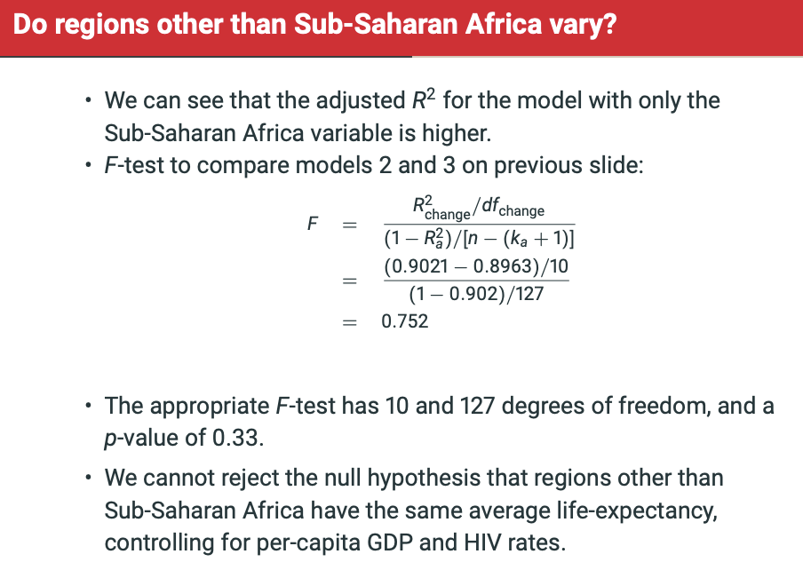

**Interactions**

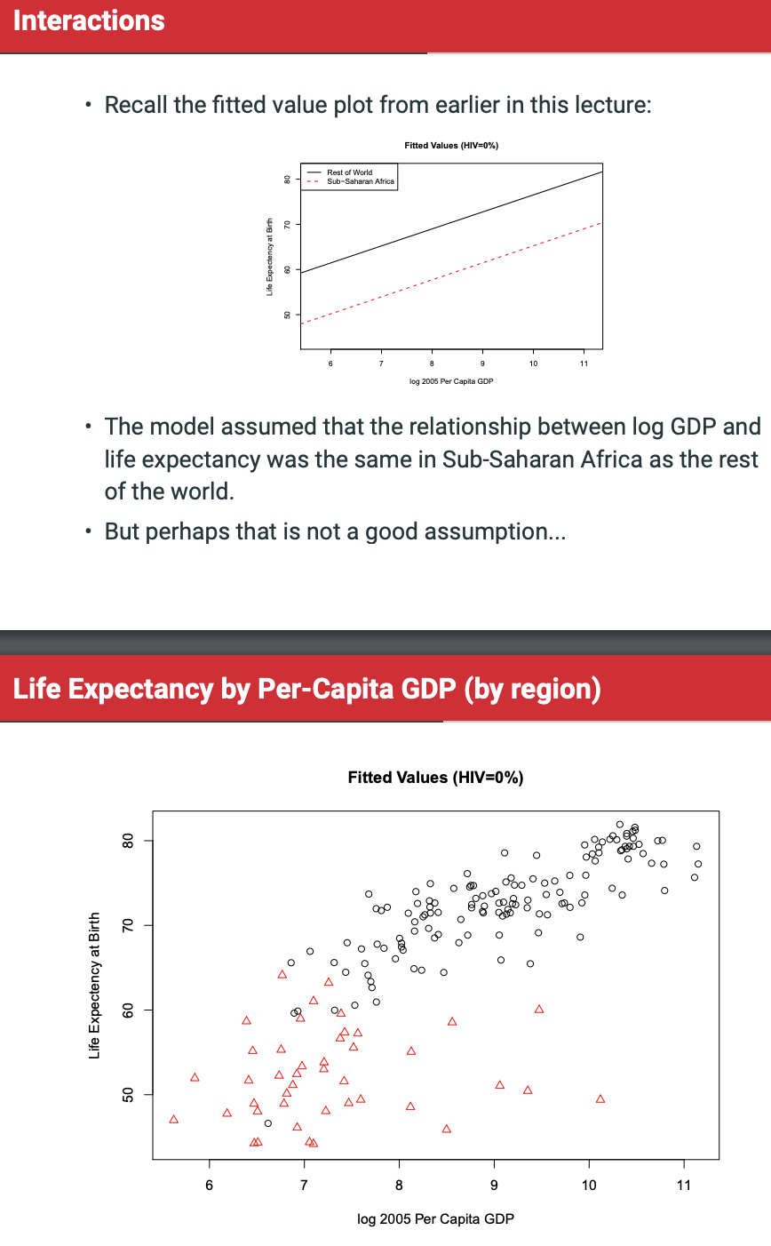

We say that there is an interaction between two explanatory variables, if the relationship between (either) one of them and the response variable depends on the value of the other.

• We can build a model that allows for the possibility of an interaction by using products of the two explanatory variables as additional explanatory variables in the model.

• We can test whether there is in fact evidence of an interaction by doing a hypothesis test on the coefficient of the product of the explanatory variables.

• For example, if we think the relationship between life expectancy and per-capita GDP Xlog(pcgdp) is different in Sub-Saharan Africa (XSSA = 1) than it is in the rest of the world (XSSA = 0), then we can include an additional variable:

• A model without interactions: E(Y) = α + βHIVXHIV + βlog(pcgdp)Xlog(pcgdp) + βSSAXSSA

• Increasing Xlog(pcgdp) by 1 increases E(Y) by βlog(pcgdp) , regardless of the value of the other variables.

• But now consider the model with an interaction: E(Y) = α + βHIVXHIV + βlog(pcgdp)Xlog(pcgdp) + βSSAXSSA + βinteractionXlog(pcgdp)XSSA

• What happens now if we increase Xlog(pcgdp) by 1?

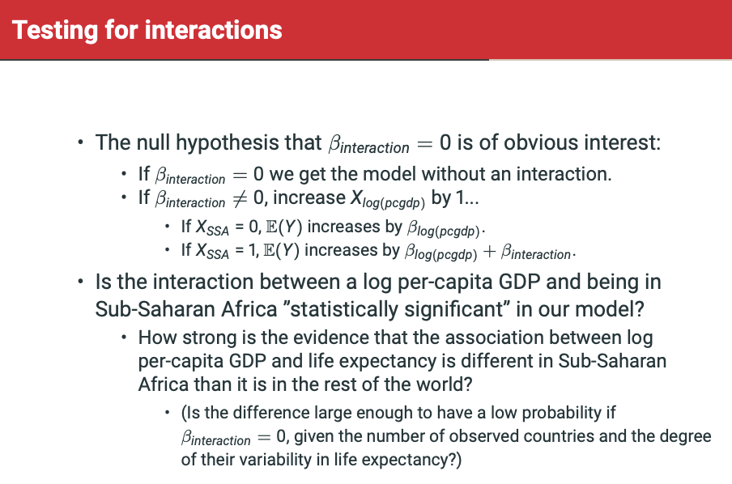

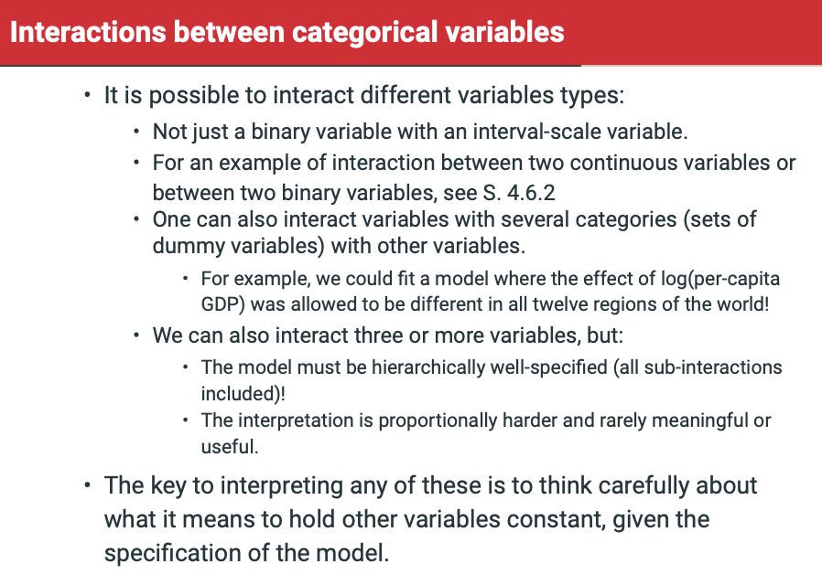

**Non-linearity**

E(Y) = alpha + Beta1*X

E(Y) = alpha + Beta1*X + Beta2*X^2

E(Y) = alpha + Beta1*X + Beta2*X^2 + Beta3*X^3

To exclude X and include X^2 is like saying ‘we know the linear term is 0,’ a very strong claim.

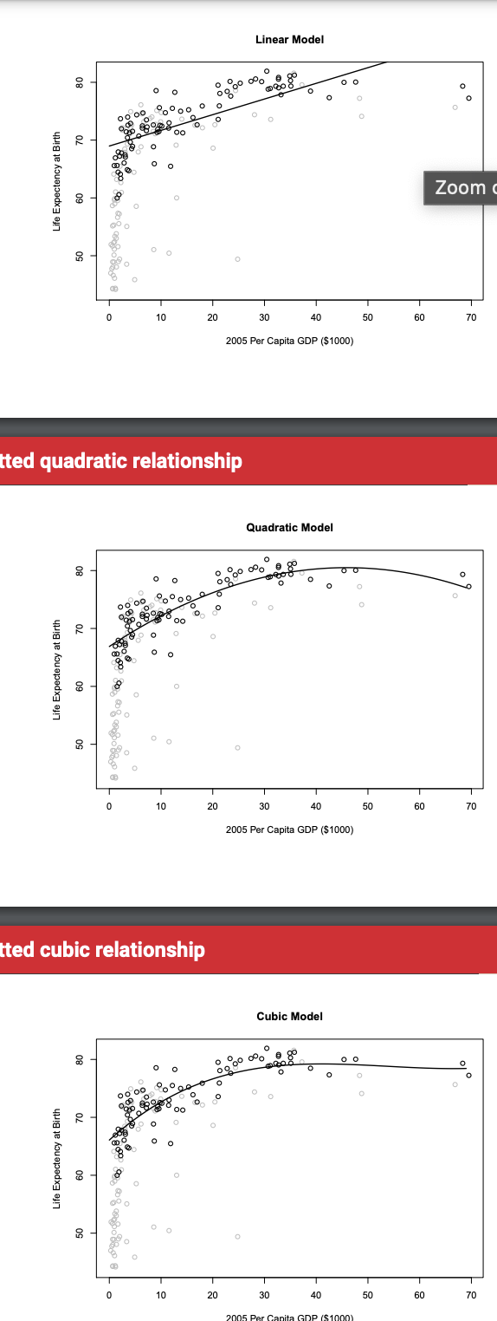

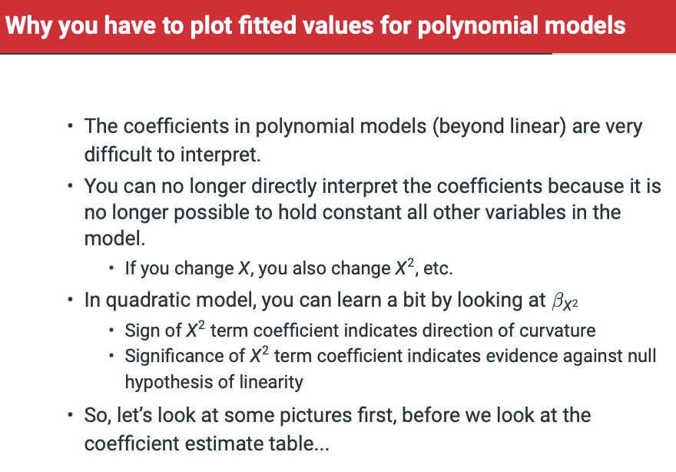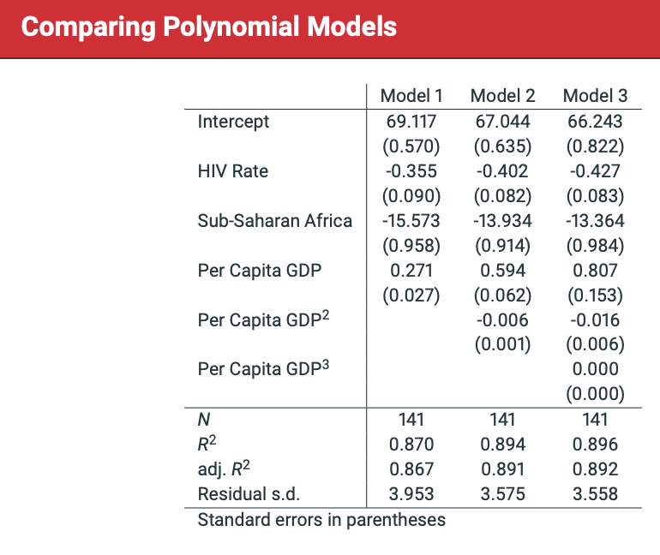

We could also categorise continuous variables like 1970-1989, 1990-2009, 2010-2029

OR even better, quintiles of data and then fitting stepwise function based on quintiles, as shown below:

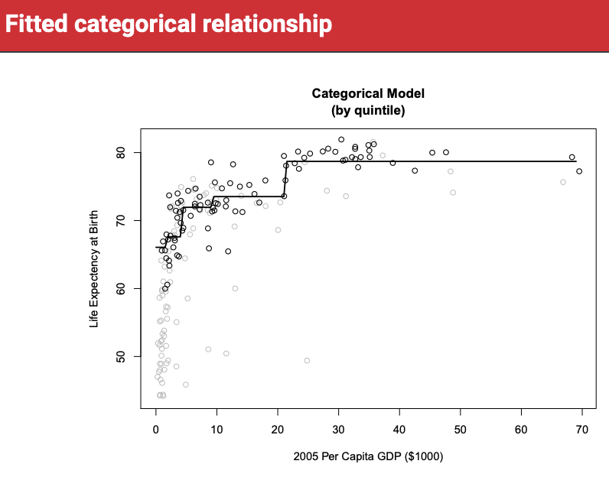

This makes assumption that life expectancy doesn’t change per quintiles.

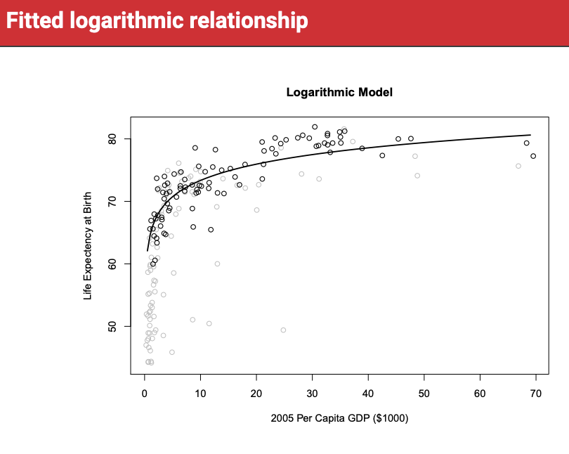

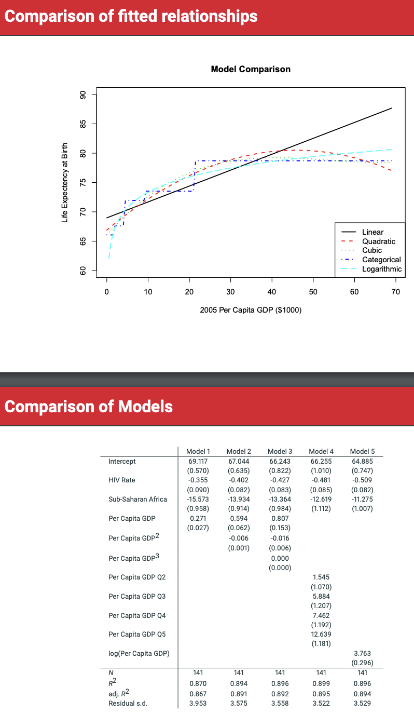

The quadratic, cubic, categorical, and logarithmic models all fit about as well as one another. However, they imply different ways of talking about the relationships in the data.

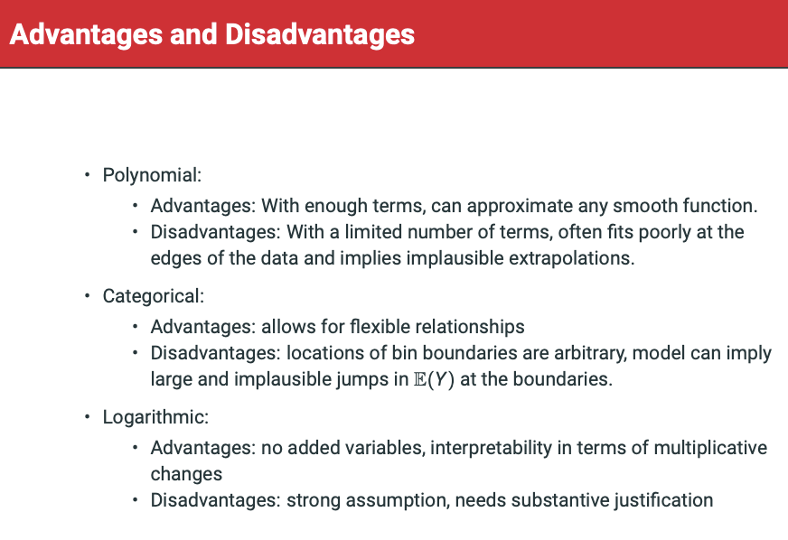

Adjusted R-squared is R-squared that is being penalised for additional variables.

**Week 4: Readings**

**4.7 Model diagnostics using residual plots**

The second tool of model assessment discussed here is the use of sample residuals ei = Yi − Yˆ i , i.e. the differences between the observed (Yi) and fitted (Yˆ i) values of the response variable, calculated for each observation i = 1, . . . , n in the data set. These can be regarded as “estimates” (more accurately, predictions) of the model residuals ϵi in equation (4.2).

For model assessment, it is often somewhat more convenient to use standardised residuals which do not have this property. Statistical software packages sometimes provide separately “standardised” residuals ei/σˆ and “studentised” residuals, which are divided by a further quantity so that they will be approximately normally distributed with a standard deviation of 1 if the model is correct.

Scatter plots of the residuals against selected other quantities are used for model assessment. This can help to detect signs of possible failures of some of the model assumptions, an activity known as model diagnostics. Depending on what the residuals are plotted against, diagnostics of different aspects of the model are obtained.

It is for another purpose that residual plots are particularly useful. This is the examination of the assumption of constant variance (homoscedasticity) of the error terms of the model. If this assumption is violated, the error terms are said to be heteroscedastic. If there is serious heteroscedasticity, usual estimates of the standard errors of the regression coefficients will be incorrect, and so will test statistics and confidence intervals. Results of statistical inference will then also be invalid, in that confidence intervals will be too wide or too narrow, and tests may lead us to conclude incorrectly that partial effects are zero when they are not or vice versa.

A plot of (studentised) residuals for this model is shown in the top-left corner of Figure 4.12. Here, and in general for this purpose, the residuals are plotted against the fitted values Yˆ i from the model. There is then only one plot even for multiple linear models, rather than separate ones against each explanatory variable. Model diagnostics from a residual plot like this are based on the general shape of the cloud of points. What we would like to see is a plot where the points form a band of roughly even width, as in the lower-left corner of Figure 4.12 (explained below) or in Figure 14.3(a) of Agresti & Finlay. Such a plot indicates that the variability of the residuals is of similar magnitude at different fitted values (and, by implication, at the corresponding values of the explanatory variables), i.e. it is evidence that the assumption of homoscedasticity is not violated. There are a number of possible remedies to heteroscedasticity of error terms, but only one of them is discussed here. This is to change the model by transforming the response variable, specifically by using log(Y ) instead of Y as the response. Residual plot for such a model in this example, with the logarithm of outpatient expenses as the response, is shown in the lower-left corner of Figure 4.12. Clearly the funnel shape of the first plot has disappeared, and there is now no obvious evidence of heteroscedasticity.

Obvious heteroscedasticity which is removed by a log-transformation of the response variable is often found when the original response has a very skewed sample distribution. This is very clearly the case for outpatient expenses, as shown by the histogram in the top-right corner of Figure 4.12. The median of this distribution is around 100, while 20 of the 1496 respondents had expenses of over 1000 dollars, largest of them 3159. The histogram of the log-expenses shows that the log-transformation removes the skewness, turning the distribution into a roughly symmetric one.

Finally, we will briefly mention another use of sample residuals, the detection of outliers. An outlier in a regression model is an individual observation which differs markedly from the rest of the data, in that its value of Y is much less well predicted by the model than those of other observations. This would be indicated by an unusually large residual for such an observation. To decide what may be “unusually large”, we can make use of the fact that, for a correctly specified model, the studentised residuals can be treated as approximately statistically independent and each having a standard normal distribution. Thus, we can use confidence intervals to spot outliers.

**4.8 Model specification and selection**

The purpose of regression models is to describe the relationship between a response variable Y and one or more explanatory variables X, in a sample or population. There are multiple reasons that we might want to do this, but three common ones are:

• There are observations for which we observe X, but not Y , and we would like to produce a prediction of what the value of Y will be.

• We want to provide a description of how observed variation in Y is related to several variables X.

• We want to provide a counter-argument to a claim that the partial association between a particular variable X1 and Y is actually due to another variable X2. It is important to know which of these is your goal, because it has consequences for how you should make decisions about which variables to include and which to exclude from your model.

**4.8.1 Model specification for prediction**

* For prediction, one should always include as many predictive variables as possible, and as few non-predictive variables as possible. Here, the question is not why there is a partial association of Y with a given variable X1, but only what the best guess of Y is given a set of X variables. In this situation, one does not want to include variables that are not significantly associated with the outcome. This is not because doing so will lead to biased predictions (too high or too low), but because it will lead to imprecise predictions (too variable).
* In the context of the regression models we consider in this course, the most common tool used for selection of explanatory variables is significance testing. In all the most common instances of selection, the null hypothesis of a test is that the coefficients of one or more explanatory variables are zero.
* Implementing this idea usually leads to a sequence of tests, after each of which the current model is either retained, or variables are added to or removed from it. This process continues until we find a model in which all its explanatory variables are significant (i.e. should not be removed), while all of the variables omitted from the model would not be significant if they were included (and hence can be left out). There are two general approaches to such a sequential search of models: forward model selection which starts from a small model and adds variables to it one at a time until the remaining ones are no longer significant, and backward selection which starts from a large model and removes nonsignificant variables until all the remaining ones are significant. In practice, however, careful model selection usually requires a combination of the two (so-called stepwise selection), alternating between steps forwards and backwards as required.

**4.8.2 Model specification for description**

* Some regression models are meant to be ”models” in the literal sense: a simple story of the approximate relationships between a set of variables. If this is the aim of a regression model, it becomes important to select variables carefully so that the model is interpretable. This means limiting the number of variables in the model, so that it is as parsimonious as possible. Models with no insignificant variables are simpler and easier to explain, and so typically this kind of regression will have few if any insignificant variables. At the same time, when thinking about a descriptive model, it is important to think carefully about what it will mean to ”hold all other variables constant”. In this type of model, we typically want to be able to interpret all of the coefficients, and so it is important to think about all the issues discussed in Section 4.6, such as the choice of the set of dummy variables for categorical variables, inclusion of interaction terms, and possible nonlinear transformations of explanatory variables. “Correct selection” of explanatory variables here implies that the forms in which the variables are used in the model should be sensible given the particular quantities that are being modeled.

**4.8.3 Model specification for counter-argument**

* Research articles sometimes report fitted models in which a large number of control variables are included, without model selection, (i.e. even when some of them are not statistically significant). In particular, this is often done with such standard controls as age, sex, race, education etc. Often, in these cases, the regression analysis is intended as a form of counter-argument. Here, the researcher is particularly interested in the partial effect of a variable X1. Usually this variable is associated with Y in a simple linear regression model. Adding additional explanatory variables can then be seen as a way of convincing a skeptical reader that the partial association with X1 is not better understood as a partial association with some other variables X2, X3, etc. In this context, these other explanatory variables are usually called ”control variables”, and we are interested in whether their inclusion reduces the magnitude and/or the significance of the relationship between X1 and Y .
* In this context, it makes sense to keep these control variables in the model, whether they are significant or not. It is important to emphasize that there is never anything wrong with including an insignificant explanatory variable X2 in the model.14 Even if control variables have no partial effect, they will only introduce a small cost in terms of the imprecision (variability) of the predictions. But for making a counter-argument agains the hypothesis that X2 better explains the association of X1 with Y , you want to keep the insignificant variable in the model because that variable is part of the argument that you are making.

Even when done very carefully, selection of regression models is not easy. Indeed, the whole exercise may seem absurd, if we argue that there is a infinite number of possible models, essentially all of which are guaranteed to be wrong. This, however, is not quite the right way to view the task. Even if all models are wrong, some are more fit to purpose than others. Careful model selection involves thinking about the role of the regression model in the social scientific argument that is being made.

**4.9.1 Multicollinearity of explanatory variables**

As discussed above, key differences between simple and multiple linear regression models emerge when the multiple explanatory variables are correlated. These correlations are not a problem, because the model is designed to allow and adjust for them (indeed, that is what it is for: there would be no need for multiple regression if all Xs were uncorrelated). They do, however, become a complication of a kind when they are very high. This case, where two or more of the explanatory variables are very highly (linearly) associated, is known as (approximate) multicollinearity.

Consider the situation depicted in plot (3) of Figure 4.13. Here two explanatory variables are strongly correlated. As such, they are in effect two very nearly identical copies of the same information and thus have nearly the same association with Y . This is indicated by the large area of overlap between them. If we now fit a simple model with either X1 or X2 as the only explanatory variable, both the overlap and the small unique contribution of the variable are wholly assigned to that variable. The complications due to multicollinearity emerge when we try to include both variables in the model. Loosely speaking, the problem is how to divide the shared contribution between them. The estimated model often fails to achieve this with any confidence, resulting in large standard errors and low precision for the coefficients of both variables.

As a rather silly example of approximate multicollinearity, consider the models for GHI shown in Table 4.13. Here two measurements of annual family income are included, one for the year before enrolment and one for the year before that. These are unsurprisingly strongly related, with a correlation r = 0.887. When either one is included in the model on its own (models 1 and 2), its effect on GHI is significant and positive. When both are included in model (3), their standard errors become much bigger and neither is now significant.

One obvious way to deal with multicollinearity is to omit one of the variables causing it. Here we might simply include only one of the income variables (probably the more recent one, as this seems to make more substantive sense). Model (4) represents an alternative approach. It still includes two variables corresponding to income, but in a different way: one variable is now the mean of the incomes in the previous two years, and the other their difference. The two very similar income variables in model (3) have thus been transformed into two pieces of information which have distinct interpretations (average income and the change in income between the two years) and a low sample correlation (r = −0.119). It can be seen that only the average is significant, so we can actually remove the difference variable to end up with model (5). Crucially, however, making this decision is now easy because the two variables are not multicollinear and, in particular, the standard error and significance of average income are unaffected by the presence of the difference variable

When approximate multicollinearity is suspected, its extent can be easily assessed. For pairs of explanatory variables, this means examining sample correlations between them; a common rule of thumb is that a correlation of 0.8 or above indicates serious multicollinearity. Groups of more than two explanatory variables may also be jointly multicollinear. This is the case if R2 for a model for one explanatory variable given the others is very high. If we have perfect multicollinearity between X1 & X2 (height in inches & cm), then one needs to go. In statistical terms, separate coefficients for X1 and X2 in the above example are formally unidentified.

**Population vs. Sample**

the HIE data can be regarded as reasonably representative of the populations (below age 62) of the six locations where the study was carried out, but not of the general U.S. population. Furthermore, inference for estimated linear models is very often used with data which are quite obviously not probability samples from the joint distribution of the variables in any well-defined finite population. For example, the following types of analyses are common:

• The values of some or all of the explanatory variables may be controlled and assigned by the researchers, as happens in randomized experiments.

• The units of analysis may form the entire group of interest, as when we analyse the aggregate school performance in every U.S. state (c.f. the example in Section 4.1) or the voting behaviour of every member of a parliament.

Fortunately, valid and meaningful inference is, at least in many cases and to the philosophical satisfaction of most people, possible also in such situations. To see why, recall the definition of the linear model on page 53. First, note that the only distributions that this refers to are conditional distributions of Y , conditional on values of X1, X2, . . . , Xk. There is no reference to any distribution of the explanatory variables themselves, which thus need not be a sample from any meaningful population. In particular, their distributions in the sample do not need to match the distributions in the group of interest: for example, inference for models for the HIE data could be perfectly valid even if it was known that some demographic groups were overrepresented in it. In fact, the “distribution of the Xs in the group of interest” does not even need to be a meaningful concept, as happens when the values of these variables are not inherent characteristics of the units but are assigned by the researchers.

These ideas might suggest that the sampling should also be conditional, i.e. that we should collect separate probability samples of Y at selected values of the Xs. Although sometimes done, this again is not and cannot be the practice in all studies. Instead, we need to broaden the view further to allow for a conceptual population of potential realisations, of the kind discussed in Section 2.1. In this spirit, the population which inference for linear regression actually refers to can be regarded as a set of conceptual populations of possible realisations of Y given the explanatory variables, one at each possible combination of the values of X1, X2, . . . , Xk.

. While this makes statistical inference for regression modelling an arguably meaningful exercise for many types of studies, it is obviously a somewhat less than straightforward construction to grasp. For example, what does it then mean for the data to be a representative sample from these populations, and how can we tell whether this is the case? To obtain some insight into this, we can consider the second formulation of the model in Section 4.3.2, i.e. equation (4.2) and the list of assumptions below it. Here all the key assumptions of the model are stated as ones about the random error terms (residuals) ϵi , which are assumed to have a zero mean and constant variance, and to be uncorrelated with the explanatory variables. In short, the residuals are required to have the characteristics of pure random noise, and our observations of (estimates of) them should be samples of such noise. One (partial and informal) way of describing “sampling noise” is that the errors ϵ around the regression surface (4.1) at any value of the Xs should also be unrelated to all other possible explanatory variables which are not included in the model. If this is not the case, some such additional variables should have been included in the first place. The model for µ is then misspecified, i.e. we are fitting a model which differs from the true model in important ways. Conversely, for the true model the assumptions are satisfied by definition. This suggests that questions of “representativeness” and “generalisability” in the context of regression models can to a large extent be reformulated as questions of model adequacy: the more correctly specified the model is, especially in including an appropriate set of explanatory variables, the more likely it is that both the estimates of the regression coefficients and inference for them are valid and meaningful.

**4.9.3 Decompositions of sums of squares**

The basic decomposition discussed on page 60 shows how the total sum of squares T SS, which measures the overall sample variation in Y , can be decomposed into a part (SSM) explained by a regression model and a part (SSE) left unexplained by it. Applying this idea repeatedly to a sequence of models where explanatory variables are added one at a time, we can further decompose the explained part (and thus also R2 ) into contributions from different explanatory variables. Ambiguities arising in this exercise also highlight an important feature of multiple regression models where the explanatory variables are correlated with each other.

Table 4.14 shows estimates for some models for GHI. Consider first model (1), which has age as its only explanatory variable. The sums of squares for this are SSM = 4566 and SSE = 380337 (and thus R2 = 0.012), which add up to T SS = 384903. Suppose now that we add education to this model, i.e. move to model (2). For this, SSM = 19500 and SSE = 365403. These sum to the same T SS as before, but in a different way. What has happened is that 14934 of the total sum of squares has moved from SSE to SSM, from the unexplained to the explained. In short, adding education to the model explains that much of the sum of squares left unexplained by the model which includes age alone. The R2 statistic increases correspondingly, from 0.012 to 0.051. We could continue by including further explanatory variables. For example, adding income to model (2) to give model (4) explains a further 4026 of the total sum of squares and raises SSM to 23525 and R2 to 0.061. Furthermore, the model sums of squares for this sequence of models [(1)–(2)–(4)] provide a breakdown of the contributions of the three explanatory variables into the variation explained by model (4), as shown in Table 4.15. Such decompositions are easily produced by statistical software packages.

A decomposition like this is, however, not quite as useful as it might at first appear. The main reason is that it is not unique: the model sum of squares can usually be divided between the explanatory variables in several different ways, depending on the order in which the variables were included. The fact that the two ovals in plot (1) overlap is used to indicate that there is an association (correlation) between X1 and X2. In terms of sums of squares, this correlation implies that the variation explained when X1 and X2 are both in the model is not simply the sum of the amounts each of them explains when included alone. Somewhat loosely speaking, some of what either of them explains alone is common to both variables (area C), while some variation (are D) is explained only if both variables are in the model. In sequential sums of squares, the variable entered first is credited for its own unique contribution (e.g. A for X1) and C, and the one entered second for its unique contribution (e.g. B for X2) and D. The total explained by X1 and X2 together (A + B + C + D) may be smaller than the sum of the single contributions (A + C plus B + C) or larger than it (i.e. D may be smaller or larger than C, in the informal notation of this graph). The details of the sequential sums of squares in particular cases, and the net effect of including a set of the explanatory variables, depend on the intricacies of the associations between the explanatory variables. The reasons for the observed patterns are usually not easy (or necessary) to examine in detail. What is more important is the general principle: when explanatory variables are correlated with each other, results for a multiple regression model cannot be predicted from those of simple models given each of the explanatory variables alone. Instead, the multiple model has to be actually fitted to see what happens. The same, of course, applies also to the values of the regression coefficient. The only case where simple and multiple regression models give identical results is when the explanatory variables are uncorrelated. Because of these convenient features, randomized experiments involving two or more experimental treatments are usually designed in such a way that the treatment variables are uncorrelated. In observational studies, however, this is not possible, because we cannot control the values of the explanatory variables. It is then inevitable that many of them will be correlated, so fitting multiple regression models is essential for these correlations to be properly controlled for.

As a final observation on this theme, note that adding new explanatory variables to the model will always increase (or at least not decrease) the model sum of squares and R2 . It is indeed often possible (by including a dummy variable for every observation, using terminology introduced in Section 4.6.1 below) to obtain a model with R2 = 1, i.e. one which exactly reproduces the observed data. This model, however, is the observed data, so it is of no use for parsimonious explanation of Y or for prediction of its values in future data. Nor do we normally pursue ever higher values of R2 in less extreme ways, by including as many explanatory variables as are available. Instead, the aim is to include all of the explanatory variables which are necessary but no others.

**4.9.4 ANOVA and ANCOVA**

The terms Analysis of Variance (ANOVA) and Analysis of Covariance (ANCOVA) are among the most venerable and widely used in statistics, especially in the context of randomized experiments. In essence, they refer to methods of analysing the effects on a continuous response variable of categorical explanatory variables or factors (ANOVA), or of both categorical and continuous variables (ANCOVA). As such, basic ANOVA and ANCOVA models can be fitted as linear regression models, with the use of dummy variables and interactions. We will thus not discuss them in detail separately.

**Lecture: Week 4 – Model Selection, Specification & Round-up on Linear Regression**

**Assumptions for linearity**

* **Observations Yi are statistically independent**
* **Conditional distribution of Yi (i.e. the distribution of Ei) is a normal distribution.** 
  + This is the least serious of the assumptions
  + The exact sampling distributions of estimates and test statistics discussed below are derived under this assumption
  + However, approximately the same distributions are obtained (using the CLT) also when i are not normally distributed, if the sample size n is not very small.
* **Conditional variance of Yi (spread, variance of error terms Ei) is sigma^2.** 
  + i.e. this is the same for all observations, and does not depend on any explanatory variables
  + Assumption of homoscedasticity (as opposed to heteroscedasticity)
  + Some (but not) all methods of checking and improving homoscedasticity will be discussed later today
  + Homoscedasticity, or homogeneity of variances, is **an assumption of equal or similar variances in different groups being compared**. This is an important assumption of parametric statistical tests because they are sensitive to any dissimilarities. Uneven variances in samples result in biased and skewed test results.
* **Model is linear and additive in the explanatory variables.** 
  + Essentially the assumption that you have specified this core part of the model adequately for your data.
  + Identifying an appropriate set of explanatory variables is the main task of model selection/specification.

**How do we choose how to specify a model?**

* Some sort of combination of theoretically implied variables.
* Art to manipulating variables.

Stepwise regression

* Can be automated
* Guaranteed to do. No worsew than just using all variables.
* Forward selection •
  + Start with intercept-only model. •
  + Fit all the one variable models, pick the one with the best fit by some criterion (e.g. adjusted R 2 , p-value, etc).
  + • Fit all the models that include the previously accepted variable plus one more, pick the one with the best fit.
  + • Continue adding variables one at a time until your fit criterion gets worse for all additional variables.
* Backward selection
  + Start with the k-variables model.
  + Fit all the k − 1 variable models, pick the one with the best fit by some criterion.
  + Continue rejecting variables one at a time until your fit criterion gets worse for any further rejection. • A combination of both: Stepwise regression.
* Advantages: • Can be automated.
  + Guaranteed to do no worse than just using all the variables (given the chosen criterion).
  + Forward selection still works if k > n.
* Disadvantages:
  + Forward and backwards selection do not, in general, yield the same model.
  + May not lead to a model that answers an interesting question.
  + Treats all the variables equally, and pays no attention to any specific hypotheses you may have.
  + Statistical interpretation of model and coefficients is affected (more on this later...)

Lessons: when is specification search (in)appropriate? •

* This kind of specification search is not what you want to do:
  + if you have substantive hypotheses to test
    - nothing wrong in failing to reject the null, with a good study design
  + if you are interested in making reliable statements and inferences about associations.
    - your estimates will ”vibrate” and their statistical significance will ultimately be over-estimated
* But it can be helpful sometimes:
  + If you are trying to identify the strongest in-sample predictors (maximize variance explained).
  + If you are trying to predict out of sample.
  + If your research hypothesis is about one (or few) explanatory variables, may be useful for helping to select the other (control) variables for the model

**Multicollinearity**

* Example: Political Determinants of Government Spending in US

• Option 1: Total transportation spending for each state per year. •

* + Minimum: $158m (Delaware)
  + • Maximum: $3429m (California)
  + • Mean: $724m
  + • Standard Deviation: $647m

• Option 2: Per-capita transportation spending for each state per year.

* + • Minimum: $87/person (New York)
  + • Maximum: $636/person (Alaska)
  + • Mean: $168/person
  + • Standard Deviation: $105/person

• Note: you cannot determine the ”right” dependent variable by any statistical test!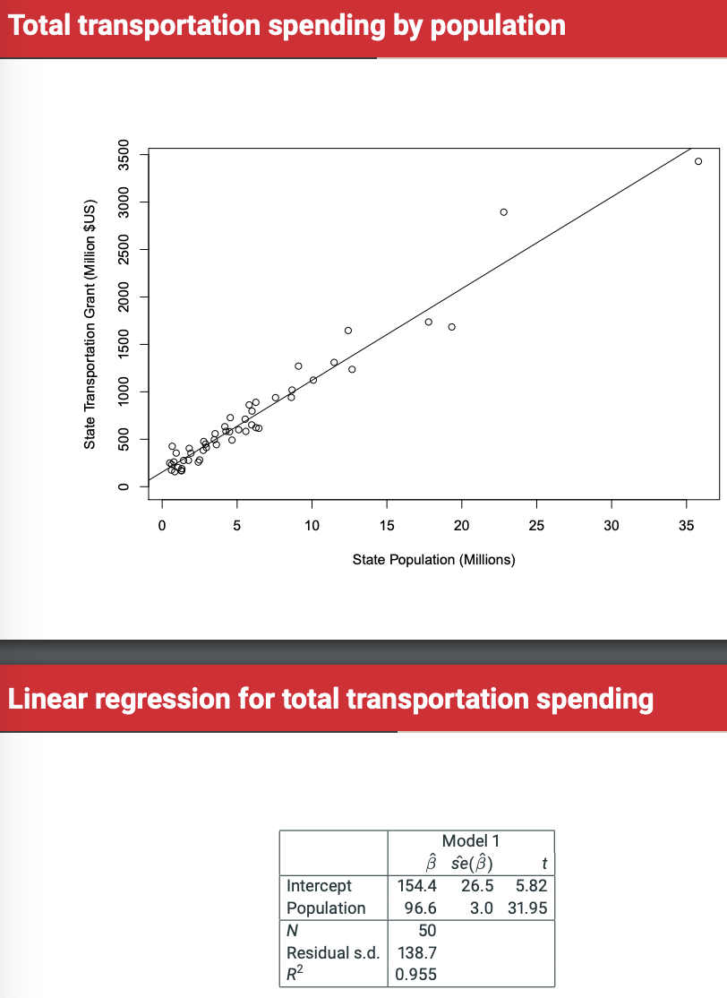

Null hypothesis for Alpha (intercept) is that if there’s no people in a state, there’s no spending.

Other variables

* Population
* Land area (miles^2)
* Existing highway mileage
* Per-capita gross state product
* Number of repub reps in US House
* Number of repub senators in US Senate
* Number of representatives in US House
* Number of senators in US Senate (no variation) not a variable, as there’s just two per state.

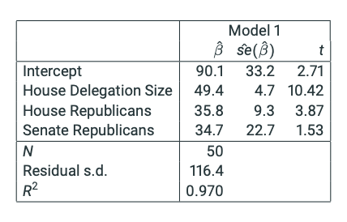



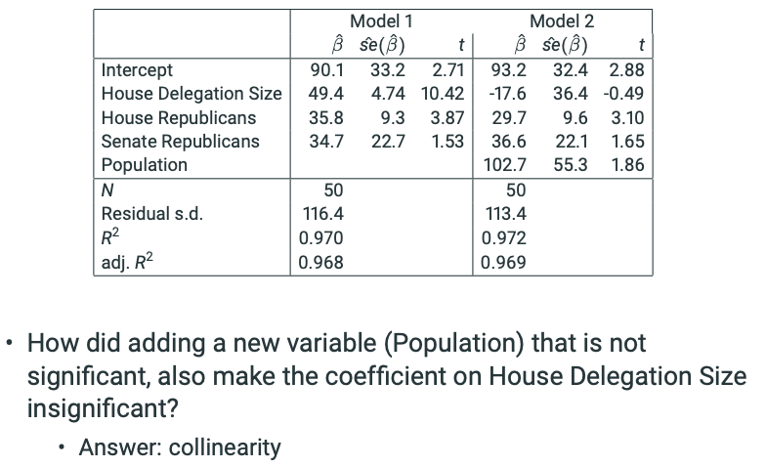

House delegation size has collinearity with population (although not exact, as correlation = 0.9988).

If two variables are highly correlated:

* It is difficult to tell which one better predicts Y.
* Data gives us very little evidence about what happens when you hold one constant while changing the other.
* Consequences:
  + The coeff on the collinear variables can take on large magnitudes with unexpected signs.
  + The standard errors on collinear variables become very large.
* Not so much a statistical problem as a substantive one!!

Multicollinearity has to be addressed by re-coding variables and/or re-specifiyng the model, in a way that still allows us to answer the question. What if we avoided the collinearity by anaalyzing the transportation spending data per-capita?

**Residual Diagnostics**

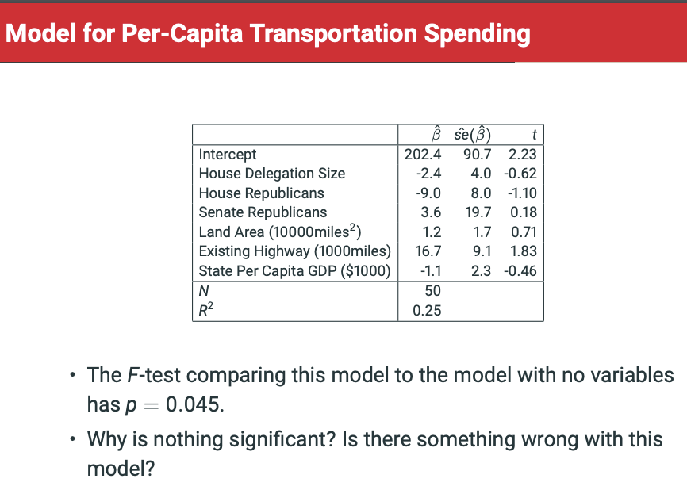

• A useful tool for assessment of linear models are the sample residuals ei = Yi − Yˆ i for all observations i = 1, . . . , n in the sample, where Yˆ i are the fitted values

• “Estimates” of the error terms (model residuals) i

• Residuals can be plotted to generate diagnostics with respect to several model assumptions...

• Homoscedasticity: is there evidence that the residual standard deviation is not constant for all values of the Xs?

• Plot residuals ei (on the Y-axis) against fitted values Yˆ i (on the X-axis).

• Plot should show roughly equal level of variation of the residuals for all values of Yˆ i

• A plot with a funnel shape (variability of residuals increasing or decreasing as Yˆ i increase) indicates heteroscedasticity (i.e. failure of homoscedasticity)

• Linearity: is there evidence that one or more variables have non-linear relationships with the outcome?

* • Plot residuals ei (on the Y-axis) against fitted values Yˆ i (on the X-axis)
* • Plot should show a mean of roughly zero for all values of Yˆ i
* • A plot with a U shape (or inverse U shape) indicates non-linearity in at least one variable.
* • Then plot residuals ei (on the Y-axis) against each explanatory variable to see which one.
* Plot residuals against explanatory variables to see non-linearity.

If we notice non-linearity, perhaps we need to alter our variables? What about senators per million?



As you can see, senators per million is powerful. R^2 has risen from 0.25 to 0.85, too.

**Model Specification and the risk of P-hacking**

• The p-hacking controversy

* • Fitting a regression model involves lots of choices regarding
  + • what data to include and exclude
  + • what variables to include and exclude (what to control for)
  + • how to measure the outcome (including transformations)
  + • how to measure the predictor(s) (including transformations)
* • Consciously or unconsciously, researchers might keep changing their analysis in order to ’fish’ for a low p-value that supports their favoured hypothesis, and/or to get published
* • If so, then they are ”second-guessing” their data, making their p-values unreliable
  + • e.g. worse case scenario: if I literally run two different tests of the same null hypothesis, and the null is true, my probability to correctly fail to reject the H0 at the 0.05 level in both cases is not 0.95 but 0.95*0.95=0.9
  + • For example, google [”science isn’t broken” 538]

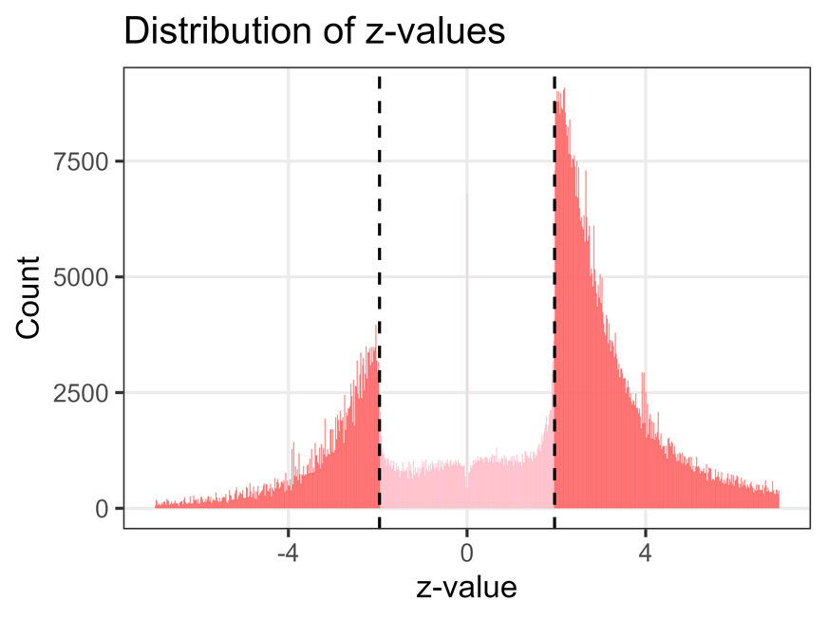

From research papers – there’s basically no statistically insignificant results.

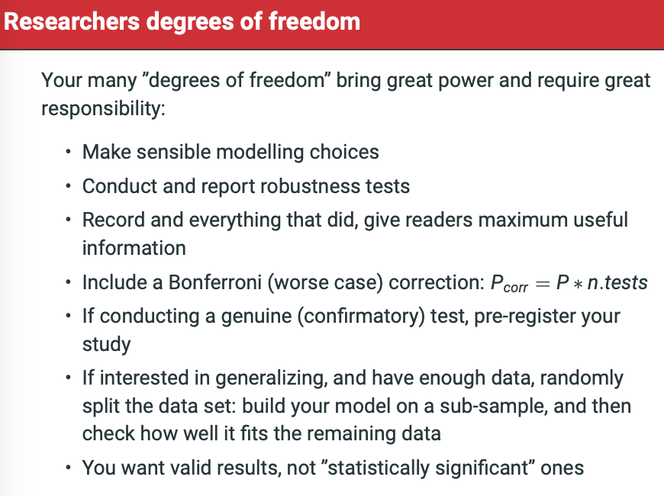

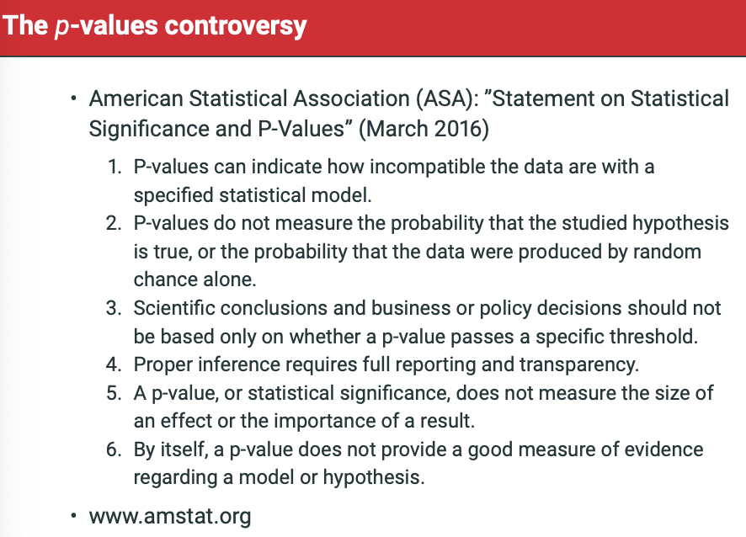

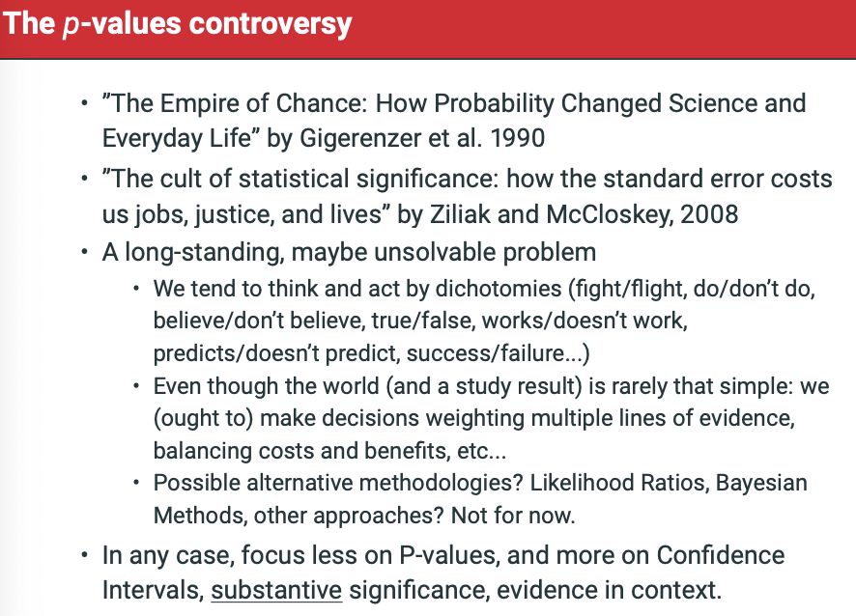

What we covered this week: Introduction:

1. The problem of model specification
2. Variable selection and the problem of multiplicity
   1. Model Specification by Sequential Testing
3. Multicollinearity
   1. Collinearity and multicollinearity
4. Residual diagnostics
   1. Nonlinearity and heteroskedasticity
5. Model specification and the risk of P-hacking

Assumptions for linear regression:

1. Observations represent separate, unconnected subjects
2. Conditional distribution of outcome is a normal distribution
3. Conditional variance of Yi (variance of error terms) is standard deviation squared (homoscedasticity) variance doesn’t differ across distribution of data.
   1. Tested with residuals

t-statistic is Beta/Standard error where we assume normal distribution.

F-test is for overall model. Not rejecting null with F-test means NONE OF THE VARIABLES ARE USEFUL. The alternative hypothesis is that at least 1 Beta coefficients does not equal 0 and is useful in affecting our predictions. Large test stat gives strong evidenc against nul hypothesis.

F-test could be significant whilst t-stat for each coefficient is non-significant. If so, let’s look at the residuals to figure out what’s going on. In particular, we want to test for homoscedasticity.

* We would then plot residuals against each explanatory variables to see where the issue is.

Bonferroni test makes a worst-case correct where P-corr = P * n.tests to penalise for multiple tests.

* What is it?
  + Controls family-wise error rate
    - The family-wise error rate is the probability of incorrectly rejecting the true null hypothesis.
    - Chance of finding a false-positive result.
    - 1 – (1-alpha, normally 0.05)*n (n is the number of tests)
      * With 1 test, its 1-(1-0.05)*1 = 0.05 – we are accepting error of 0.05
    - If we are trying to perform ANOVA to understand if there is statistical significance in difference of means within 4 groups, we would have to conduct 6 tests as each group needs to be measured relative to the other.
      * This way, we have 1 – (1 – 0.05)^6
        + 1 – 0.95^6 = 26.5%

**So, just by doing 6 tests, there is a 26.5% chance of discovering one or more false-positive results.**

* + - **Bonferroni = alpha/k (k = number of tests)**
      * 0.05/6 = 0.0083
      * If we recalculate family-wise error rate using this, we get:
        + 1 – (1-0.008)^6 = 1 – 0.992^6 = 0.047
      * **By correcting the alpha through the Bonferroni method, we have reduced the FWER back down to around 5%.**
* Why should we do it?
  + Control for the above family-wise error rate
    - Correct alpha alpha-bonferroni-corrected.
      * Can only deem result the test to be statistically significant if the p-value is less than the Bonferroni-corrected alpha (0.008 in our example).
  + Drawbacks
    - Only tests false positives, not false negative. So, by correcting for Bonferroni then we increase chances of false negatives.

P-values do not measure the probability that the studied hypothesis is true, or the probability that the data were produced by random chance alone.

**Week 5: Readings - Binary Logistic Regression**

The response value is typically coded as 0 and 1. The probability distribution appropriate for a binary variable is the binomial distribution. The population parameter we are interested in explaining and predicting is the probability that Y = 1. P(Y = 1) or Pr(Y = 1). This is also the expected value of Y E(Y).

There are two main problems with the linear probability model:

1. The error terms ε = Y −π are no longer even approximately normally distributed, and other standard assumptions about them cannot possibly be satisfied. For example, the variance of ε (i.e. the conditional variance of Y given the explana- tory variables) is σ2 = π(1 − π), which depends on the explanatory variables, because π depends on them. The homoscedasticity assumption of a standard linear model thus cannot be satisfied. As a consequence, standard tests and con- fidence intervals from fitted linear regression will not be valid, and conclusions from them will be misleading.
2. Some expected values may be smaller than 0 or greater than 1 — i.e. poetical but meaningless values of “less than impossible” or “more than certain”. For example, suppose we fit a linear probability model for the knowledge question in the biotechnology example (the results are not shown here). Consider then a Greek woman who is 90 years old, finished education before age 19, recorded a 0 for the technological optimism scale, and belongs to the attitude class of “Don’t know”. The fitted probability that she answers the question correctly is

πˆ = 0.506 − 0.192 − 0.0037 × 90 = −0.019.

This is admittely not a very convincing example, because an extreme configura- tion of the variables is needed to produce a negative fitted probability. This is because average fitted probabilities are here close to 0.5, and ones which are very far from it are very unusual. In general, however, the problem cannot be ignored. In examples where typical values of π are closer to 0 or 1, a linear probability model can easily produce many inappropiate fitted probabilities.

**The Logistic Transformation**

he problem of impossible fitted values, however, is unavoidable in general. A logistic model avoids such values by modelling not π directly, but a transformation of it. We start by considering the odds:

Odds= π / (1−π )

i.e. the ratio of the probability that an event will occur to the probability that it will not. In the knowledge example, this is the ratio of the probability of a respondent answering vs. not answering the question correctly:

* If Odds = 1, the probability of a correct answer is equal to the probability of an incorrect answer.
* If Odds > 1, the probability of a correct answer is greater than the probability of an incorrect answer.
* If Odds < 1, the probability of a correct answer is smaller than the probability of an incorrect answer.

In our sample π = 0.464 and Odds = 0.464/(1 − 0.464) = 0.866. Thus the probability of a correct answer is smaller than the probability of an incorrect (or “Don’t know”) answer, at least for an average respondent. Later we will consider how these odds vary by the characteristics of the respondents.

Logistic regression models the logarithm of the odds, known as the logistic transfor- mation of π or simply the logit of π. It is defined as

Logit = log(Odds) = log(pi/(1-pi))

Logits can be transformed back into probabilities using the formula:

Pi = exp(logit)/(1+exp(logit)) = Odds/Odds + 1

where exp(x) denotes the exponential of x (or “e to the power of x”). You can calculate exp(x) for any number x using statistical software such as Stata or SPSS.

1. If π = 0.5, then Odds = 0.5/(1−0.5) = 1 and logit = log(1) = 0. Thus when the probability of an event happening (π) is equal to the probability of the event not happening (1 − π), the odds are one and the logit is zero.
2. If π > 0.5, then Odds > 1 and logit > 0. Thus the logit is positive when the probability of an event happening is greater than the probability of the event not happening.
3. If π < 0.5, then Odds < 1 and logit < 0. Thus the logit is negative when the probability of an event happening is smaller than the probability of the event not happening.
4. The logit increases as π increases, and vice versa; the logit decreases as π de- creases, and vice versa.
5. The logit can take any values, but π is constrained to be between 0 and 1. As the logit takes on increasingly large values, π becomes closer and closer to 1; as the values of the logit become smaller and smaller, the values of π approach 0. This gives the probability curve based on the transformation (5.3) its characteristic S-shape, as the curve bends to avoid going below 0 or above 1.
6. Although π can be arbitrarily close to 0 and 1, it can never be exactly 0 or 1.4

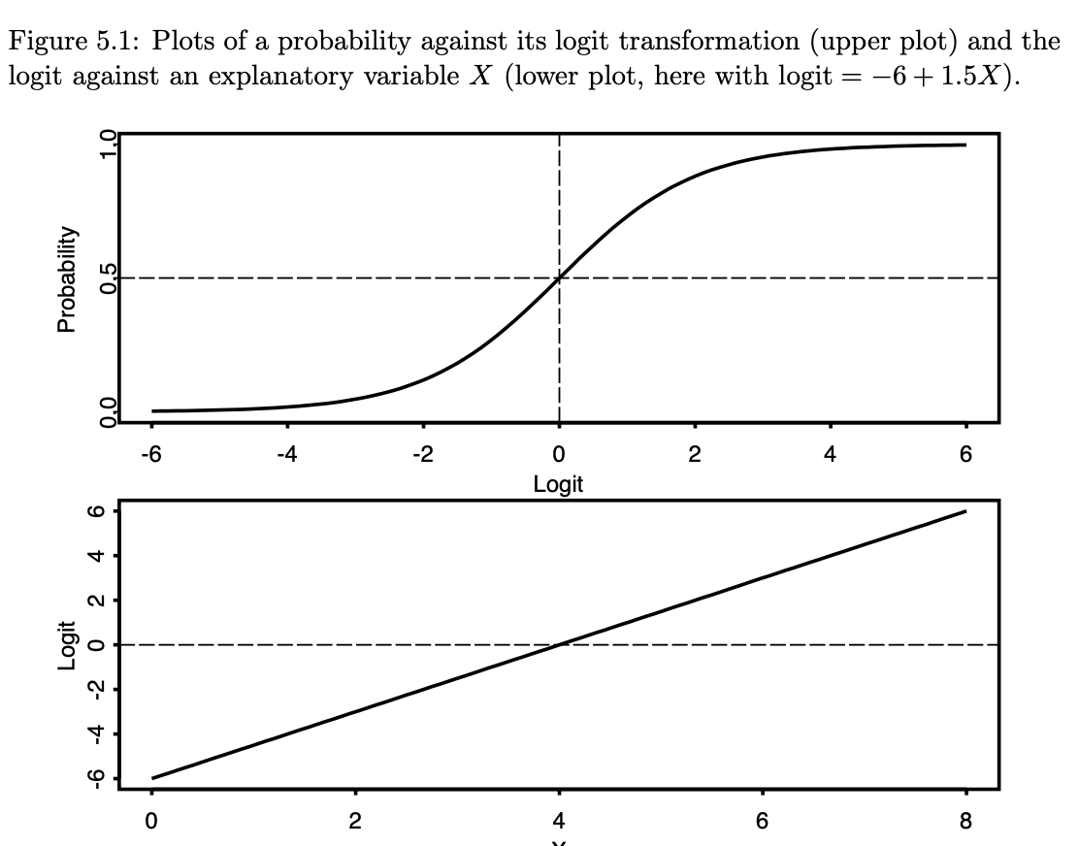

**The Logistic Regression Model**

The basic idea of a logistic regression model is to model the logit of the probability π — instead of π directly — as a linear additive function of the explanatory variables.

Suppose we have data on n sets of observations (Yi,X1i,...,Xki), i = 1,...,n, where Y is a dichotomous response variable with values 0 and 1, and X1, . . . , Xk are explanatory variables. The binary logistic regression model is defined by the following assumptions:

1. Observations Yi are statistically independent of each other.
2. Observations Yi are a random sample from a population where Yi has a binomial distribution with probability parameter πi = P (Yi = 1).
3. The logit of πi for each unit i depends on the values of the explanatory variables through the linear function

Note that because Yi are dichotomous and assumed to have a binomial distribution, no further assumptions about any error terms εi = Yi − πi or their variances are required. The error terms are usually not explicitly included in formulas for logistic regression.

Unlike for linear models, the parameters are not estimated using the method of least squares, but something called Maximum Likelihood Estimation (MLE). A discussion of this method is beyond the scope of this class. A brief explanation of it is given in (unexaminable) Section 5.5.4, and more information in many textbooks.

The calculations of ML estimation are handled by computer programs like Stata and SPSS. They produce both estimates of the parameters (αˆ and βˆj) and their estimated standard errors sˆe(αˆ) and sˆe(βˆj). For our purposes it is enough to know that these maximum likelihood estimates have, at least for moderately large samples, good statis- tical properties, in that they are approximately unbiased, efficient, and approximately normally distributed. This allows statistical inference using statistics which are very similar to the ones we already know about.

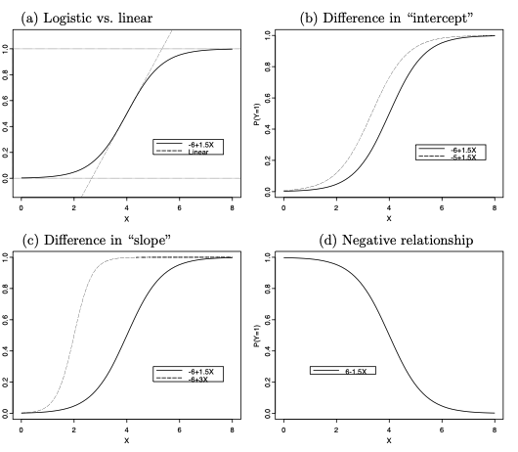

Another way of saying this is that increasing α shifts the curve to the left, so that a given value of π is achieved with a smaller value of X. The intercept is thus related to the overall level of the probabilities implied by the model.

The regression coefficient (“slope” parameter) β determines the strength of the associ- ation between X and Y . This is illustrated by plot (c) of Figure 5.3, which compares fitted probabilities for two models with the same value of α but different values of β. Here the curve with the larger value of β is steeper, so that for the same change in X, the resulting change in π is larger than for a curve with a smaller β. Thus β describes the strength of the dependence of π on X. This dependence is positive when β is positive as in plot (c), and negative when β is negative as in plot (d) of Figure 5.3. In both cases the association is strong and the curve steep when the value of β is far from 0. The value β = 0 would correspond to no association and a flat curve where π does not change at all as a function of X.

In addition to such generalities about the roles of the parameters, we also need a quan- titative interpretation of their values — especially that of the coefficients βj. Recalling the story for linear models, the most obvious and most intuitive interpretation for the coefficients of logit models would be in terms of changes in the probability π in response to changes in an explanatory variable. Unfortunately, however, this is not equally convenient for logit as for linear models, for reasons which are illustrated by Figure 5.3. The problem is that since the dependence of π on X is nonlinear, the same change in X results in different changes in π depending on which values of X we consider.

For example, in plot (a) a change of X from 0 to 2 clearly increases π much less than a change from 2 to 4, even though both are 2-unit increases. Furthermore, in a multiple logistic model the change in π in response to even exactly the same change in one Xj depends on the values at which the other explanatory variables are fixed. Thus what was for linear models the universal interpretation of “the effect of a change of 1 unit in Xj (from any starting value), holding other explanatory variables constant (at any values), is a βj-unit change in μ” becomes for logit models a particular in- terpretation where the change in π is different for different starting values of Xj and choices of the fixed values of the other variables.

For the regression coefficients, however, we will consider a different direct interpretation. This takes the form of consideration of odds ratios.

**Odds Ratios**

An odds ratio (OR) is simply the ratio of two odds corresponding to two groups or, more generally, two values of an explanatory variable.

This can also be treated as a comparison of odds given values 1 and 0 of an explanatory variable X which is a dummy variable for group 2. The odds ratio describes the association between the group and the binary response variable Y as follows:

* If OR21 = 1, the odds of Y = 1 are the same in both groups. This also implies that the probability π = P(Y = 1) is the same in both groups. There is no association between X (being in group 2 rather than 1) and Y .
* If OR21 > 1, the odds (and π) are larger for group 2 than for group 1. There is a positive association between X and Y .
* If OR21 < 1, the odds (and π) are smaller for group 2 than for group 1. There is a negative association between X and Y .

In the example we have

OR21 = Odds2 = 1.151 = 1.47 Odds1 0.783

for education levels 2 vs. 1. This is greater than 1, so the odds of a correct answer for group 2 are higher than for group 1. More specifically,

Odds2 = OR21 · Odds1 = 1.47 · Odds1.

In other words, the odds of a correct answer for a member of group 2 (those who finished their education at age 20 or later) are 1.47 times the odds of a correct answer for a member of group 1 (those who finished their education at age 19 or earlier). Another way of stating this is to say that the odds are 47% higher for group 2

**Regression Coefficients as log odds ratios**

The regression coefficients of a logistic model are interpreted in terms of odds ratios, controlling for other explanatory variables.

This states that the logit (the log of the Odds) is a linear function of the X-variables. On the scale of the logits, we can thus use exactly the same argument as for linear regression models in Section 4.3.3. Suppose that we consider two observations, labelled 1 and 2, such that both observations have the same values of explanatory variables X1,...,Xk−1 but that the value of Xk is 1 unit higher for observation 2 than for observation 1.

Look at page 121 for equations

Subtracting the latter from the former gives us  
log(Odds2) − log(Odds1) = βk.

The coefficient βk can thus be interpreted as the change in the logit as Xk increases by 1 unit, while the other explanatory variables are held unchanged. Note that this inter- pretation holds for any initial value of Xk and for any values of the other explanatory variables.

Differences in log odds are not easily understandable, so the interpretation is usually stated in terms of ratios of odds instead.

Odds2 = exp(βk) × Odds1.

The exponential function thus transforms a difference of log odds to a ratio of odds (i.e. the odds ratio), and this is given by the exponential of the regression coefficient. In general, the coefficients of a logistic model are interpreted is as follows:

Suppose that βj is the regression coefficient of an explanatory variable Xj in a multiple logistic regression model. When Xj is increased by one unit (from any value), while holding all other explanatory variables constant (at any values), the odds of the outcome Y = 1 are multiplied by exp(βj).

In specified model 5.2:

• Increasing age by 1 year, controlling for gender and education level, multiplies the odds of a correct answer by exp(βˆage) = exp(−0.020) = 0.980, i.e. decreases them by 2%.

The sign of the regression coefficient also has a clear interpretation. If, as here, βˆj is negative, exp(βˆj) is smaller than 1, and the effect of increasing Xj is to decrease the odds (and thus also the probability) of Y = 1. Here this means that older respondents are, other things being equal, less likely than younger ones to answer the question correctly. If βˆj is positive, exp(βˆj) is greater than 1, and the effect of increasing Xj is to increase the odds of Y = 1. For example, if the coefficient of age had been βˆage = 0.02, the effect of a one-year increase in age would have been to multiply the odds of a correct answer by exp(0.020) = 1.020, i.e. to increase the odds by 2%. Finally, since exp(0) = 1 and since an odds ratio of 1 means no association, βˆj = 0 implies that Xj has no effect on the odds of the response.

An interpretation which refers to a one-unit change is not the most appropriate for many continuous explanatory variables. For example, one year is a rather small in- crease in age. It would be more convenient to describe its effects in terms of larger increments, say five years. This can be done using the same logic as above. The simple result is that the effect of an increase of c units in Xj, while holding other explanatory variables constant, is to multiply the odds of Y = 1 by exp(cβj). For example, the effect of a five-year increase in age in the example is to multiply the odds of a correct answer by exp(5 × −0.020) = exp(−0.100) = 0.905, i.e. to decrease them by 9.5%.

The general interpretation of the logistic regression coefficients applies equally well when an explanatory variable is not continuous but a dummy variable. The only difference is again that the “1-unit increase” we consider is from 0 to 1, i.e. a comparison of the group for whom the dummy is 1 to the group for whom it is 0. The first illustration of this in Figure 5.2 is the coefficient of male, which is a dummy variable for men. Its estimated coefficient βˆmale = 0.048 is interpreted as follows:

• Controlling for age and education level, the odds of a correct answer for a man are exp(βˆmale) = exp(0.048) = 1.050 times the odds for a woman (i.e. the man’s odds are 5.0% higher).

As before, a categorical explanatory variable with three or more categories is included in the model as several dummy variables, one for all but one of its categories. The coefficients of each of these dummy variables are interpreted as odds ratios relative to the reference category.

The two coefficients for educ are thus interpreted as odds ratios between one of the other categories and the reference category:

* Controlling for age and gender, the odds of a correct answer for a person who finished education at age 20 or later are exp(βˆeduc(1)) = exp(0.223) = 1.250 times the odds for a person who finished education at age 19 or earlier (i.e. they are 25.0% higher).
* Controlling for age and gender, the odds of a correct answer for a person who is aged 15–19 and still studying are exp(βˆeduc(2)) = exp(−0.353) = 0.703 times the odds for a person who finished education at age 19 or earlier (i.e. they are 29.7% lower).

The interpretation of the estimates in terms of proportional changes in odds may seem somewhat unintuitive, at least until we get used to it. It would be more convenient to give such interpretations in terms of changes, either proportional or absolute, in the probabilities themselves. Unfortunately, however, there is no equally simple way of describing these changes in a logistic model, for the reasons outlined in Section 5.3.1.

**Interpretation of Interaction Effects**

In linear regression, a (two-way) interaction between two explanatory variables means that the effect on the response variable of a variable involved in the interaction depends on the value at which the other variable in the interaction is considered fixed (c.f. Section 4.6.2). The same is true of interactions in logistic regression models, but now with the effects defined as odds ratios. In other words, an interaction in a logit model implies that the effect of an explanatory variable on the odds of a response depends on the value at which the other variable in the interaction is fixed. For instance, below we will consider two interactions in the biotechnology example:

* An interaction between age and education level. This means that the effect of education on knowledge depends on age. In other words, the odds ratios of correct answer between different education levels are higher at some ages than at others; specifically, it turns out that the difference in chances of a correct answer between more and less educated respondents is largest for young people and smallest for old ones. Alternatively, the same interaction can be presented by focusing on the effect of age on knowledge, by stating that it is different at different education levels. Specifically, it turns out that the probability of a correct answer declines with age for less educated respondents, but is virtually unrelated to age for more educated ones.
* An interaction between gender and education. This means that the effect of education on knowledge depends on gender (i.e. that the ratios of odds of a correct answer between different education levels are different for men and women) or, expressed the other way round, that the effect of gender on knowledge depends on education (i.e. that differences in chances of a correct answer between men and women vary by education level).

The value of this odds ratio depends on the value at which X1 is fixed, so there is indeed an interaction between X1 and X2 in this model. Alternatively, we can focus on the effect of X1, and read from (5.12) that the coefficient of X1 is β1 + β3X2, which depends on X2. This highlights the fact that an interaction between two explanatory variables can always be interpreted in two ways, focusing on the effect of one or the other of the variables. Often one of these is substantively more natural than the other, so the results are reported in one way only. Interaction effects are inevitably more complicated than results for models with no interactions. It is then particularly important that the results are explained carefully using a combination of odds ratios and fitted probabilities.

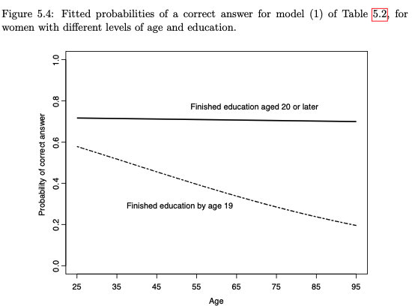

**Week 4 Readings: Lent Term Review**

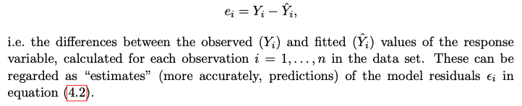

**Model assessment with Sample Residuals**

The magnitude of the residuals depends partly on the units in which Y is measured. For model assessment, it is often somewhat more convenient to use standardised residuals which do not have this property. Statistical software packages sometimes provide separately “standardised” residuals ei/σˆ and “studentised” residuals, which are divided by a further quantity so that they will be approximately normally distributed with a standard deviation of 1 if the model is correct. We will use studentised residuals here and standardised ones in the computer classes. It is important to note, however, that raw, standardised and studentised residuals are not qualitatively different: all of them will always give residual plots of a similar shape.

Scatter plots of the residuals against selected other quantities are used for model assessment. This can help to detect signs of possible failures of some of the model assumptions, an activity known as model **diagnostics**. Depending on what the residuals are plotted against, diagnostics of different aspects of the model are obtained.

Plots of residuals (usually placed on the Y -axis) against individual explanatory vari- ables X can suggest changes to the model. If the X-variable in this plot is already included in the model, the plot cannot have a linear trend (which is already included) but it can show a nonlinear one.

A plot of this kind which most closely matches the ideas of multiple regression is actually one that plots the residuals against not X but the residual from a fitted model for X given all the other explanatory variables in the model. This is known as the partial regression plot or added-variable plot.

Plots of residuals against explanatory variables provide suggestions about which vari- ables might be added to a model. These variables would then usually be examined further with a significance test, and included if they are significant. It is for another purpose that residual plots are particularly useful. This is the examination of the as- sumption of constant variance (homoscedasticity) of the error terms of the model. If this assumption is violated, the error terms are said to be heteroscedastic. If there is serious heteroscedasticity, usual estimates of the standard errors of the regression co- efficients will be incorrect, and so will test statistics and confidence intervals. Results of statistical inference will then also be invalid, in that confidence intervals will be too wide or too narrow, and tests may lead us to conclude incorrectly that partial effects are zero when they are not or vice versa.

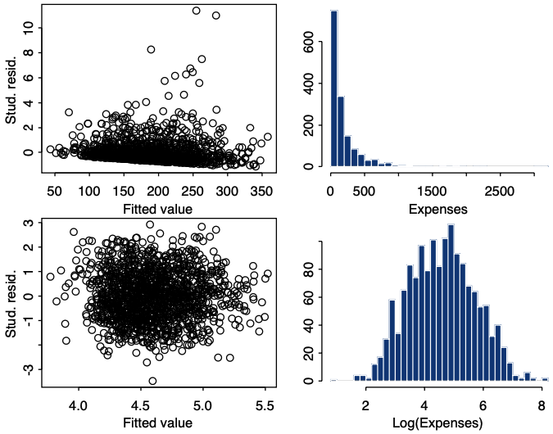

Model diagnostics from a residual plot like this are based on the general shape of the cloud of points. What we would like to see is a plot where the points form a band of roughly even width, as in the lower-left corner of Figure 4.12 (explained below) or in Figure 14.3(a) of Agresti & Finlay. Such a plot indicates that the variability of the residuals is of similar magnitude at different fitted values (and, by implication, at the corresponding values of the explanatory variables), i.e. it is evidence that the assumption of homoscedasticity is not violated.

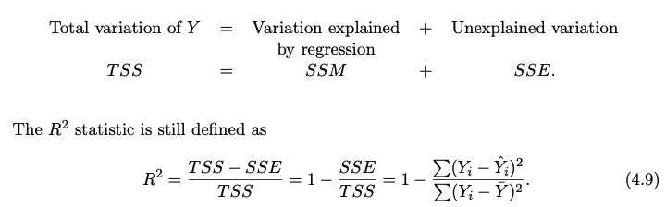

**Week 5: Lecture – Binary Logistic Models**

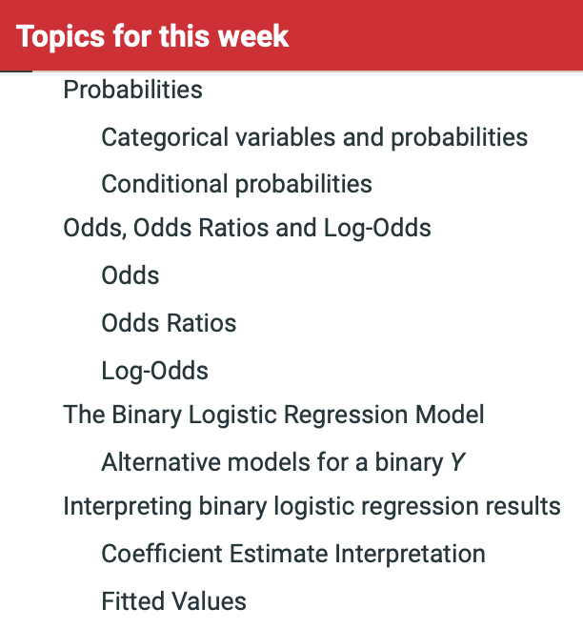

Some response variables are limited in the possible values they may have

* Two possible values (binary ; dichotomous ; binomial)
* Three or more possible values
  + Without logical ordering (nominal ; multinomial)
  + With logical ordering (ordinal)
  + With logical ordering and interval spacing (counts)
* For such responses, the linear regression model can produce undesirable or nonsensical results.

Y = 1 if something is ‘true’, or occurred

Y = 0 if something is ‘not true’, or did not occur

* Yes/no in surveys
* Agree/disagree
* Vote/Abstain
* Treatment/Control
* Pass/Fail

Example: Incumbent Parties & US Presidential Elections

The US has presidential elections every 4 years. In each of these elections, the incumbent party wins (Y = 1) or loses (Y = 0).

* Consider 16 US Presidentail eelctions from 1952-2012 as sample of ‘modern US Presidential elections’
* Without any other data, we can calculate incumbent re-election rate
* Won 8 of 16. 50%

A regression for these dependent variabvles would be useful to:

1. Describe how explanatory variables are associated with (the reporting of) having been a victim of crime or whether incumbent gets elected.

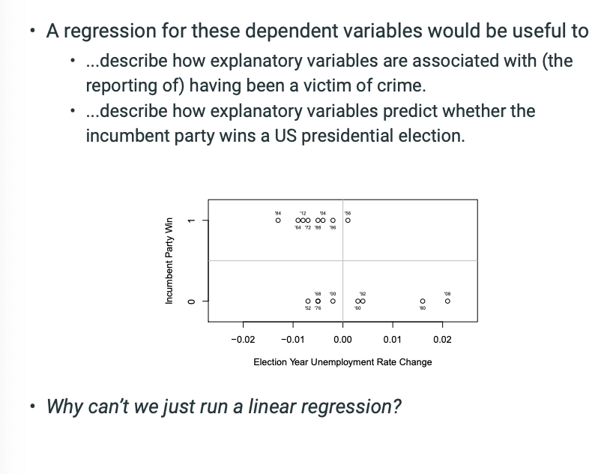

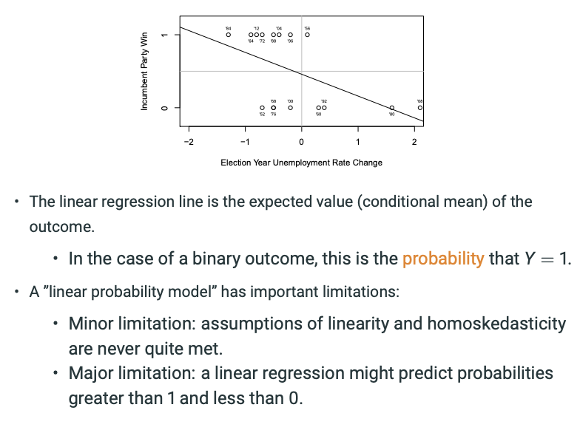

For binary response variables, we are interested in the **proportion** of the subjects in the population for whom Y = 1.

* Can also think of this as the probability (pi) that a randomly selected member of the population will have the value Y = 1 rather than Y = 0.
* Pi = p(Y = 1)
* 1 – Pi = p(Y = 0)

Binary Predictor of being a Victim of Crime

* Respondents were asked if they had been stopped by the police in the past year (on foot or in car)
* There appears to be a strong association between being stopped and being a victim:

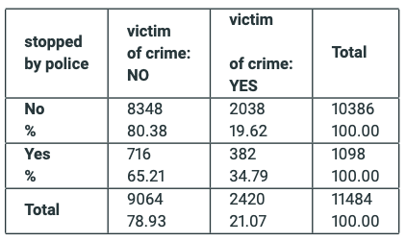

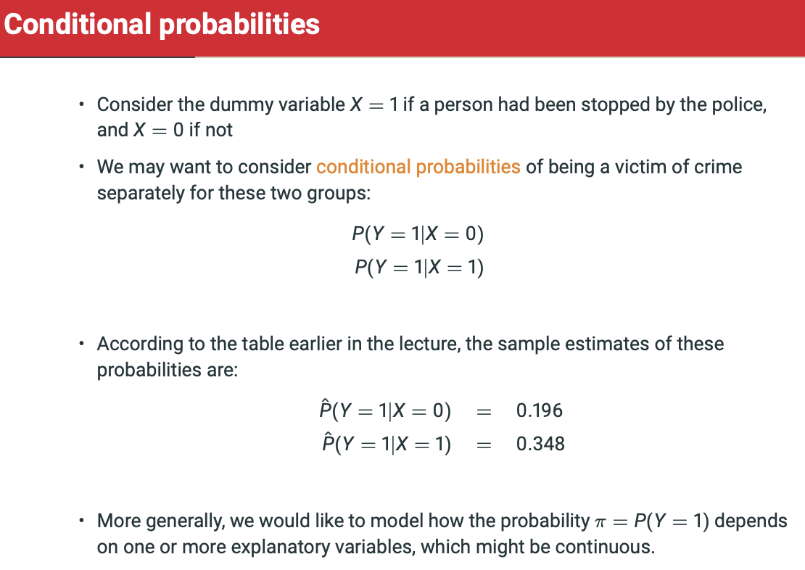

Binary outcomes cannot have a normal distribution, as we only have two values.

* The Bernoulli distribution is a special case of the binomial distribution – (remember lady tasting tea).
  + Possible values of Y are 0 and 1.
  + Pr(Y = 1) = Pi
  + Pr(Y = 0) = 1 – Pi
  + Expected value (mean) of the distribution is Pi
    - E(Y) = pi
  + Variance of Y is
    - Var(Y) = pi(1-pi)

**Odds, Odds Ratios and Log-Odds**

* In linear regression model, the conditional mean equaled a linear equation of explanatory variables.
* We cannot assume the same for the conditional mean Pi-I of the Bernoulli distribution:
  + We need some way to make sure 0 <= Pi-I <= 1
* This is done by modelling not the *probability* pi directly, but a transformation of *pi.*

Odds = pi / 1 – pi

* If probability of being a victim of crime is pi = 0.2107
* The odds of being a victim of crime are 0.2107/0.7893 = 0.2669
* Odds of not being a victim of crime are 0.7893/0.2107 = 1/0.2669/ 3.7461

Odds vs. Probabilities

If odds = 1, both outcomes have 0.5 probabilities.

Odds are just dividing probability of event by 1-probability.

**Odds = pi/1-pi – USE FOR ASSIGNMENT**

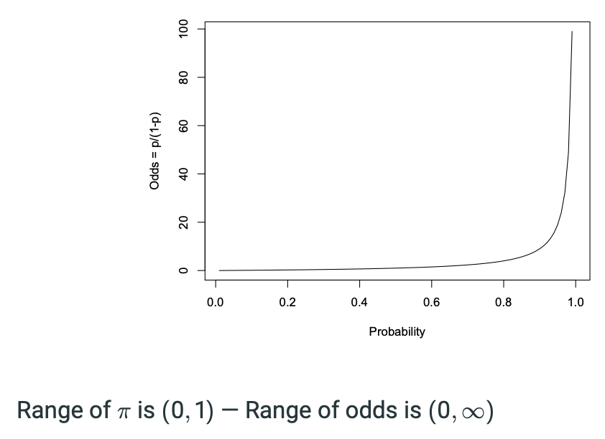



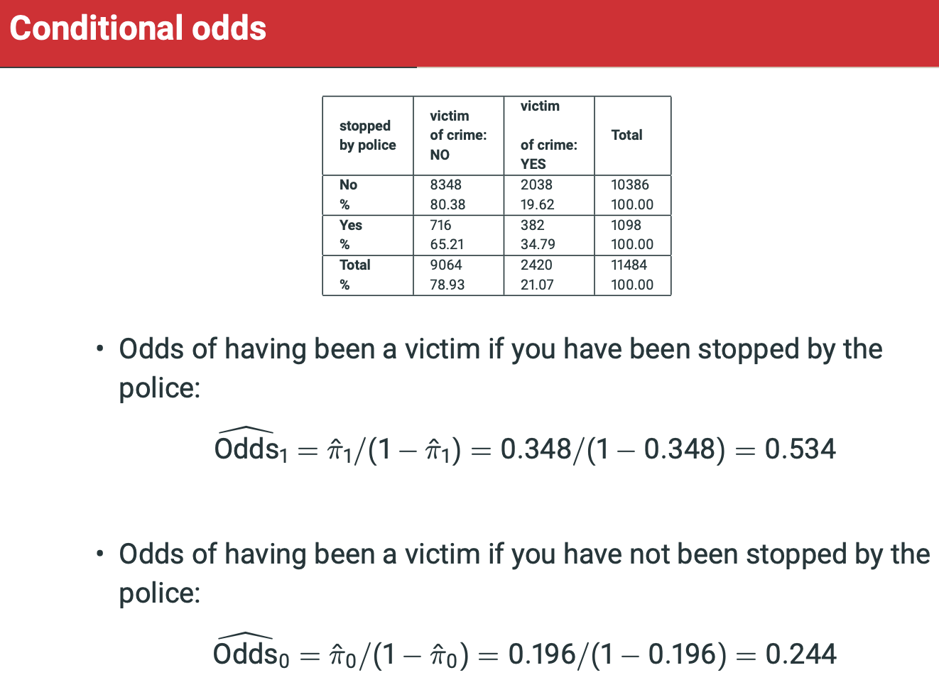

* An odds ratio is the ratio of two odds, here for example:
  + ORc10 = Odds [1 Odds [0 = 0.534 0.244 = 2.21
* It describes an association between two variables, here between being stopped (X) and being a victim of crime (Y)
* Because ORc10 > 1, the odds of Y = 1 (being a victim of crime) are higher when X = 1 (person has been stopped by the police) than when X = 0 (person has not been stopped by the police)
* Specifically, the odds of being a victim if have been stopped are 2.21 times the odds if not been stopped, i.e. the odds of having been a victim are 121% higher if you have been stopped •
* This also means that the probability of being a victim is higher when X = 1 than when X = 0
* In other words, having been stopped by the police is associated with higher odds (and probability) of having been a victim of crime.

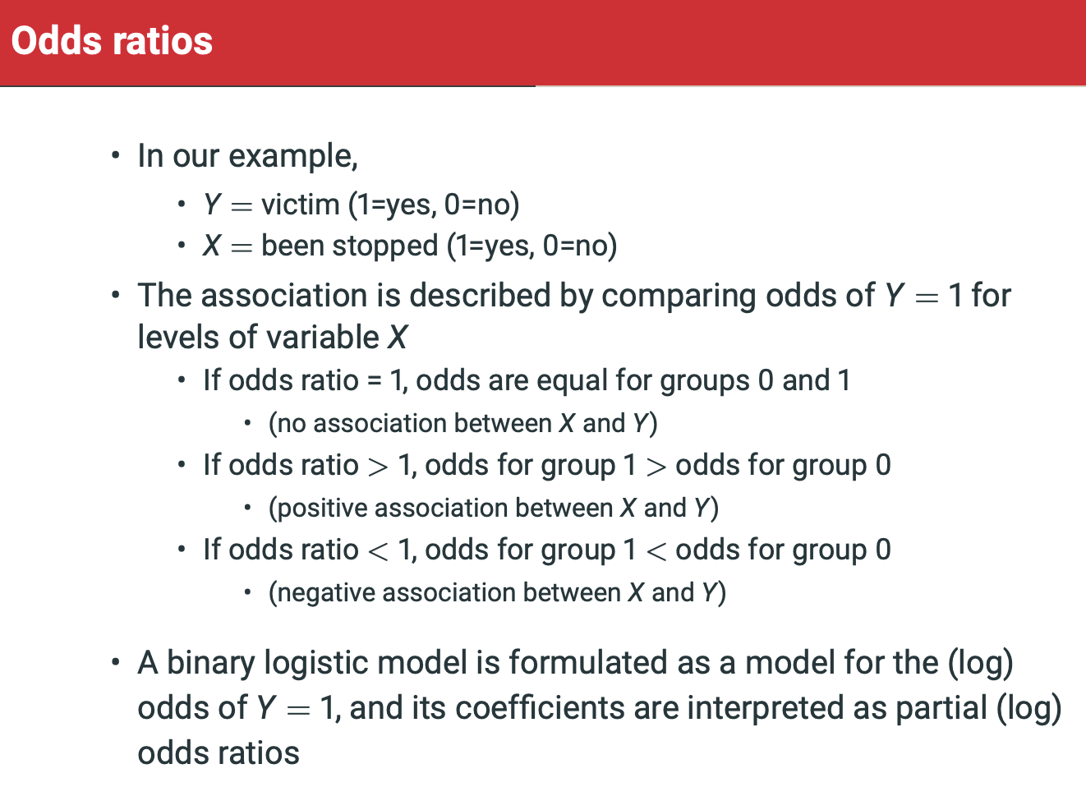

Recall that we need the solve the problem that:

* The linear prediction can take values from – infinity and infinity.
* The Bernoulli probability pi-I must be between 0 and 1.

We now have the pieces to solve the problem.

* Turning pi-I into the odds expanded the range to;
  + 0 < pi / 1-pi < + infinity
    - Now we have converted to odds, we can go to positive infinitt
  + By taking the logarithm of the odds:
    - - infinity < log(pi/1-pi) < + infinity
      * Now, we can go down to minus infinity too.
      * So we’re not constrainted between 0 and 1 on left hand side.
  + This transformation is known as the **logit.**
  + **The binary logistic model is specified for the logit transformed probability of Yi = 1**
    - **Log( pi / (1-pi)) = alpha + Beta1X1 + …**

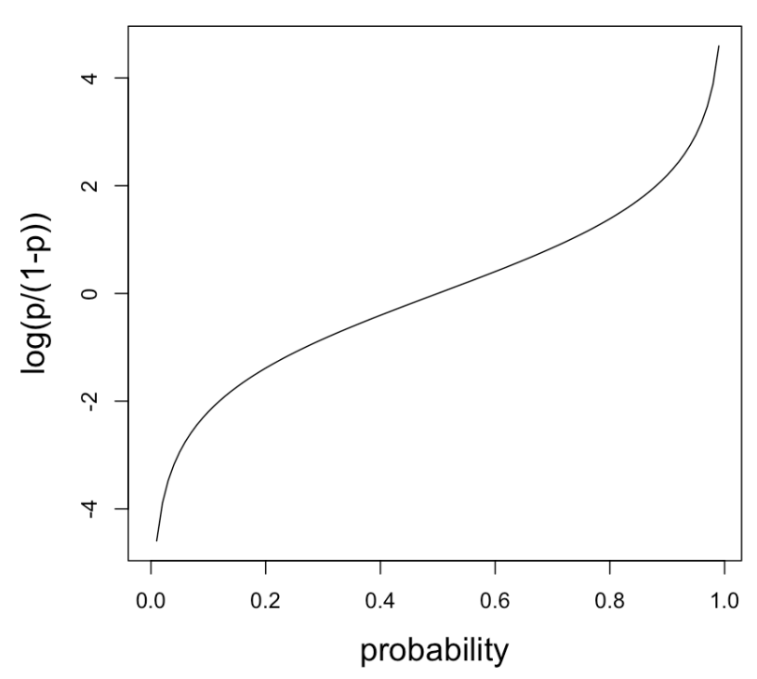

**Range of pi is (0,1) – Range of log-odds in (-infinity, infinity)**

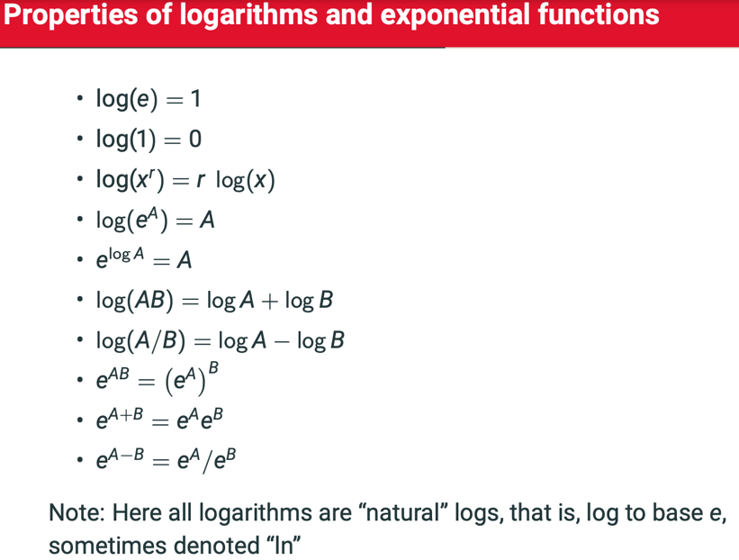

**The Binary Logistic Regression Model**

* Y is a binary response variables with values 0 or 1
* Xk are k explanatory varaibles
* Observations Yi are statistically independent of each other.
* For each unit i, the following equation holds for P(Yi = 1) = pi-i
  + Log(Odds-i) = log(Pi-i/(1-Pi-i)
* Where alpha and all beta coefficients are unknown parameters to be estimated from the data.

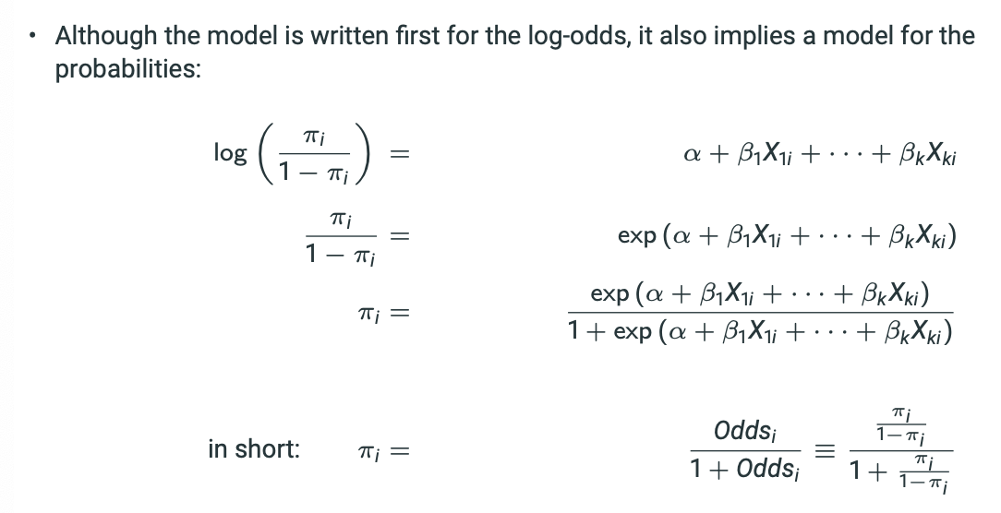

**USE TO CALCULATE PROBABILITY AND ODDS.**

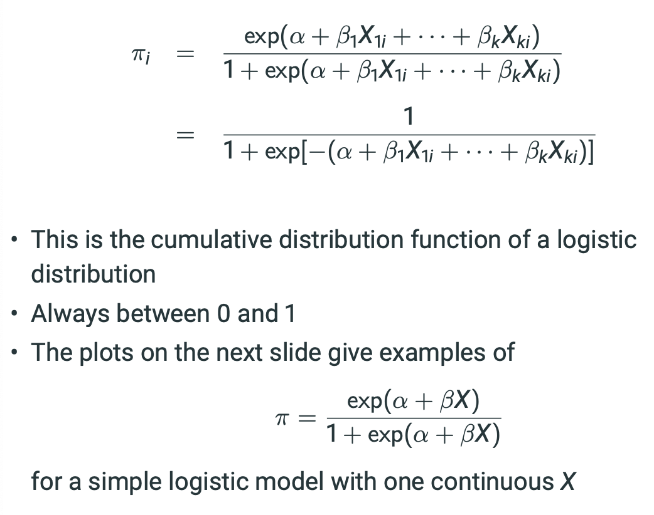

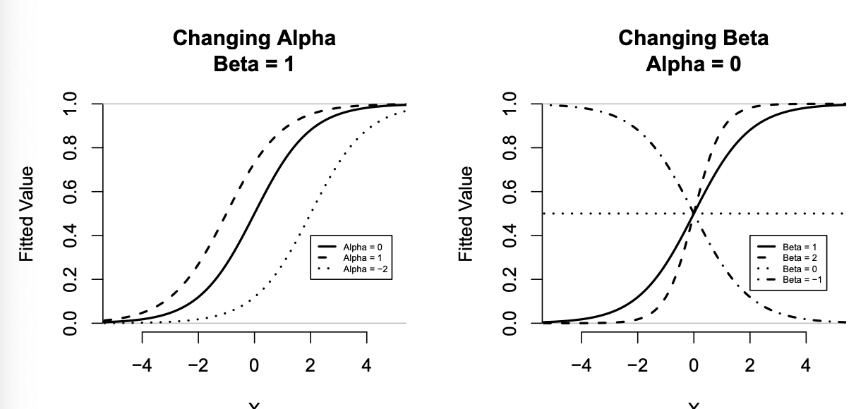

Notice that central region has same movement but they’re intersecting y = 0.5 at different values of X.

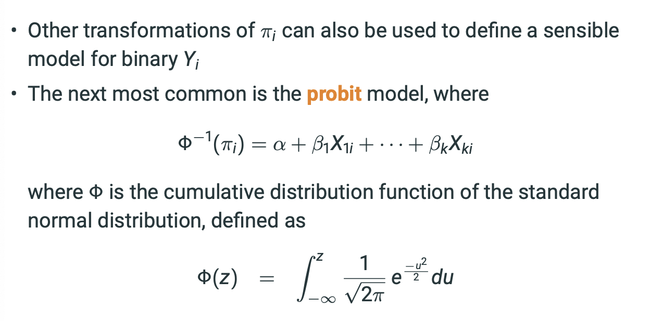

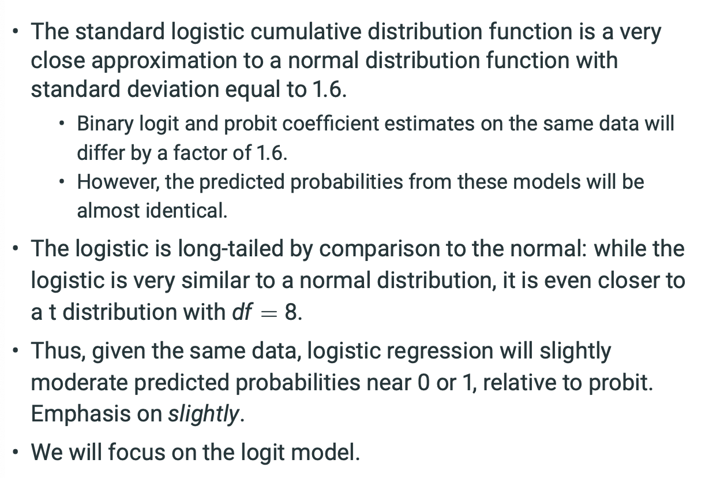

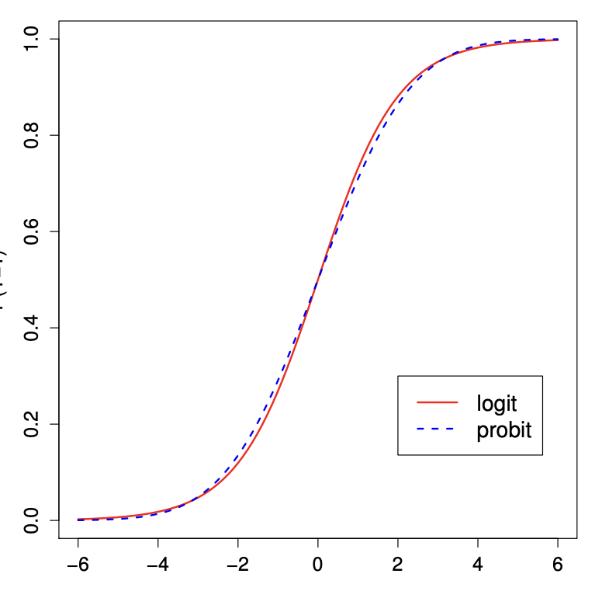

Logit ever so slightly steeper in middle and less certain at tails.

**Interpreting the Coefficient Estimates**

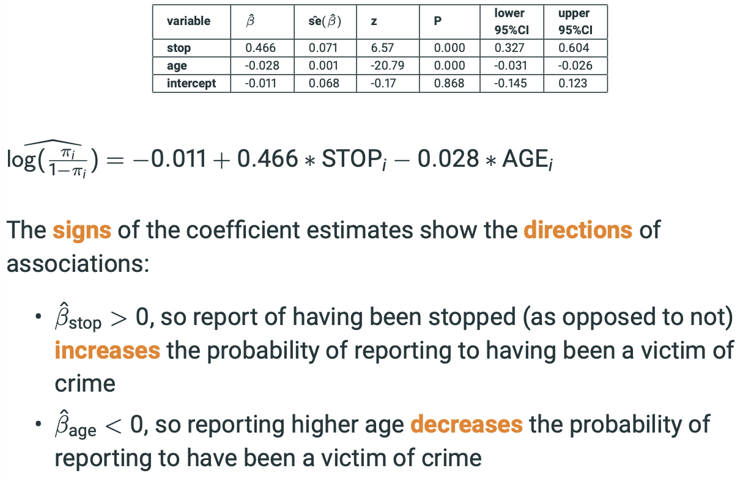

Be careful here.

* We interpret these coefficients as **partial odds ratios**.
* If Beta > 0, theres a positive association between having been stopped before and having been a victim of crime.
* Instead of interpreting the coefficients on the log-odds scale, we can make better sense of them by taking the exponential, thus interpreting coefficients directly as odds ratios.
  + Why?
    - If log(Odds-x) = alpha + beta(X+1)
    - Then log(Odds-x+1) – log(Odds-x) = Beta
    - i.e. Beta = log(Odds-x+1/Odds-X)
    - So e^Beta = Odds-X+1/Odds-X
* In our example: exp(Beta-stop) = exp(0.465) = 1.592 (odds ratio for have experienced crime whilst being stopped by police compared to not being stopped by police).
  + 1.592 = exp(Beta-stop): On average, contreoling for age, having been stopped (stop = 1) multiplies the odds of having been a victim of crime by 1.592, compared to not having been stopped (stop = 0).
  + Odds increase by 59.2%.
* Exp(Beta-age) = exp(-0.028) = 0.972 (On average, controlling for whether has been stopped by police, a 1 year increase in age multiples the odds of having been a victim of crime by 0.972).
  + i.e. decreasing the odds by 2.8%.
  + For a 5 year increase in age, the odds ratio is exp(-0.14)
  + Odds ratio of 0.869.

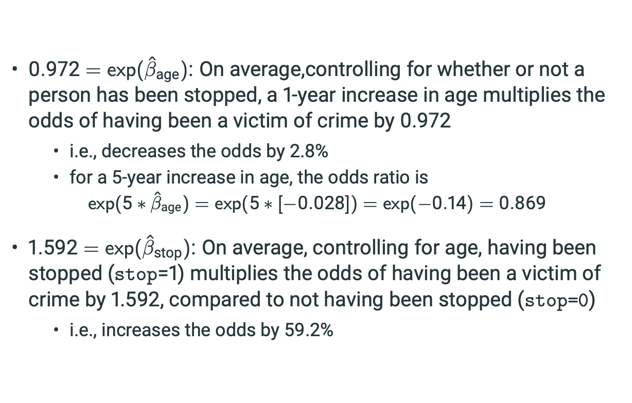

Just as we are interested in fitted values for linear regression, we are often interested in fitted probabilities for logistic regression. Let’s return to US Presidential election example:

* Fit model with just unemployment rate change during the election change
* Fit a second model with an additional dummy variable for whether the incumbent president is running for re-election

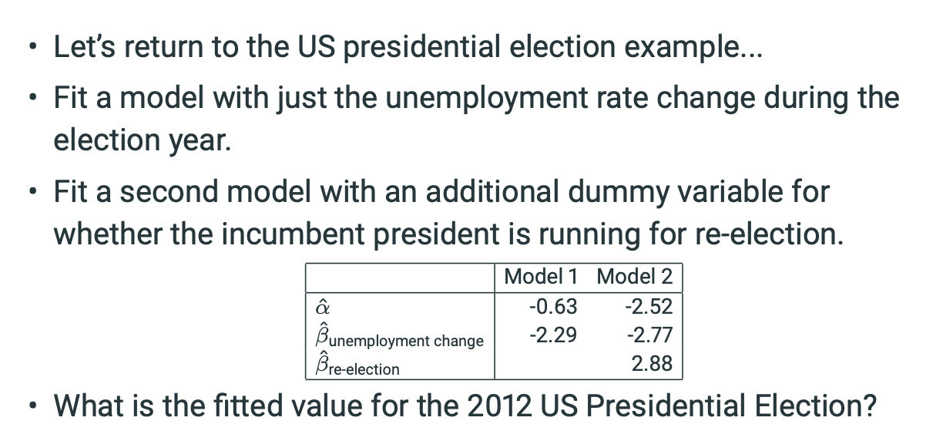

Xunemploymentchange = -0.8(unemployment going down), X_re-election = 1

Model 1:

* 1/ (1 + exp(-(-0.63 + -2.29*-0.8)) = 0.77

Model 2:

* 1 / (1 + exp(-(-2.52 + -2.77*-0.8 + 2.88*1) = 0.93

Model 1: So, the probability of the incumbent party winning declines as the unemployment rate change becomes more positive.

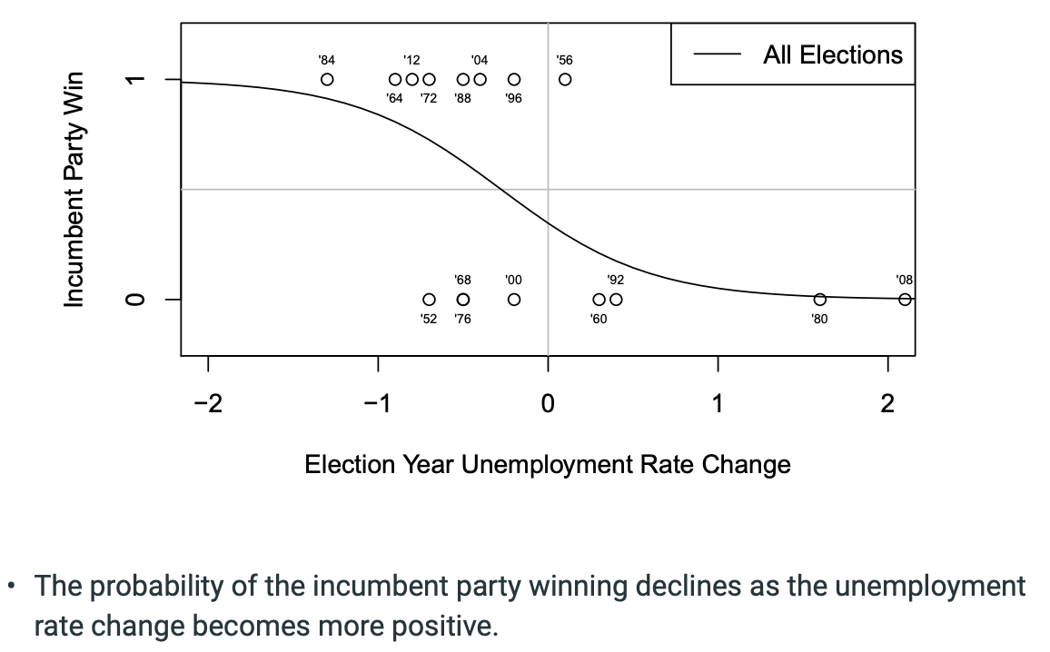

Model 2: The probability of the incumbent party winning is much higher if the sitting president is running for re-election.

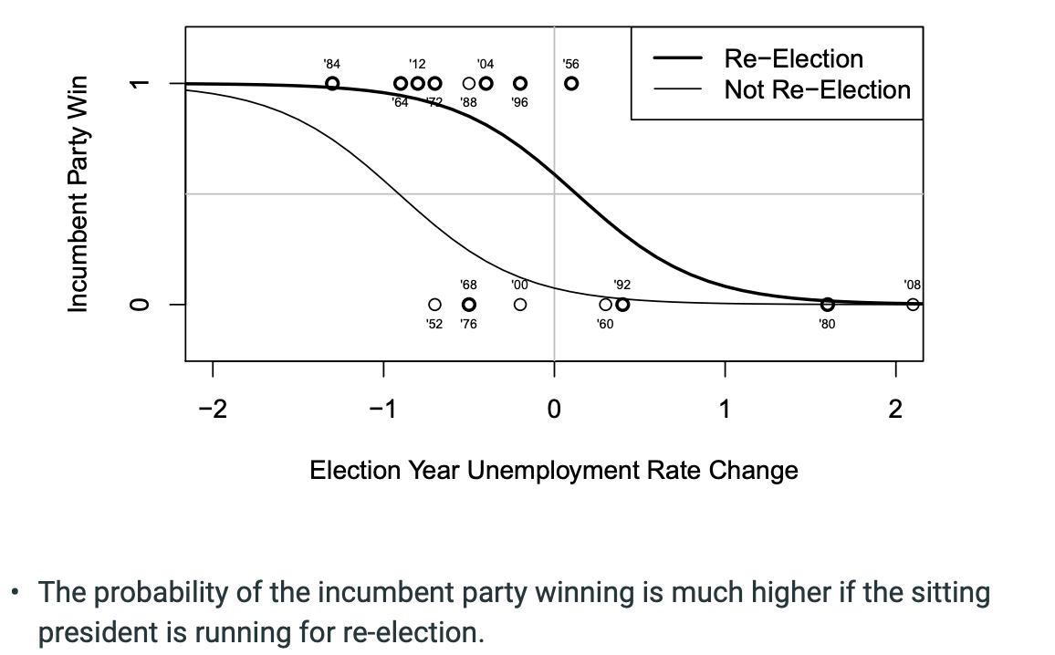

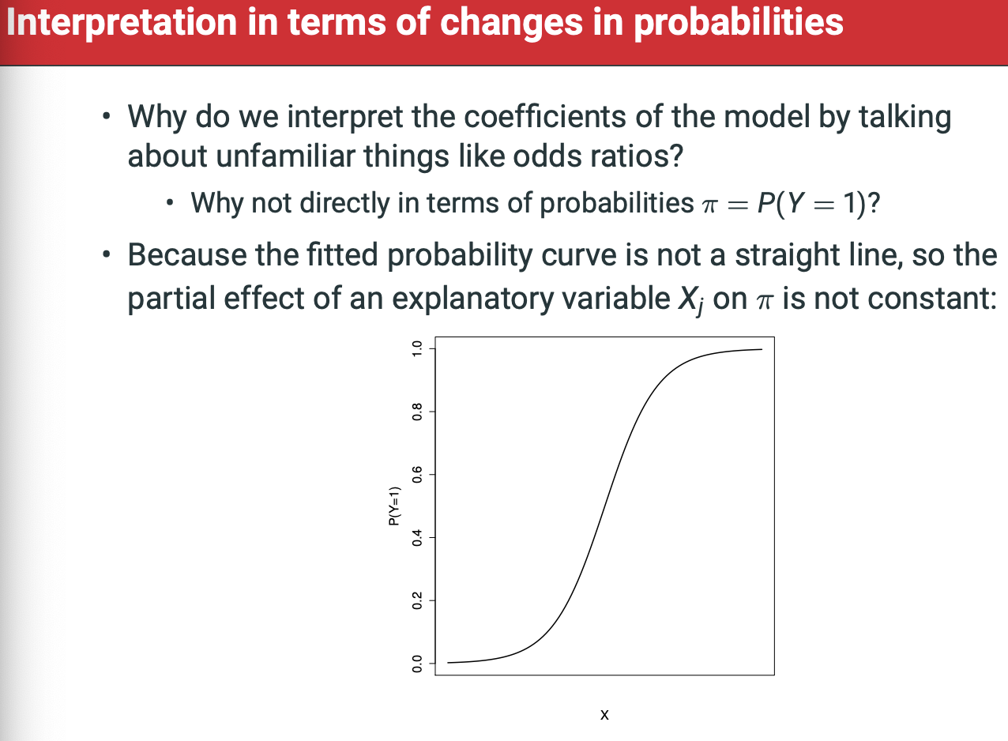

* No single number that can describe the Xj on pi everywhere. Cant describe change on pi everywhere, can only think of the multiplicative effect on the odds.
  + Exp(Beta-J) is the odds ratio corresponding to any 1-unit change in Xj, holding other explanatory variables fixed at any values. This is constant, with no curvature.
  + However, we can calculate estimated effects of Xj on Pi at specific values of Xj, holding other variables fixed at specific values.
    - Under Model 2, the probability of President Obama’s relection given the actual -0.8 percentage point decline in unemployment was 0.93.
    - Under model 2, the probability of Pres-ident Obama’s re-ection if the unemployment rate had increase by 0.2 percentage points would be 0.45. So, from -0.8 to 0.2, the model predicts that Obama probability of re-election drops by 0.48 from 0.93 to 0.45.

When line is at its steepest, what is that change relative to a one unit increase in X? Interpretations in terms of changes in probabilities

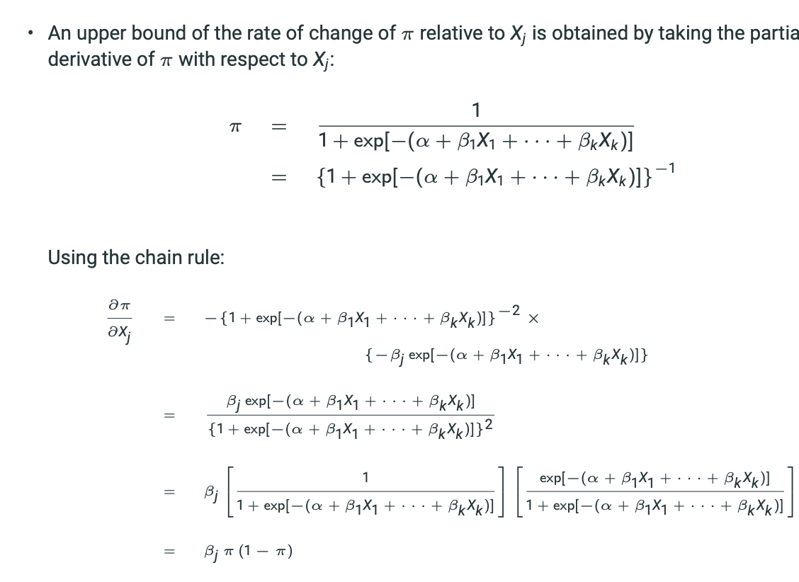

Beta-J * Pi * (1-Pi) = Change in Pi / Change Xj

The largest possible value of this, obtained when Pi = 0.5, is Bj * 0.25 = Bj / 4

Thus, the effect of a 1-unit change in Xj on the probability of Y = 1, controlling fr the other explanatory variables, is at MOST Beta-J / 4.

CANNOT say increase/decrease in Y is Beta*Xj

**Binary Logistic Regression Lecture Recap**

The LOGIT is log(Coefficient-i/(1 – coefficient-i)

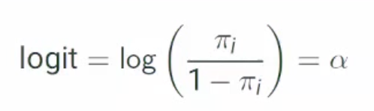

Thus, probability of any given observation being 1 is equal to:

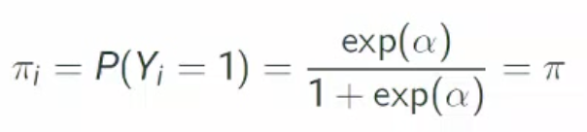 with no explanatory variables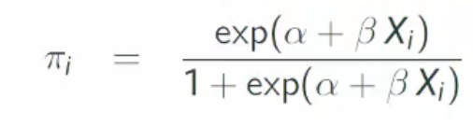 with explanatory variables

Likelihood function is the probability of the observed data given our model. The likelihood is proportional to the probability of obtaining the observed pattern of results in the sample if that model were true.

**Maximum likelihood estimates for alpha and beta are obtained by maximising Log-likelihood (MLE) with respect to alpha and beta.**

We

**Week 7: Readings – 5.4 Statistical Inference for Binary Logistic Regression**

We want to:

1. Test null hypothesis
2. Calculate confidence intervals for single coefficients
3. Calculate Odds ratios for single coefficients
4. Wald test for single coefficients
5. Likelihood ratio test for one or more coefficients (Similar to F-test in linear regression).

If null hypothesis is not rejected, this implies that the corresponding explanatory variable or variables have no partial effect on the response, so they may be omitted from the model. Significance test can be used for model selection with same considerations.

* + 1. Wald Test for single regression coefficients

To test the single-coefficent null hypothesis we use a test statistic that is the ratio of the estimate coefficient to its standard error (similar to t-test(). However, z is not compared to the t-distribution but to a standard normal distribution. If ratio > 2 then we can reject null.

Z = Beta-hat-j / standard-error-hat(Beta-hat-j)

Z^2 = Beta-hat-j-squared / variance-hat-of-Beta-j

Where variance-hat-of-Beta-J is the estimated variance of Beta-J. The statistic z^2 is simply the square of Z, which is known as the Wald statistic. The sampling distribution of z^2 under null hypothesis is a X^2 distribution on 1 degree of freedom so 2-sided P-values for the test are obtained from this distribution.

The above two calculations give us two versions of the same test, not two different tests. A P-value optained from standard normal distribution for z is identical to P-value from the X^2-I distribution of z^2. More specifically, this is the case for a test with 2-sided alternative hypothesis. A 1-sided can be tested only with z.

An extension of the single-parameter Wald test can be used to test the multivariate null hypothesis. This is essentially a multivariate version of z^2. Its sampling distribution under the null hypothesis is χ 2 with the degrees of freedom equal to the number of regression coefficients set to 0 by the null hypothesis. SPSS calculates the multivariate Wald test for any categorical explanatory variables with more than two categories (and hence two or more dummy variables). An example of this is the test statistic for the effect of education in Figure 5.2. The row labelled “educ” in the table of estimated coefficients shows the Wald test for the 2-parameter hypothesis that the coefficients of both dummy variables for education are zero. For hypotheses like this, we usually prefer the likelihood ratio test described in Section 5.4.3; some further discussion of the multivariate Wald test is given there.

* + 1. Confidence Intervals for coefficients and Odds ratios

Same as for linear models, main difference is that they are now always based on a standard normal distribution. We calculate CI for beta and odds ratios.

Since the most convenient interpretation of the coefficient is based on the odds ratio exp(βj ), a confidence interval for this is also useful. Such an interval is obtained simply by applying the exponential transformation to the end points of the interval (5.20). In other words, a 95% confidence interval for exp(βj ) is the interval.

Note that this is asymmetric in the sense that the lower limit of (5.21) is always closer to the estimated odds ratio exp(βˆ j ) than the upper limit. The interval (5.21) can be included in Stata and SPSS output for fitted logistic models, as explained in the computer class.

The confidence intervals are related to the Wald test (5.19) of βj in a familiar way. Thus if the null hypothesis that βj = 0 is not rejected at the 5% level of significance, βj = 0 will be included in the 95% confidence interval (5.20) and, equivalently, exp(βj ) = 1 will be included in interval (5.21). Conversely, if the null hypothesis is rejected, 0 will not be included in (5.20) and 1 not in (5.21).

As an example, consider the coefficient of Age in the model output in Figure 5.2. The estimated coefficient is βˆ age = −0.020 and its standard error ˆse(βˆ age) = 0.003. The 95% confidence interval for βage is thus

(−0.020 − 1.96 · 0.003; −0.020 + 1.96 · 0.003) = (−0.026; −0.014)

and the 95% confidence interval for the odds ratio exp(βage) is

[exp(−0.026); exp(−0.014)] = (0.974; 0.986).

We are thus 95% confident that the effect of a 1-year increase in age, controlling for gender and education, is to decrease the odds of a correct answer by between 2.6% and 1.4%. The interval for the odds ratio does not include the null value of 1 (i.e. a 0% change), so it agrees with the conclusion from the Wald test of the coefficient of the age variable.

* + 1. Likelihood Ratio Tests

The two general hypotheses (5.16) and (5.17) — of which the single-parameter hypotheses (5.14) and (5.15) are a special case — introduced on page 129 correspond to two logistic models: H0 to a model which includes only explanatory variables X1, X2, . . . , Xg, and Ha to a model which also includes Xg+1, Xg+2, . . . , Xk (as always, the subscripts are here arbitrary, so the set of variables included only in Ha can be any subset of the explanatory variables). This is an example of a pair of nested models. Two models are said to be nested if one model may be constructed from the other by either removal of variables or addition of variables, but not both, so that one model is a simpler (restricted) version of the other (full) model.

A very general statistical test that can be used to compare any pair of nested models is the likelihood ratio test (LR test). It is a generalisation of the F-test for linear models discussed in Section 4.5.3. The LR test compares two nested models by comparing the values of the likelihoods of the models. The likelihood is, loosely speaking, a measure of how well a model fits the data.

Suppose we have fitted two nested models. Let Model 1 be the simpler model and Model 2 a more complex version of Model 1 with some extra variables added. We wish to know whether the extra variables included in Model 2 are necessary, i.e., whether the extra parameters in Model 2 are equal to zero. Model 1 thus corresponds to the null hypothesis (5.16) and Model 2 to the alternative hypothesis (5.17). We begin by fitting both models and recording the likelihood values for each of them. Let L1 be the likelihood for Model 1 and L2 the likelihood for Model 2. If the null hypothesis is correct — i.e. the larger Model 2 is no better than the simpler Model 1 — we would expect L1 and L2 to be similar, while a large difference between them — indicating that the larger model fits much better than the simpler one — would suggest that H0 should be rejected. The likelihood ratio test is based on this simple idea. For mathematical reasons the test statistic is not defined as the difference between L1 and L2 themselves, but as the likelihood ratio statistic.

L^2 = -2log L1 – (-2logL2)

This is compared with a χ 2 distribution with degrees of freedom equal to the number of extra parameters (regression coefficients) included in Model 2 but not in Model 1. In practice, an easy way to check that the difference (5.22) has been calculated the correct way round is that its value must always be non-negative.

As an example, consider the model shown in Figure 5.2 on page 117. The value of −2 log L for it is 2947.68, as shown under “-2 Log likelihood” in the “Model Summary” table of the output. This model includes age, education and gender as explanatory variables. Consider now the null hypothesis that gender has no effect on knowledge, once we control for age and education. We fit a model with age and education included as explanatory variables, but gender (i.e. the dummy variable for men) excluded. The value of −2 log L for this model is 2947.99. This model has the role of the smaller Model 1 in (5.22), and the model with gender included is Model 2. Thus the LR test statistic is:

2 = −2 log L1 − (−2 log L2) = 2947.99 − 2947.68 = 0.31.

This is compared to a χ 2 distribution with 1 degree of freedom. The degrees of freedom are 1 because the larger model includes 1 parameter — the coefficient of the dummy variable for men — which is not used in the smaller model. The P-value for 0.31 from the χ 2 1 distribution is 0.58. The null hypothesis is thus not rejected. There is no evidence that the larger model fits better than the smaller one, i.e. no evidence that gender has an effect on the probability of a correct answer, once we control for age and education. We can drop gender from the model.

Consider now the model with only age and education included. Suppose we try the even simpler model which further excludes age. The value of −2 log L for this is 3002.84, and the LR test statistic is L 2 = 3002.84 − 2947.99 = 54.84. The P-value for this, again from the χ 2 1 distribution, is P < 0.001. The null hypothesis is clearly rejected — age is associated with knowledge, and we cannot drop age from the model. Similarly, comparing the model with age and education to a model with education omitted gives L 2 = 9.12. The degrees of freedom for this are now 2, because leaving out education reduces the number of parameters by 2 — the coefficients of the two dummy variables for two of the three levels of education. The P-value for L 2 = 9.12 from the χ 2 2 distribution is P = 0.010. This null hypothesis too is rejected at the 5% level of significance, and we keep education in the model.

The LR test can be used for any kinds of nested models. Another example is combining categories of a categorical explanatory variable. This is achieved by omitting dummy variables for some but not all of the categories of the variable.

As an example, consider education in Figure 5.2. Here the Wald test of the coefficient of “educ(2)”, which denotes the dummy variable for education level 3 (still studying and aged 15–19), has a P-value of 0.090. This suggests that this dummy variable might be omitted from the model, while keeping the dummy for level 2. Doing so has the effect of combining level 3 with the reference level 1 (finished education before age 20). We are then comparing only two levels of education, “High” (finished education at age 20 or later) against “Low” (finished education before age 20 or aged less than 20 and still studying). Fitting models in this way with education as a two-level vs. three-level variable gives another nested pair of models (with age included in both). The LR test statistic is L 2 = 2.90, with 1 degree of freedom (because the larger model has 1 extra parameter, the coefficient of the dummy for education level 3), and P = 0.089 > 0.05. We can thus simplify the model into one which includes age and the two-level education variable. In the last example, the Wald test (with P = 0.090) and the LR test (P = 0.089) gave very similar results for the same hypothesis. This is typically the case, for hypotheses of both single and multiple parameters. Either test can be used in practice. The Wald test is more convenient for tests of regression coefficients of logit models, because it is automatically included in Stata and SPSS output. It is, however, very useful to know also how to use the likelihood ratio test. Its applicability is not limited to logistic models or tests of regression coefficients, but extends much wider to other models and hypotheses. The general idea of the test and the form of the test statistic (5.22) are the same in all situations. Note that the LR test cannot be used for pairs of non-nested models. For example, it cannot be used to compare the model with only age included to a model with only education included. This comparison does not correspond to hypotheses of the form (5.16)–(5.17).

* + 1. Model Selection for Logit Models

Likelihood ratio tests (or Wald tests) can be used for model selection for logistic regression models. The general issues and caveats of this are the same as for linear models.

EXAMPLE OF USING LIKELIHOOD RATIO TESTS & WALD TESTS FOR MODEL SELECTION ON PAGE 134-135

Week 7 – Lecture:

Covered last week:

* Probabilities
* Odds, Odds Ratios & Log Odds
* Wald
* Etc.

This week:

* Estimation of Binary Logistic Coefficients
* Significance Tests for Estimated Coefficients
* Fit Statistics and Model Selection
* Examples w/ Interactions
  + Campaign Spending in 2002 Iirish Elections
  + Determinants of Infant Mortality

**Estimation of Binary Logistic Coefficients**

• How is the binary logistic regression model estimated?

•Recall that the linear regression model is estimated by minimizing the sum of squared residuals.

• The binary logistic is estimated using a more general approach: maximum likelihood estimation.

• Minimizing the sum of squared residuals maximizes the likelihood function for the linear regression model.

• What is a likelihood function and how do we (get our computer to) maximize it?

Estimation is carried out using a general method known as maximum likelihood (ML) estimation

• Goal: Find values of the parameters which maximize the probability of the observed data under the fitted model • (maximize likelihood of the model parameters given the data)

• To illustrate, begin with an empty model (no explanatory variables), where

Logit = log(pi-i/1-pi-i) = alpha

**Estimating the binary logistic regression model**

Likelihood function L is here the probability of the observed data, which for empty models is:

Pi^m * (1-m)^n-m

Now we ask: what value of Pi would give the highest likelihood for the data we actually observed?

This value – the MLE (Maximum Likelihood Estimate) pi-hat of pi is obtained by maximising L with respect to pi.

Maximising likelihood function is harder than maximising the log likelihood function. Because A > B imlies logA > LogB, the coefficients that maximise logL will also maximise L.

Pi-hat = m/n (VERY SIMPLE)

Adding explanatory variables – for typical models, the calculus solution is intractable. If we add an explanatory variable, the log-likelihood becomes..

PI-I = exp(alpha + Beta*X1)/1+exp(alpha + Beta*X1)

ML estimates Alpha-hat and Beta-hat are obtained by maximising LogL with respect to alpha and beta.



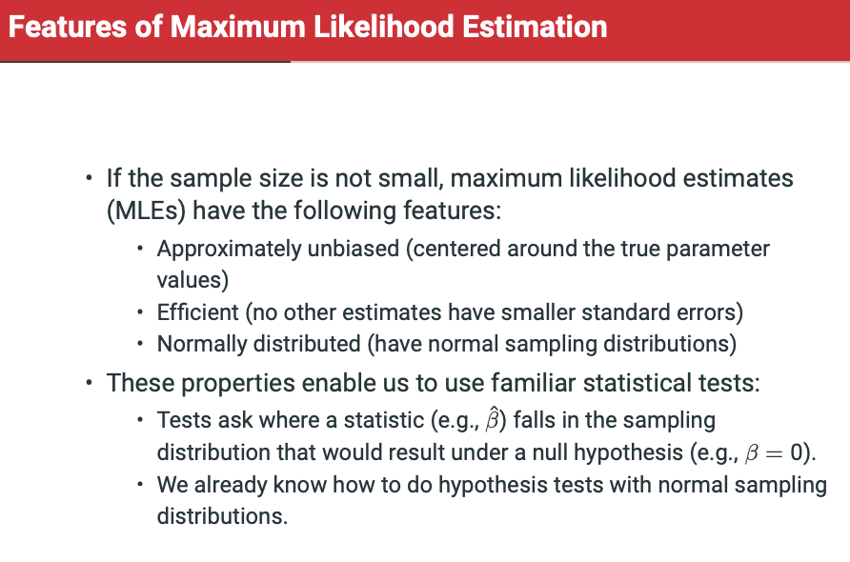

**Significance Tests for Estimate Coefficients**

p-value is now obtained from the standard normal distribution, rather than a t-distribution.

If z > 1.96 or z < -1.96 then we can reject at the 5% level.

The **Wald test statistic** is the square of the z statistic:

Wald = (Beta-j-hat/standard-error-hat*Beta-j-hat)^2

This is compared to a chi-squared distribution with 1 degree of freedom. For single regression coeffs, Stata and R show Z but SPSS shows Wald.

Confidence intervals with +- qnorm(0.025)*standard-error-hat

Likelihood Ratio Test:

* An alternative way of testing coefficients for significance
  + Individual coefficients as before
  + Several coefficients at one.
* The likelihood L is proportional to the probability of obtaining the observed pattern of results in the sample of that model were true.
  + So larger values are good
* Idea of the test: *compare* the likelihoods of two models: one including the variable(s) in question, one excluding them
  + If difference is small, excluding the variable(s) did not reduce the fit of the model.

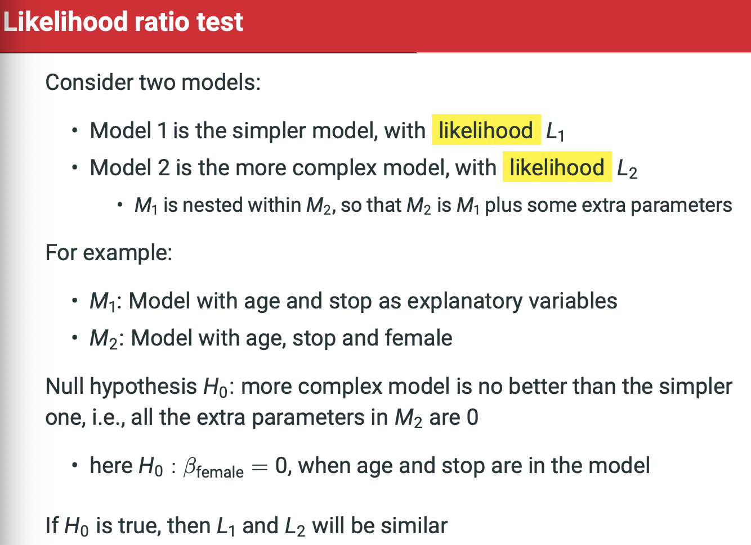

The logic of the likelihood ratio test is as follows:

* Recall that a larger likelihood function indicates a better fit
* Likelihood of a model with more independent variables will be larger than the likelihood of a model with fewer independent varaibles
* L1/L2 will be between 0 and 1.
* L^2 = -2log(L1/L2)
  + Follows a chi-squared distribution with degrees of freedom equal to the number of extra parameters in the larger model M2.
* L2 = 2log(L2) – 2log(L1)
* If Null hypothesis (that extra variables model isn’t better than original nested model) is true, then L^2 has a chi-squared distribution with degrees of freedom equal to the number of extra parameters in the larger model M2.
* Small p-value for test stat = larger evidence against H0.
* Large p-value for test statistic = smaller evidence against H0.

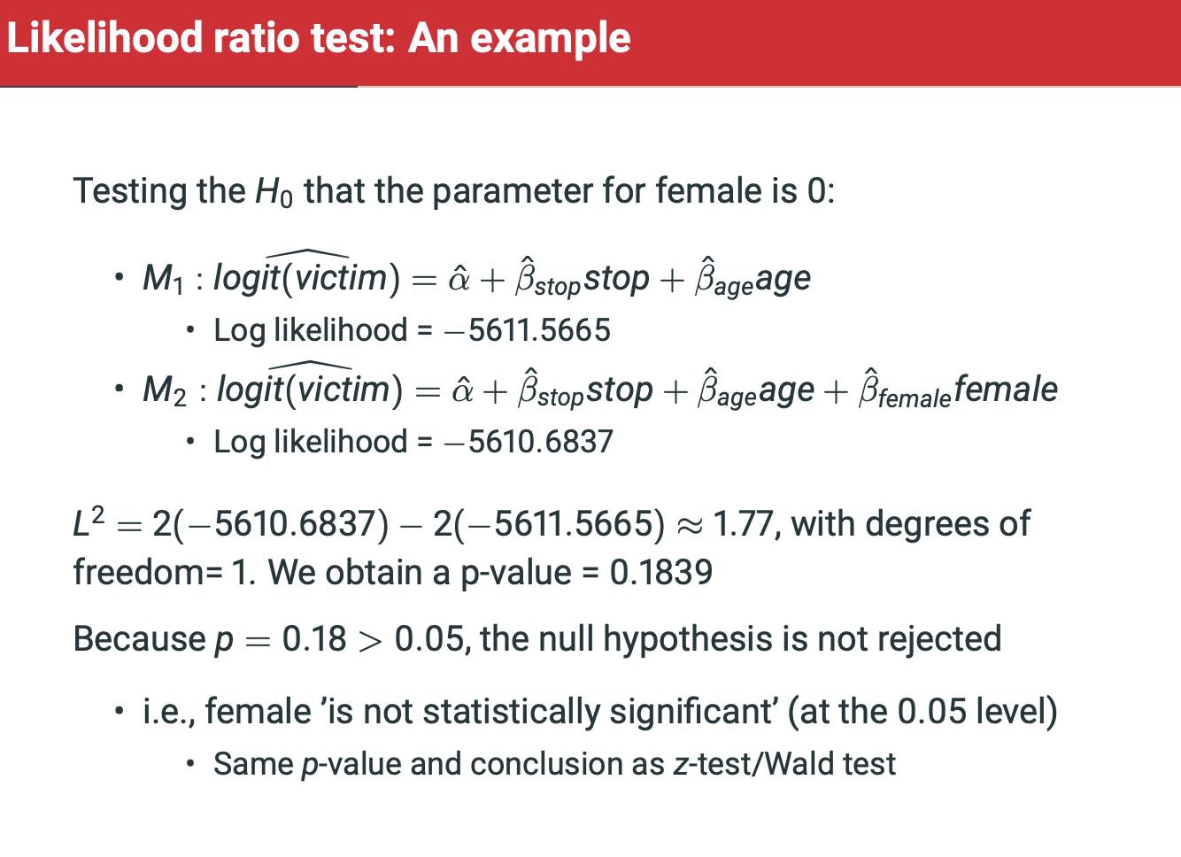

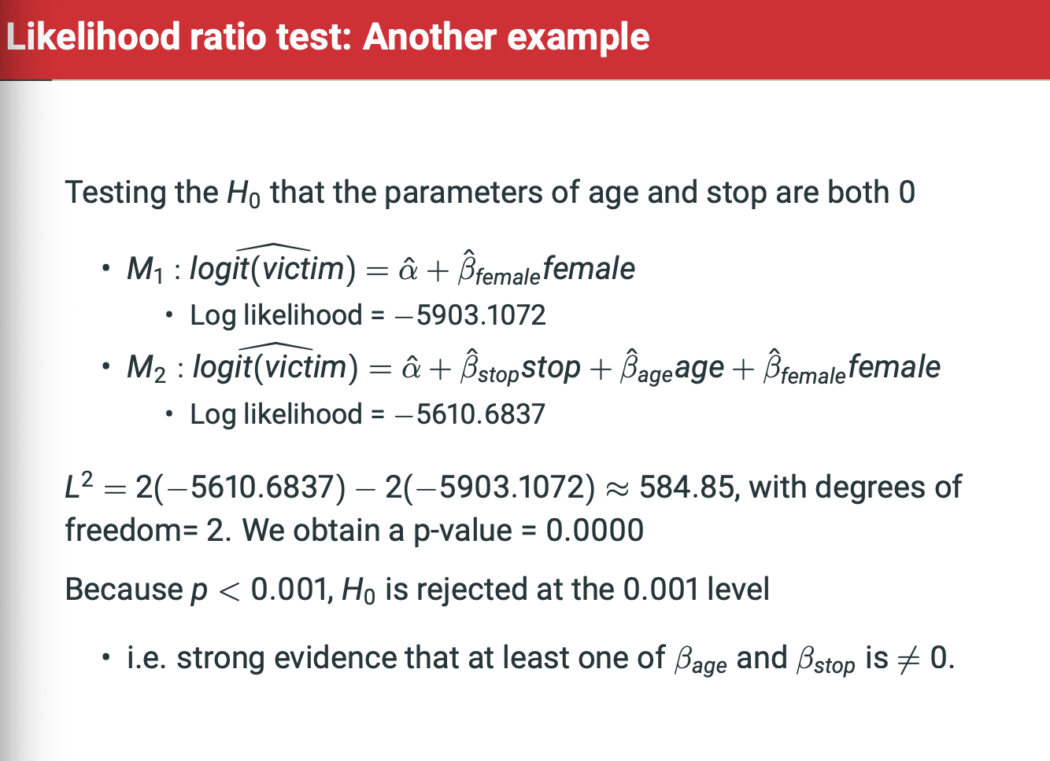

Notice interpretation above! **AT LEAST ONE** of two variables is statistically significant.

**Different Tests for different problems**

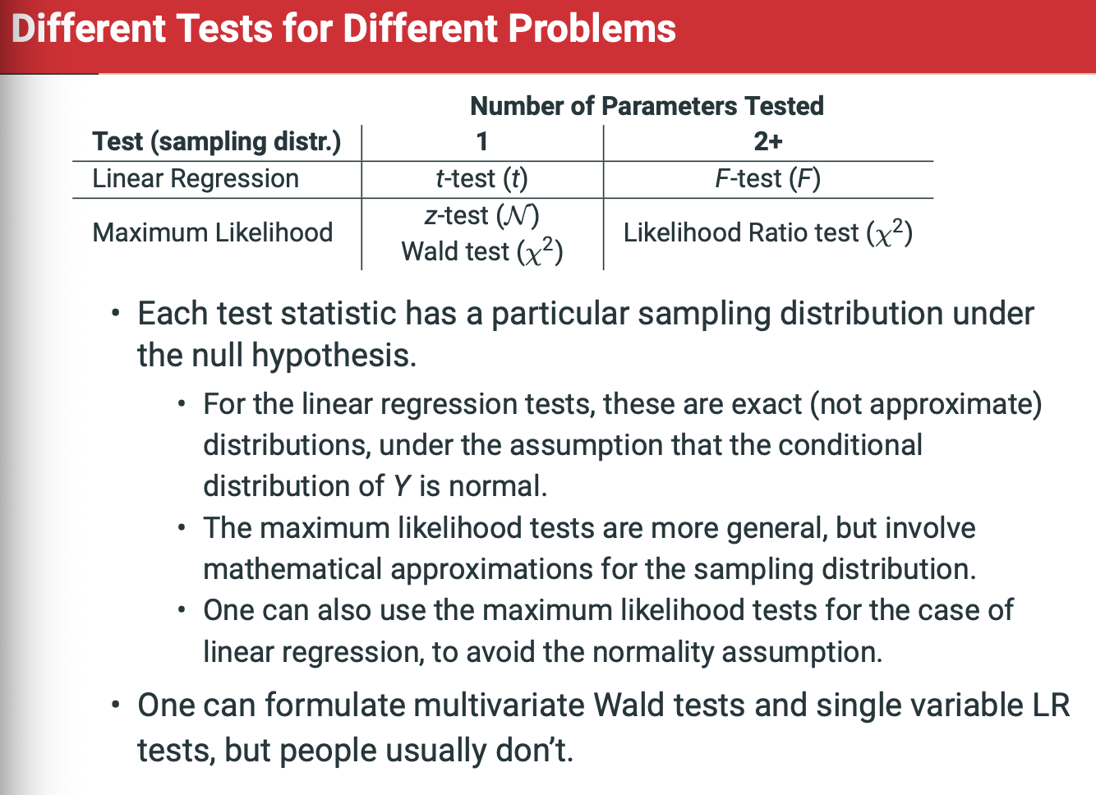

F-test is dependant on R-squared values. The reason we pivot to likelihood ratio test for MLE is that there is no R-squared value for GLM, including binary logistic model.

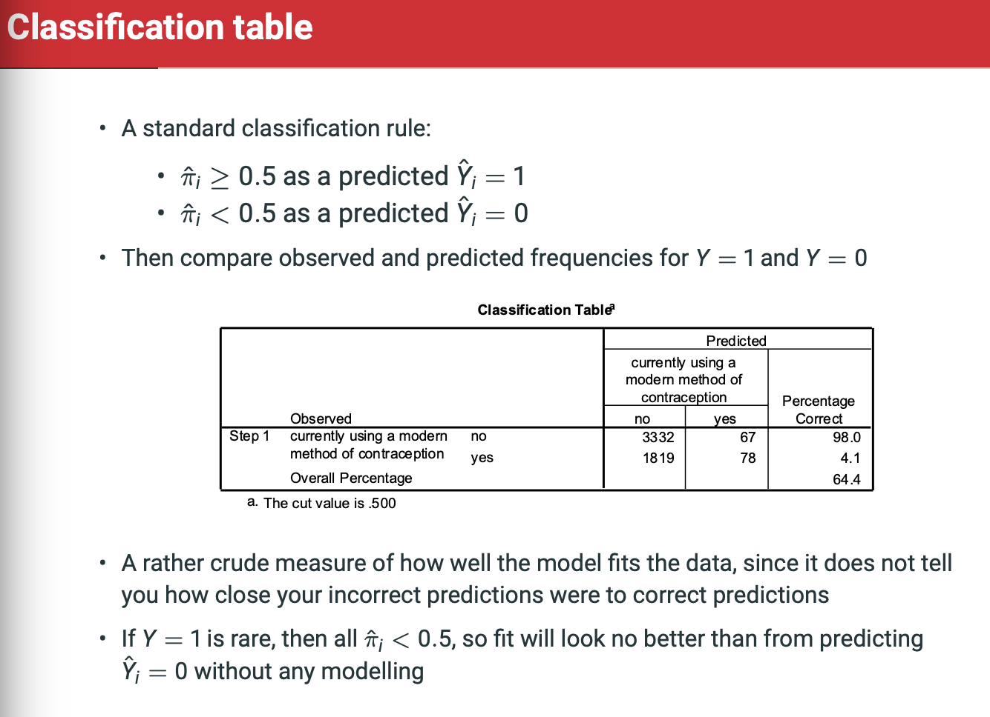

**Confusion Matrix – Crudeness of 50% classification cutoff. What is the actual difference between 49.9% and 50.1%? One gets associated with 1780 USA and the other gets associated with North Korea 2015?**

**Pseudo-R^2 Measures**

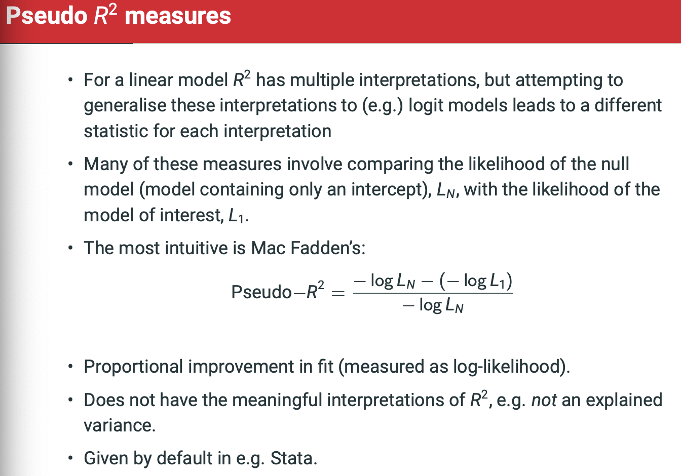

* **McFaddens measures proportional improvement in fit.**

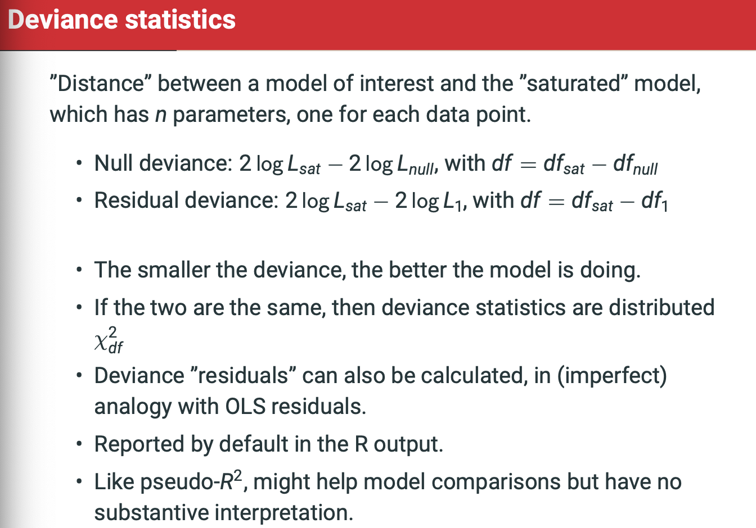

A saturated model is one that has as many parameters as it has data points. It’s the most overfitted as it just replicates the data.

Null deviance looks at likelihood of saturated vs. Null

Residual deviance looks at likelihood of saturated vs. model of interest

Df = saturated – (null or model_1, dependant on whether null or residual).

**Information Criteria**

Measures that penalizw the log-likelihood scores when we make these models more complex (increased number k of model parameters)

* AIC, BIC, TIC etc.
* Akaike’s Information Criterion is first and best known:
  + AIC = -2logL + 2k
  + Distance from the ‘true’ (unknown, represents reality) model.
  + The smaller the AIC, the better the model.

**Caution!**

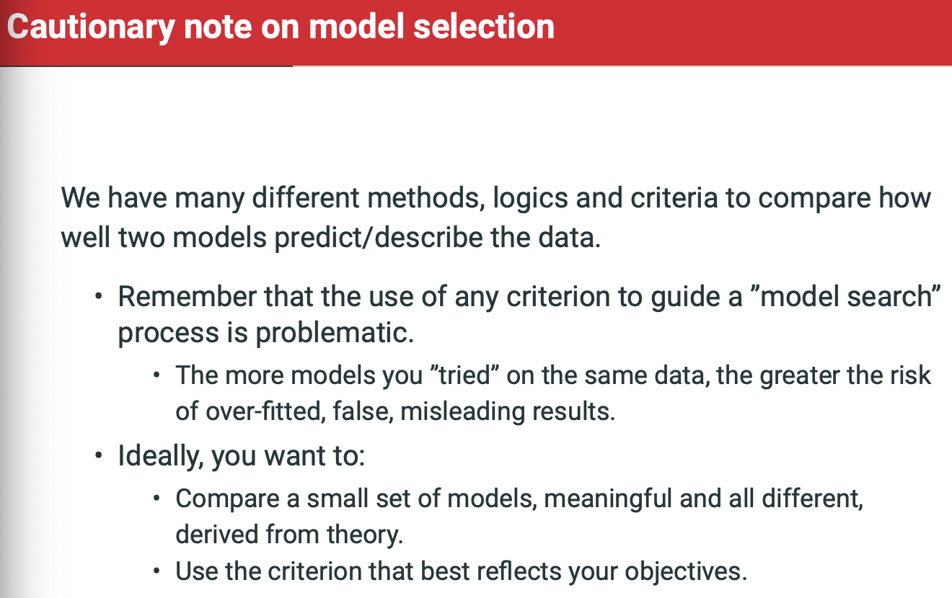

**Examples with Interactions**

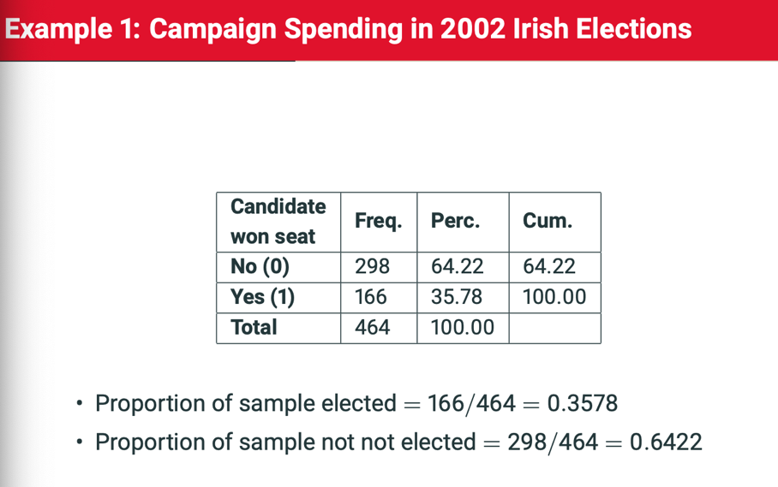

**Odds = Pi/1-Pi**

**So Odds of winning a seat are .3578/.6422 = .5571**

**& Odds of not winning a seat are .6422/.3578 = 1.7946**

**Odds and Pi:**

**If odds > 1, P(Y=1) > P(Y=O) i.e. Pi > 0.5.**

**Vice versa, and,**

**If odds = 1, P(Y = 1) = P(Y = 0), i.e., pi = 0.5**

**Adding interaction just introduces CONDITIONALITY.**

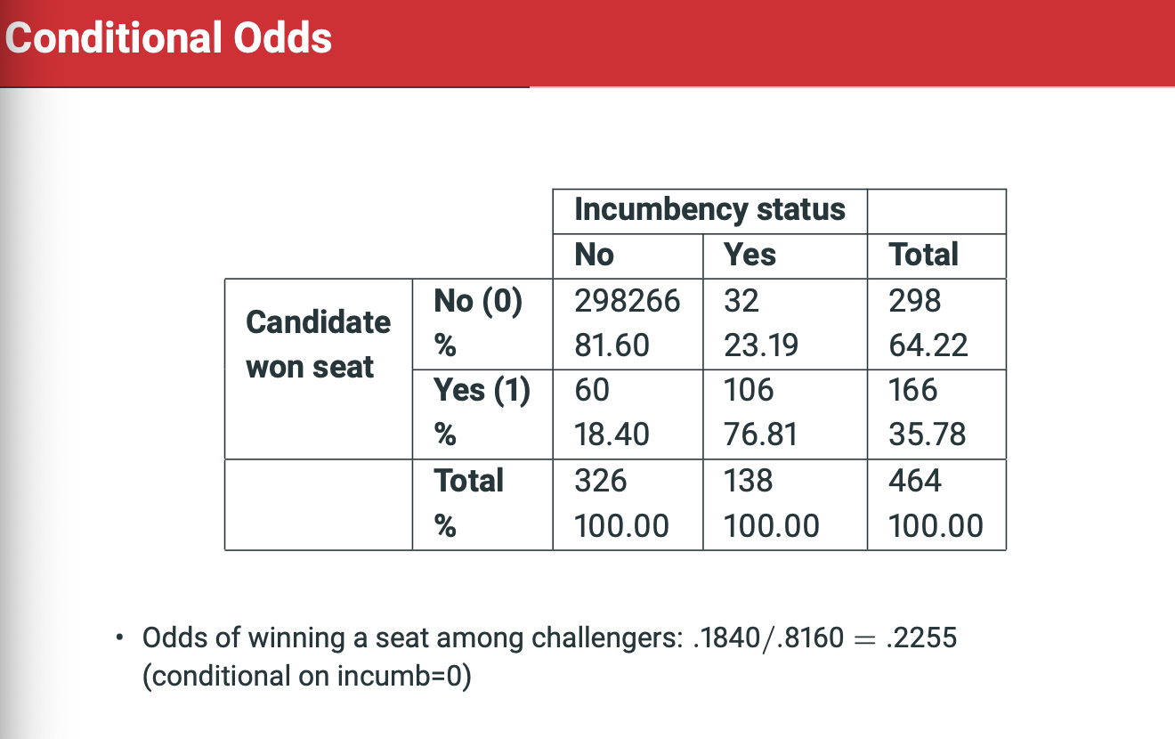

Odds of winning a seat among challengers (incumb = 0): .1840/.8160 = .2255

Odds of winning a seat among incumbents (conditional on incumb = 1): .7681/.2319 = 3.312

The odds ratio is the ratio of the odds of winning a seat for incumbents vs. chalengers. In describes the association between incumbency and winning.

Odds for incumbents / odds for challengers = 3.312 / .2255 = 14.69

* The odds of winning for incumbenrts are 14.69 times the odds of winning for challengers
* So 1369% more likely, or 13.69% higher for incumbnets than challengers.

Odds ratio is the ratio of the odds of winning a seat for incumbents v. challengers. It describes the association between incumbency and winning.

Same in reverse: the odds for challengers / odds for incumbents = .2255/3.312 = 0.681

* Odds for winning are for challengers are 0.0681 times the odds of winning for incumbents.

Now, add in campaign spending:

Y = won a seat (1=yes, 0=no)

X1 = incumbency (0=challenger, 1=incumbent)

X2 = spending(continuous variables, measured In euros)

X3 = SpendingXincumbent (X1 * X2, for the interaction)

Log(estimated odds of winning a seat) = alpha-hat + Beta1*X1 + Beta2*X2 + Beta3*X3

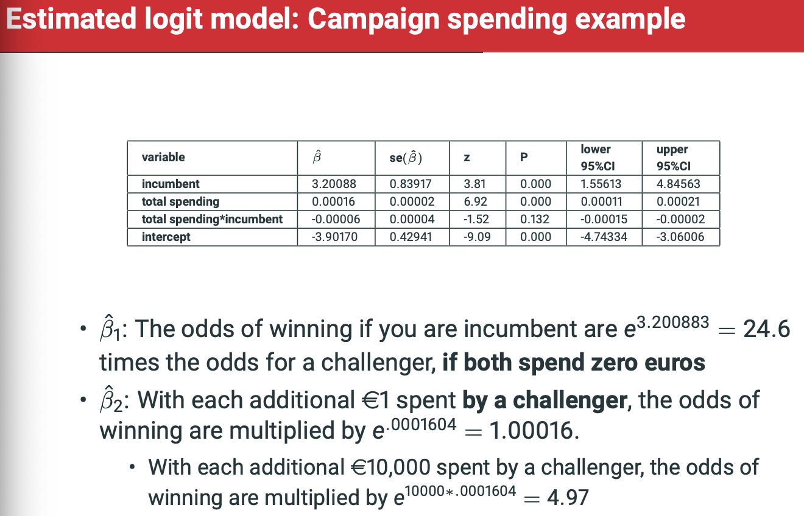

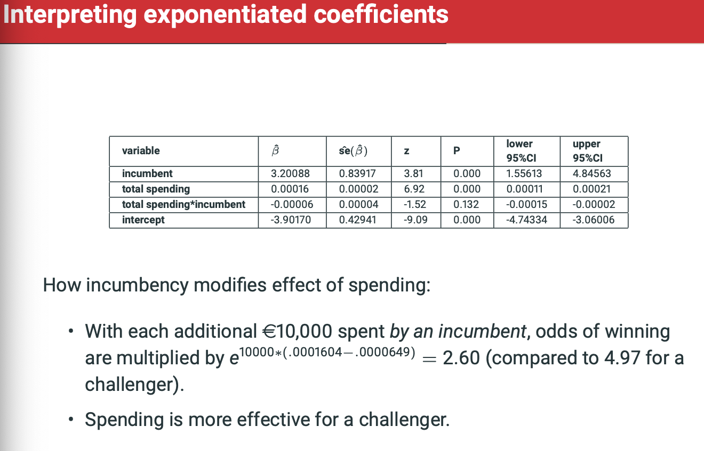

This is explained well above.

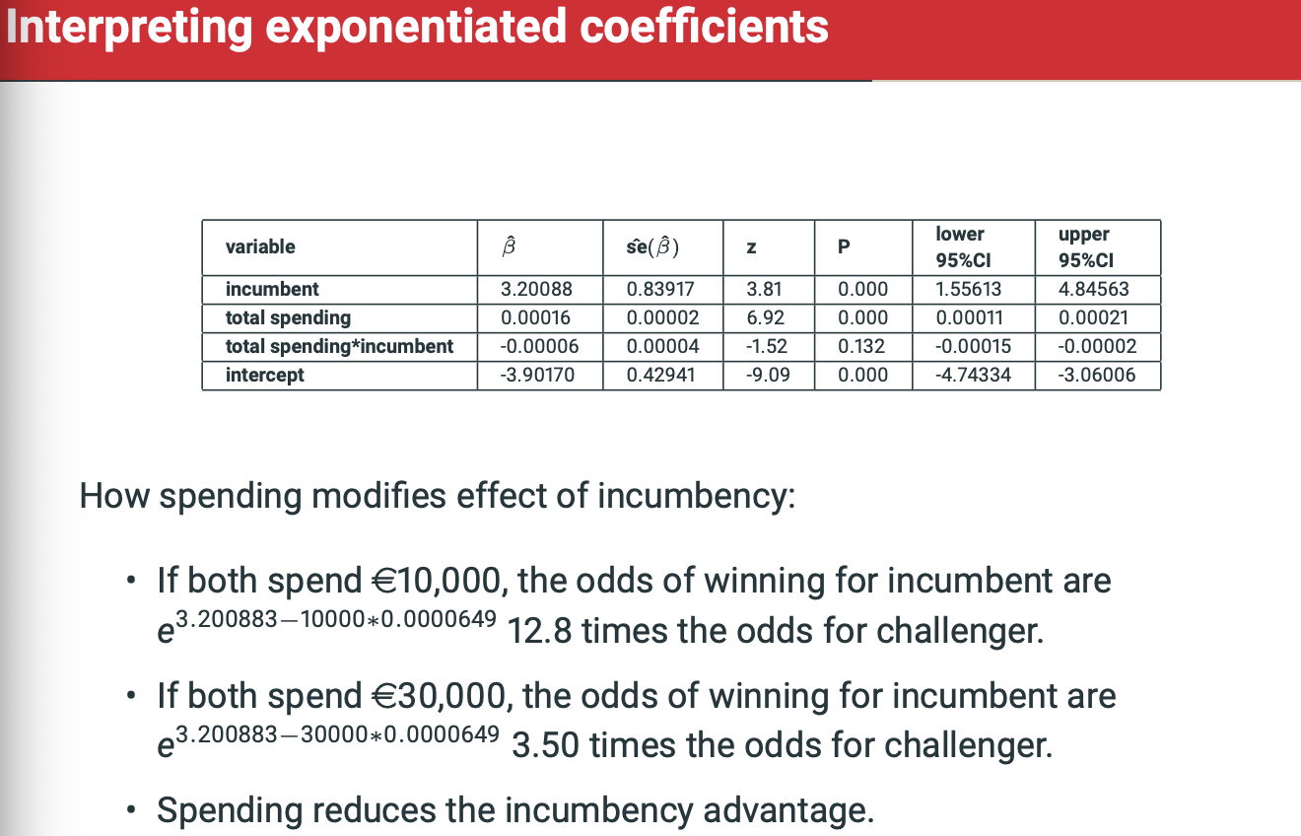

SPENDING REDUCES THE INCUMBENCY ADVANTAGE.

**Lent Term – Multinomial Logistic Regression Lecture Recap**

**Week 8 – Readings: Multinomial Logistic Regression**

A multinomial logistic model is basically a model, given the explanatory variables, for the log of the odds that the value of the response variable is in a particular category rather than in the reference category.

Suppose we have data on n sets of observations (Yi , X1i , . . . , Xki), i = 1, . . . , n, where Y is a response variable with C categories, and X1, . . . , Xk are explanatory variables. The multinomial logistic model is defined by the following assumptions:

1. Observations Yi are statistically independent of each other.
2. Observations Yi are a random sample from a population where Yi has a multinomial distribution with probability parameters π (0) i , π (1) i , . . . , π (C−1) i .
3. The log odds of each non-reference category j = 1, . . . , C−1 against the reference category 0 depend on the explanatory variables through: log((pi-i-1)/(pi-i-0)) = alpha-1 + Beta1*X1 ….

**Interpretation**

**Probabilities of the Response Categories**

Multinomial logistic model is defined as log(pi-j/pi-0) = L(j) where:

L(j) = alpha-j + beta-1-j*X1 + Beta-k-j*X-k

Thus, probabilities of the categories j = 1 is:

Pi-j = P(Y = j) = exp(L-j)/1+exp(L-1) +… + exp(L-C-minus-1)

An the probability of the reference category 0 as:

Pi-0 = P(Y = 0) = 1/1+exp(L-1) + … + exp(L-C-minus-1)

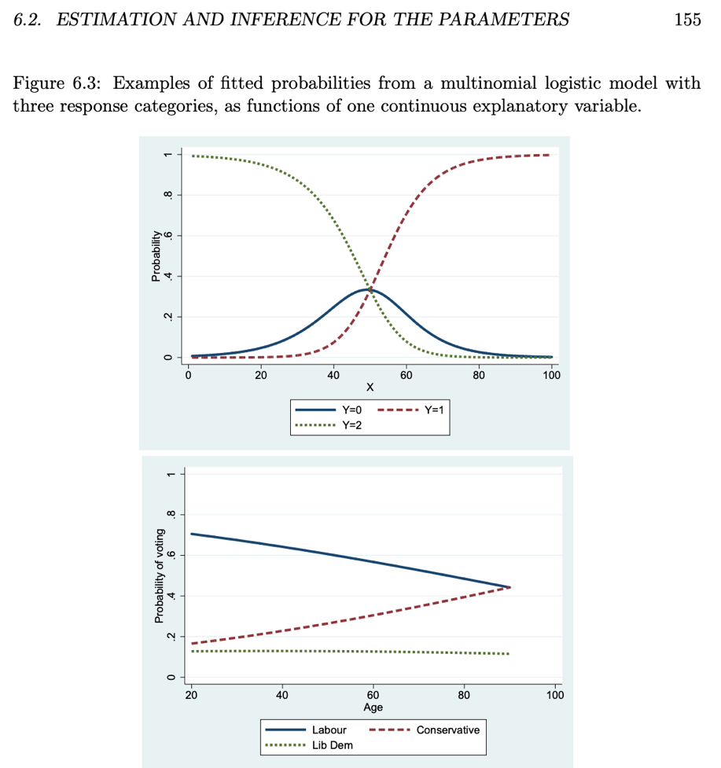

**Estimation and Inference for the Parameters**

As for binary logistic models (c.f. Section 5.2.6), the parameters of a multinomial logistic model are estimated using the method of Maximum Likelihood Estimation. The calculations are done with computer algorithms. This gives us maximum likelihood estimates βˆ (j) l of the regression coefficients, and estimated standard errors ˆse(βˆ (j) l ) of them.

Confidence intervals for individual coefficients and odds ratios are also calculated the same way as for binary logistic models (c.f. Section 5.4.2). 1.96*Standard error is included in exp() when calculating confidence intervals.

**Model Selection**

The reason why we do not in practice pay much attention to significance tests of individual coefficients in multinomial logistic models is that these tests cannot easily be used to aid the selection of explanatory variables. In the example above we concluded that βˆ (Cons) Age was significantly different from 0, while βˆ (Lib) Age was not. This suggests that the explanatory variable age might be omitted from the model for the log odds of Lib vs. Lab, but not from the model for Cons vs. Lab. In practice, however, this is rarely done: as noted in Section 6.1.2, we usually consider only multinomial logistic models where all the models for the different log odds include the same explanatory variables.

The hypothesis regarding age which we are really interested in is whether it has any effect on voting at all, after controlling for other explanatory variables. That hypothesis is not the same as either H0 : β (Cons) Age = 0 or H0 : β (Lib) Age = 0 individually, but

H0 : β (Cons) Age = β (Lib) Age = 0.

When (6.16) is true, age affects neither the odds of voting Cons rather than Lab, nor the odds of Lib vs. Lab; furthermore, these together also imply that age has no effect on the odds of Cons vs. Lib either. The hypothesis that age has no effect on voting is thus the hypothesis that both coefficients of age in the model are 0 at once. This can also be seen by considering the formulas (6.11) and (6.12) for the response probabilities. When (6.16) is true, none of the linear predictors L (j) contain anything involving age, so the probabilities π (j) do not depend on age either.

Hypotheses of main interest in multinomial logistic models are thus inevitably of the form of (6.16) and (6.17), where several regression coefficients are set to zero at once. In Section 5.4.3, we described how the likelihood ratio (LR) can be used to test such hypotheses for binary logistic model. Exactly the same test is used again here. Suppose that the null hypothesis H0 claims that all the coefficients corresponding to a particular explanatory variable Xl (or possibly several of them, as in the case of several related dummy variables) are 0. The test is carried out as follows:

1. Fit the multinomial logistic model under the null hypothesis, i.e. a model which omits the explanatory variable Xl . Record the log likelihood value log L1 for this model (the restricted model).
2. Fit the multinomial logistic model which includes Xl , and record the log likelihood value log L2 for this model (the full model).
3. The LR test statistic, here denoted L 2 , for testing H0 is: L^2 = −2 log L1 − (−2 log L2).
4. The P-value of the test is obtained by referring L 2 to its approximate sampling distribution, which is a χ 2 distribution with degrees of freedom df equal to the number of coefficients set to 0 by the null hypothesis. For example, if H0 concerns a single continuous explanatory variable, df = C−1. If it refers to the coefficients of a set of K related dummy variables, df = K(C − 1).

As an example, consider a model for voting where we include all the eight explanatory variables listed on page 143. Suppose we want to test whether age has an effect on voting, after we control for the other seven variables. This is done as follows:

1. Fit a model without age but including the other explanatory variables. For this, −2 times the log likelihood is −2 log L1 = 2250.782.
2. Fit a model with age and the other explanatory variables included. For this, −2 log L2 = 2228.298.
3. The LR test statistic is thus L 2 = 2250.782 − 2228.298 = 22.484.
4. The degrees of freedom of the test are df = 2. This is because there are 2 coefficients of age, one for the model for the log odds of voting Cons vs. Lab, and one for Lib vs. Lab. The P-value for L 2 = 22.484 from a χ 2 2 distribution is P < 0.001. The null hypothesis is thus clearly rejected. Age has an effect on vote choice, even after controlling for the other explanatory variables.

Likelihood ratio tests like these are used to select which explanatory variables should be included in the model. The principles and procedures of this are the same as those discussed in Sections 4.8 and 5.4. For illustration, suppose that we start with the set of potential explanatory variables for voting in the upper part of Figure 6.4. Suppose further that we have a substantive research hypothesis about the explanatory variable (labelled brn abr in the table) which indicates whether the respondent was born outside the UK. Because this variable is the focus of our research question, it is kept in the model throughout. The other explanatory variables are regarded as control variables. We can then examine whether any of them may be omitted as not statistically significant, using the kind of a stepwise testing procedure illustrated for binary logistic models in Section 5.4.4 and computer class 7.

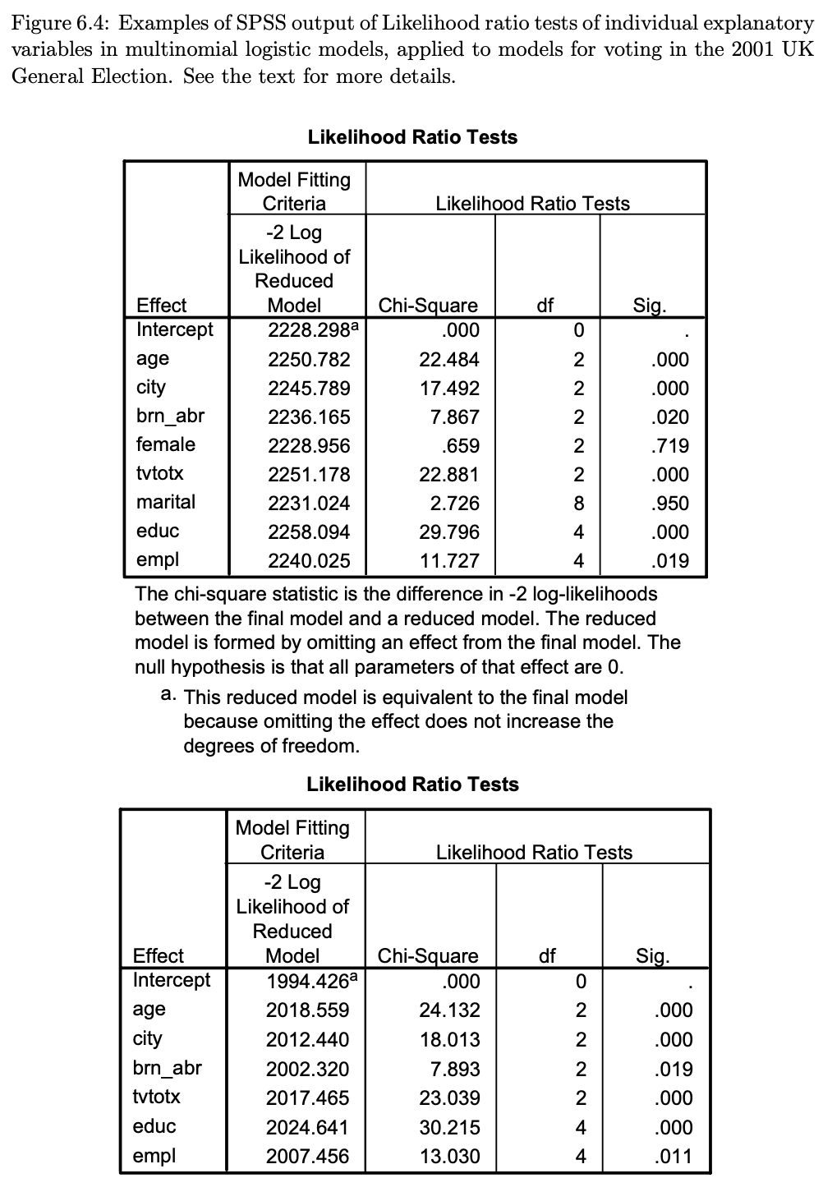

The upper table of Figure 6.4 shows that either sex (the dummy variable female) or marital status may be removed from the model if the other seven explanatory variables are included. Further tests (not shown here) show that the other one of these two is not significant even after the other one has been omitted, so both sex and marital status can be removed from the model. After that, all of the remaining six explanatory variables are significant at the 5% level of significance, as shown by the output in the lower part of Figure 6.4. In particular, the dummy variable for having been born outside the UK is statistically significant (P = 0.019), indicating that this variable is associated with vote choice even after controlling for age, domicile, education, employment status and TV viewing habits.

Standard Stata or SPSS output does not contain test results for some common types of hypotheses about the explanatory variables. One such case is the hypothesis that some but not all categories of a categorical explanatory variable have the same effect on the response variable, i.e. that those categories can be combined in the model. This can be formulated as a hypothesis about the coefficients of individual dummy variables (c.f. the discussion in Section 4.6), which can also be tested using likelihood ratio tests. Two examples from the voting model illustrate these possibilities:

1. • In the model reached above, the P-values of the Wald test statistic (6.15) for the coefficients of the dummy variable for the third category of employment status (not in paid employment) are 0.87 in the model for voting Cons rather than Lab, and 0.35 in the model for Lib vs. Lab. On the other hand, at least one of the coefficients of the second category (self-employed) is clearly significant according to this test. This suggests that there are no differences in probabilities of voting between the employed and those in paid work, but both may differ from the self-employed. The null hypothesis corresponding to this is that both coefficients of the dummy variable of the third employment category are zero. We can test it with a LR test which compares two models, both with the other five explanatory variables included: a model with dummy variables for both the self-employed and for those not in work included (the full model), and a model with only the dummy variable for the self-employed included (the reduced model). The resulting test statistic is L 2 = 1.07 with 2 degrees of freedom, and P = 0.59. We can thus combine the categories “employed” and “not in paid work”, and proceed with a model which only distinguishes these from being self-employed.
2. • In the model obtained after the previous step, the coefficients (not shown here) of the two dummy variables for the two higher education levels are clearly significantly different from 0, but quite similar to each other (relative to their standard errors) in the models for both Cons vs. Lab and Lib vs. Lab. This suggests the null hypothesis that these coefficients are equal in both submodels separately. If this is not rejected, we can combine the two higher categories of education (upper secondary and post-secondary) and contrast them together with the lowest level (lower secondary or less). The hypothesis is tested with a LR test which compares two models, both with the other five explanatory variables included: a model with separate dummy variables for the two highest categories included (the full model), and a model with only the dummy variable for the combined category included (the reduced model). The resulting test statistic is L 2 = 0.97 with 2 degrees of freedom, and P = 0.62. We can thus combine the two higher categories, and proceed with a model with a dichotomous education variable.

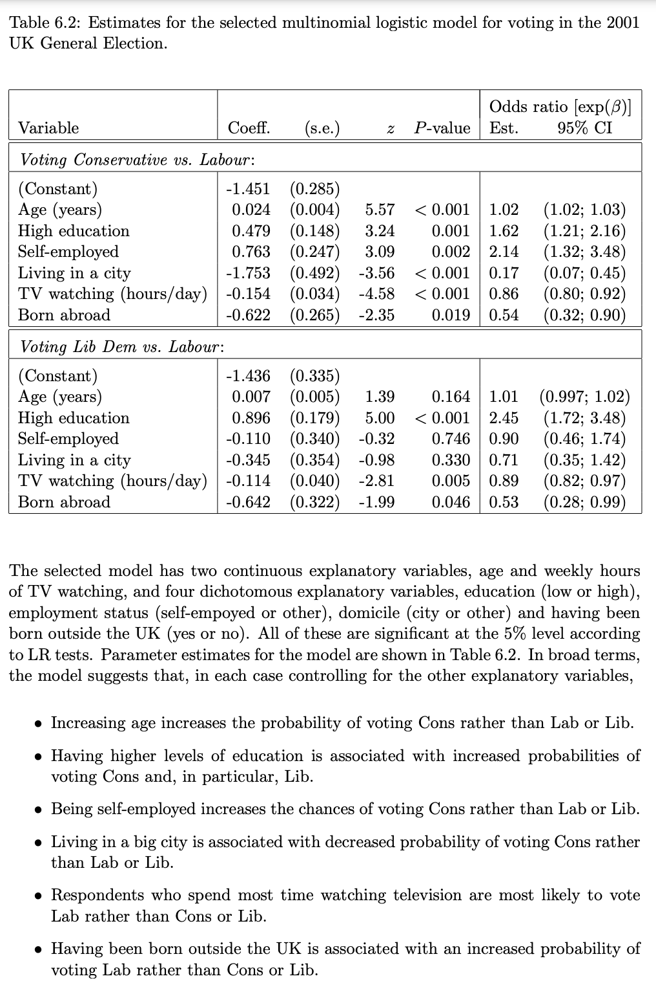

• Increasing age increases the probability of voting Cons rather than Lab or Lib.

• Having higher levels of education is associated with increased probabilities of voting Cons and, in particular, Lib.

• Being self-employed increases the chances of voting Cons rather than Lab or Lib.

• Living in a big city is associated with decreased probability of voting Cons rather than Lab or Lib.

• Respondents who spend most time watching television are most likely to vote Lab rather than Cons or Lib.

• Having been born outside the UK is associated with an increased probability of voting Lab rather than Cons or Lib.

**6.3 Interpreting the model with fitted probabilities**

The most concise way of describing a fitted multinomial logistic model is in terms of its coefficients, interpreted as odds ratios as explained in Section 6.1.3. Even this, however, is not entirely straightforward nor as intuitive as for many other regression models, largely because of the inevitably large number of coefficients involved in a multinomial model. To ease the interpretation further, it is desirable to supplement the discussion of the coefficients with other ways of presentation. Fitted response probabilities are the main method of doing this.

Fitted probabilities for different values of the response variable can be calculated from the formulas (6.11) and (6.12) given any values of the explanatory variables. We can thus use such probabilities at selected values of the explanatory variables to illustrate the implications of the model.

Fitted probabilities may be displayed in tabular or graphical form. Table 6.3 shows an example of a table of such probabilities, again for the voting model in Table 6.2. The fitted probabilities of all three parties are shown, given all 16 combinations of the four dichotomous explanatory variables in the model, in each case fixing the two continuous ones at their sample mean values (52.7 years for age, 3.25 hours for TV watching)3 . For example, the first row of the table gives the probabilities for the case (low education, self-employed, living in a city and born in the UK) considered above.

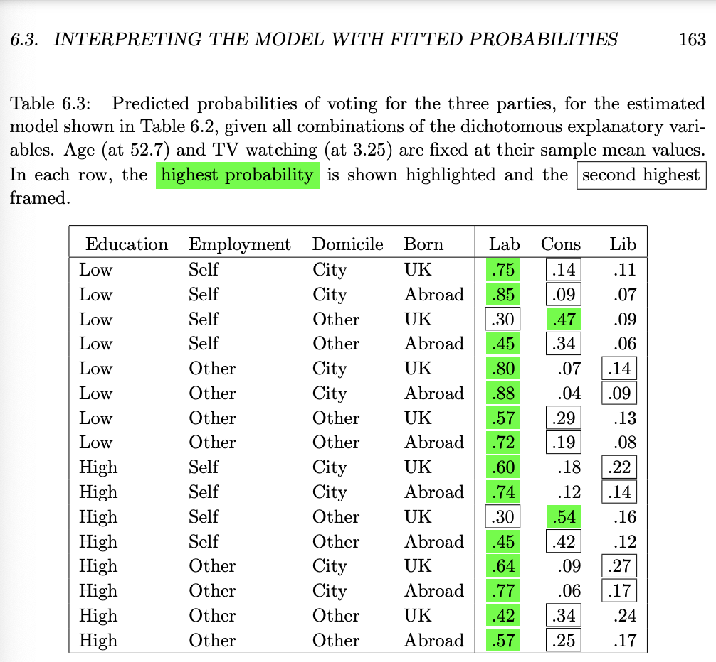

The table shows that the predicted probability is highest for Labour in all but two cases, and the second highest for the Conservative party in most cases. The cases where Liberal Democrats have the second highest probability are all ones where the respondent lives in a city. For continuous explanatory variables, we may display a table of fitted probabilities calculated at selected values, or a plot of the probabilities over an appropriate range of values of the explanatory variable. Figure 6.5 shows fitted probabilities of voting as the number of daily hours spent watching TV varies between 0 and 5, holding all the other explanatory variables at their sample mean values4 . The plot shows, in particular, the extent to which higher amounts of TV watching are associated with increased probabilities of voting Lab and decreased probabilities of voting Cons.

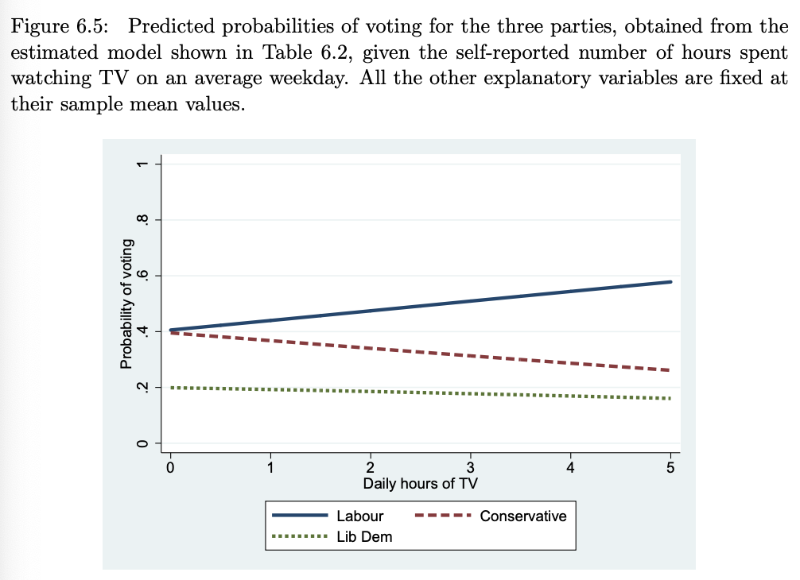

**Week 8: Lecture - Multinomial Logistic Regression**

**Topics:**

1. **Odds and Multinomial Outcomes**
   1. **Example: Vote Choices**
2. **The Multinomial Logistic Regression Model**
   1. **Interpreting coefficients**
3. **Interpreting Results** 
   1. **Fitted probabilities**
   2. **Hypothesis tests and confidence intervals**
4. **What Multinomial Regression can and cannot do**
   1. **Summarizing a complex pattern**
   2. **The independence of irrelevant alternative properties**

**Strike Action next week:**

* **ARA Lecture will go ahead on Friday at 10am.**
* **Class may not**

**Odds = prob that they did / probs that they didn’t**

**Odds-sub-k-prime(Y = 1) = P(Y = k)/P(Y = k-prime)**

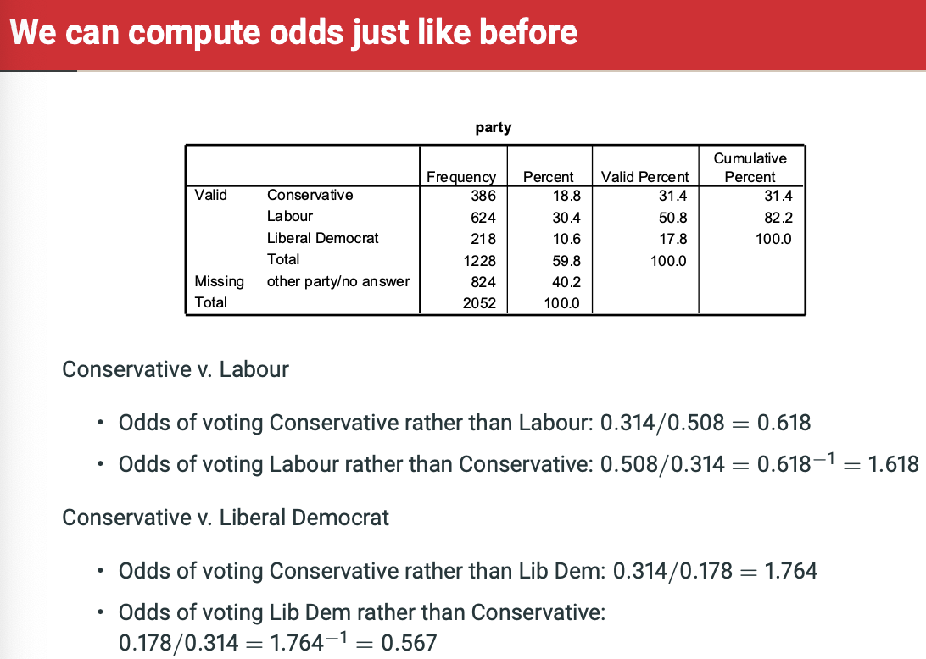

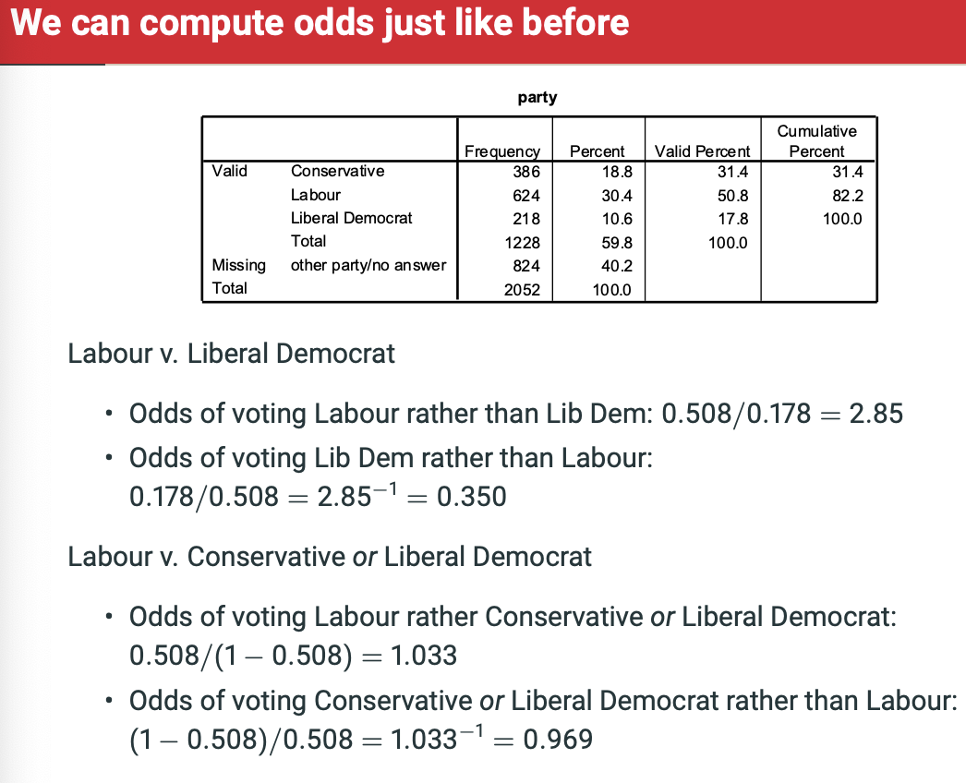

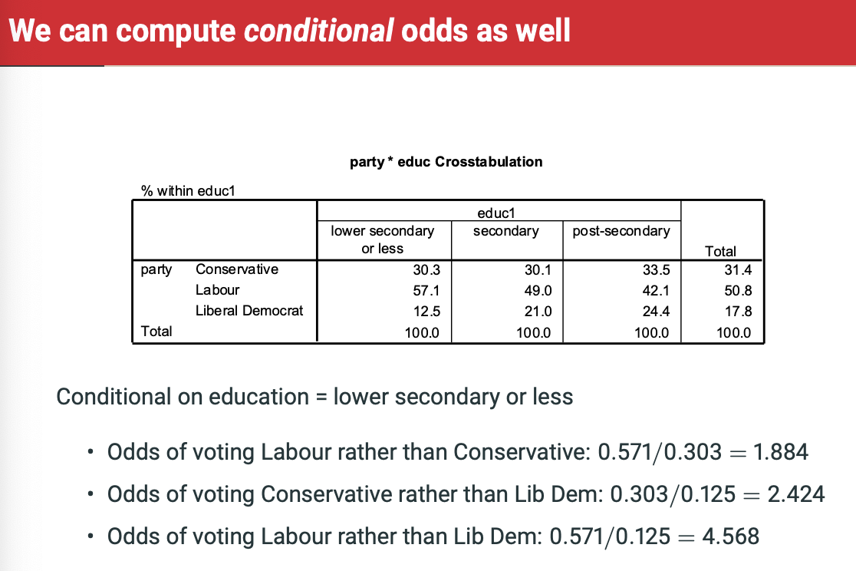

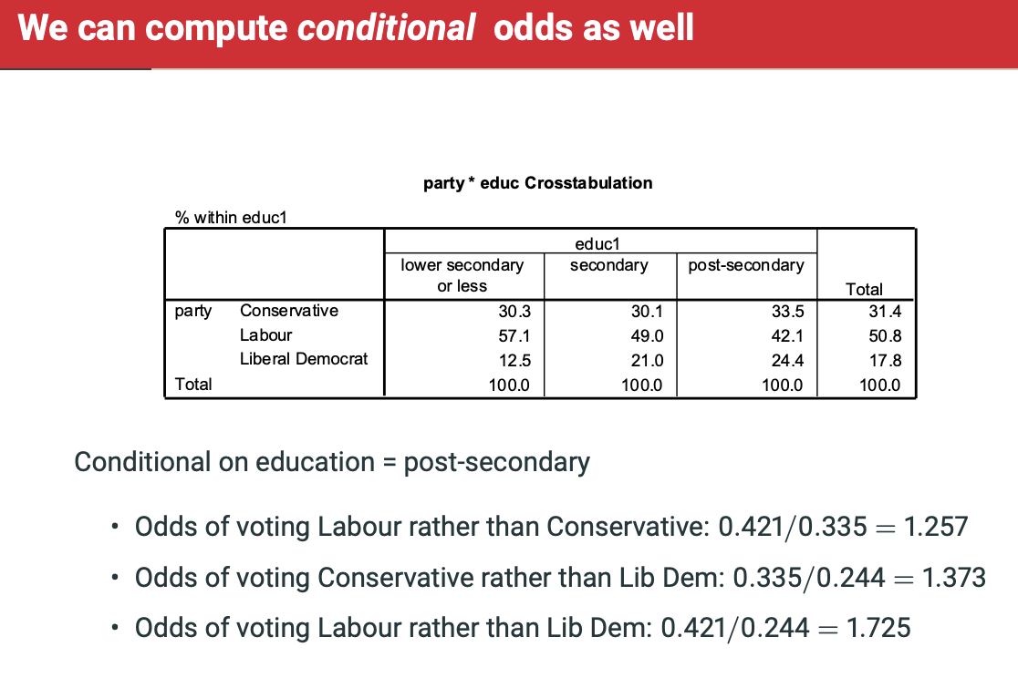

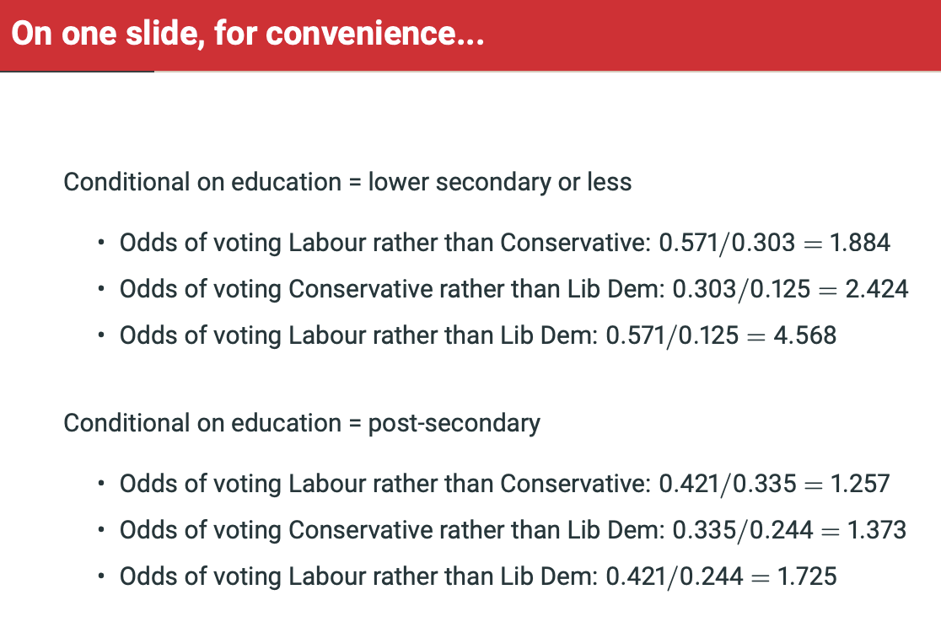

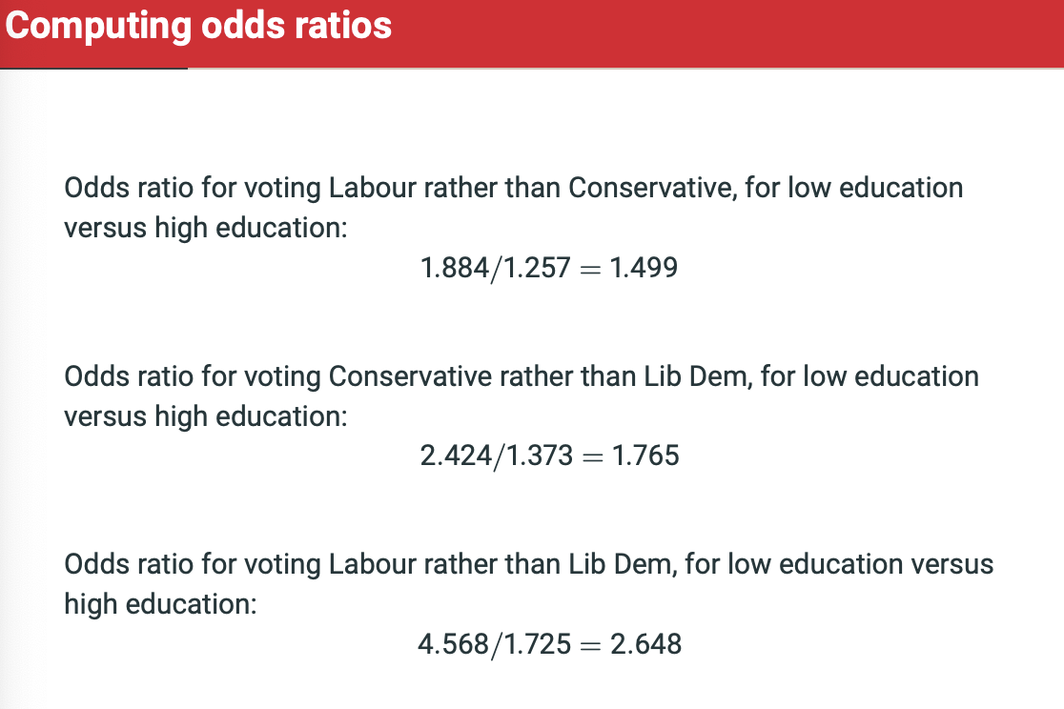

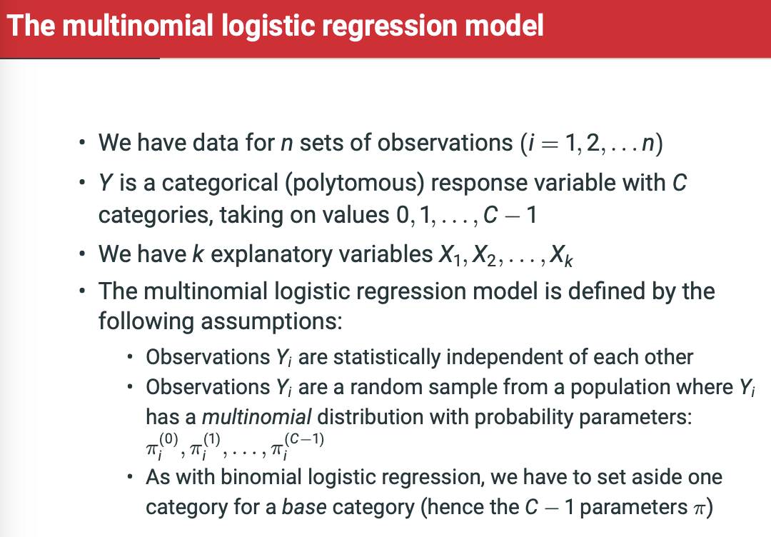

**Index categories with ‘C’, so Y is a categorical (polytomous) response variable with C categories, taking on values 0, 1, …, C-1.**

**It’s C-1 because we have a base category!**

**Pi-sub-i-0 to Pi-sub-i-C-1 are the probabilities that each of the response categories are realised.**

**Individual = i**

**Response category = j**

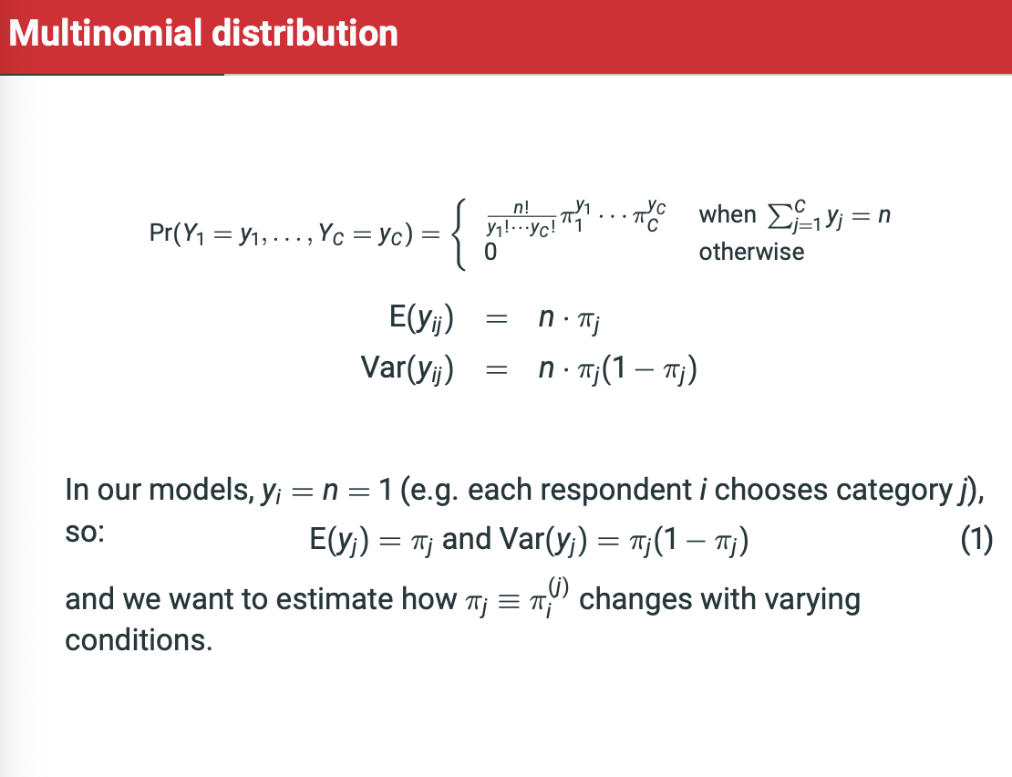

Expected value E(y-i-j) = n * pi-j

Expected number of times that we’d get any number of those things

Say we got 300 balls with 0.25 chance of pulling red, we expect 75 red balls.

The logit for each non-reference category j=1,…,C-1 against the reference category 0 depends on the values of the explanatory variables through:

Log(Pi-i-j/Pi-i-0) = alpha(j) + B1(J)*X1-I + …, + Bk(j)*Xk-i

For each j = 1,…,C-1 where alpha and coefficients are unknown population parameters.

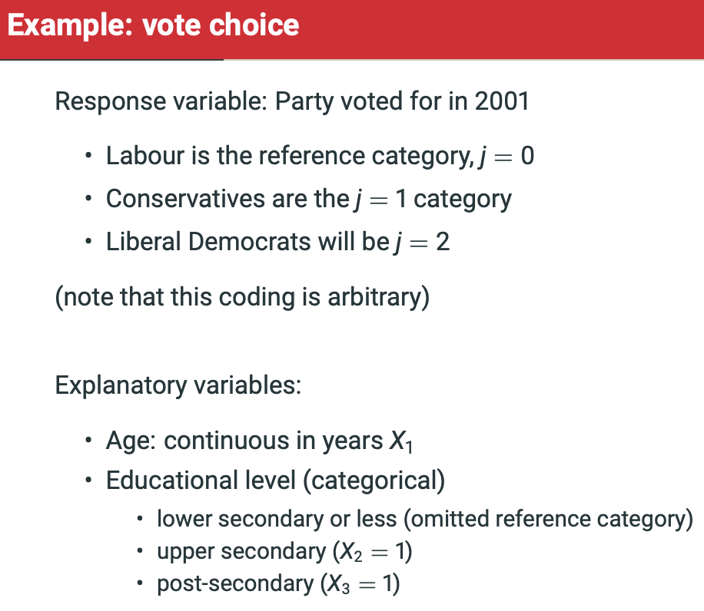

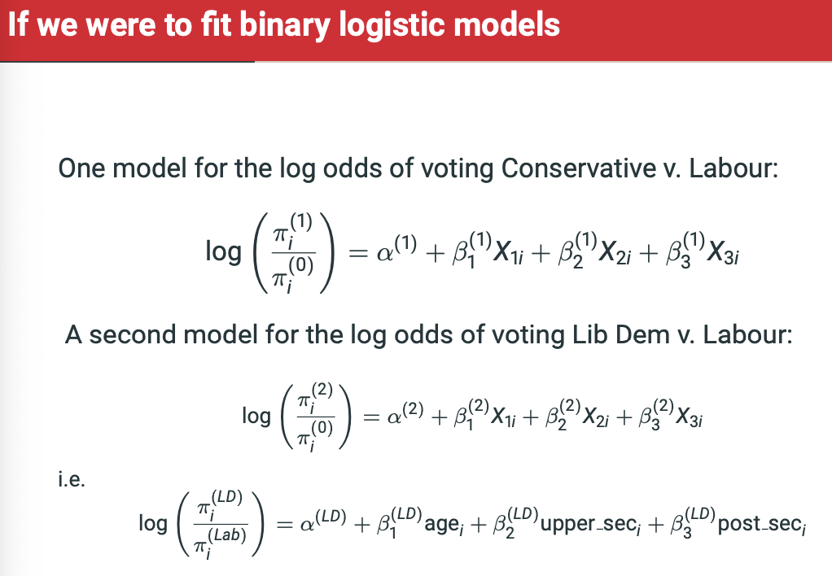

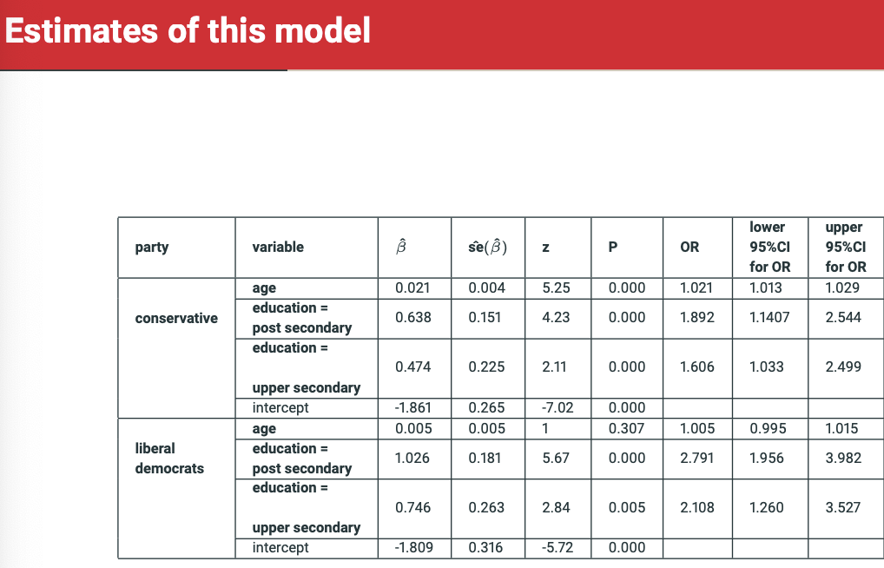

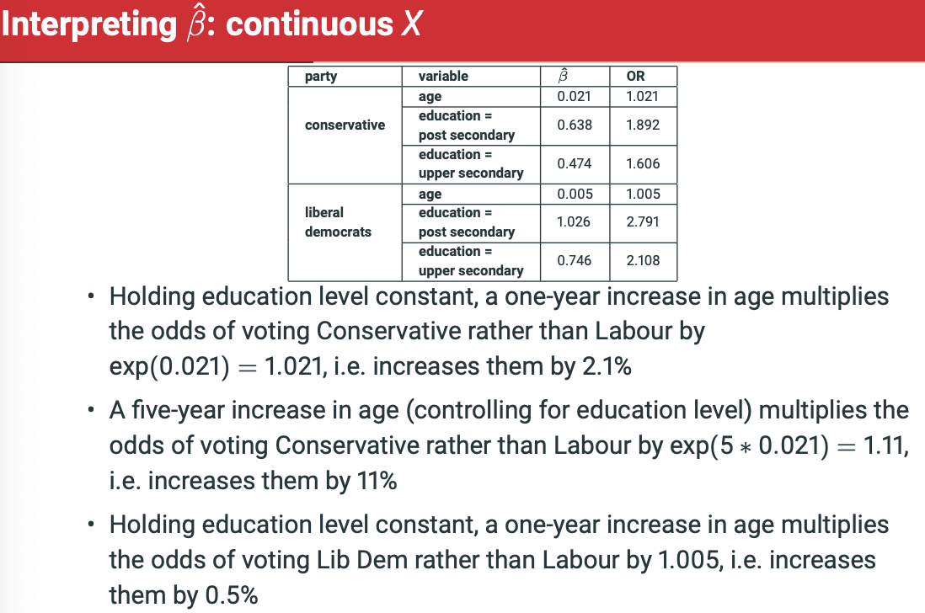

Use template response – Holding all other explanatory variables constant, the odds for someone who ‘Conditional’ of voting ‘C-1’ rather than C=0 are 1.23 times the odds for someone with ‘Conditional-reference category’

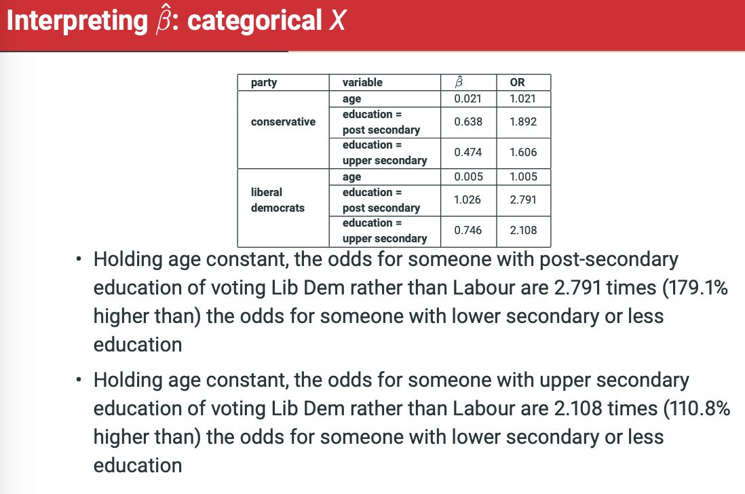

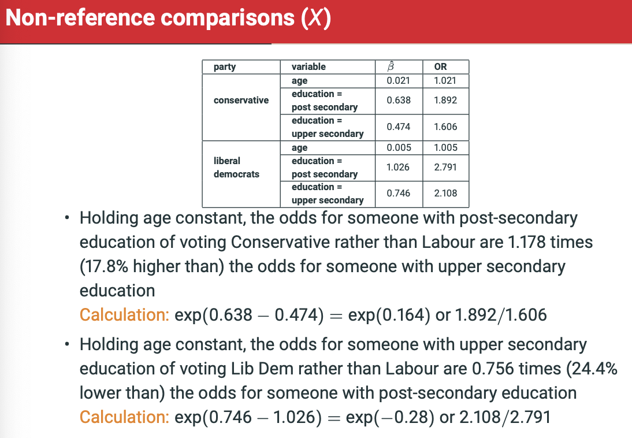

Can either do calculation within exponential calculation exp(coeff1 – coeff2) OR

Odds ratio 1 / Odds ratio 2.

**What if I want to do lib dem vs conservative??**

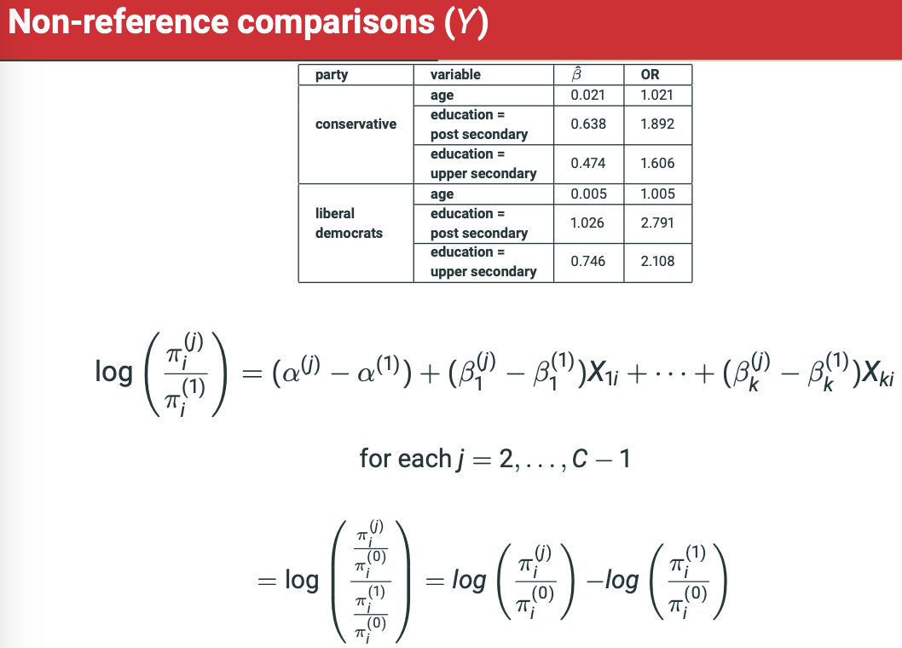

So now, I’m interested in log odds of tories vs lib dems.

1/exp(0.638-1.026) =1.47.

2.791/1.892 = 1.47

Dividing INSIDE a log is the SAME THING as minusing the log odds of first category from second.

So log(odds1/odds2) = log(odds1) – log(odds2)

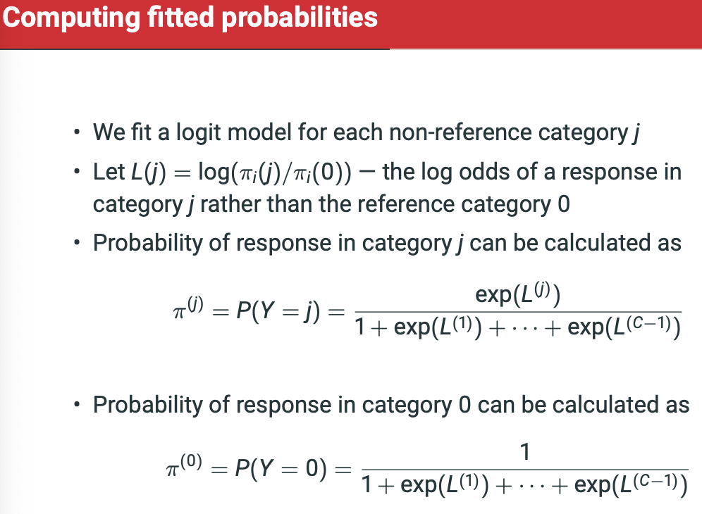

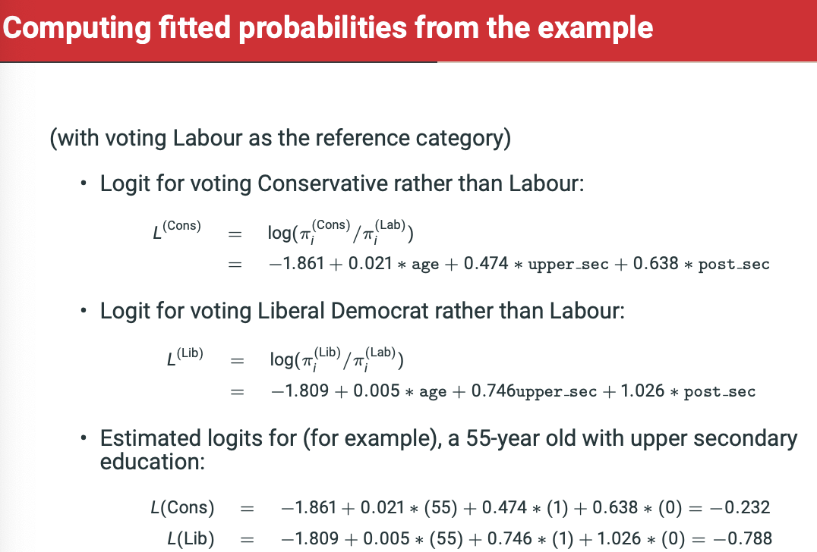

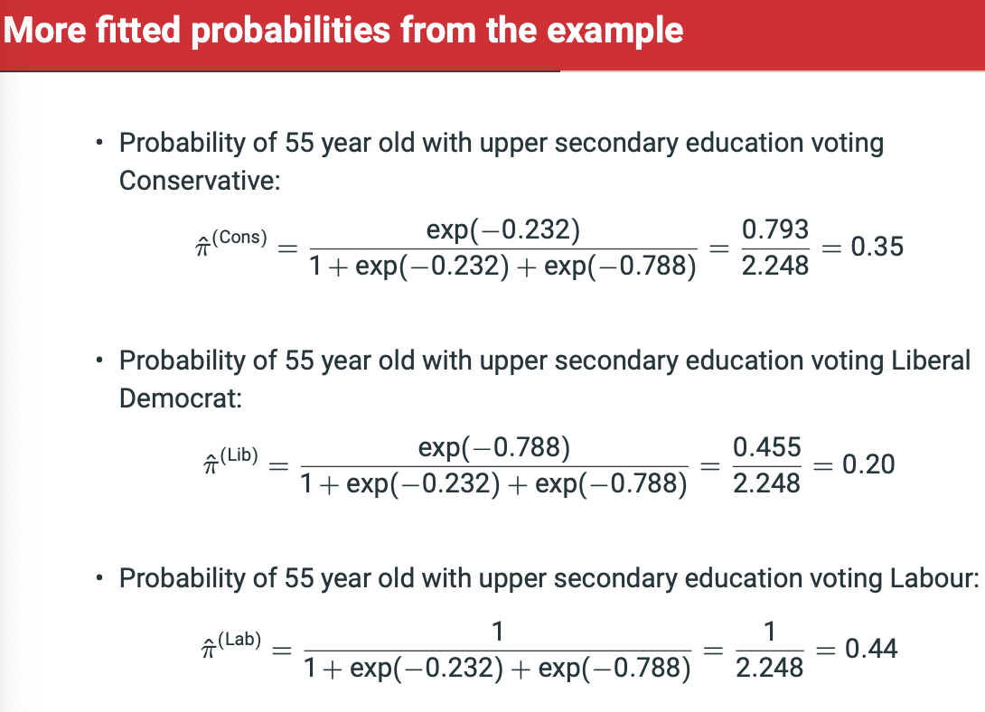

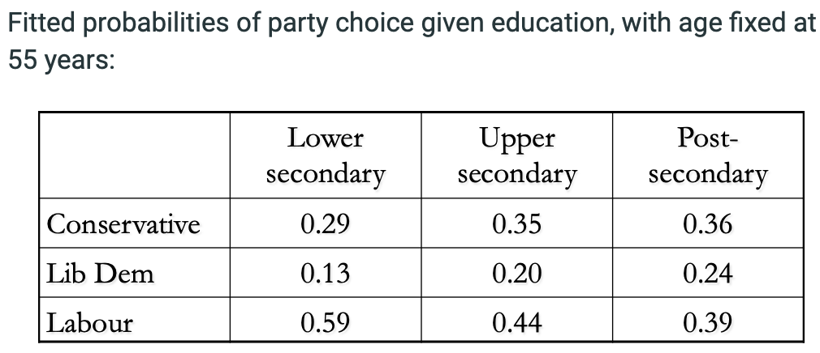

**PLOTTING FOR CONTINUOUS VARIABLE CHANGE. Change in probability of voting for each group relative to changes in age.**

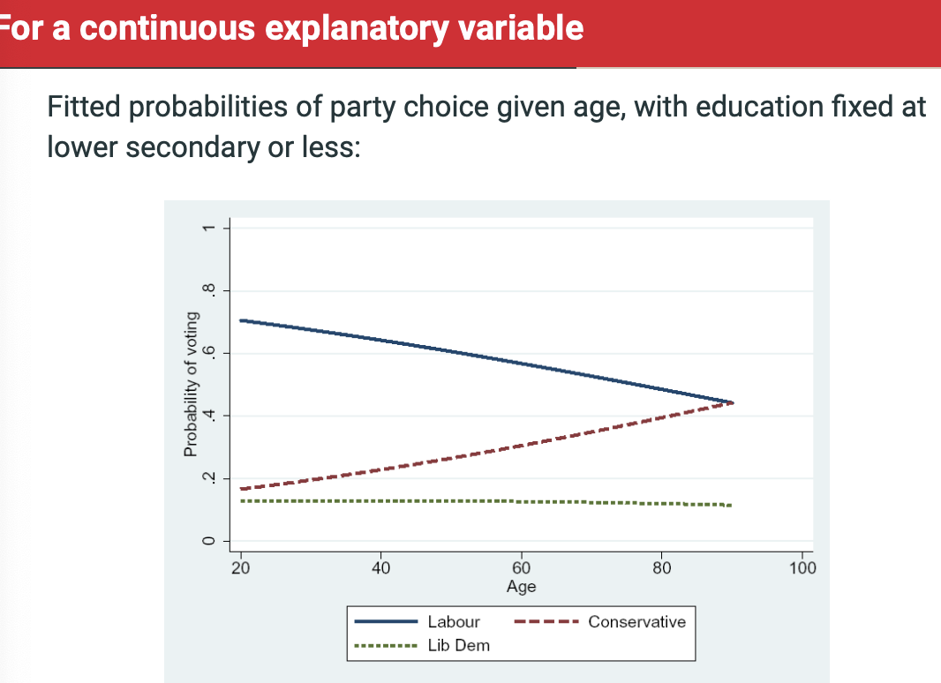

PLOTTING FOR RESPONSE CATEGORIE PROBABILITY.

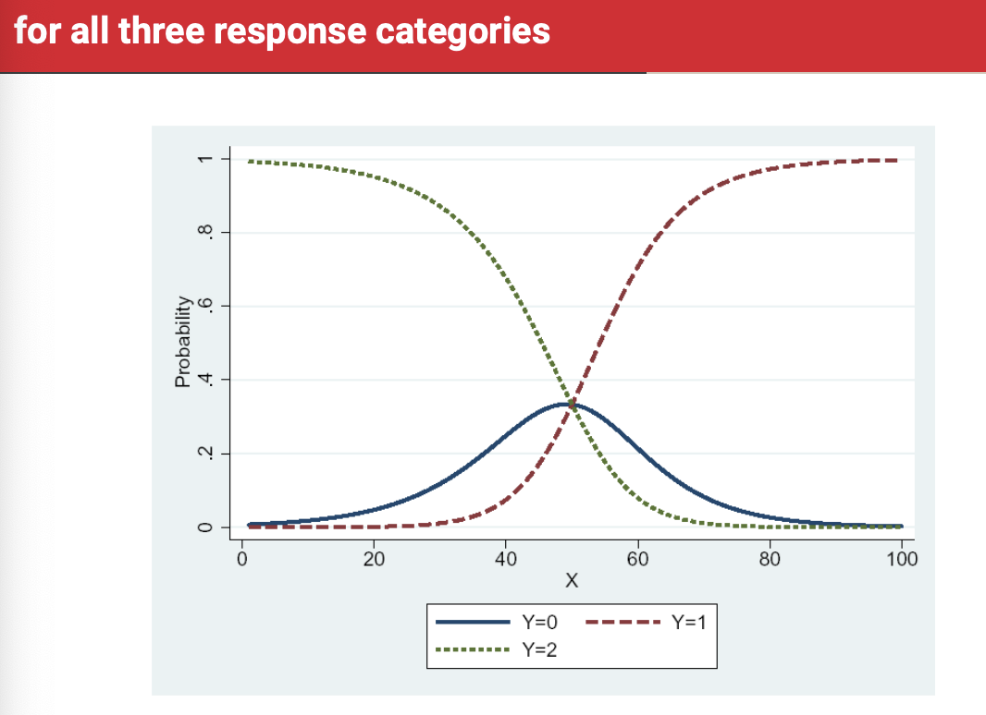

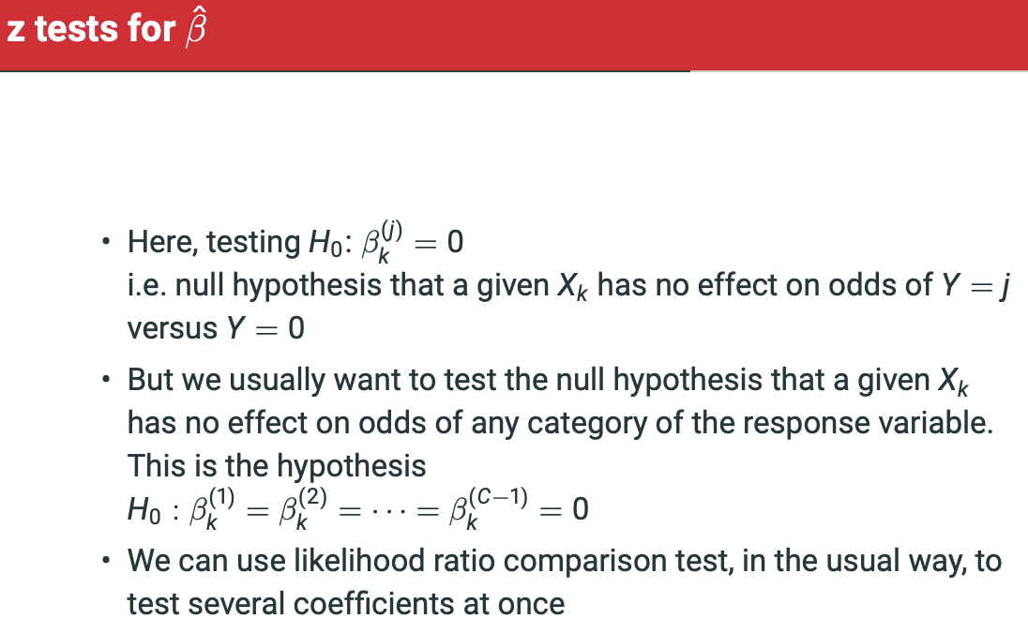

Z test is for PARTIAL ASSOCIATION. Aka. That Xk has no effect on odds of Y = j versus Y = 0.

However, we usually want to test for several coefficients at once, so we use a likelihood ratio comparison test.

We want to test whether addition of coefficients has general lack of association or whether it impacts the outcome as a whole. We compare this to a chi-squared distribution.

Likelihood Ratio Test = -2 log-likelihood-model-1 – (-2-log-likelihood-model-2-)

Null hypothesis is that model 2 is no better than simpler model 1.

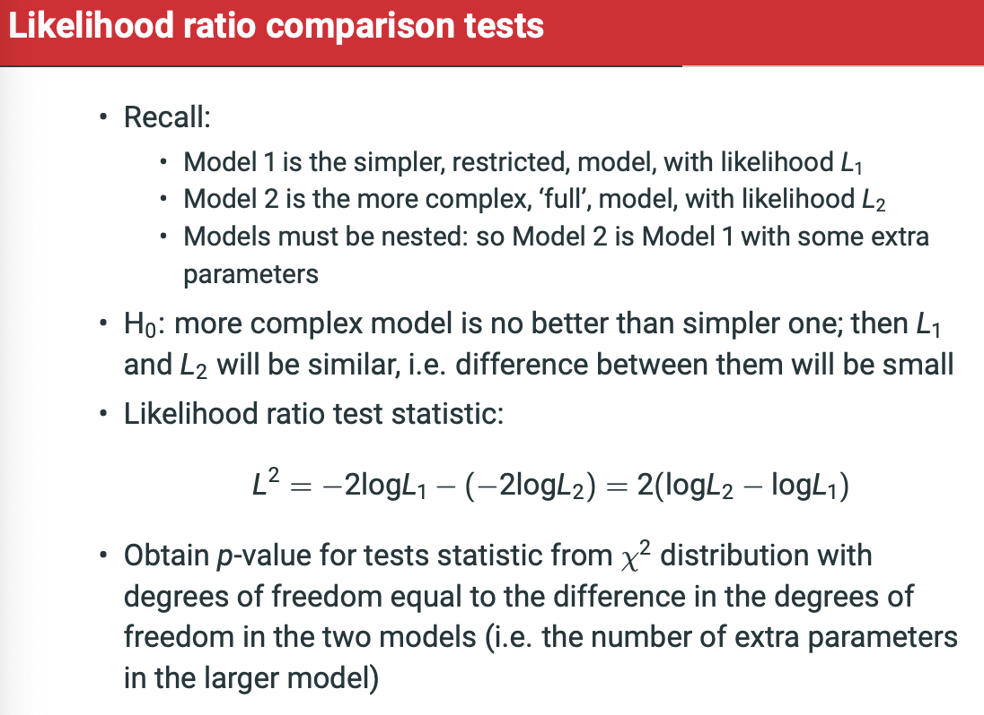

Likelihood value is the MAXIMUM probability (the peak) for each explanatory/output combination.

For age:

* -2 LL model 1, without age, = 977.718
* 02 log likelihood of model 2 including age = 951.778
* LL ratio test = 977.718-25.940
* Difference in degrees of freedom = 2 BECAUSE age has two coefficients – one for tories and one for lib dems.
* P.value for 25.94 on chi-squared distribution with 2 d.f. < 0.001
* So, we can reject the null hypothesis that age doesn’t improve the model.

For education:

* -2LL model 1, without education = 992.019
* 02LL model 2, including education = 951.778
* LL ratio test = 40.241
* Difference in degrees of freedom = 4 (2 educ * 2 parties)
* P-value for 40.241 on chi-squared distribution with 4 df < 0.001
* Reject null hypothesis – at least one of those coefficens expect to be non-zero.

Choices to make:

* Does it make sense to combine categories of the outcome or explanatory variables?
  + E.g. combining minor parties in the UK.
* Nonlinear terms
* Interaction terms

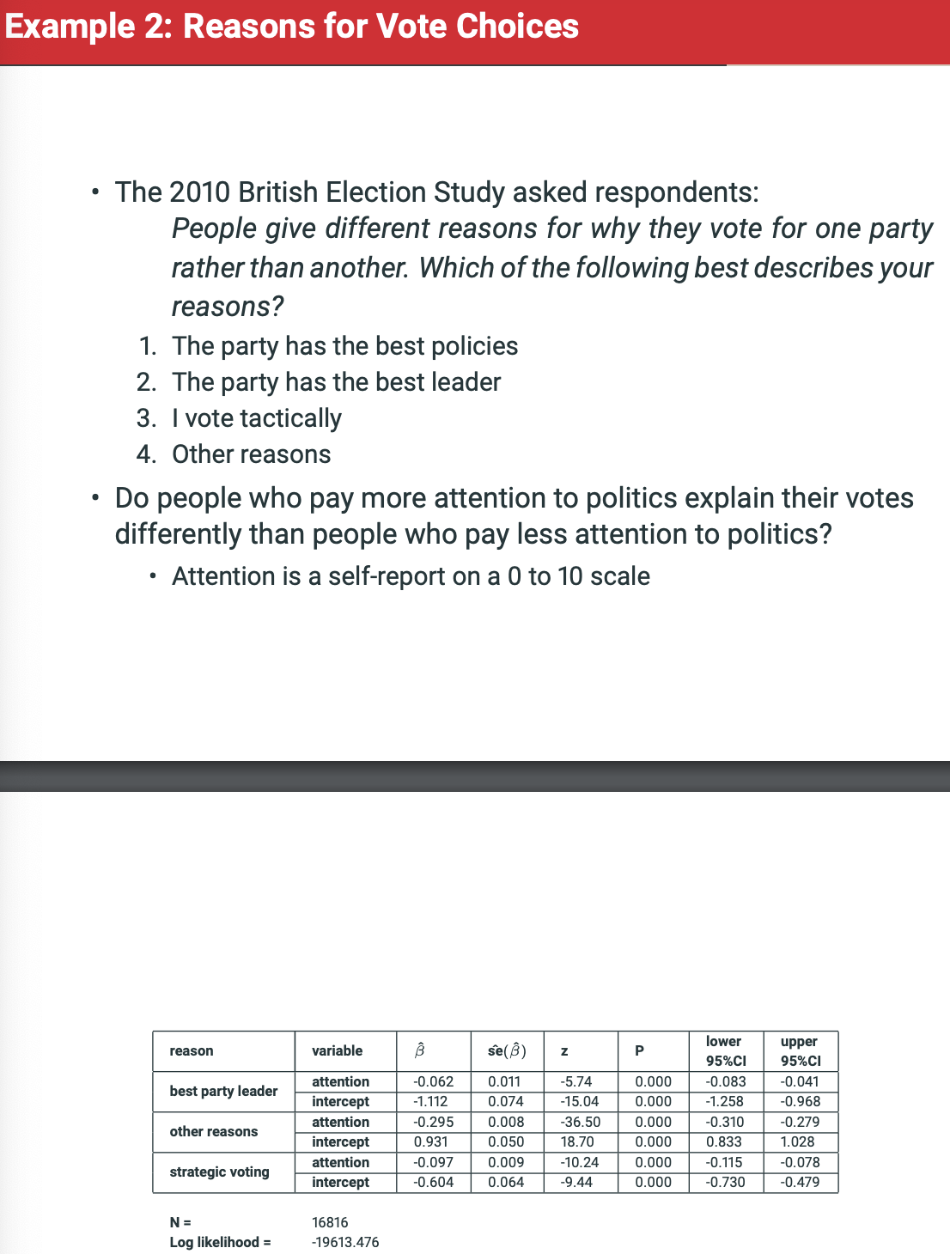

* We have dependent variable – Why did they vote for party X?
  + Reference = best policies
  + Best Leader
  + Tactically
  + Other
* We have one explanatory – attention to politics
  + Continuous from 0 to 10.

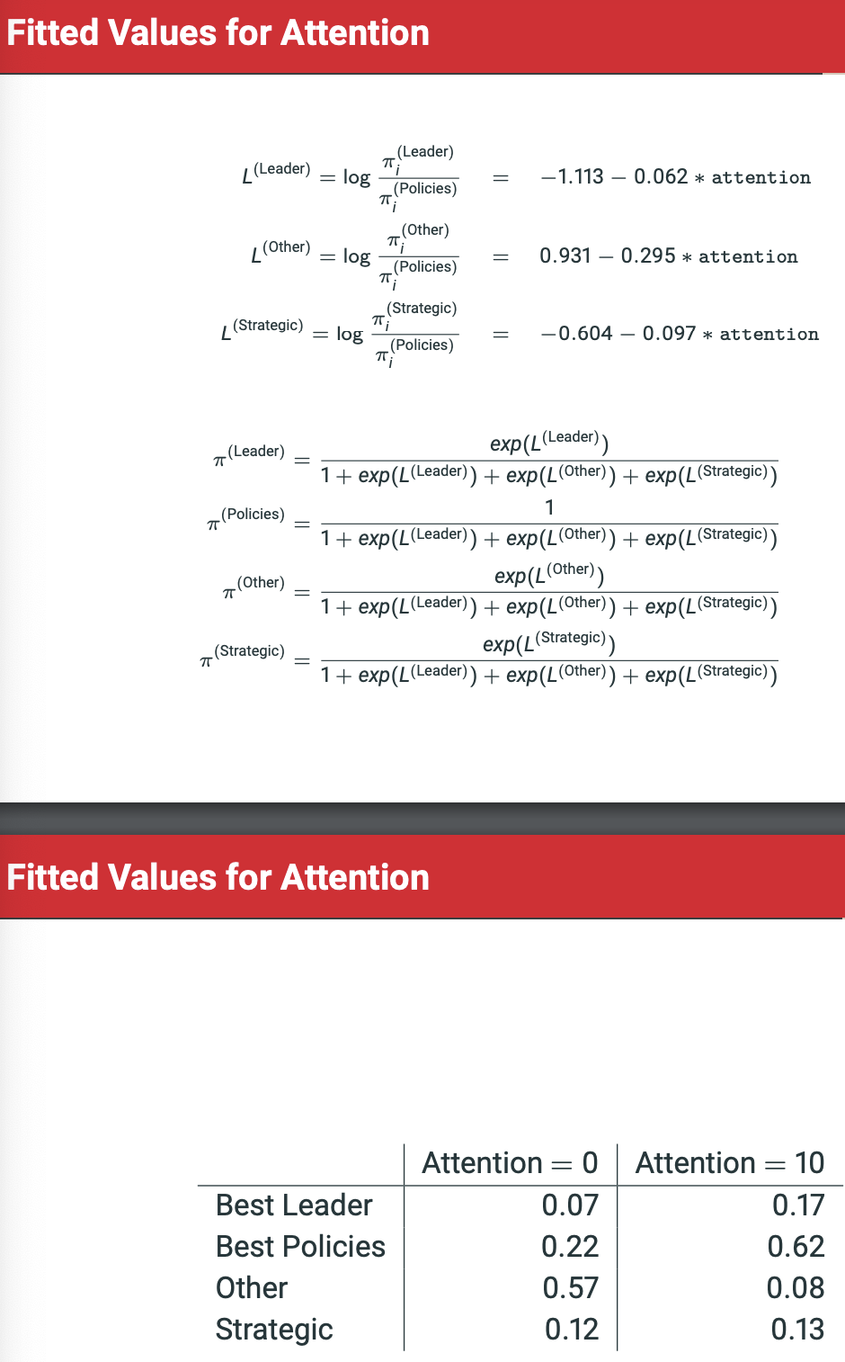

However, we might want to control for the party supported?

Certain parties supporters might pay more or less attention.

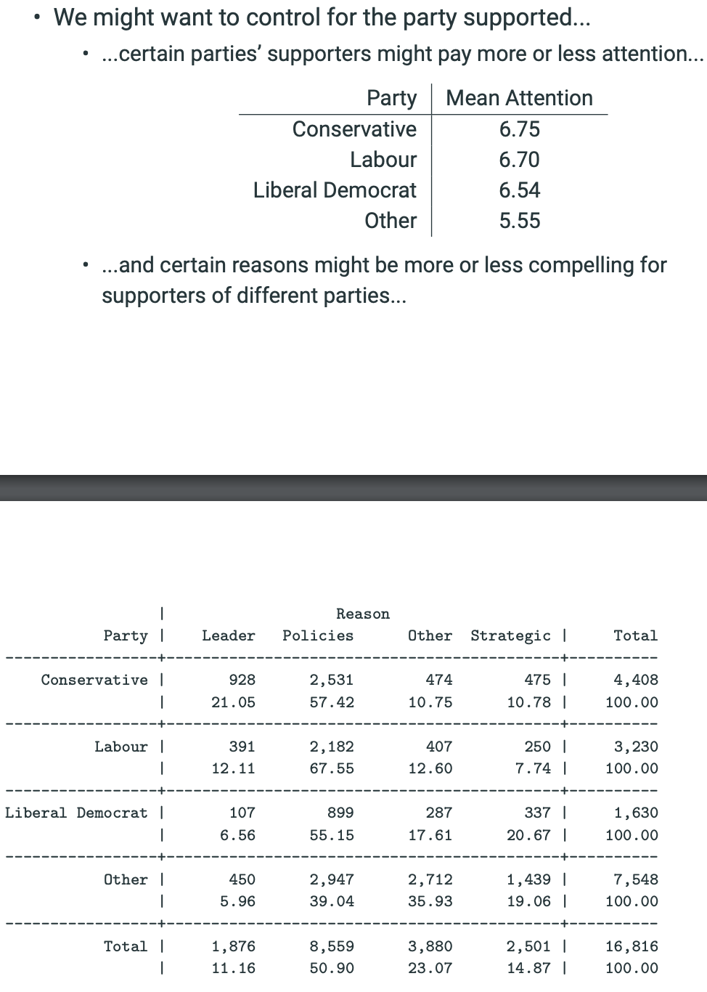

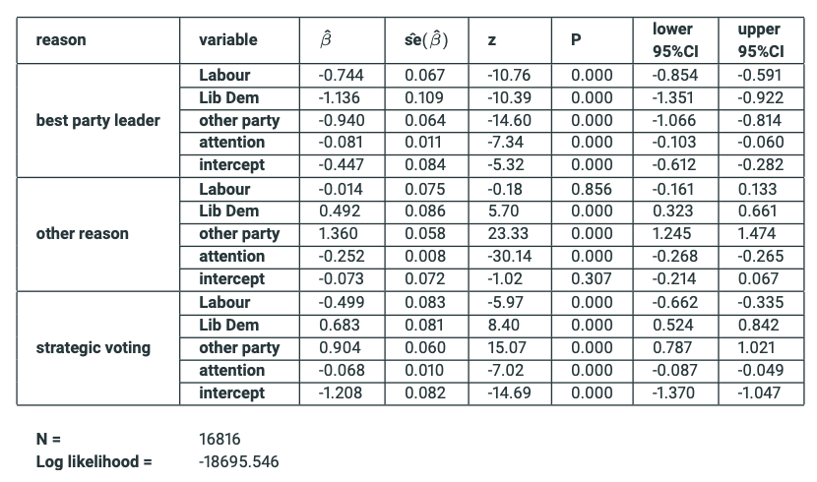

We can now look at attention score relative to reasons for voting whilst holding the party voted for as constant.

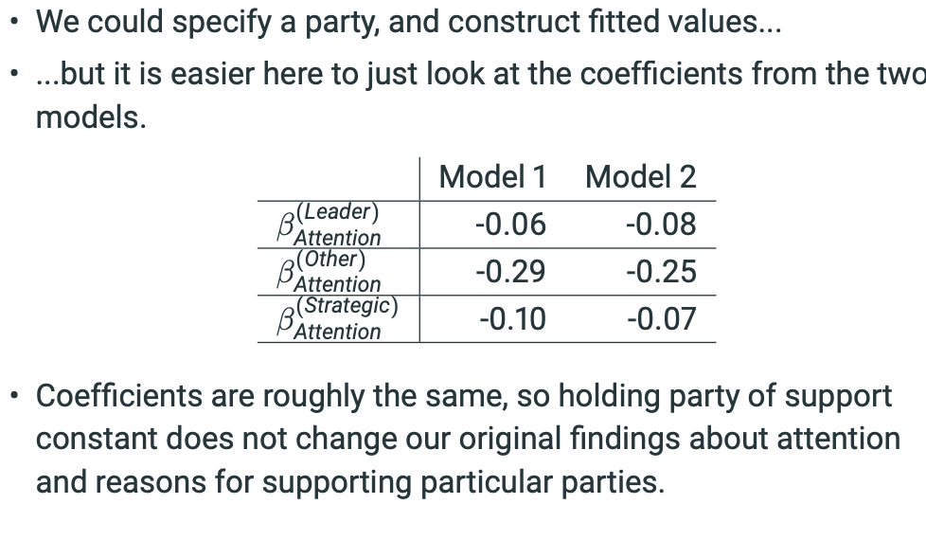

The coefficients are similar. Holding party constant doesn’t change the original findings.

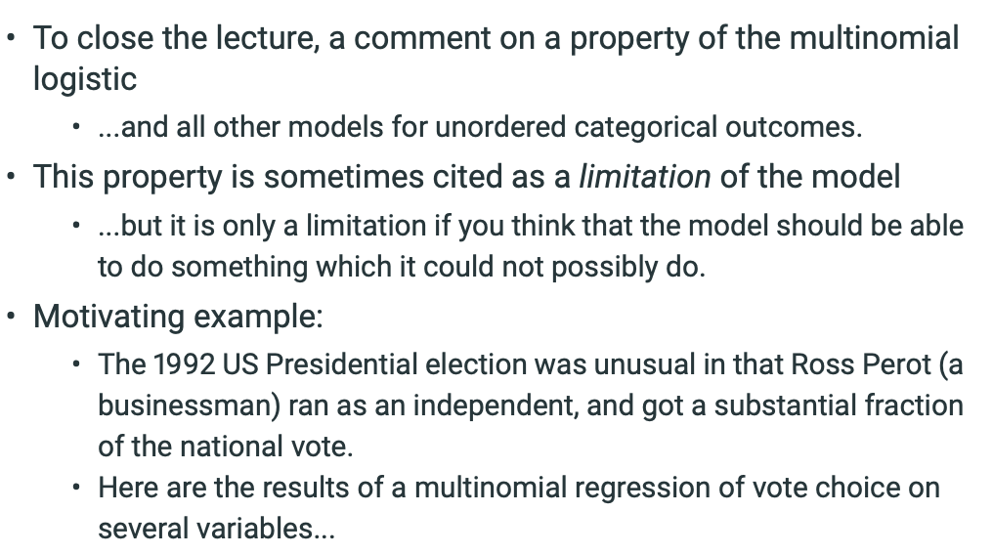

Ross Perot is running! Whats the implications on modelling?

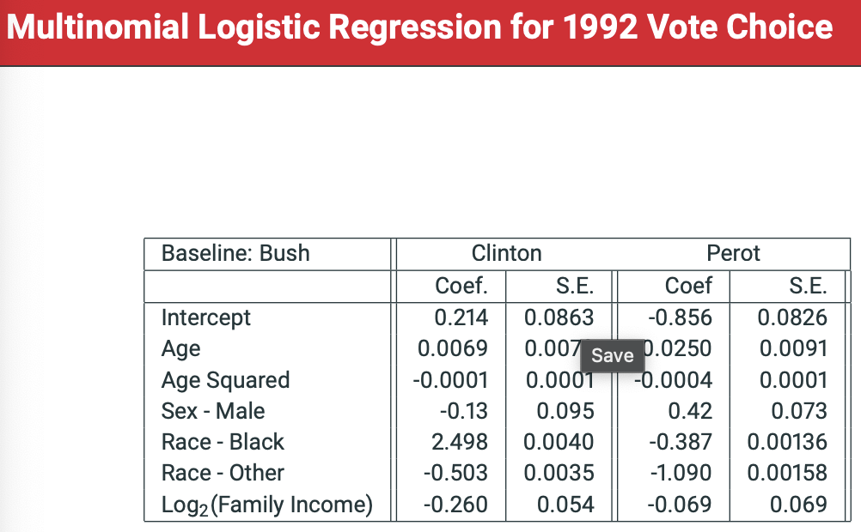

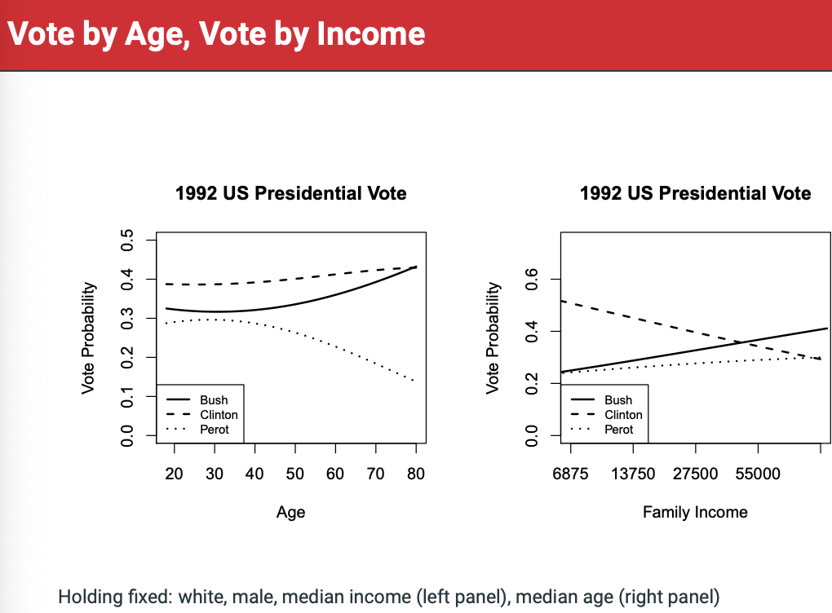

What would have happened if Perot hadn’t run?

Can we answer this question using the multinomial logistic regression model?

* WE CAN’T DO THIS.
* The multinomial logistic has a property called the Independence of Irrelevant Alternatives (IIA):
* **THE PRESENCE OR ABSENCE OF AN ALTERNATIVE HAS NO EFFECT ON THE RELATIVE PROPORTION OF INDIVIDUALS CHOOSING AMONG THE REMAINING ALTERNATIVES.**
* In this example, the presence or absence of Perot would have no effect on the relative proportions of individuals (with a given set of explanatory variables) choosing Bush as opposed to Clinton.
* This is implausible in this example.

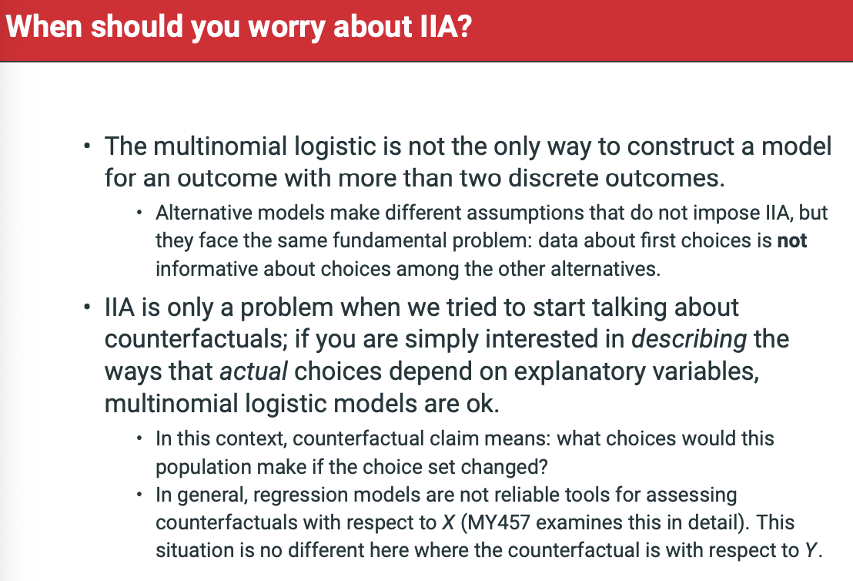

**Week 9: Readings – Ordinal Logistic Models**

In multinomial logistic models for unordered response variables we modelled these category probabilities π (j) directly. For ordinal response variables, we will consider instead the cumulative probabilities γ (j) = P(Y ≤ j) = P(Y = 1) + · · · + P(Y = j) = π (1) + · · · + π (j) for j = 1, . . . , C.

The cumulative probability γ (j) of level j is the sum of the individual category probabilities summed (“cumulated”) from level 1 to level j. In other words, it is the probability that the value of Y is at most j — i.e. j or one of the lower-numbered categories. In our example, γ (1) is the probability that self-reported health is Very bad, γ (2) the probability that it is Very bad or Bad, and so on.

The corresponding proportions in the example, conditional on sex, are shown in part (b) of Table 7.1. This shows, for example, that in this sample the proportion of respondents who report Very bad, Bad or Fair general health (corresponding to the cumulative probability γ (3)) is 0.336 among men and 0.409 among women. The same information is also displayed graphically in Figure 7.1, which shows the cumulative proportions for each of the five categories against the numbers of the categories.

• γ (j−1) ≤ γ (j) : The cumulative probability for a category is never smaller than the one for the previous category.

• γ (1) = π (1): For the lowest category, the cumulative probability is the same as the probability of the category itself.

• γ (C) = 1: The cumulative probability of the highest category is 1. This is simply a way of stating the fact that the value of Y must be one of its possible levels.

• Putting these results together, we get formulas for the category probabilities expressed in terms of the cumulative probabilities.

• P(Y < j) = γ (j−1) , P(Y > j) = 1 − γ (j) and P(Y ≥ j) = 1 − γ (j−1): These show how the cumulative probabilities, i.e. the probabilities that Y is less than or equal to a particular level, can be used to calculate also the probabilities of less than, greater than, and greater than or equal to any level.

As explained in the next section, an ordinal logistic model is essentially a set of binary logistic models for cumulative probabilities. It can be used to examine associations between explanatory variables and the ordinal response variable. For example, in Figure 7.1 we can see that at all levels of self-reported health the cumulative probability of that level and all worse levels of health is higher for women than for men. It thus seems appropriate to say that women’s self-reported health tends to be worse than men’s in this sense. We will see later how the ordinal logistic model summarises this association.

s. The ordinal logistic model — which is also known as the ‘cumulative logistic model’ or the ‘proportional odds model’ — is defined by the following assumptions:

1. Observations Yi are statistically independent of each other.

2. Observations Yi are a random sample from a population where Yi has a multinomial distribution with probability parameters: π (1) i , π (2) i , . . . , π (C) i , and thus with the cumulative probabilities: γ (j) i = P(Yi ≤ j) = π (1) i + · · · + π (j)

3. The log odds based on the cumulative probabilities depend on the explanatory variables through:

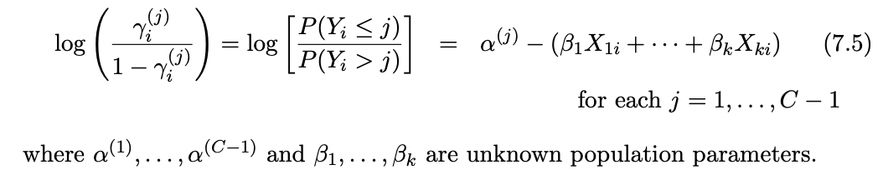

We note immediately three points about the model parameters:

• The model has C − 1 distinct intercept terms α (1), . . . , α(C−1). These must be (and their estimates will always be) ordered in size, so that α (1) ≤ α (2) ≤ · · · ≤ α (C−1). This ensures that the necessary conditions γ (j−1) i ≤ γ (j) i for cumulative probabilities always hold.

• Unlike for the multinomial logistic model (6.7), the regression coefficients β1, . . . , βk in (7.5) do not have a superscript j. In other words, in an ordinal logistic model each explanatory variable has only one regression coefficient, which applies to the models for each of the cumulative probabilities γ (1) i , . . . , γ (C−1) i .

• The negative sign (−) in front of the (β1X1i + · · · + βkXki) in (7.5) will be explained in Section 7.4.3 below.

In Chapter 6 we observed that a multinomial logistic model could be thought of as a set of binary logistic models, each of them for just two of the C categories of Y at a time. The ordinal logistic model can also be thought of as a set of binary models, but now for sets of dichotomous responses obtained by combining adjacent categories of Y . This motivation is as follows:

• For each level j = 1, . . . , C −1 of Y , define a new binary variable with two levels: 1 if Y is at most j, and 0 if Y is greater than j.

* For instance, if C = 5, the first of these dichotomies (corresponding to j = 1) constrasts level 1 of Y with levels 2–5 combined, the second 1–2 vs. 3–5, the third 1–3 vs. 4–5 and the fourth 1–4 vs. 5.
* For self-reported health, these dichotomies are thus Very bad vs. all other levels, Very bad and Bad vs. the other three levels, and so on.

Define a binary logistic model for each of these new dichotomous variables, in such a way that all of these models have the same values of the regression coefficients (the βs) but not of the intercept terms (the α (j) s).

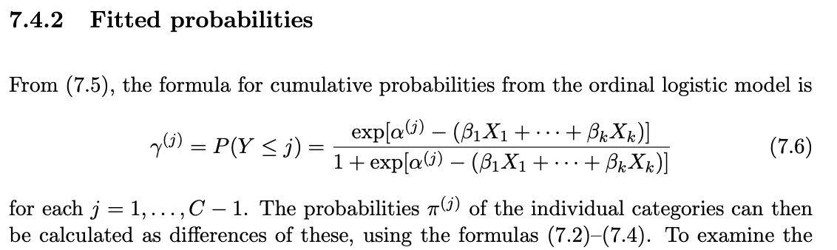

Suppose than an ordinal logistic model (7.5) holds for Y given X, withe intercept terms α (1) = −2, α (2) = 1 and α (3) = 2, and the coefficient of X being βX = 1. The model is thus given by logit[γ (j) ] = α (j) − βXX for j = 1, 2, 3. The topmost plot of Figure 7.2 shows the cumulative probabilities (7.6) in this case. From this plot, we note the following general points:

• The magnitude of the coefficient βX determines the steepness of the curves, that is how strongly γ (j) depend on X. The value βX = 0 would correspond to no association, i.e. flat curves which would not depend on X at all.

• The curves for γ (j) have the same steepness for each category j. This is because they all have the same coefficient βX for X. This is the proportional odds assumption of the ordinal logistic model, which we will discuss further in other sections below.

• Here the positive value of βX = 1 translates into curves where the probabilities γ (j) decrease as X increases (and, correspondingly, a negative βX would imply that the curves would increase wth X). This is a consequency of the − sign in front of βXX in the model specification, and in general in (7.5). The motivation of this choice is discussed below.

• The intercept terms α (j) determine the heights of the curves. The differences between α (j) for different j determine how far the corresponding curves are from each other. For example, here α (2) = 1 is closer to α (3) = 2 than to α (1) = −2, so the curve of γ (2) is closer to that of γ (3) than that of γ (1). These differences are related to the probabilities π (j) of the individual categories, as discussed below.

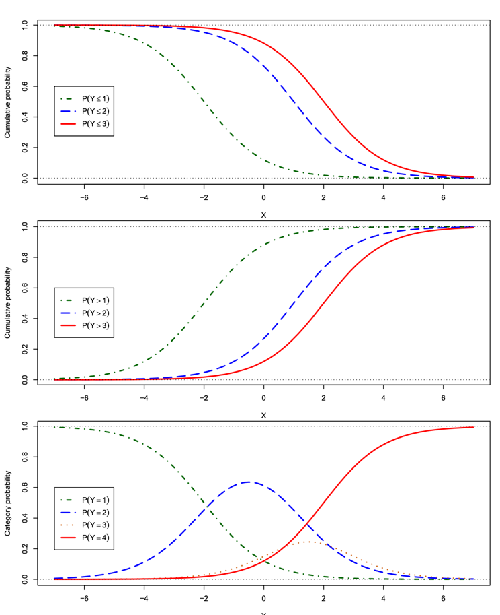

The middle plot of Figure 7.2 shows the complementary cumulative probabilities P(Y > j) = 1 − γ (j) , that is, the probabilities that Y has a value higher than a given category j. These curves are mirror images of those in the top plot. The important point to note from the middle plot is the following:

* When βX is positive, the curves for P(Y > j) increase when X increases. This is again a consequence of the − sign in the model equation, and the reason for why that sign is there. With it included, we obtain a model specification where a positive regression coefficient of an explanatory variable X implies that increasing the value of X increases the cumulative probability of high values of Y (and, similarly, a negative coefficient means that increasing X decreases the probability of high values of X). It is in order to obtain this convenient (and easiest-toremember) interpretation for what ‘positive’ and ‘negative’ associations mean in an ordinal logistic model that the negative sign is included in front of the regression coefficients in (7.5). This convention is always used on this course, and it is also used in computer output from both SPSS and Stata4.

The bottom plot of Figure 7.2 shows the probabilities π (j) = P(Y = j) of the individual categories, which are obtained as differences of the cumulative probabilities as shown in equations (7.2)–(7.4). From these, we note the following:

• In the same way as for multinomial logistic models (see Figure 6.3 on page 155), the probabilities of two categories tend to 0 and 1 when a continuous variable like X here takes on very large or very small values. For an ordinal logistic model, these two are always the highest and lowest category of Y . The intermediate categories obtain their highest probabilities at some intermediate values of X.

• If the coefficient of X is positive, the probability of the lowest category of Y tends to 0 and that of the highest category to 1 as X increases, and the values of X at which the intermediate categories of Y obtain their maximum probabilities are in the same order as the numbers of the categories. All of these results are reversed if the coefficient of X is negative.

• The maximum values of the probabilities of the intermediate categories depend on the differences between successive values of the intercepts α (j) . For example, here α (1) and α (2) are further apart than are α (2) and α (3). A consequence of this is that the largest value that P(Y = 2) obtains as X varies is larger than the largest value of P(Y = 3).

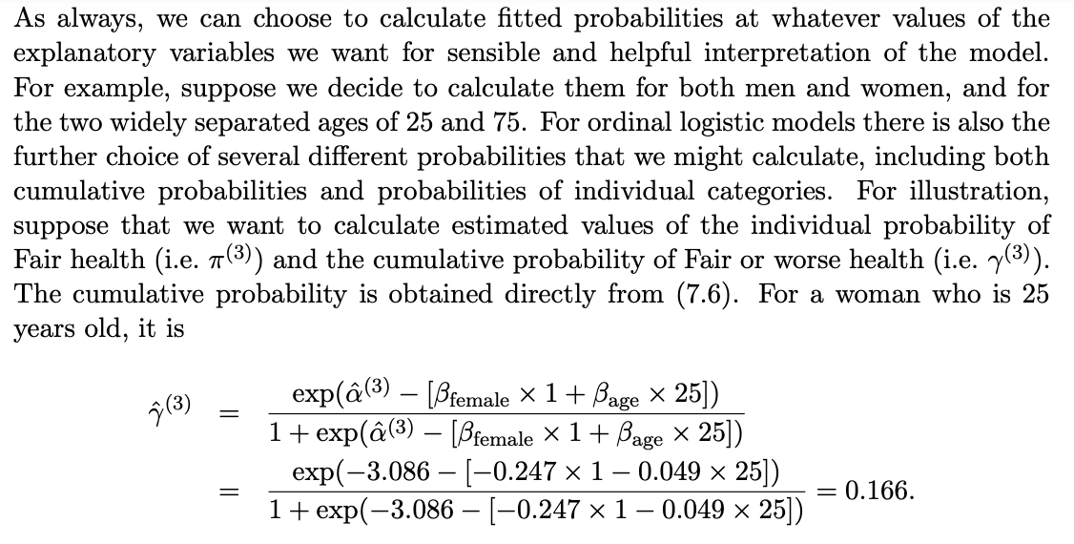

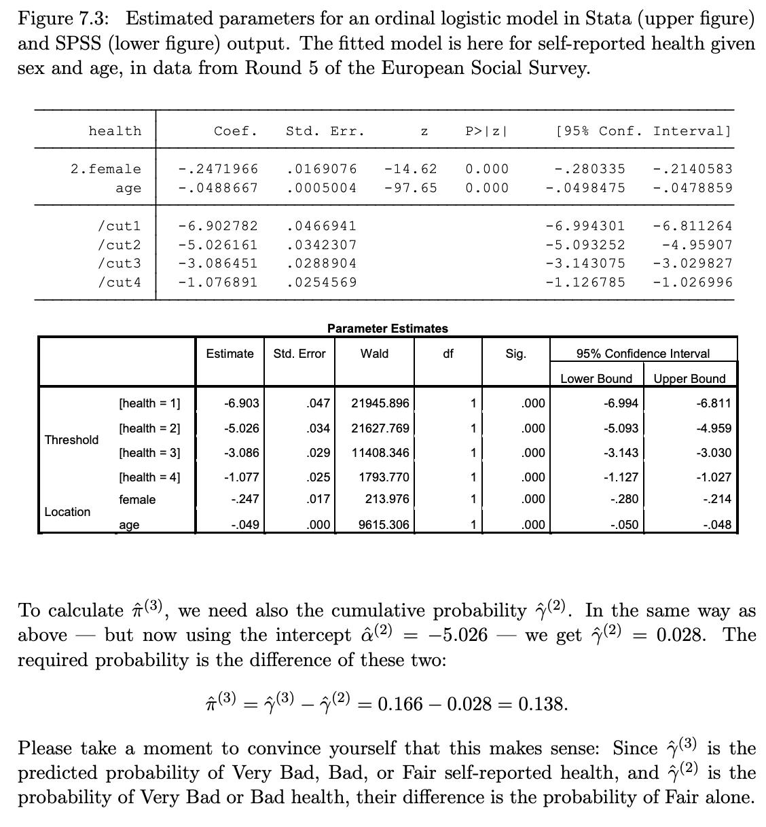

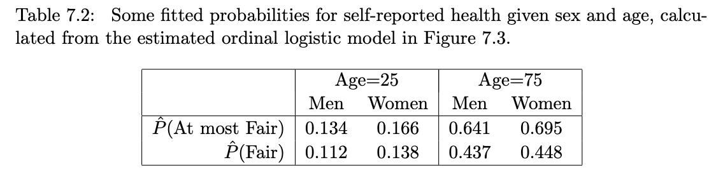

The regression coefficients of ordinal logistic models are interpreted as log odds ratios. This is done in essentially the same way as for binary logistic models, with only the following modifications: (i) the odds ratios that we consider for an ordinal model are for dichotomies defined by grouping the response levels into two groups, “high” and “low”; (ii) the odds ratio is for the high group against the low, because of the change of sign of the coefficients in the model formula; and (iii) the same odds ratio applies to each grouping into high vs. low, because of the proportional odds assumption.

The regression coefficient of an explanatory variable X is then interpreted as the log odds ratio (and its exponential as the odds ratio), associated with a one-unit increase in X, for the choice of the high rather than low value in these dichotomies. Although there are C − 1 ways of grouping the response levels into high and low, the same odds ratio applies to each one of them, because the model (7.5) specifies the same regression coefficient for the log odds of the cumulative probability γ (j) at each level j. Because of the negative sign inserted in front of the terms which depend on the βs and Xs in (7.5), the odds ratio is specifically for the comparison of high against low, in this direction. This implies the interpretation for positive and negative signs of the regression coefficients which has already been discussed in Section 7.4.2.

For example, consider the estimated model in Figure 7.3. Here the coefficient of age is βˆ age = −0.049. Because the coefficient is negative, we can immediately conclude that increasing age is associated with a decreasing probability of higher-numbered levels of self-reported health — i.e. levels which correspond to better levels of health. A quantitative summary of this negative association is provided by the odds ratio, given by exp(βˆ age) = 0.952:

* Controlling for a person’s sex, a one-year increase in age multiplies the odds of high rather than low levels of self-reported health by 0.952, i.e. decreases them by 4.8%.

The estimated coefficient for the dummy variable for women is βˆ female = −0.247 and exp(βˆ female) = 0.781. The negative sign indicates that women tend to report worse levels of health than men. The odds ratio interpretation is as follows:

* Controlling for a person’s age, the odds for a woman of high rather than low levels of self-reported health are 0.781 times the odds for a man, i.e. 21.9% lower.

• The parameters of the model are typically estimated using the method of maximum likelihood estimation (see Section 5.5.4).

• Significance tests of the regression coefficients are carried out using the types of tests we are already familiar with. Wald tests, most often applied to single coefficients (see Section 5.4.1), and likelihood ratio tests for any number of parameters (see Section 5.4.3) are both defined and conducted in exactly the same way as for binary logistic models. The hypothesis of no association between an explanatory variable and the response variable is again that the regression coefficient of the explanatory variable is 0, so this is again the null hypothesis that we most often test in practice.

• Confidence intervals for regression coefficients and exponentials of them (i.e. odds ratios) are again calculated as described in Section 5.4.2.

**A defining feature of the ordinal logistic model is that in its equation (7.5) the regression coefficients (the βs) are the same for all j = 1, . . . , C − 1. In other words, the model states that the odds ratios for the cumulative probabilities are the same irrespective of the point at which the response categories are divided into a Low and a High set. A visual expression of this assumption is that in a figure like the top graph of Figure 7.2 the curves of P(Y ≤ j) for each j have the same shape and do not cross each other. This condition is known as the proportional odds assumption of the ordinal logistic model, and the model itself is also known accordingly as the proportional odds model.**

The proportional odds assumption is not necessarily satisfied. In other words, even when the response variable is clearly ordinal, its cumulative probabilities do not need to depend on explanatory variables in the particular way specified by the ordinal logistic model. If they do not, conclusions from the model can in principle be misleading, at least if the deviation from the proportional odds assumption is severe. So we have some reason to examine the adequacy of the assumption when we use ordinal logistic models. Unfortunately, however, the tools for doing so are not entirely satisfactory or convenient for routine use. We discuss them only briefly in this section, finishing with some tentative practical suggestions. Addressing the proportional odds assumption involves two steps: (i) assessing whether the assumption holds, and (ii) if it does not, deciding how to modify the model to relax the assumption. Although (i) clearly comes first in order of action, it is convenient here to begin by discussing (ii). There are very broadly speaking three general approaches that we might take if the proportional odds assumption of an ordinal logistic model does not hold:

* • Extending the right-hand side of the model, for example by adding interactions of the explanatory variables. This is of course easy to do, and may (or may not) yield a model for which the proportional odds assumption is more appropriate.
* Modifying the model in some other way, while still maintaining its basic form as a model for cumulative probabilities. The various possible ways of doing this will not be discussed here in more detail, with one exception. This is the extension which might seem the most obvious, that of abandoning the proportional odds assumption and allowing the regression coefficients in (7.5) to vary with j. If this is done for every explanatory variable Xk, we end up with a model which has the same number of parameters as the multinomial logistic model but which is less appealing than it in a number of ways. An intermediate possibility is to relax the proportional odds assumption in this way only for some (but not all) of the explanatory variables, resulting in a ‘partial proportional odds model’. This, however, has one unappealing implication for these variables. Recall that the proportional odds assumption implies that fitted probability curves like the ones in the top plot of Figure 7.2 have similar shapes, so that they are essentially shifted versions of each other. This is no longer true if the proportional odds assumption is relaxed, which in turn has the implication that the curves will cross at some value of the explanatory variable. But this means that for some values of the explanatory variable we have P(Y ≤ j) > P(Y ≤ j + 1) for some j, i.e. that the cumulative probabilities will be in a logically impossible order. This crossing may not actually happen within the observed range of the explanatory variables, but even the possibility of it is a weakness of the partial proportional odds model.
* Fit the multinomial logistic model and use the ordering of the response categories only in an informal way as part of the interpretation of the estimated model. This is the approach which we will focus on in this section.

The situation where we would contemplate these actions is the one where we had first concluded that the proportional odds assumption is inadequate for the data at hand. This returns us to the question of how this conclusion would have been reached. There are several possible methods of assessing the adequacy of the assumption, but none of them fully satisfactory.

* An obvious possibility would be a significance test of some kind where the null hypothesis corresponds to the proportional odds model and rejecting that hypothesis implies a failure of the proportional odds assumption. Such tests exists, but they are not always fully satisfactory (and not implemented in standard software) and will not be described here
* A test which would seem possible given the last bullet point above would be a likelihood ratio test of the ordinal logistic against the multinomial logistic model. This, however, is not appropriate because the assumptions of the test are not satisfied: although the ordinal logistic model is smaller (has fewer parameters) than the multinomial logistic model, it is not formally nested within the multinomial logistic in the way required by the likelihood ratio test.
* Instead, the most we will suggest on this course is to compare the ordinal and multinomial logistic models in less formal ways. If they appear to be similar, the simpler ordinal logistic model can be used; if not, it is prudent to use the multinomial model even when the response variable is ordinal.

We will mention two partial ways of using the multinomial logistic model to assess the appropriateness of the ordinal model. The first of them considers the minimal requirement that the multinomial should at least agree with the ordering of the response categories. This can be examined, still somewhat informally, by checking whether the coefficients of each explanatory variable are in the right order of magnitude.

for example, the coefficients of age in the multinomial model in Figure 7.5. Taking the coefficient of the reference category Very Bad to be 0, these coefficients, from Very Bad to Very Good, are 0, −0.011, −0.048, −0.072, and −0.103. The thing to note here that the coefficients are in order of size, here in the sense that they get smaller for the submodels for the categories which are further from Very Bad according to the proposed ordering of the response categories. If this is the case, the multinomial logistic model implies the same ordering of the categories as the one assumed a priori in the ordinal model.

Apparently correct ordering is, however, just the minimum requirement for appropriateness of an ordinal model, and one which we would expect to be satisfied in most sensible applications of the model. Checking it is not the same as checking the more stringent requirement of the proportional odds assumption. To assess the latter, the approach which we suggest here is to compare fitted probabilities from ordinal and multinomial logistic models for the same variables.

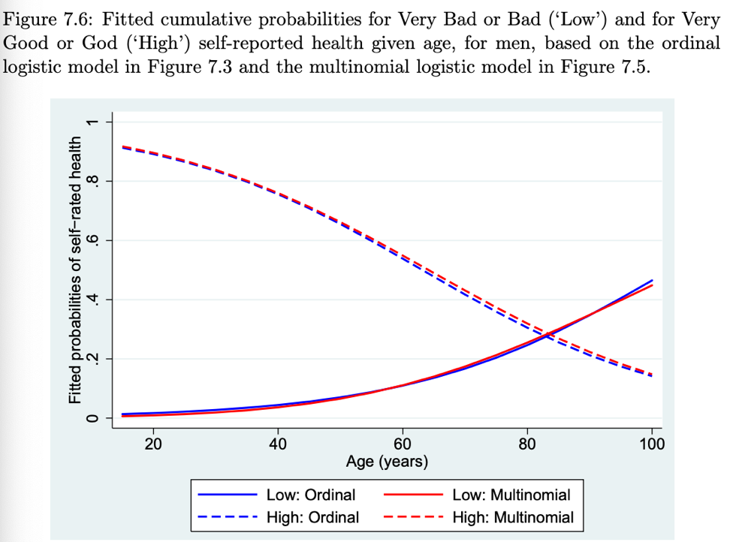

The motivation of binary regression models in terms of an underlying latent continuous variable, which was discussed in Section 5.5.3 on page 139, can also be extended to ordinal models. This is done by starting again from equation (5.25), and then supposing that the ordinal outcome Y is obtained by dividing all the values of the latent variable Y ∗ into three or more ranges of adjacent values at two or more cut-off points (rather than into just two ranges at the cut-off point of 0, as in the binary case). This yields an ordinal model for cumulative probabilities, the exact form of which depends on the distribution of ϵ in (5.25); in particular, an ordinal logistic model is obtained if ϵ follows the standard logistic distribution, and an ordinal probit model if ϵ has the standard normal distribution. The values of the cut-off points translate into the intercept terms α (j) of the ordinal model, and it is this reasoning which explains the use of terms like “cuts” or “thresholds” for the intercept terms in computer output for ordinal logistic models. As in the binary case, this latent variable motivation of the model is a mathematically convenient device which is always possible but never necessary for interpretation of ordinal regression models for cumulative probabilities.

**Week 9: Lecture – Ordinal Regression Model**

**Why not just use multinomial regression?**

* • The multinomial ignores the fact that the categories are ordered.
* • An Ordinal Logistic model (proportional odds model) does take the ordering into account. • Advantages of the Ordinal Logistic:
* • The Ordinal Logistic model has fewer parameters than the Multinomial Logistic.
* • This interpretation of the parameters is far more natural for variables that reflect a latent scale.
* • Disadvantages of the Ordinal Logistic:
  + • The Ordinal Logistic model is strictly less flexible than the Multinomial Logistic.
  + • The Ordinal Logistic model imposes a particular interpretation on the outcome categories.

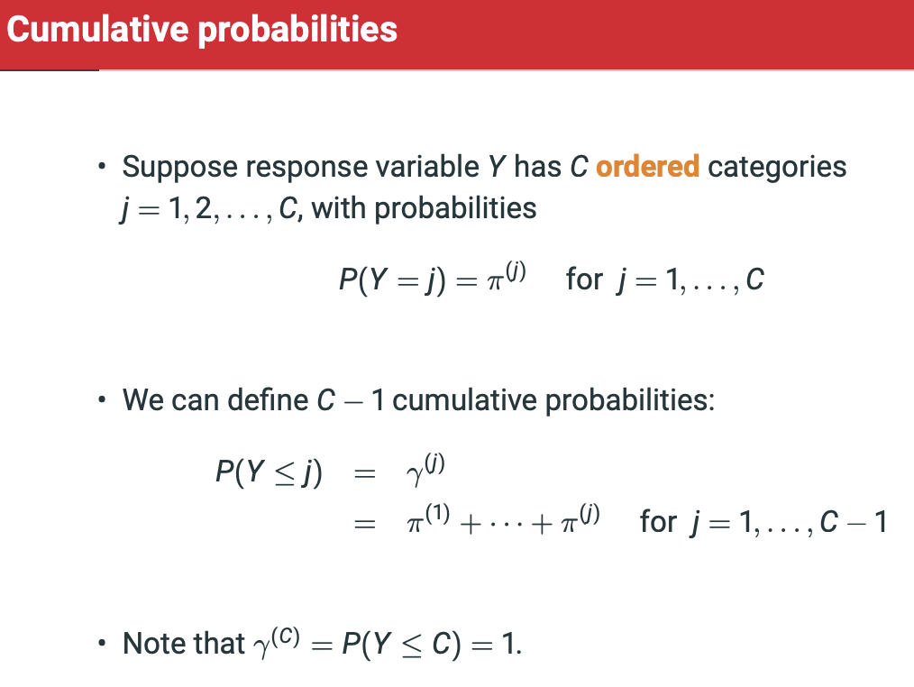

**Model Parameters**

**Alpha – intercept terms must be alpha(1) < alpha(2) < … < alpha(c-1) to guarantee that gamma(1) < gamma(2) < … < gamma(c-1)**

**Beta (Coefficients) are the SAME for each value of j.**

* **There is thus only one set of regression estimates, not C-1 as in the multinomial logistic model.**
* **The curves for gamma(1), … , gamme(c-1) are ‘parallel’ due to *proportional odds assumption.***

**Estimation and Interpretation**

Everything here is unchanged from binary logistic models:

• Parameters are estimated using maximum likelihood estimation

• Hypotheses of interest are typically of the form βk = 0, for one or more coefficients βk

• z tests, likelihood ratio tests and confidence intervals are defined and used as before

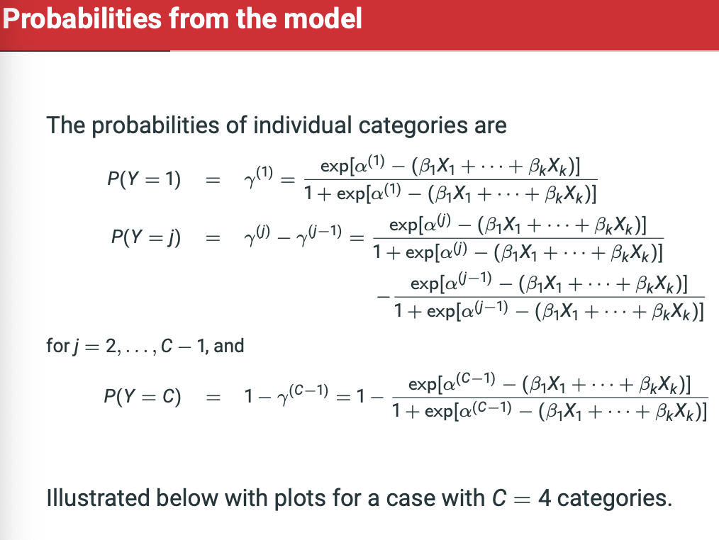

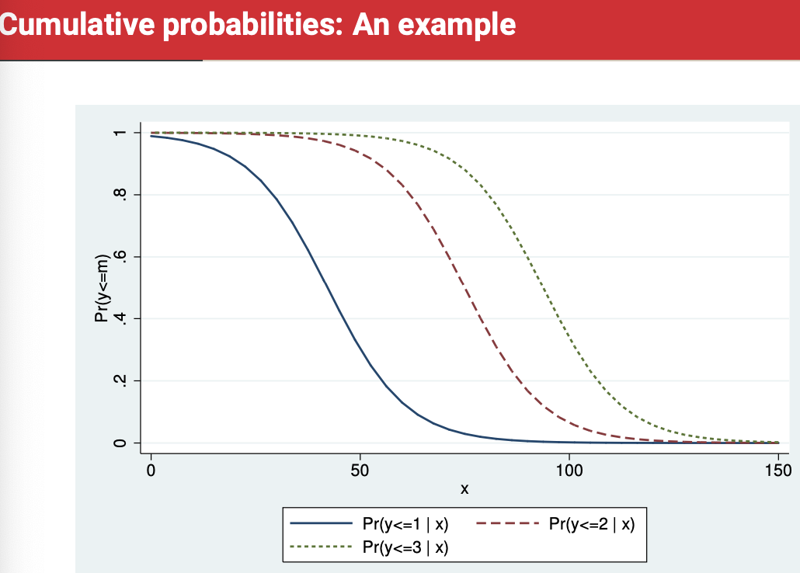

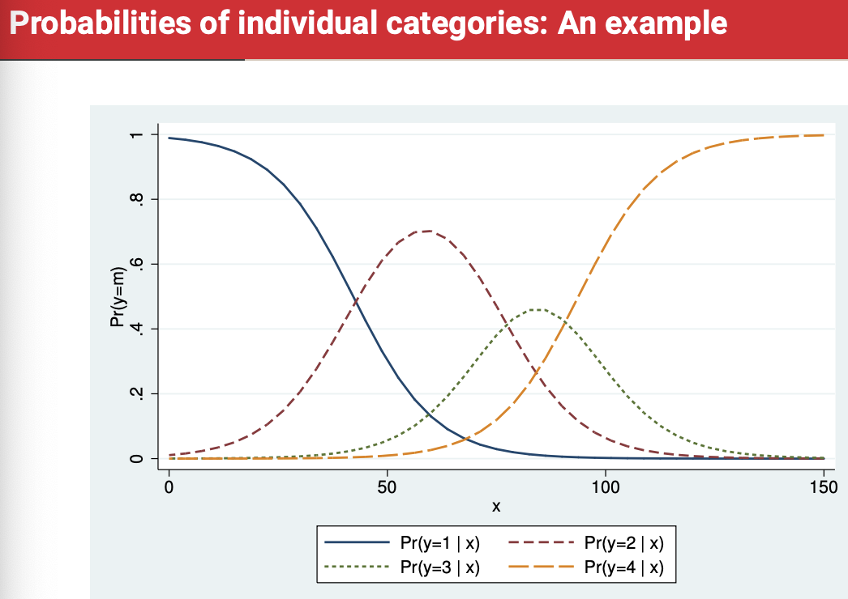

**Example 1: US Attitudes towards Maternal Employment**

Response variable Y (variable warm): “A working mother can establish just as warm and secure a relationship with her children as a mother who does not work.”,

with levels SD, D, A and SA

Explanatory variables:

* • yr89: a dummy variable for survey year 1989 (1=1989, 0=1977)
* • white: a dummy variable for self-identifying as white
* • age in years
* • ed: years of education • male: a dummy variable for self-identifying as man

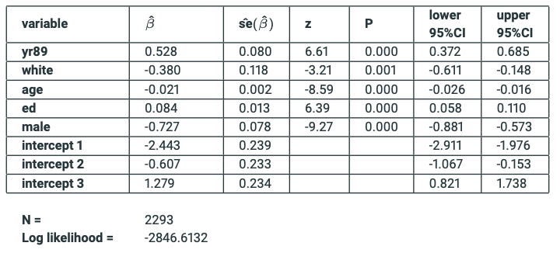

• Exponentiated coefficient estimates are interpreted as partial odds ratios for being in the higher rather than the lower half of the dichotomy

• here (SA, A, or D) vs. SD, (SA or A) vs. (D or SD), and SA vs. (A, D, or SD)

• odds ratio is the same for each of these

**• e.g., exp(βˆmale) = 0.48: Controlling for the other explanatory variables, (we estimate that) men have 52% lower odds than women of giving a response that indicates higher levels of agreement with the statement**

**• e.g., exp(βˆ ed) = 1.088: Controlling for the other explanatory variables, 1 additional year of education is associated with an 8.8% increase in (estimated) odds of giving a response that indicates higher levels of agreement with the statement**

**• exp(βˆ ed ± 1.96 ∗ se(βˆ ed)) = [1.06; 1.12]: with 95% confidence we estimate that [...] 1 additional year of education increases the odds... 95% CONFIDENCE, NOT 95% PROBABILITY, as the true parameter is either in it or isn’t.**

^^ Great template statements for Ordinal Regression Model.

**FOR EXAM – FORMULAS, TEMPLATE STATEMENTS, CONFIDENCE INTERVAL STATEMENTS,**

Now, let’s consider adding an interaction – between sex and education.

One trick to make the interaction easier to interpret is to not include education alone, but instead to include it in the form of two interacted variables:

* maleEd = male * ed
* femaleEd = (1-male) * ed

Instead of using ed and male * ed, as previously.

Both versions give the same model. In this version, the coefficient estimates for maleEd AND femaleEd are the coefficient estimates of education for men and women respectively, so no need to add ed estimates.

This version of interaction can be tested using a likelihood ratio test:

1. M1) warm = yr89 + white + age + male + ed
2. M2) warm = yr89 + white + age + male + maleEd + femaleEd
3. L1 = log − likelihood(M1)
4. L2 = log − likelihood(M2)
5. 2(L2 − L1) = 4.48 (1)
6. Pχ2 = 0.0344

**Can reject the null hypothesis that these two likelihoods are the same, so there is an improvement in the model fit by including the interaction.**

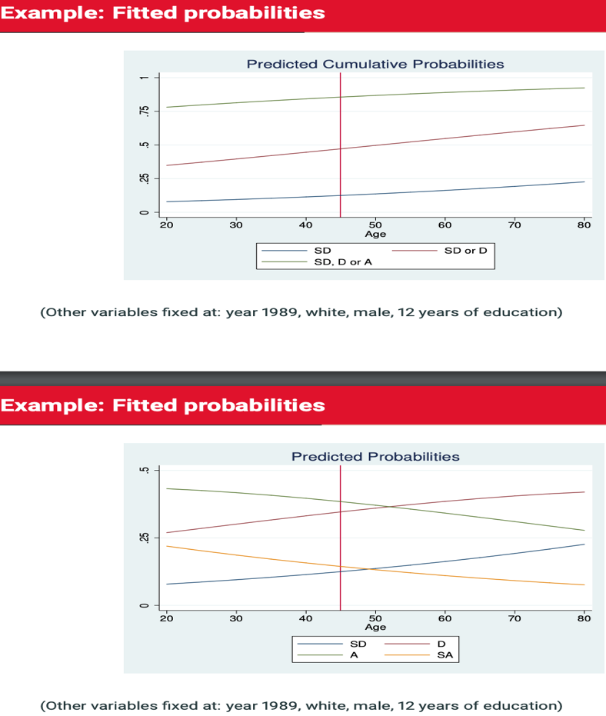

• The ordinal logistic model log[γ (j) /(1 − γ (j) )] = α (j) − (β1X1 + . . . βkXk) assumes the same coefficients β1 , . . . , βk for each cut-off j.

• The effect of an explanatory variable on the ordinal response is described by one parameter

• This is a restriction on the flexibility of the model, which may be inconsistent with the data.

• There are explicit tests of the proportional odds assumption, but they all have limitations (see later example and coursepack). • Alternatively, we can informally compare estimates and fitted probabilities between ordinal and multinomial logistic model.

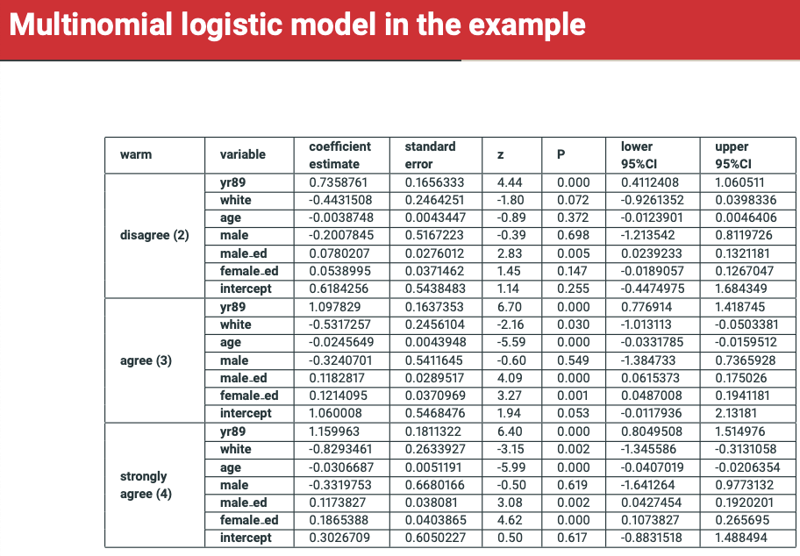

**You can see above that the coefficients are ordered (kind of) according to our assumption of ordinality, and thus the ordinal regression is an appropriate model.**

• e.g., for age: 0 (SD) > −0.004 (D) > −0.025 (A) > −0.031 (SA)

* This may not have been so, giving early warning that the assumption is not met

Next, we seek further evidence by comparing the two models’ fitted probabilities. See below.

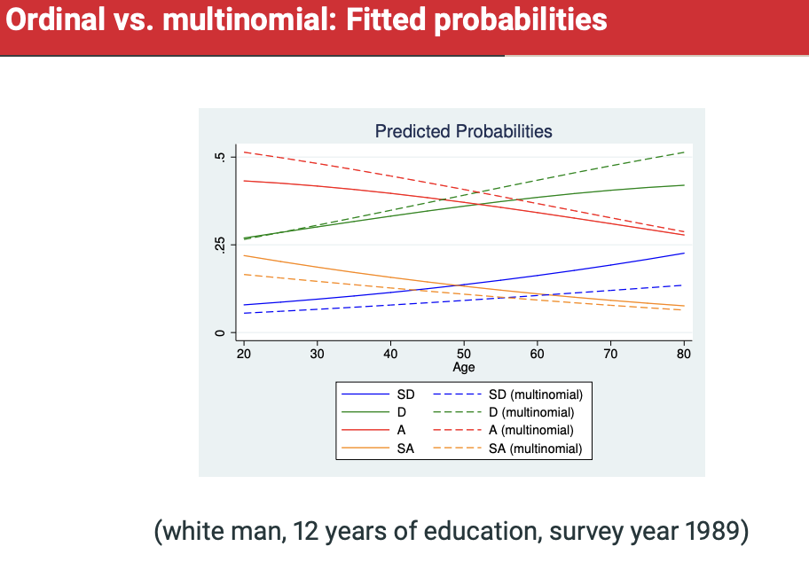

They’re not perfect, but they’re pretty bloody similar!

• For fitted probabilities in our example:

• for most of the variables, the agreement in the strengths of association is reasonable if not perfect

• The biggest difference is for period (1977 vs. 1989):

• the ordinal model forces the change (in cumulative odds) to be the same for all cut-off points • according to the multinomial model, some categories have shifted more than others between the two periods

• in particular, the shift away from “Strongly disagree” has been a bit stronger than the ordinal model allows

• Which model should we prefer?

• Recall that since 1973 the GSS has asked people in the US whether “sexual relations between two adults of the same sex” are “always wrong”, “almost always wrong”, “wrong only sometimes” or “not wrong at all.”

• Over time, acceptance of homosexuality has greatly increased:

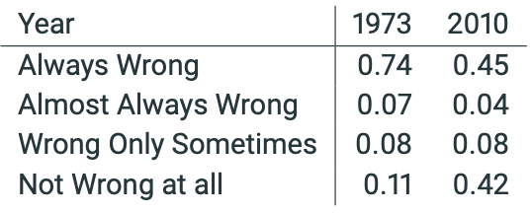

• We are going to use ordered logistic regression to assess the relative degree to which this is the result of: 1. Opinion change 2. Cohort replacement

• Response options:

• “always wrong”

• “almost always wrong”

• “wrong only sometimes”

• “not wrong at all”

• Options seem to be ordered as a function of some general, unobserved attitude towards the permissibility of homosexuality. However, the difference between the categories aren’t exactly equidistant.

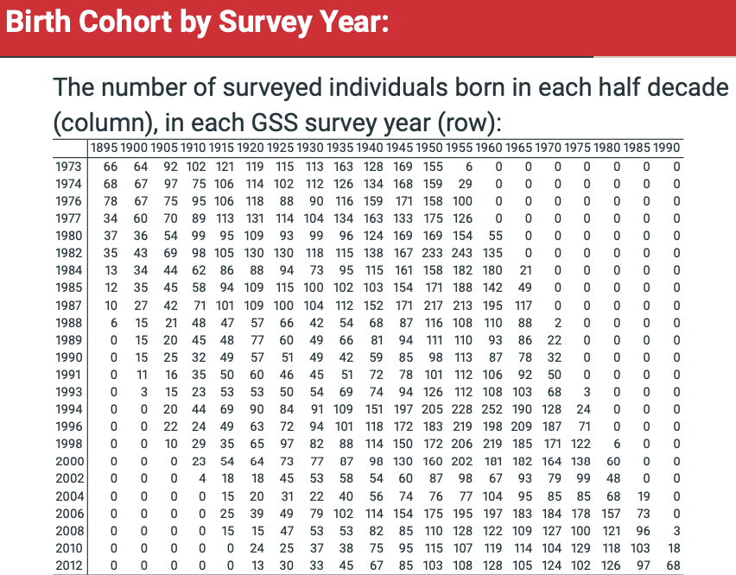

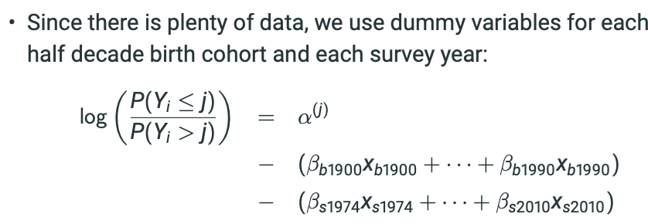

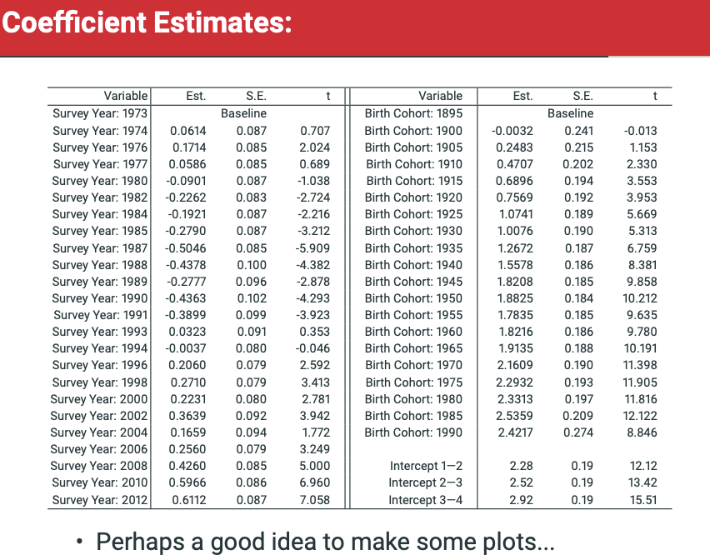

**Range in the coefficients are MUCH larger than the range in the intercepts, suggesting that most people answer in the extremes (hate homosexuality, love homosexuality) because there is little shift in the cumulative probabilities as we transition through the categories.**

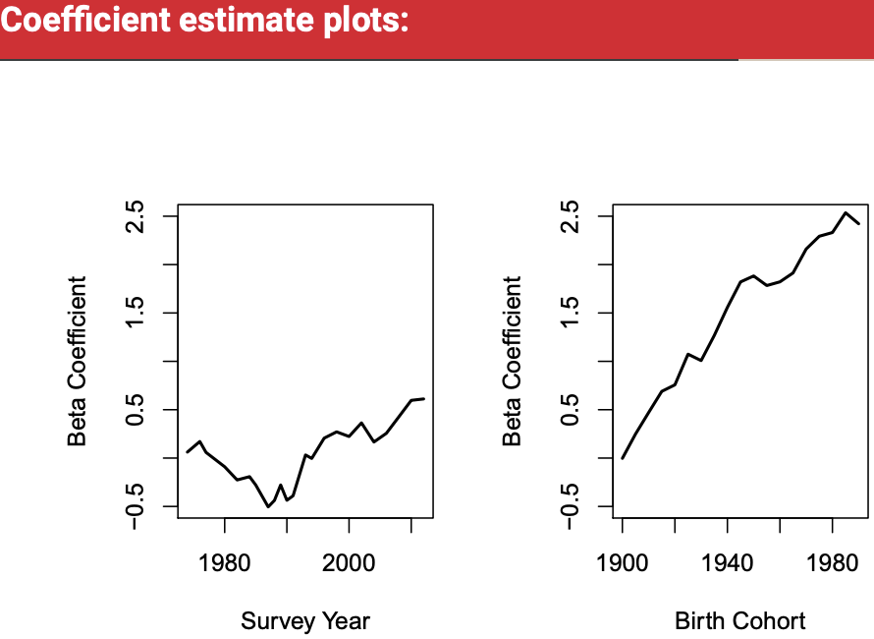

• Coefficient estimates on Survey Year:

• The coefficient estimates for survey year change little from 1973 to 1980, become more anti-homosexuality from about 1980 to 1987, level off until about 1991, then become less anti-homosexuality through to 2010.

• Coefficient estimates on Birth Cohort:

• Respondents born later are (on average) less anti-homosexuality than those born earlier.

• The differences in attitudes as a function of birth cohort are much larger than the differences in attitude as a function of survey year.

• Coefficient estimates for Intercepts:

• The intermediate categories are very ”narrow”; most responses are in the extreme categories.

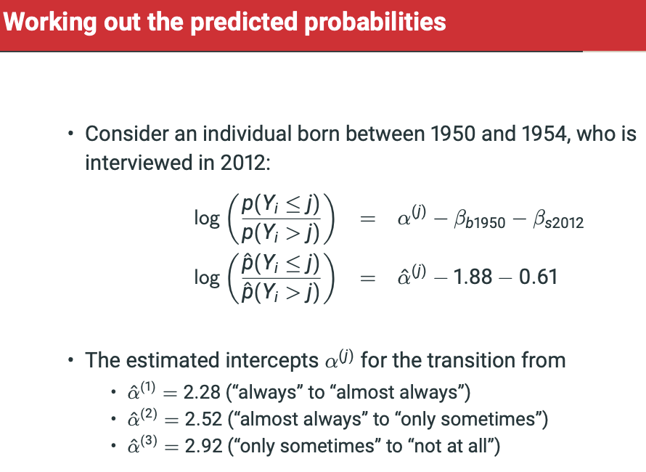

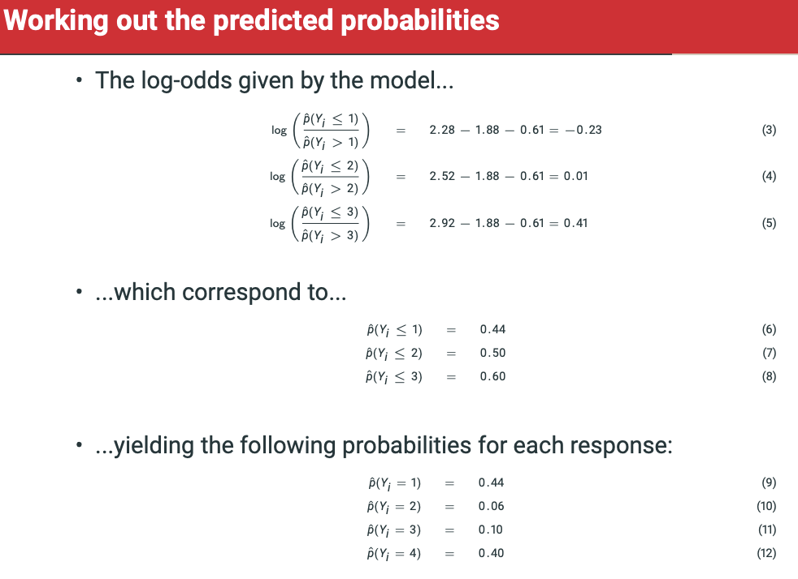

**GREAT EXAMPLE.**

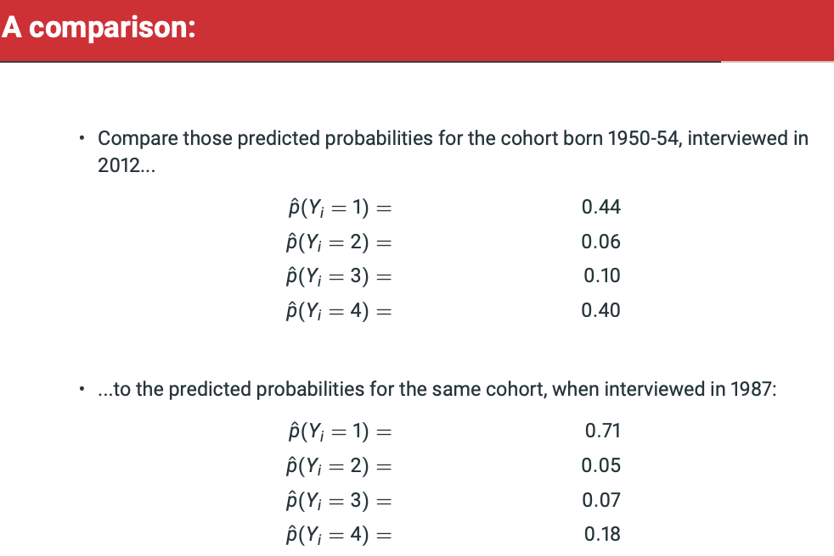

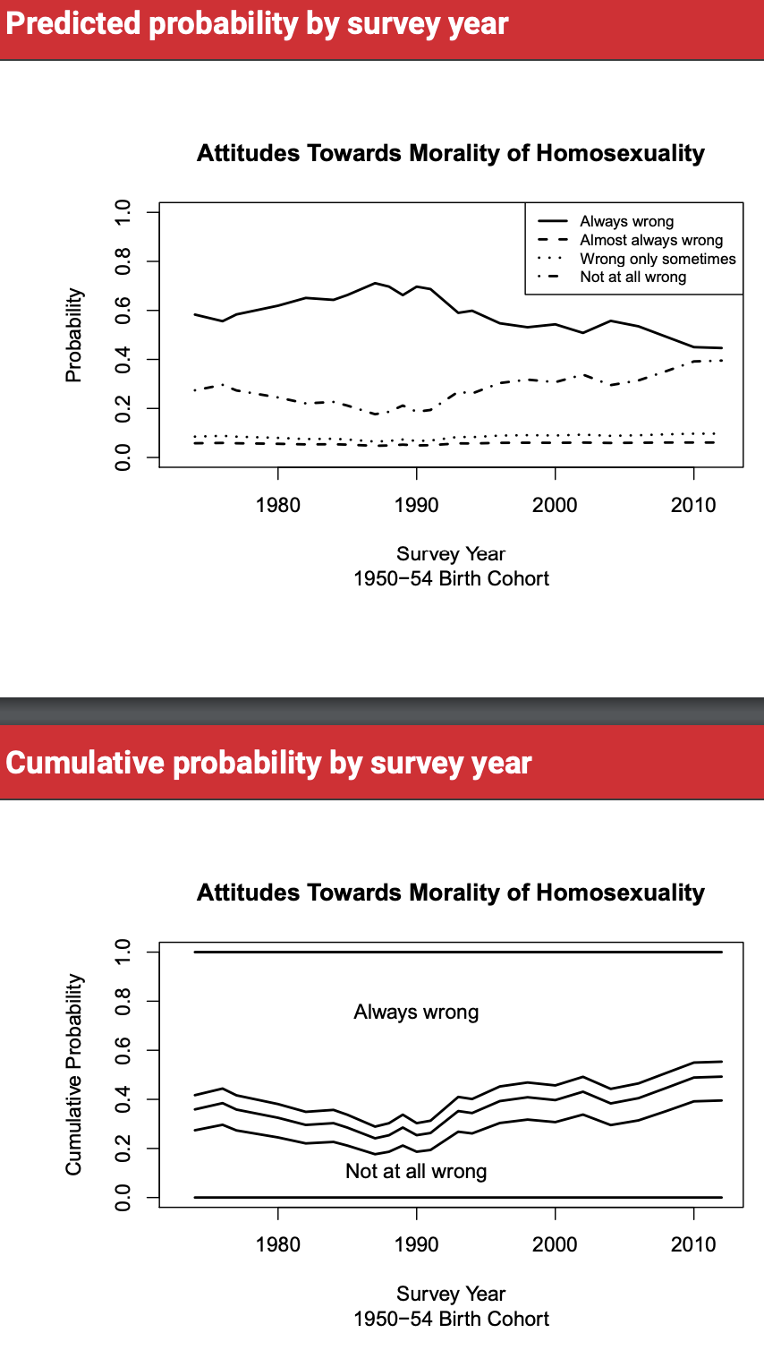

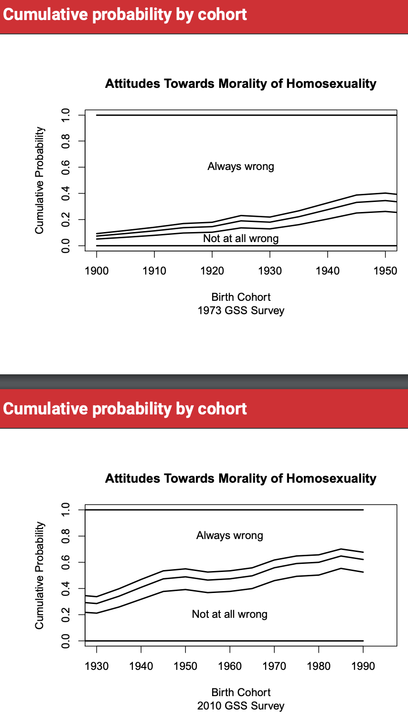

**Assessing the proportional odds assumption**

• There are explicit tests of the proportional odds assumption. Why not use them here?

* • We could. However, they encounter, once more, the limitations of ”null hypothesis significance testing”.
* • Hypothesis tests consider whether we can reject a strict null hypothesis: in this case that there is no improvement in fit at all.
* • Hypothesis tests give no information about the substantive magnitude of deviations from the null, only the statistical magnitude.
* • In large data sets (this one has over 30,000 observations), the statistical evidence against the null can be quite strong even when the substantive deviation is small.
* • In this case, the substantive deviation of the multinomial fit from the ordinal fit is very small...]

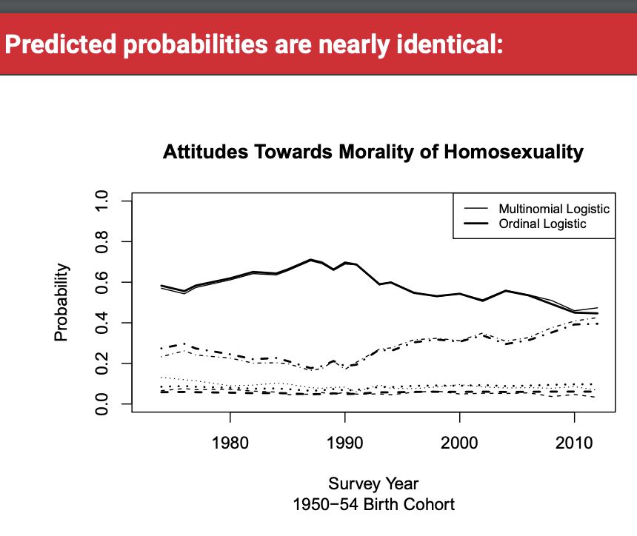**multi vs ordinal.**

• Choosing models purely based on statistical fit is not always a good idea.

• Moving from the ordinal to the multinomial logistic means giving up the interpretability of coefficient estimates, probably not worth it for a model that fits only slightly better.

• Even if you are very confident that it fits slightly better!

• If you have good theory (in this case, knowledge of the meaning of the question alternatives), it is usually better to follow that!

• In the home and class work this week, we will look at a case where the choice between ordinal and multinomial is not easy.

**Week 10 – Lecture: Count Models**

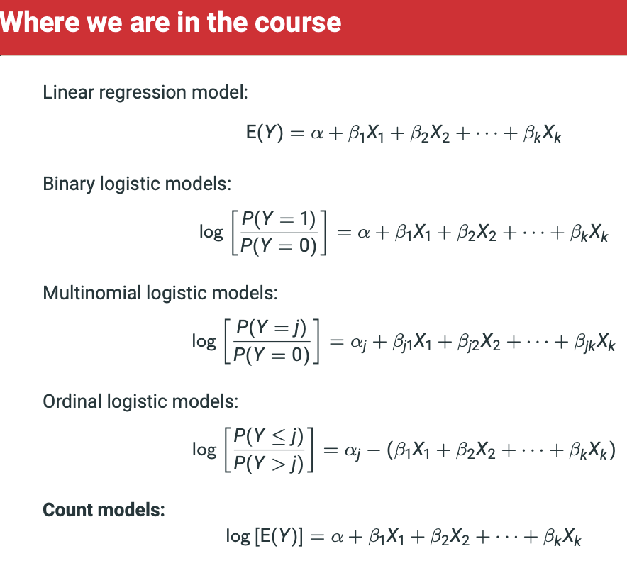

Poisson Regression for Count Data

• Often it makes sense to think about counts as though they come from very large numbers of trials, each of which have a very low probability of a “success.”

• For example, a car crash could occur at any moment on any stretch of road in London. • In the vast, vast majority of those places and times, no crash occurs.

• In fact, it is difficult to figure out how many of these “trials” there are.

• But sometimes there are crashes!

• We could map London as a grid, and count the crashes that occur in each square, in an hour.

• Or just count the total number of crashes in London, in a minute (a second?), and then another, and then another.

• Either way, we obtain a distribution of the number y of rare events in a given unit.

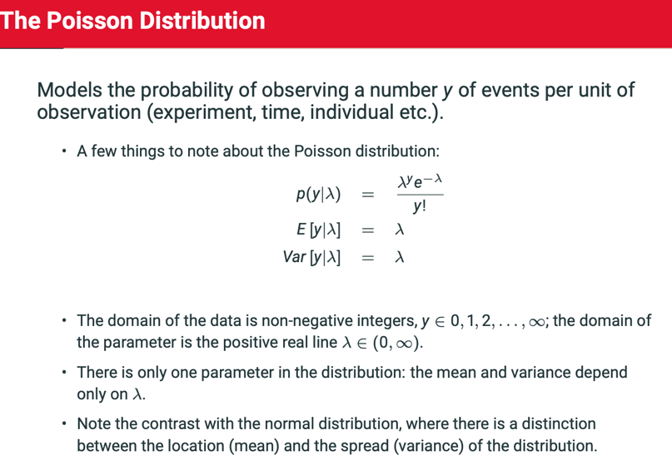

Models the probability of observing a number y of events per unit of observation (experiment, time, individual, etc.)

In the Poisson distribution formula, lambda (λ) is **the mean number of events within a given interval of time or space**. For example, λ = 0.748 floods per year.

• The single parameter λ ∈ (0, ∞) of the Poisson distribution is the expected value of the distribution.

* If we are going to model that parameter, we need to describe a model that can only take on positive values.
* • We will introduce here the concept of a ”link function” g (·)

• From our discussion of models for binary data:

• For binary data and the bernoulli distribution, we wanted a function g (·) that mapped the range (0, 1) onto (−∞, ∞).

• For count data and the Poisson distribution, we want a function g (·) that maps the range (0, ∞) onto (−∞, ∞).

While in principle other functions can be used, almost all applications of the Poisson in regression modelling employ the log function: g(·) = log(·):

log(λi) = α + β1X1i + ... + βkXki

λi = exp (α+β1X1i+...+βkXki)

Notice that this means the regression coefficients are interpreted in the same way as in a linear regression with a log dependant variable:

* Increasing Xk by 2 multiplies E[Y|X] by e^Beta-k

• A famous (and sad) example of count data is the number of o-ring failures on early US space shuttle launches.

• In 1986, the Challenger space shuttle and all its crew were lost to a tragic accident. A failure of the o-ring seal was found by subsequent investigations to be the explanation for disaster.

• An o-ring is a piece of rubber used to make a seal between two parts.

• There is a lot of historical and technical detail here that we are going to ignore! • e.g. docuseries ”Challenger” on Netflix.

• One component of the story is the relationship between weather (temperature) and incidents involving o-rings partially failing on previous launches. • We are going to look at the number of o-ring incidents in previous launches, as a function of air temperature on the launch day.

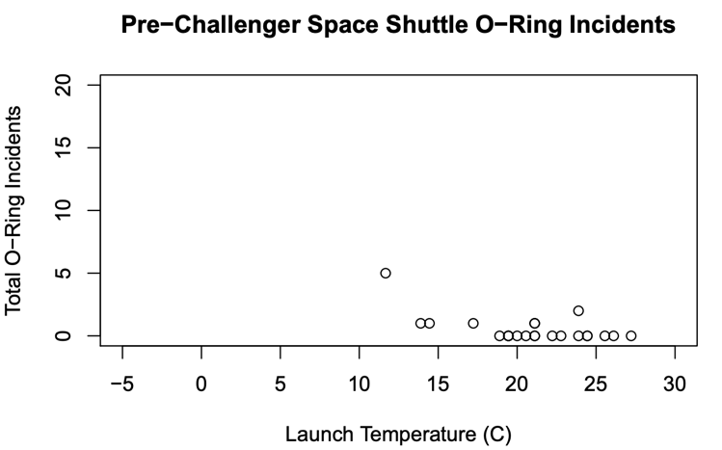

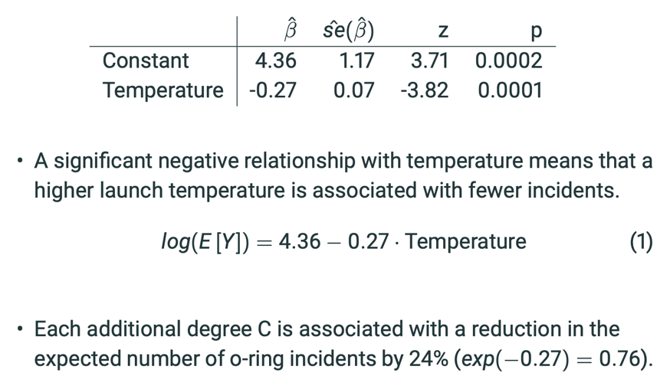

• On the Challenger’s launch day, the temperature was -1 C. What is the expected number of incidents under such conditions, accoding to our model?

log(E [Y]) = 4.36 − 0.27 · (−1)

E [Y] = exp (4.36−0.27·(−1))

= 103

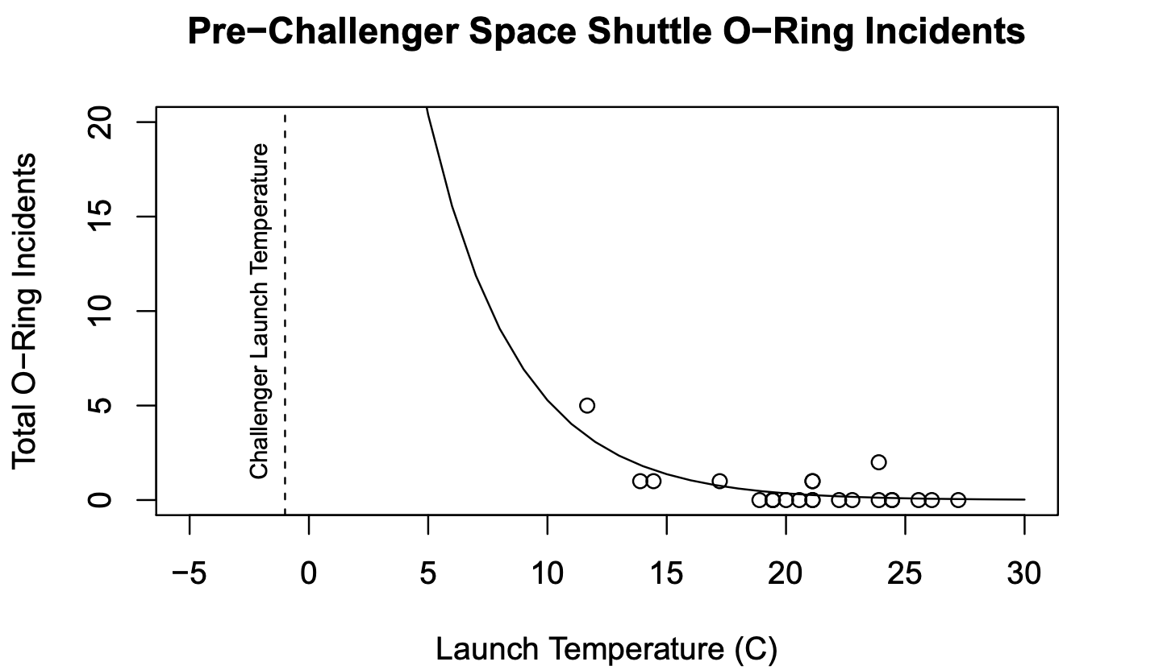

• This is an extreme extrapolation!

• The coldest previous launch occurred at a temperature 13 degrees higher.

• If we fit a model with a linear mean function, it would lead to a very different extrapolation.

• The honest answer is that we have no idea what the expected number of incidents is with a temperature of -1 C, but it could be very large given the observed trend in the data.

• The sad part is that this is more or less what some of the rocket engineers said, before the launch.

**Negative Binomial Regression**

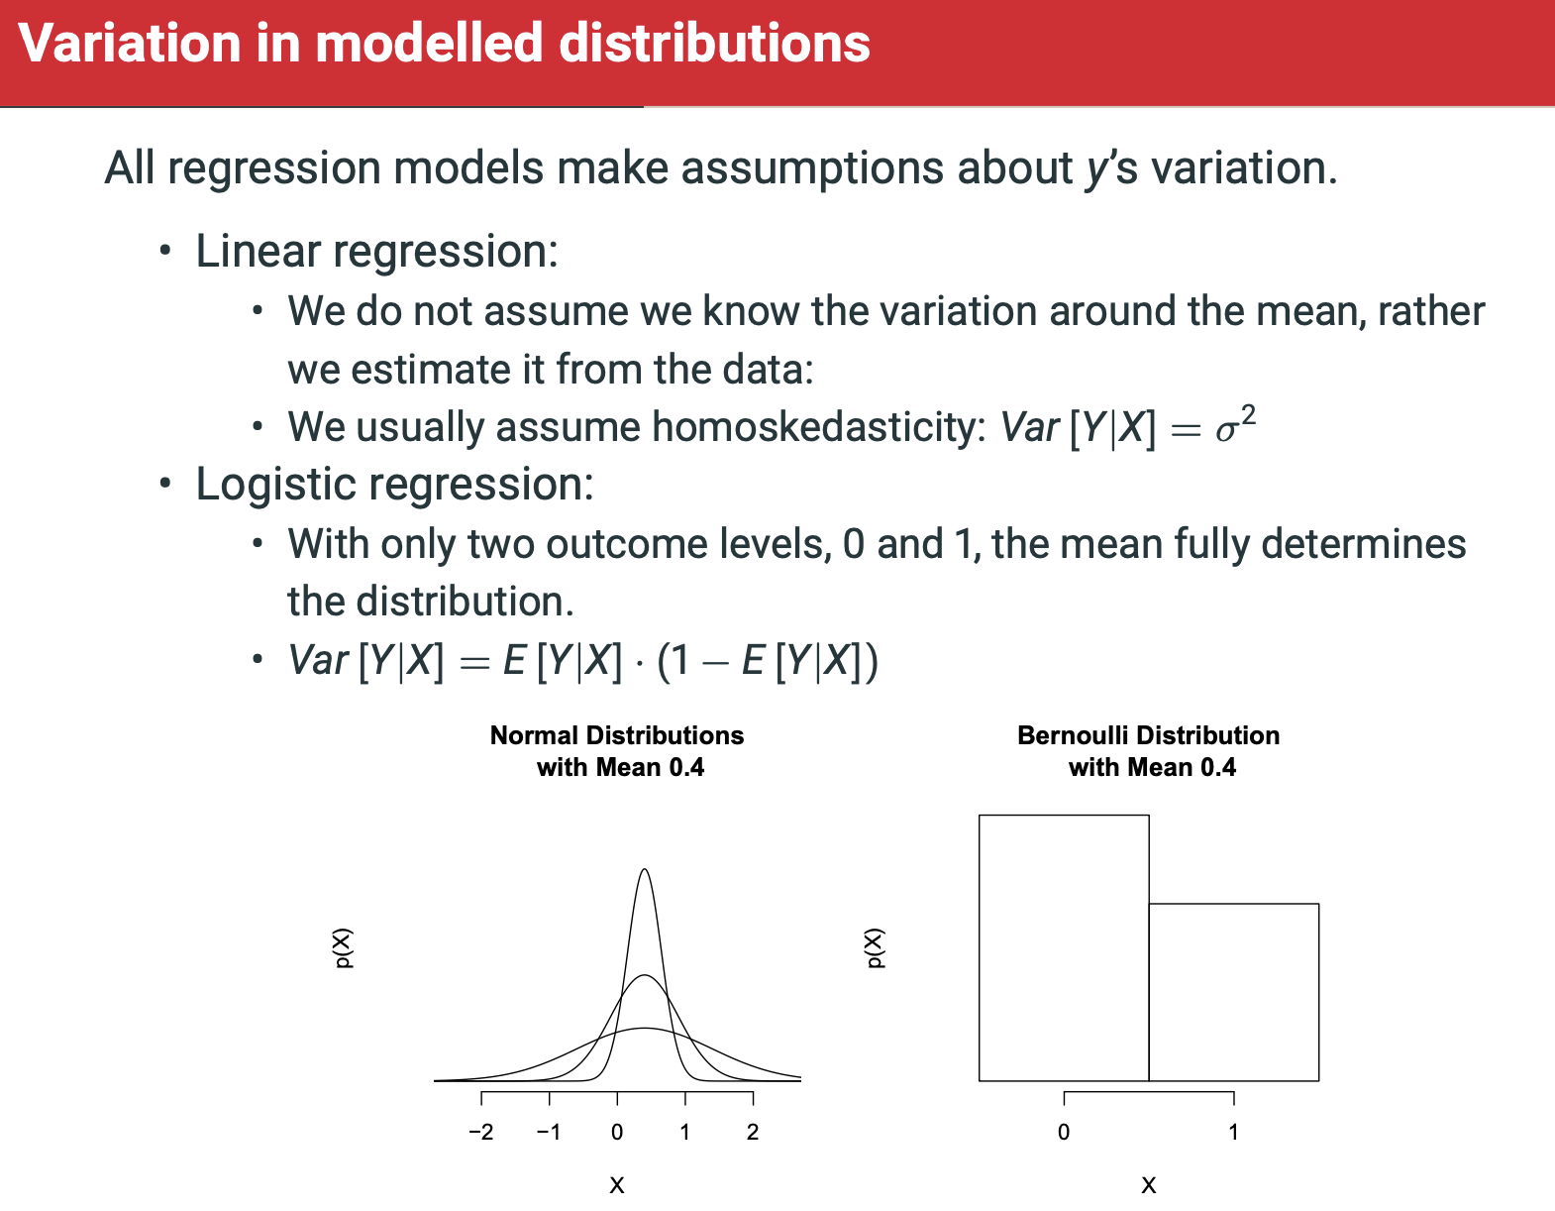

* **The Poisson regression model makes a very strong assumption about the scatter of points around the regression line.**
  + **For a given mean, there is one and only one possible value for the variance.**
  + **Among other consequences, this means that the probability of a zero outcome is tiny if the mean is greater than about 10.**

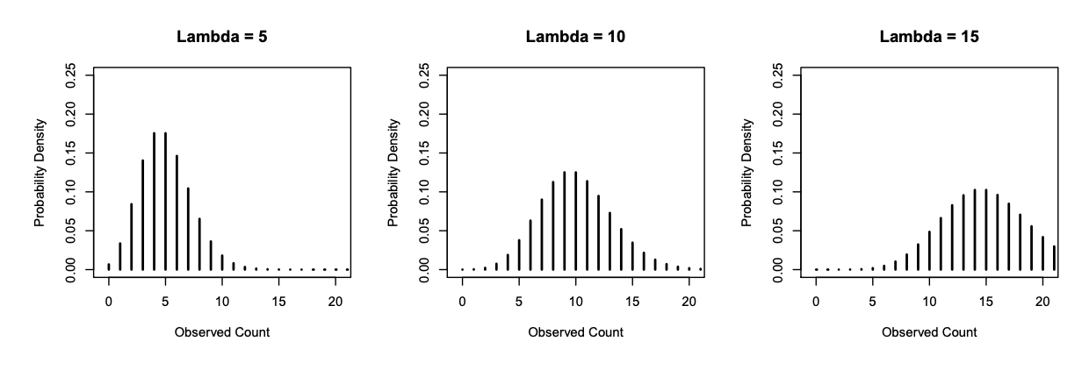

• There is a straightforward generalization of the Poisson distribution, called the Negative Binomial, which allows for overdispersion by comparison to the Poisson.

* Overdispersion means extra variation. The Poisson has mean λ and variance λ, the negative binomial will have mean λ and variance λ + λ 2
* (...or in alternative but equivalent specifications λ + αλ2 )
* Overdispersion in a Poisson regression model can occur even if Poisson distribution is correct for each individual, because we may be missing variables that predict λi
* The Negative Binomial does not allow for **underdispersion**.

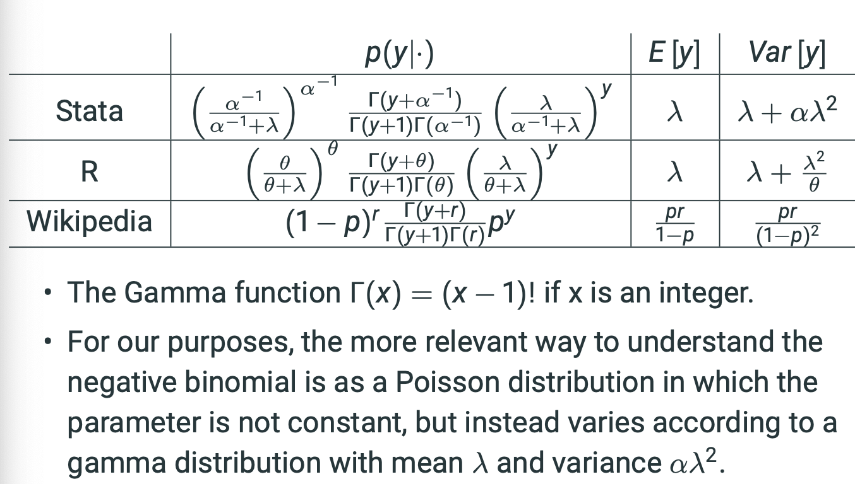

The negative binomial can take on a more varied set of shapes than the Poisson.

For example, the distributions below all have lambda = 5

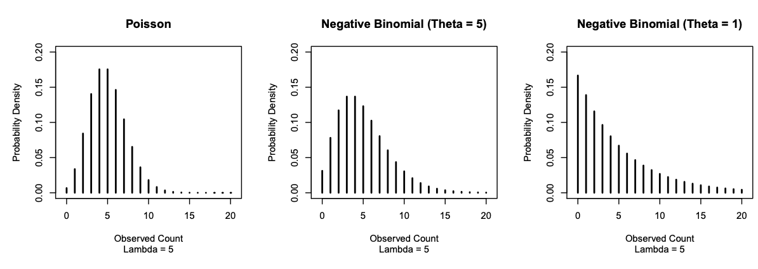

Notice the radically different probability of the zero outcome under these three probability distributions , all of which have the same mean.

They can be interpreted in much the same way as Poisson regression models

In the typical setup, the mean parameter lambda-I = e^a+b1k1+…+ just as in the Poisson.

There is also an estimate of the parameter describing the degree of overdispersion, which is theta or alpha.

When there is overdispersion, the Poisson will tend to yield standard errors that are too small.

* It is always wise to check whether the negative binomial fits the data better than the Poisson, because it is just as easy to interpret and is often more plausible substantively.



x• Setting aside the explanatory variables...

• Recall that under the Poisson:

E [Y] = Var [Y] • E [Visits] = 5.77

• Var [Visits] = 45.69

• This large discrepancy indicates that under the null model (no explanatory variables), the negative binomial will fit much better than the Poisson.

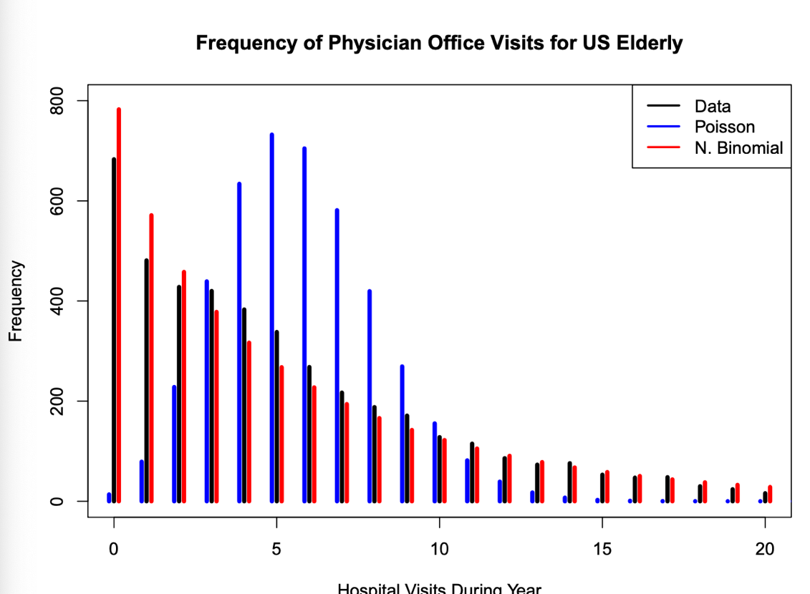

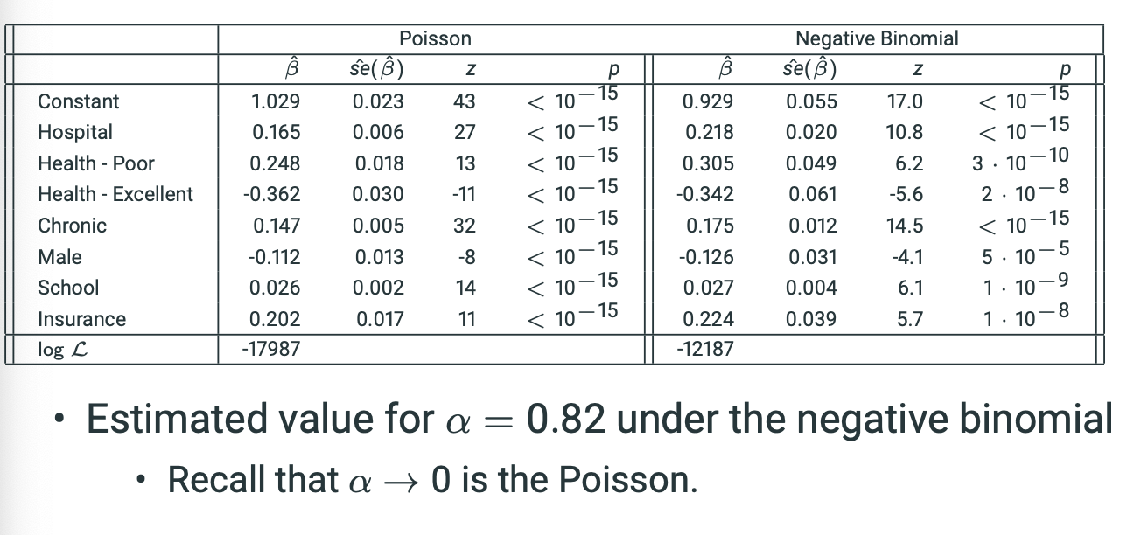

The coefficients are not all that different, but the standard errors are much smaller for the Poisson.

• As promised, we can interpret the coefficients quite easily:

• Having supplementary private insurance is associated with an increase in physician office visits by a multiplicative factor of e 0.224 = 1.25.

• 25% more visits

• Being male is associated with a decrease in physician office visits by a factor of e −0.126 = 0.88.

• 12% fewer visits

We can construct a likelihood ratio test because a negative binomial with alpha = 0 is identical to the Poisson.

The likelihood ratio test statistic is very, very large:

2((-12187) – (-17987)) = 11600, we can very strongly reject the null that alpha = 0.

• If the Poisson regression is a special case of the negative binomial regression, why would we ever use it?

• It has computational advantages with underdispersed data. • Software will often give errors when fitting the negative binomial, and the Poisson will fit without problems.

• The Poisson standard errors will be too large, but that just means that statistical tests will be overly conservative; e.g. a ”95%” test will reject the null less than 5% of the time when the null is true.

**Introduction to Generalised Linear Models**

**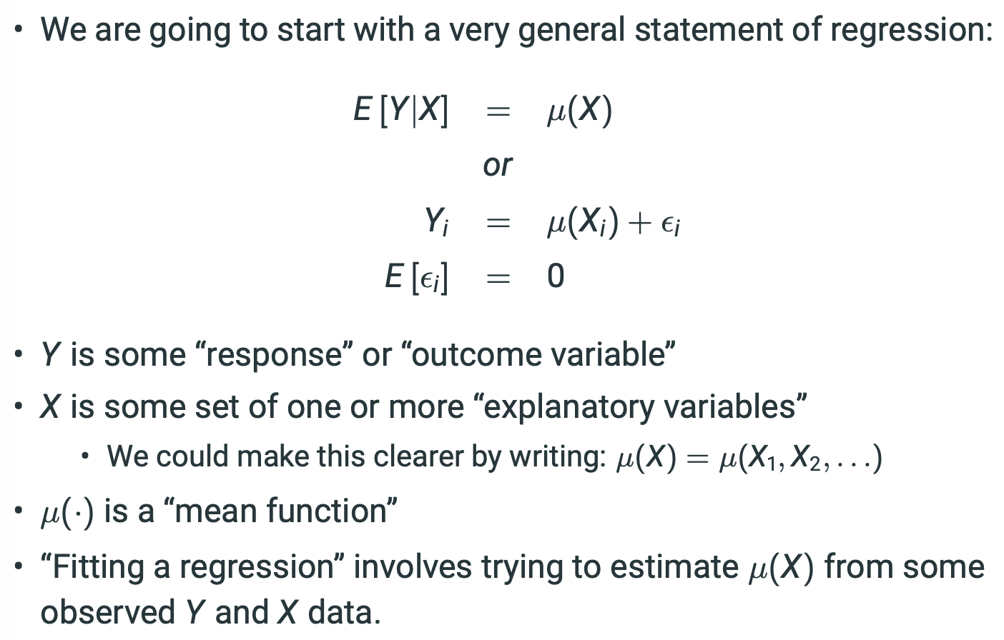  
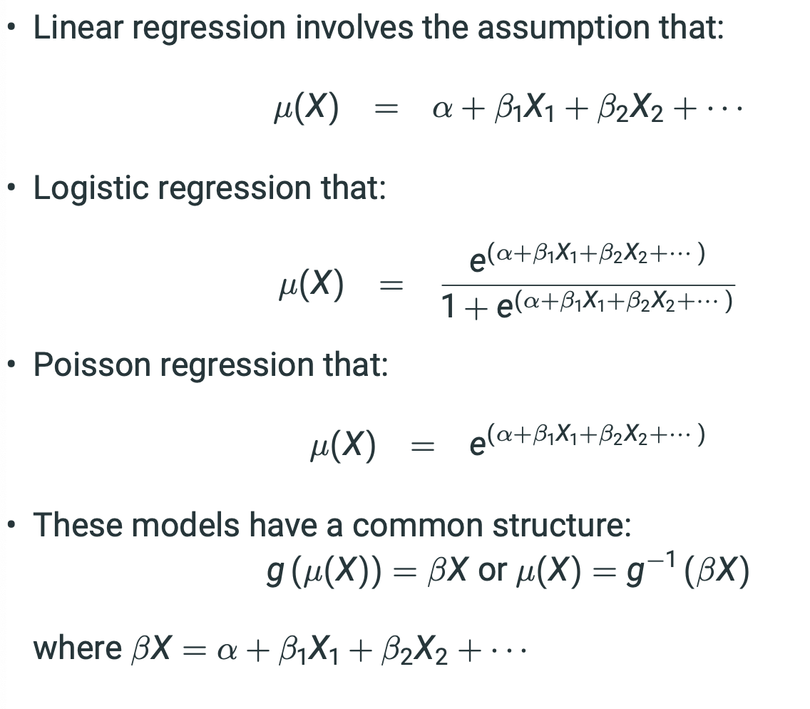**

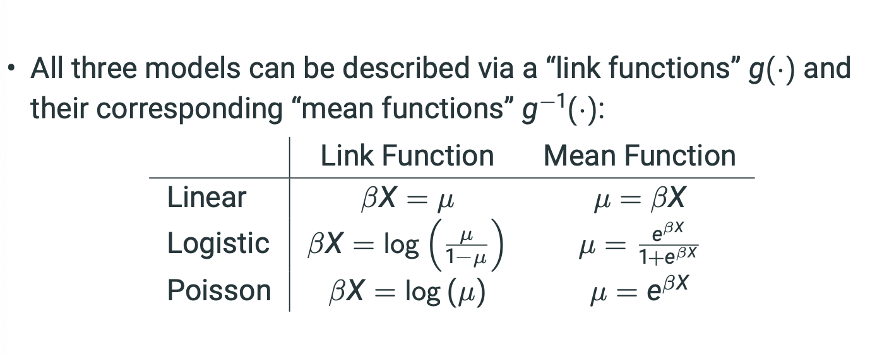

• In 1972, John Nelder and Robert Wedderburn showed how these and many other models had the same fundamental structure and could therefore be unified into a single mathematical description.

Unifying regression models into a Generalized Linear Model (GLM):

1. A ”random component” with probability distribution from the exponential family: f(yi; θi, φ) = exp{ yiθi−b(θi ) a(φ) + c(yi, φ)} • This function can describe a Gaussian (linear regression), a binomial (logistic), a Poisson and many more!

2. A ”link” function g(·) of the expected value of unit i’s response as a linear function of a set of X variables: g (µ(X)) = βX • In linear regression, it is the expected value (mean) of Yi that is a linear function of the data βXi . • In logistic regression, it is the log-odds of Yi that is a linear function of the data βXi . • In the Poisson and negative binomial regression models, it is the log(mean) of Yi that is a linear function of the data βXi .

3. The likelihood for any such model can be estimated and maximized using the same algorithms...

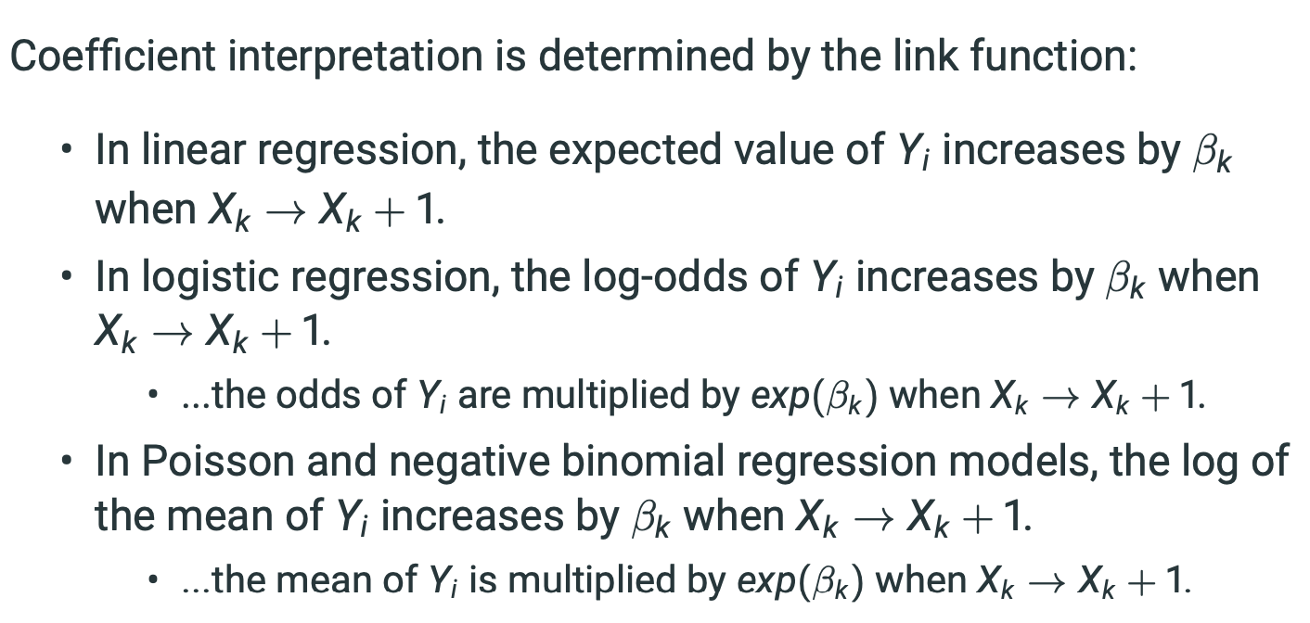

• Link functions are how we model parameters with limited domains.

• If, for example, our outcome variable Y can only equal 0 or 1, we want the mean to be in the range (0, 1).

• But the linear function βX can take on, in principle, any value from (−∞, ∞). • Therefore, we need a function that takes inputs that potentially range from (−∞, ∞) and provides outputs that range from (0, 1).

• This link function g(·) should be strictly increasing so that it provides a 1 to 1 mapping between inputs and outputs.

• The distributional properties of data are handled separately from the link function.

We are not transforming Y (which could create problems to a linear analysis), but just its mean!

• Our powers to model complex and divers social data expand further!

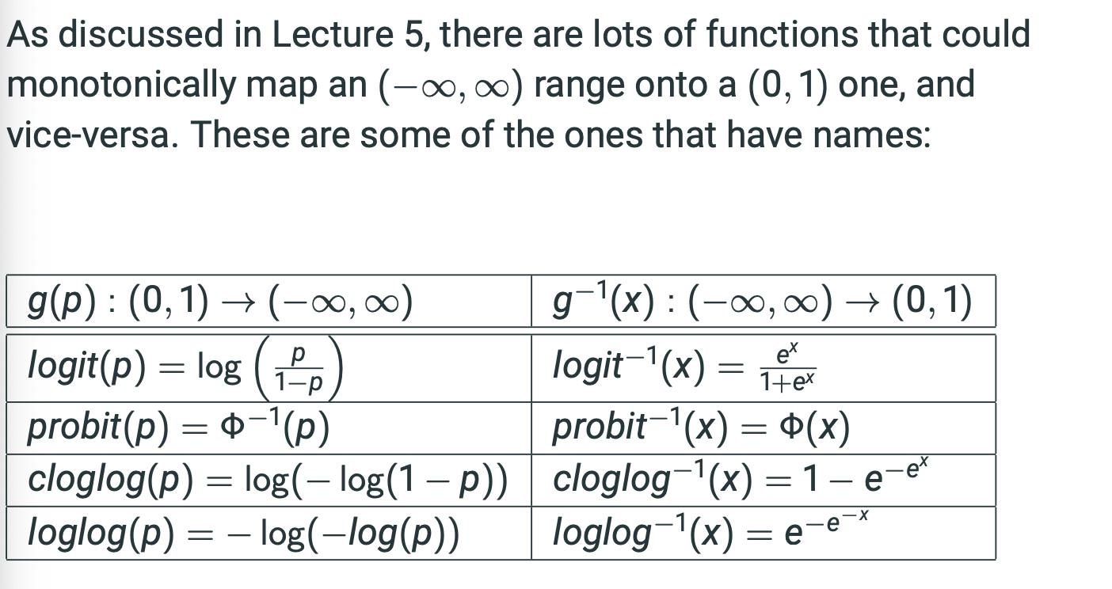

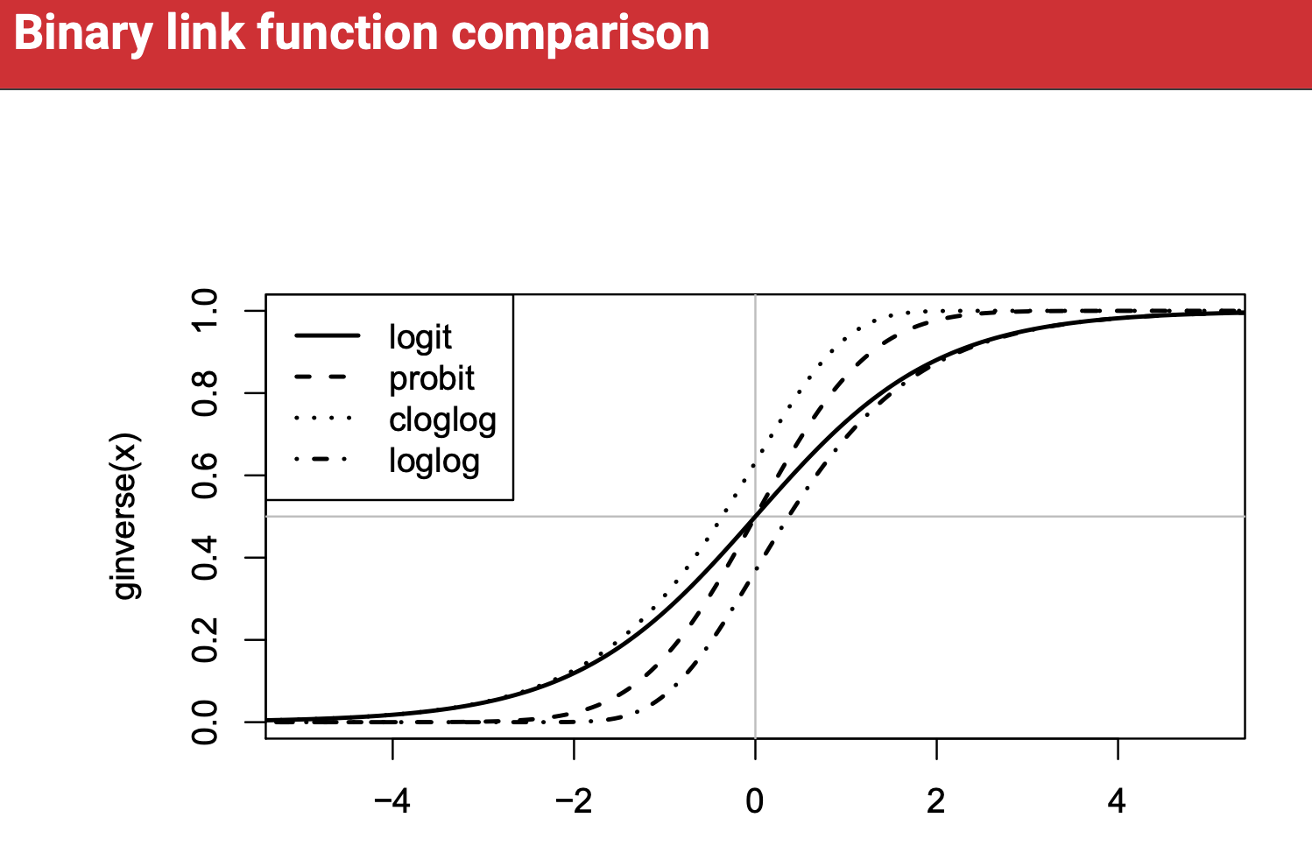

**Week 10 – Lecture: Count Models**

**Poisson Distribution**

* Only has lambda as a parameter.
* Mean is lambda.
* Variance is lambda.

Modelling:

* Basically like binary data, as we’re predicting probability of between 0 and 1. Instead, the observed y values can be 0 – infinity rather than 0 to 1 in case of binomial logistic.
* Easiest way to bound from 0 to infinity is to LOG IT.
* Log(lambda-i) = alpha + beta1*x1 + … + betak*xk
* Lambda-I = exp(alpha + beta1*x1 + … + betak*xk)
* Just e to the power of regression equation for lambda.
* Thus, increasing Xk by 1 multiplies E[Y|X] by e^betak

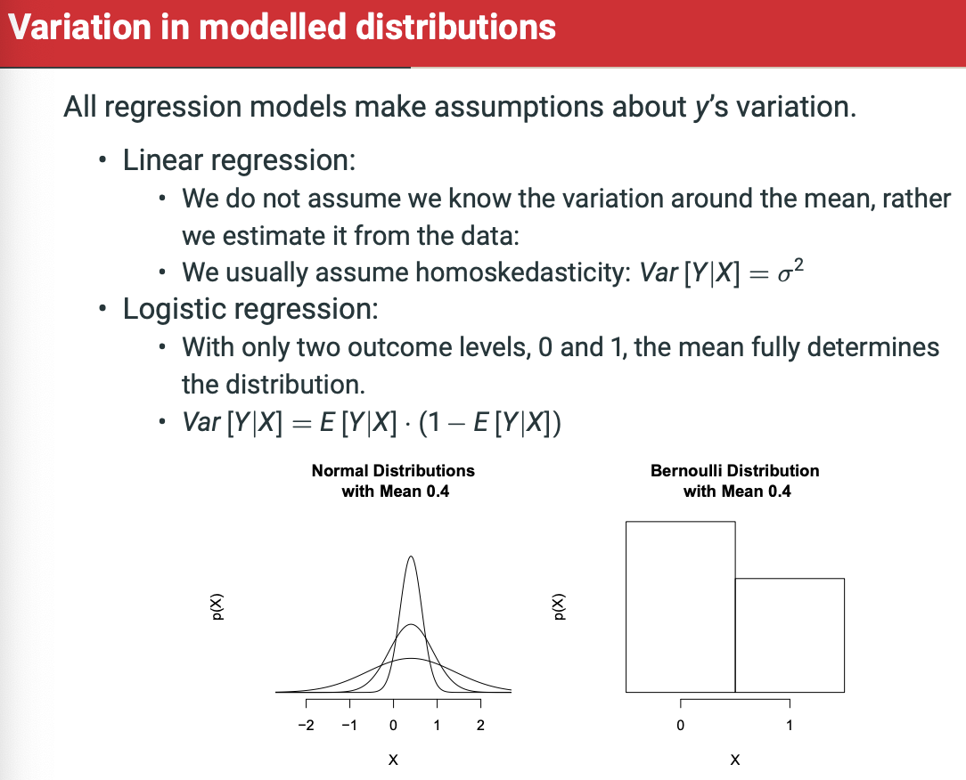

**Negative Binomial Model**

• The Poisson regression model makes a very strong assumption about the scatter of points around the regression line.

* • For a given mean, there is one and only one possible value for the variance.
* • Among other consequences, this means that the probability of a zero outcome is tiny if the mean is greater than about 10.

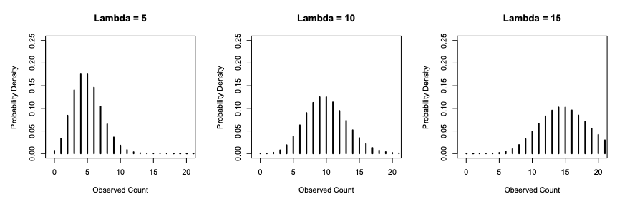

There is a straightforward generalization of the Poisson distribution, called the Negative Binomial, which allows for overdispersion by comparison to the Poisson.

* • Overdispersion means extra variation.
* The Poisson has mean λ and variance λ,
* the negative binomial will have mean λ and variance λ + λ^2/θ (theta)
* variance = alpha*lambda^2

Negative binomial can take on a more varied set of shapes than Poisson.

Varying value of theta adjusts variance term, so:

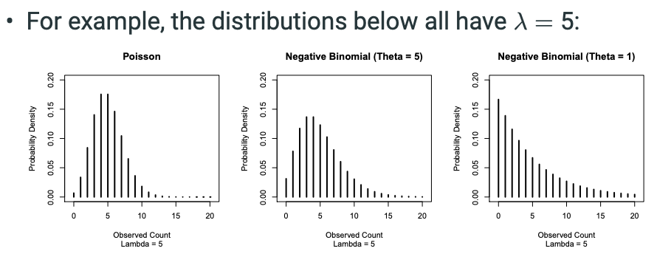

Notice that above, there are radically different probabilities of a zero outcome under three differing probability distributions.

There is an estimate of the parameter describing the degree of overdispersion, which is theta or alpha.

* When there is an overdispersion, the Poisson will tend to yield standard errors that are too small.

This can be shown below. Notice that the z scores for Neg Binom is about half that of the Poisson, so we’re about half as sure under the neg binom.

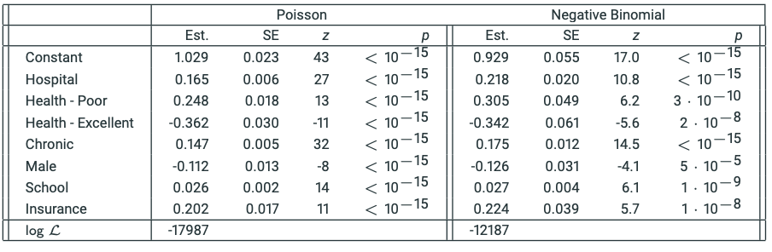

For likelihood ratio tests, think of Poisson model as a simpler nested version of the negative binomial model.

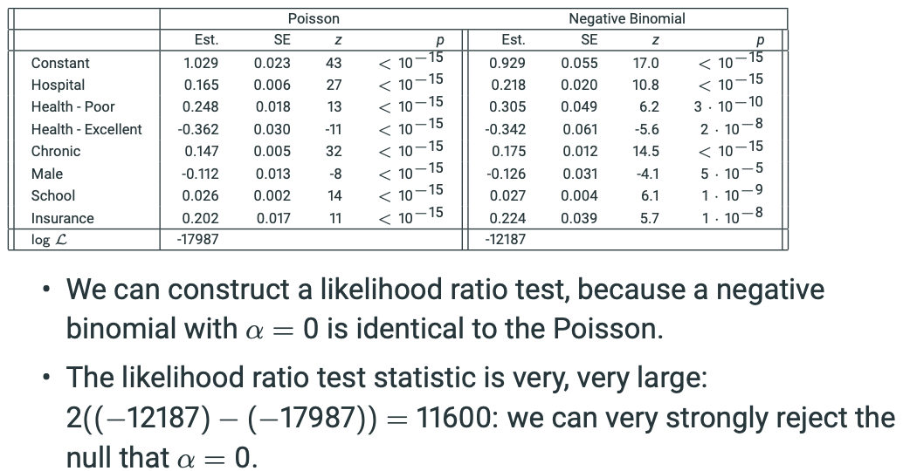

**Generalised Linear Models**

We want to model the expected outcome, given a set of explanatory values.

* We put our values through some function, mu, to estimate an expected value of Y.
* Yi is thus the function mu of the explanatory variables + a small amount of error (epsilon).
* Mu(.) is a ‘mean function’

Fitting a regression involves trying to estimate mu(X) from some observed Y and X data.

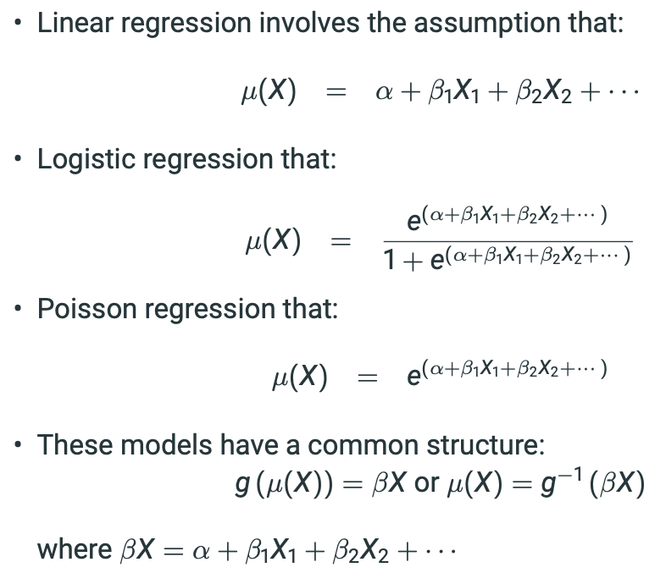

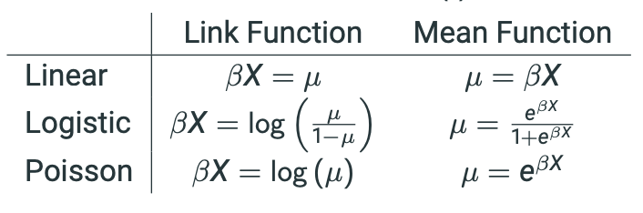

Each model has a ‘link’ and a ‘mean’ function. Shown above.

Unifying regression models into GLM:

1. A random component with probability distribution from exponential family.
   * This function can describe a GAUSSIAN, a BINOMIAL, a POISSON, etc.
2. A ‘link’ function g(.) of the expected value of unit I’s response as a linear function of a set of X variables: g(mu(X)) = BetaX
   1. • In linear regression, it is the expected value (mean) of Yi that is a linear function of the data βXi .
   2. • In logistic regression, it is the log-odds of Yi that is a linear function of the data βXi .
   3. • In the Poisson and negative binomial regression models, it is the log(mean) of Yi that is a linear function of the data βXi .
   4. Coefficient interpretation is determined by the link function:
      1. In linear regression, the expected value of Yi increases by βk when Xk → Xk + 1.
      2. • In logistic regression, the log-odds of Yi increases by βk when Xk → Xk + 1.
         1. • ...the odds of Yi are multiplied by exp(βk) when Xk → Xk + 1.
      3. In Poisson and negative binomial regression models, the log of the mean of Yi increases by βk when Xk → Xk + 1.
         1. • ...the mean of Yi is multiplied by exp(βk) when Xk → Xk + 1.
3. The likelihood for any such model can be estimated and maximised using the same algos.

**Why is this useful?**

Link functions are how we model parameters with limited domains.

* If, for example, our outcome variable Y can only equal 0 or 1, we want the mean to be in the range (0, 1).
  + But the linear function βX can take on, in principle, any value from (−∞, ∞).
  + Therefore, we need a function that takes inputs that potentially range from (−∞, ∞) and provides outputs that range from (0, 1).
  + This link function g(·) should be strictly increasing so that it provides a 1 to 1 mapping between inputs and outputs.
* The distributional properties of data are handled separately from the link function.
  + We are not transforming Y (which could create problems to a linear analysis), but just its mean!
* Our powers to model complex and diverse social data expand further!

**REVISION KNOWLEDGE BANK**

**Statistical Tests**

**T-test**

**Definition:** *Defines the number of standard deviations away from null hypothesis (that X and Y are not related) that the observed data is under t-distribution*

**Formula:** *T = Beta-hat / SE-hat(Beta-hat)*

**Application:** *Used to measure P-value*

**Models:** *Linear*

**Symbols:** *t*

**Notes:** *Uses a t-distribution. if t > 1.96 then p-value is 0.05 or less.*

**Z-test**

**Definition:** *Defines the number of standard deviations away from null hypothesis (that X and Y are not related) that the observed data is under standard normal distribution*

**Formula:** *Z = Beta-hat / SE-hat(Beta-hat)*

**Application:** *Used to measure P-value*

**Models:** *Logistic*

**Symbols:** *Z*

**Notes:** *Uses a standard normal distribution. if t > 1.96 then p-value is 0.05 or less. Is SQRT of Wald Test*

**Wald Test**

**Definition:** *This is a tricky one. It is both a rough approximation for LRT and also can be used as replacement for Z-test. Can test both single coefficients and entire models.*

**Formula:** *W = Z^2*

**Application:** *Used to confirm whether a set of independent variables are collectively ‘significant’ for a model or not OR whether a single independent*

**Models:** *Logistic (binary, multinomial, ordinal)*

**Symbols:** *W*

**Notes:** *This uses a Chi-squared instead of a standard normal distribution. if t > 1.96 then p-value is 0.05 or less (more or less). Z^2 = W. This is a rough approximation of the Likelihood Ratio Test. Only requires one model, whereas LRT requires two for comparison.*

**F-test**

**Definition:** *Considers a hypothesis that the coefficients of several variables are all 0.*

**Formula:** *(R^2 change/df change)/(1-Adjusted R^2)/(n – (k-a + 1)) where df change = ka – k0 and ka is the number of explanatory variables included in bigger model.*

**Application:** *Tests the null hypothesis that all coefficients are 0 versus the alternative hypothesis that at least one coefficient is not 0.*

**Models:** *Linear*

**Symbols:** *F*

**Notes:** *If F < 0.05 then AT LEAST ONE of the coefficients in not 0.*

**Likelihood Ratio Test**

**Definition:** *Test that measures relative model fit between nested and larger model.*

**Formula:** *L^2 = -2*log(L1) – (-2*log(L2)) where L1 and L2 are likelihoods for model 1 and 2.*

**Application:** *To test whether more complex model has significantly more explanatory power*

**Models:** *logistic regression*

**Symbols:** *L^2*

**Notes:** *Generates a likelihood ratio statistic which then needs to be measured to a chi-squared distribution. A simple way to know if this has been calculated correctly is that the value must always be non-negative.*

**P-value**

**Definition:** *Probability of observing this value under the null hypothesis.*

**Formula:** *p is measured against relevant distribution table (depends of type of model) with associated degrees of freedom.*

**Application:** *Used to justify statistical significance*

**Models:** *ALL*

**Symbols:** *p*

**Notes:** *p value varies based on 3 things: the relevant distribution, the degrees of freedom and the test statistic.*

**Likelihood Ratio Statistic**

**Definition:** *Probability of observing this value under the null hypothesis.*

**Formula:** *p is measured against relevant distribution table (depends of type of model) with associated degrees of freedom.*

**Application:** *Used to justify statistical significance*

**Models:** *ALL*

**Symbols:** *p*

**Notes:** *Must be measured to x^2 (chi-squared) distribution with degrees of freedom equal to the number of additional parameters in model 2 over model 1.*

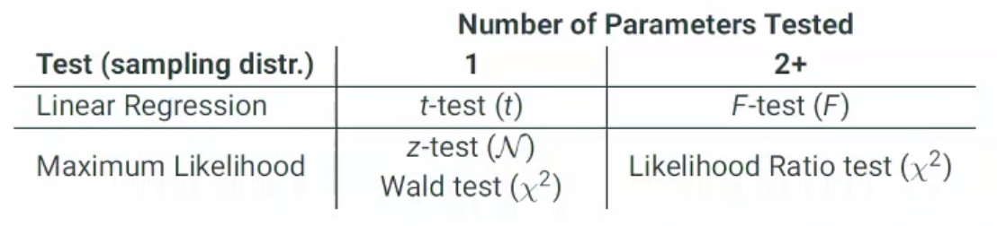

**Model Parameters**

**Total Sum of Squares /Sum of Squares (TSS)**

**Definition:** *A measure of the total variation in Yi in the sample.*

**Formula:** *((Yi-mean(Y))^2) OR the sum of the difference between each observation and the mean, squared*

**Application:** *To determine the total variation in Yi in the sample and also used to re-engineer a calculation for SSE and R^2.*

**Models:** *Linear, as we need residuals.*

**Symbols:** *TSS or 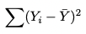*

**Notes:** *TSS = SSM + SSE. Also, note that TSS/(n-1) = sample variance of y.*

**Sum of Squared Error / Residual Sum of Squares (SSE/RSS)**

**Definition:** *The total unexplained variation in our model. Parameter estimation that minimises this is the least squares estimate.*

**Formula:** *SSE = sum((Yi-Y-hat)^2)*

**Application:** *Used to estimate parameters and to determine the amount of unexplained variation in our model.*

**Models:** *Linear, as we need residuals.*

**Symbols:** *SSE, RSS,*

**Notes:** *SSE = TSS – SSM.*

**Model Sum of Squares (SSM)**

**Definition:** *The reduction in squared prediction errors achieved when we make use of Xi to predict values of Yi instead of just using the mean of Y.*

**Formula:** *sum((Yi-hat – Y-mean)^2) or SSM = TSS - SSE*

**Application:** *To determine how much additional explanatory power was introduced by adding explanatory variables*

**Models:** *Linear, as we require regression*

**Symbols:** *SSM*

**Notes:** *SSM can be reverse engineered when we know the TSS and SSE.*

**Residual Standard Deviation**

**Definition:** *Standard deviation of all the residuals from our prediction vs. observed data*

**Formula:** *Sqrt(SSE/(n – (k + 1))) where k = the number of explanatory variables.*

**Application:** *To understand the spread of our residuals to determine homoskedacicity*

**Models:** *linear, as we need residuals.*

**Symbols:** 

**Notes:** *The n – (k+1) is also known as the degrees of freedom of the parameter estimates.*

**R^2 / R-squared (Coefficient of Determination)**

**Definition:** *A measure of the proportion of total variation of Y in the sample explained by our model.*

**Formula:** *R^2 = (TSS – SSE)/TSS OR 1 – SSE/TSS OR 1 – sum((Yi – Y-hat)^2)/sum((Yi – Y-mean)^2)*

**Application:** *A measure of the proportion of the total variation of Y in the sample explained by the fitted regression model.*

**Models:** *Linear regression, as we require residuals.*

**Symbols:** *R^2, R-squared.*

**Notes:**

* *Has to be between 0 and 1!*
* *Remember, R^2 will increase as we add additional explanatory variables but that does not necessarily mean we have a better model. To penalise for additional variables, we use adjusted R^2.*
* *TSS – SSE shows the reduction in the level of prediction errors when we allow the predicted Y-i-hat to depend of values of Xi. R^2 expresses this reduction as a proportion of TSS.*
* *Square root of R^2 ® is the correlation between Yi and the fitted values Y-hat-I, also known as* ***multiple correlation coefficient,*** *and is always between 0 and 1.*

**Adjusted R^2**

**Definition:** *R^2 calculation but adjusted for number of explanatory parameters – in order to address limitation of R^2 that increases for each additional explanatory variable added*

**Formula:** *R^2-adjusted = 1 – (((1-R^2)*(n-1))/(n-k-1)) OR 1 – (((1-R^2)*(n-1))/(n-k-1)))*

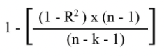

**Application:** *Penalises R^2 based on additional variables*

**Models:** *Linear*

**Symbols:** 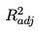

**Notes:** *Need to be able to calculate. This is typically used In prediction settings rather than R^2. K includes intercept!!*

**Pseudo-R^2**

**Definition:** *Generalising R^2 from linear to logistic through measuring relative to null model (intercept-only)*

**Formula:** *One is Mac Fadden’s, which equals: (-Log(Likelihood-Null) – (-Log(Likelihood-1))/-Log(Likelihood-Null) 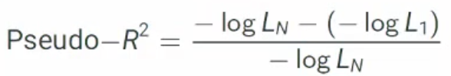*

**Application:** *Trying to capture proportion of variance in sample that is captured by model.*

**Models:** *Logistic*

**Symbols:** *Pseudo-R^2*

**Notes:** *Many compare intercept-only model with model of interest! Mac Faddens gives the proportional improvement in fit (measured as log-likelihood).*

**Akaike’s Information Criterion (AIC)**

**Definition:** *Measures that penalise the log-likelihood by some measure of model complexity (some function of the number of model parameters, k)*

**Formula:** *-2log(likelihood) + 2k*

**Application:** *Derived as the distance from the ‘true’ unknown model.*

**Models:** *Logistic*

**Symbols:** *AIC*

**Notes:** *The smaller the AIC, the better!!*

**Estimated Residual Standard Deviation (RSE)**

**Definition:** *The standard deviation of residuals**from model.*

**Formula: sqrt(SSE/(n-p-1))**



**Application:** *To determine the fit of the model.*

**Models:** *Linear*

**Symbols:** σ̂

**Computing Probabilities**

**Probability of an Event under Logistic Regression**

**Steps:**

1. *Run model*
2. *Compute logit by taking intercept and relevant coefficient*value*
   1. *Alpha + Beta1*X1 + Beta2*X2, …, BetaN*Xn*
3. *Compute probabilities by exponentiating E by predicted logit.* 
   1. *REMEMBER Exp(logit) is odds ratio*
   2. *E^logit/(1 + E^logit)*
   3. *Probability = OR / (1 + OR)*
   4. 
   5. *Or, use: y = 1 / (1 + exp(-(logit)))*

**Cumulative Probabilities under Ordinal Logistic Regression**

1. Intention is to find the cumulative probability under ordinal logistic regression where y(1) is always less than y(2) because y(2) also contains y(1).
2. REMEMBER – each value of Y has its own alpha, but proportional odds assumption means only this changes.
   1. So, use formula:
   2. 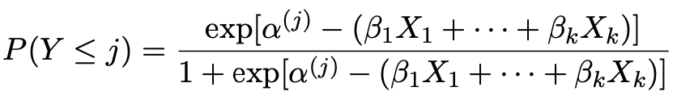
   3. The above formula measures the cumulative probability ‘UP-TO’ j, not j itself or greater than j.

**Odds of an event under Logistic Regression**

**Definition:** *The probability of something happening compared to it not happening*

**Formula:** *Odds = Probability / (1 – Probability) = P(Y = k) / (1 – P(Y = k))*

*Odds of something happening are the inverse of it happening.*

**Odds Ratios under Logistic Regression**

**Definition:** *The ratio of the conditional odds given Xi = VALUE*

*Formula: Odds(Xi =VALUE) / Odds(Xi not equal to VALUE)*

*For non-reference comparisons, comparing conditional odds you can do exp(coefficient for condition 1 – coefficient for condition 2)*

**Odds of an event under Ordinal Logistic Regression**

*Exponentiated coefficient [exp(beta-hat)] estimates are interpreted as partial odds ratios for being in the* ***higher*** *rather than the lower half of the dichotomy.*

*Interpretation: Controlling for the other explanatory variables, we estimate that group 1 has X% lower odds than group 2 of giving a response that indicates higher levels of agreement with statement Y.*

**Confidence Intervals**

**Definition:** *With 95% confidence (not probability), we estimate that a change in X increases the odds of Y by Xi.*

**Probabilities under the Poisson Distribution**

**Definition:** *The probability of observing a number y of events per unit of observation*

*Formula: (Lambda^y*e^-lambda)/y!*

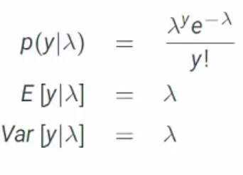

**Notes:**

1. *Mean (lambda) and Variance are the same!*
2. *Low lambda means that there is a high probability density near 0. A higher lambda means that this gets levelled out.*
3. *Lambda is the expected value of the distribution.*
4. *Log(lambda-i) = linear regression equation*

**Probabilities under the Negative Binomial Distribution**

**Definition:** *The probability of observing a number y of events per unit of observation*

*Formula:*

*Notes:*

1. *Overdispersion means extra variation. The poisson has mean lambda and variance lambda. The negative binomial will have mean lambda and variance lambda + lambda^2/Theta. Theta is dispersion parameter.*
2. *Use if mean isn’t equal to variance.*

**Model Assumptions**

**Multinomial Logistic Regression**

**Assumption 1: Independence of Irrelevant Alternatives**

1. *Definition: a condition that states that the relative likelihood of choosing from A from B won’t change if a third choice is placed into the mix.*
2. *Definition 2: IIA implies that the presence of absence of an alternative has no effect on the relative proportion of individuals choosing among the remaining alternatives.*
3. *Result: We can’t say anything about ‘counterfactual’ that is not observed.*

**Ordinal Logistic Regression**

**Assumption 1: Proportional Odds Assumption**

1. *Definition: Curves for values of Y are ‘parallel,’ meaning that all coefficients (except alpha) have consistent values for all values of Y.* 
   1. *This implies that odds are not conditional on values of covariates.*

|  |  |  |  |
| --- | --- | --- | --- |
| **Concept** | **Applicable Models** | **Formula** | **Interpretation** |
| **t-test** | Linear | Text  Description automatically generatedT = Beta-hat/se(Beta-hat) | Observed data is t number of standard deviations away from mean |
| **z-test** | Logistic | Text  Description automatically generatedz = Beta-hat/se(Beta-hat) | Observed data is Z number of standard deviations away from mean |
| **Wald Test** | Logistic | Diagram, venn diagram  Description automatically generatedW = (Beta-hat/se(Beta-hat))^2 |  |
| **F-test** | Linear | Text  Description automatically generated  OR  Text  Description automatically generated with medium confidence  Where K = number of parameters | 1 or more explanatory variables in a multiple linear regression are (not) significant |
| **Likelihood Ratio Test** | Logistic |  | Expanded model is(not) a better explainer of outcome than nested model.  *At least one of the new coefficients are not 0.* |

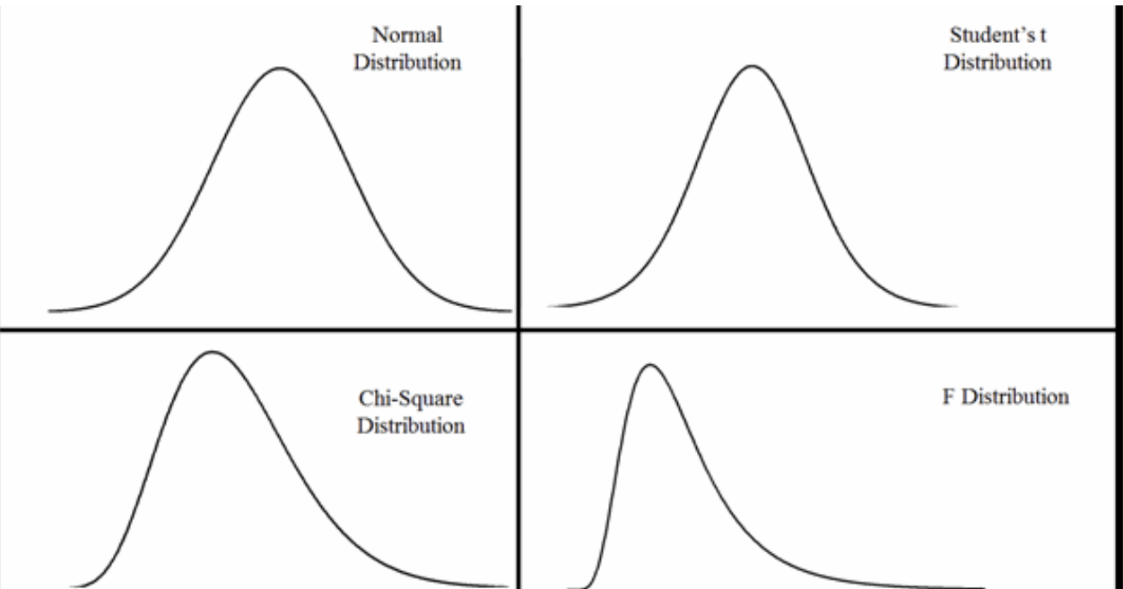

**Template Responses**

* Holding ‘controlling covariates’ constant, a one-unit increase in explanatory variable multiplies the odds of voting for Y1 rather than Y0 by ???, i.e. increases them by ???%.
* (Interpreting Beta-hat in multinomial) Holding ‘controlling covariates’ constant, the odds for someone with ‘Conditional term’ of voting Y1 rather than Y0 are ???? times (???% higher than) the odds for someone with ‘alternative conditional term’ or less.
* For Poisson – increasing Xk by 1 multiplies E[Y|X] by e^Beta-k

|  |  |  |  |  |
| --- | --- | --- | --- | --- |
|  | **Probability / Expected Value** | **Odds** | **Odds Ratio** | **Log Odds** |
| **Definition** | **Probability of an event occurring or expected number of occurrences** | **Ratio of the probability of an event occurring to the probability of an event not occurring** | **Ratio of odds of the event for one group over the odds of the event occurring for another group.** | **The log of the odds of an event occurring** |
| **Linear** |  | **N/A** | **N/A** | **N/A** |
| **Binary Logistic Regression** |  | **E^logit**  **OR**  **Exp(logit)** |  | **logit** |
| **Multinomial Logistic Regression** |  | **E^logit**  **OR**  **Exp(logit)** |  | **logit** |
| **Ordinal Logistic Regression** |  | **E^logit**  **OR**  **Exp(logit)** |  | **logit** |
| **Poisson Count** |  | **N/A** | **N/A** | **N/A** |
| **Negative Binomial Count** | **E[y | lambda] = lambda**  **Var[y] = lambda + alpha*lambda^2** | **N/A** | **N/A** | **N/A** |

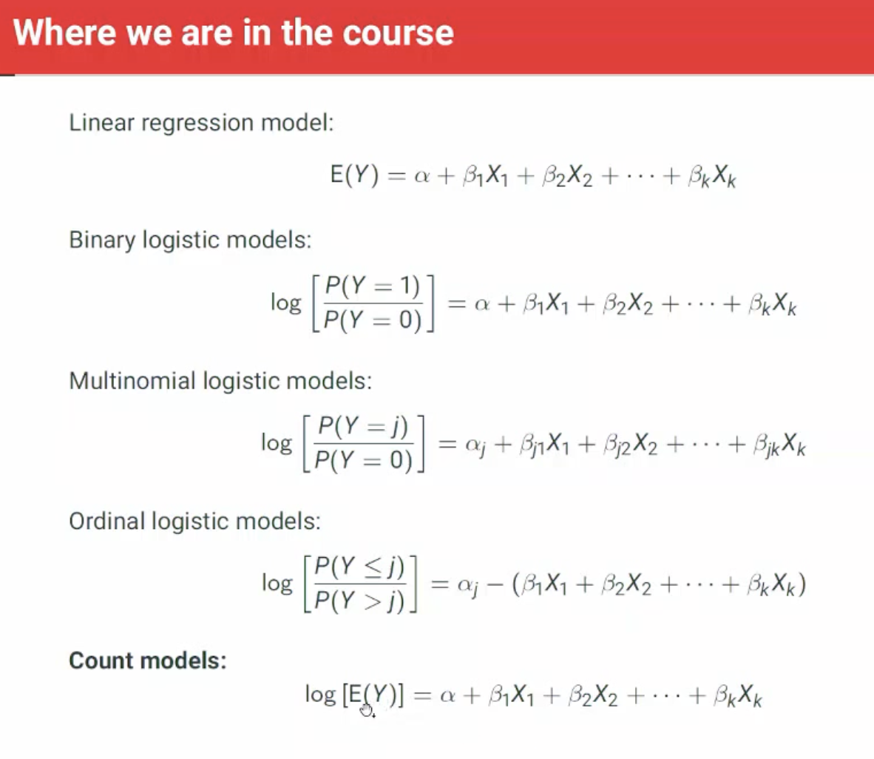

Poisson vs Negative Binomial – Negative Binomial allows for **overdispersion** to sustain non-zero probabilities.